CS 5635 – Assignment 2

Part 1: Load the Data

Q1. Visualization of Statistics for 1-D Data
- Which number occurred the most frequently and how many times did it occur?

The number 10 occurred the most frequently with a frequency of 10.

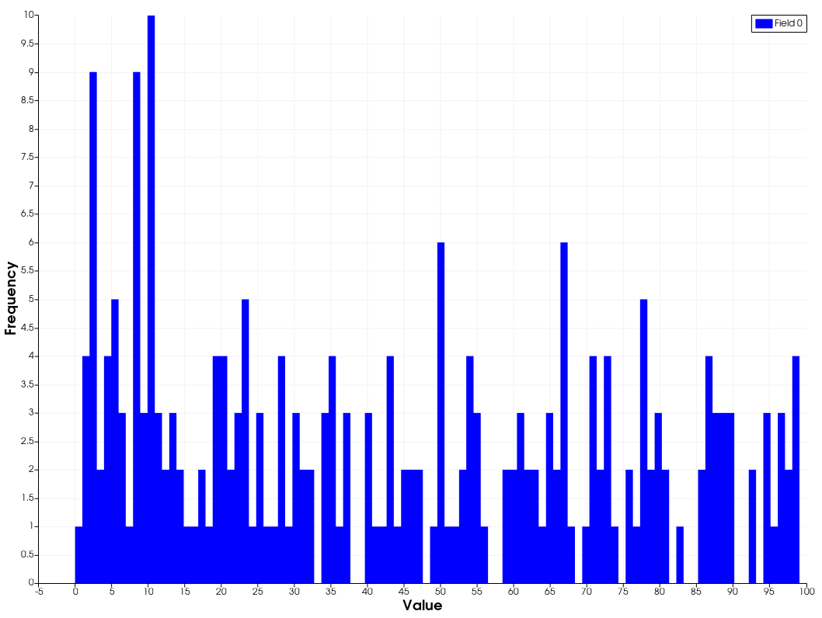
- How many numbers were never used by the class?
14 numbers were never used by the class.

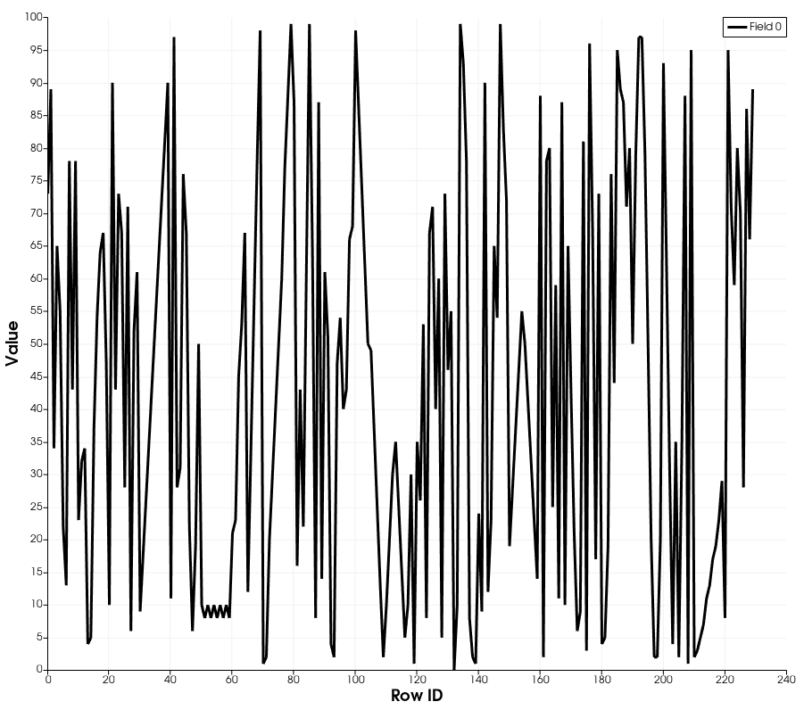

Q2. Visualization of 2d Image
- What threshold did you use for capturing the riverbed? Experiment with other thresholds and explain what features you may or may not have missed with this approach.

I selected a threshold of 60 after looking at a histogram with 10 bins. After trying some other threshold settings it looks like my approach makes it appear like a lake could exist at the end of the canyon. Removing the river bed also seems to make the base look like a uniform height, which I think takes away from the visualization.

- Using the Information panel, report the number of points in the thresholded image. Note that ParaView automatically creates cells from an input image, implicitly forming a structured quad mesh.

My threshold image had rough 8.4 million points and about that number of cells.
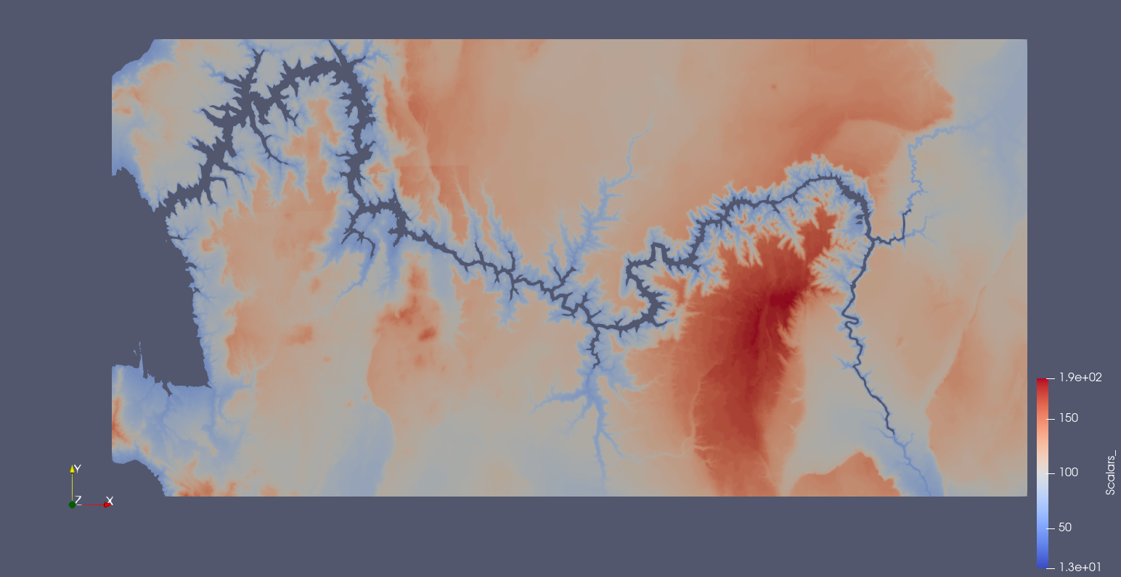

Q3. Exploring Data on Polygonal Meshes
- What were the minimum and maximum values that best captured the single cylinder associated with the bolt’s cylinder?

I used a range of [0,40] on a threshold filter to achieve a solid blue cylinder.
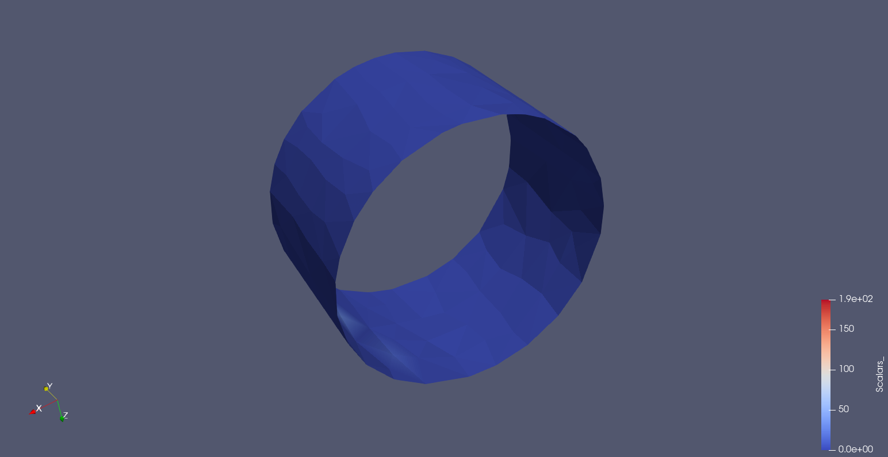

- How many ventilation slots are there?

There are 6 ventilation slots per quadrant or 24 in total. Achieved using a clip filter to easily view the ventilation slots.
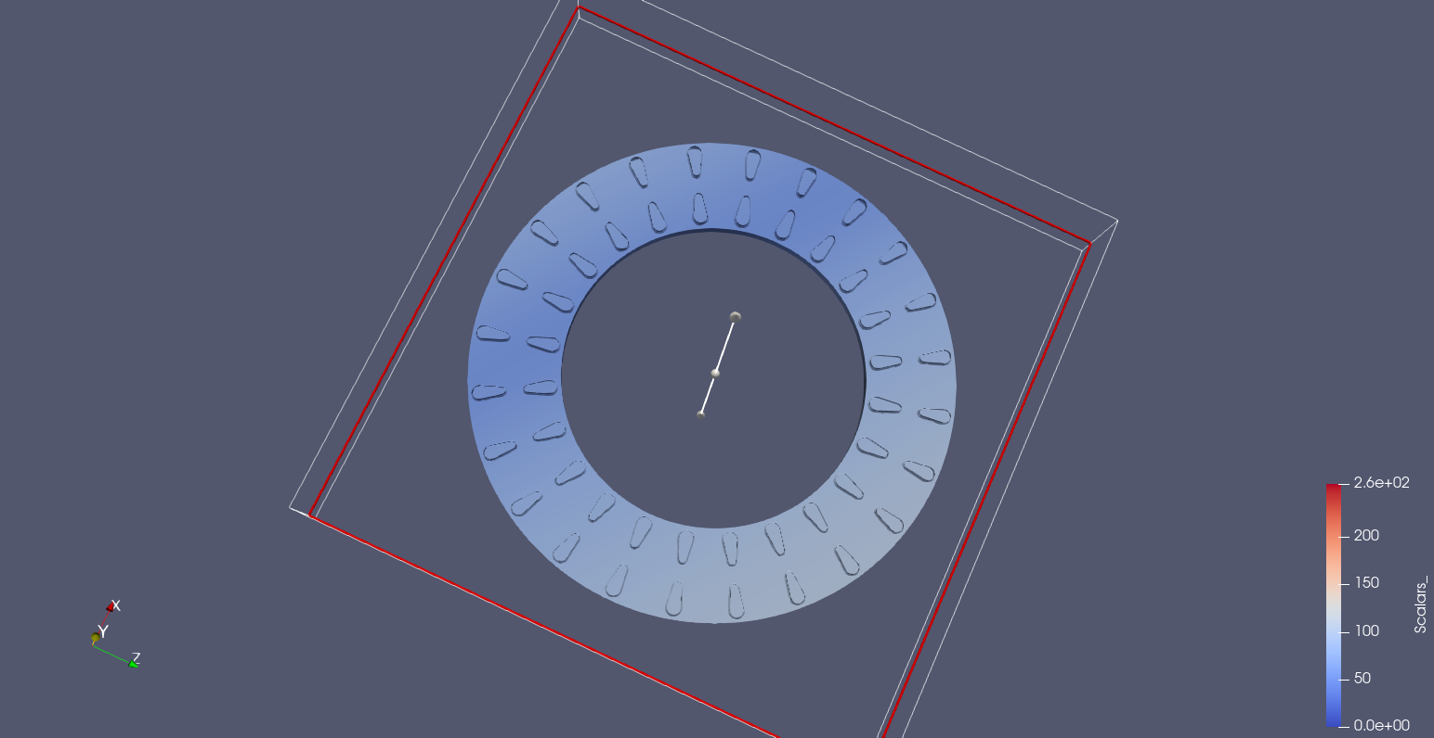

Q4. Visualization of 3D Images
Screenshot of all linked views working at once, achieved using 3 slice filters in linked and unified views.
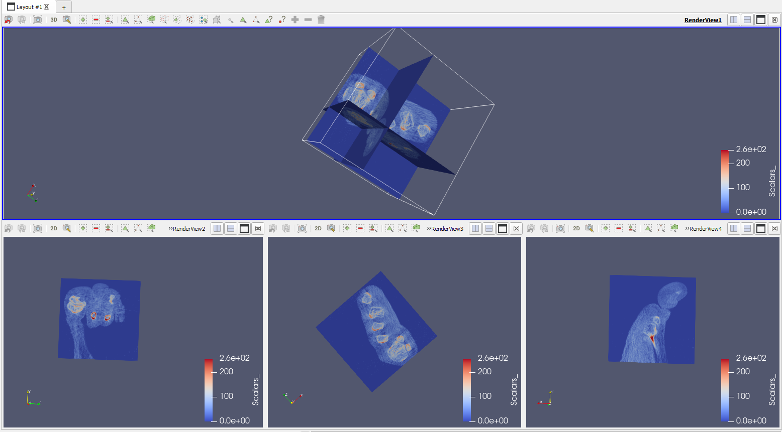

Part 2: Code with Python Script

Q1. Use batch script to create a pipeline.
- Use batch script to render 16 arrows in the renderview. Set the Orientation of the arrow and let them rotate 360° in XY plane. Change the property "TipResolution" to 12.

- Hide the arrows, Then apply shrink filter & extractedge filter to the arrow. Render the filter in the renderview.

Q2. Read file and process it with Python script
- Load the data "2d.vti" into the view with python script. Plot the scalar data use filter "PlotOverline" with script and render it a multiple view.

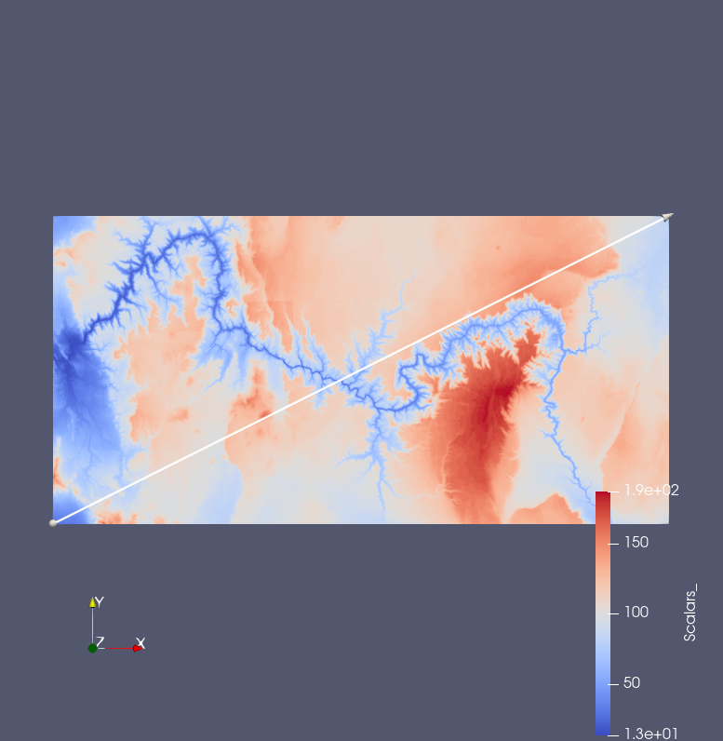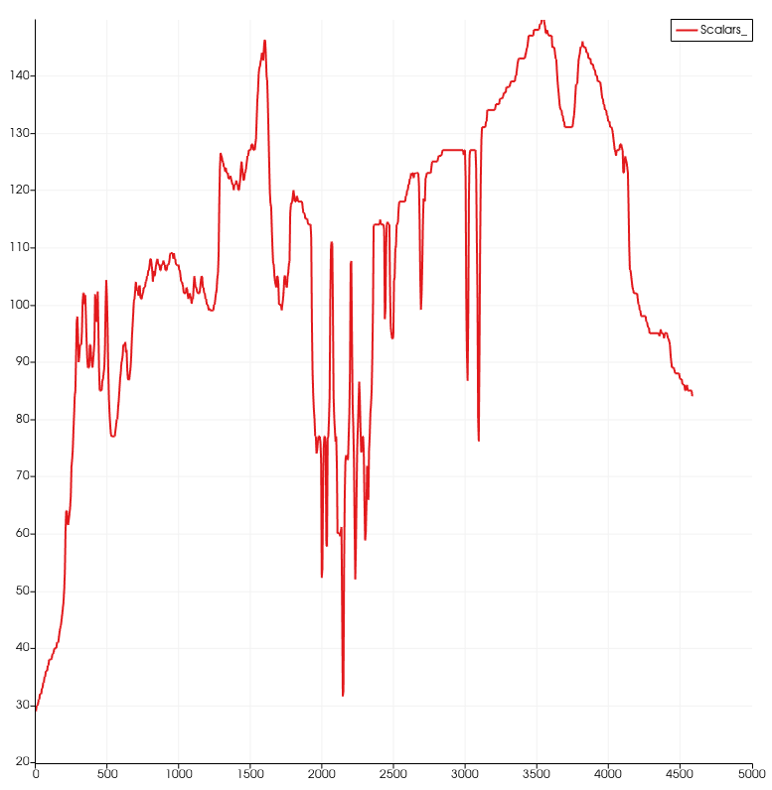

- Find a filter and apply it with Python script to generate a 3D map from the 2D scalar data. Change the filter's property in the script to change the scale factor of scale data.

I used the warp by scalar filter to achieve my 3d representation.

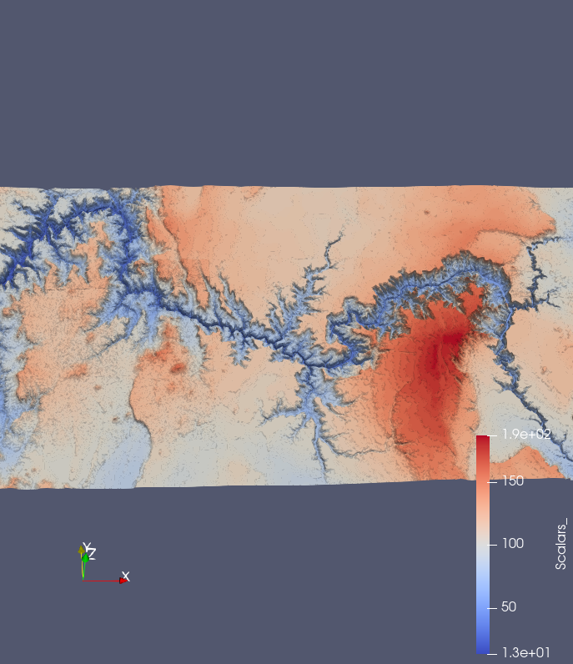

Part 3: Not required for Undergraduate

Conclusion
Paraview is a powerful piece of software for visualizing datasets. I’m interested in continuing to use it and get better with it. I feel like I could use some more guided tutorials for scripting, as I’m really just guessing and recording traces until it works. Elevation maps seem to be an easy but great way of using this piece of software and slightly addicting.

