Applied probability models for CS: Exercise 3

Daniel Bazar 314708181

Lior Krengel 315850594

## Part 1

We decided the threshold for stopping criteria in the EM algorithm to be **10.** In scale of the large numbers of the log-likelihood, 10 is a very small number. We tested many thresholds and there weren’t big differences.

## Part 2

Log-likelihood and mean perplexity plots until convergence (30 iterations):

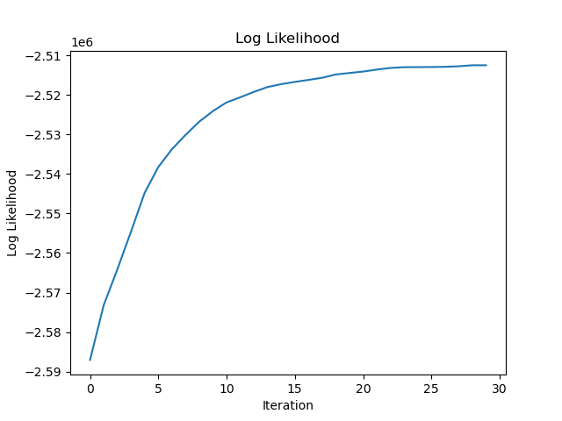 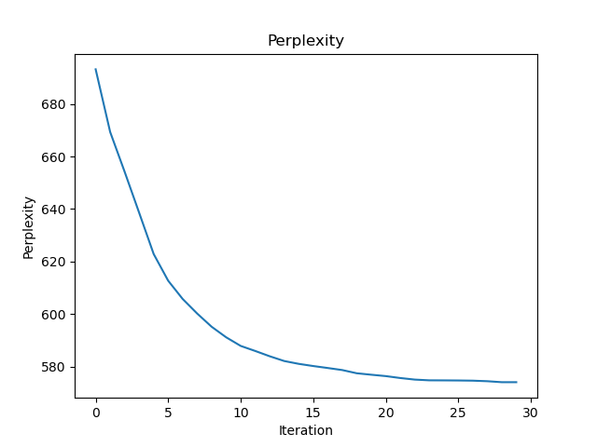

## Part 3

Confusion matrix:

|  |  |  |  |  |  |  |  |  |  |  |
| --- | --- | --- | --- | --- | --- | --- | --- | --- | --- | --- |
|  | acq | money-fx | grain | crude | trade | interest | ship | wheat | corn | size |
| 6 | 347 | 5 | 1 | 26 | 6 | 3 | 29 | 1 | 0 | 418 |
| 7 | 0 | 7 | 155 | 26 | 13 | 1 | 9 | 84 | 66 | 361 |
| 0 | 0 | 196 | 14 | 11 | 7 | 112 | 2 | 12 | 5 | 359 |
| 5 | 7 | 82 | 12 | 32 | 77 | 115 | 3 | 5 | 5 | 338 |
| 2 | 7 | 7 | 98 | 44 | 14 | 12 | 21 | 60 | 38 | 301 |
| 8 | 9 | 44 | 16 | 15 | 193 | 7 | 2 | 3 | 7 | 296 |
| 3 | 2 | 87 | 55 | 16 | 17 | 15 | 18 | 19 | 33 | 262 |
| 1 | 8 | 13 | 29 | 51 | 5 | 4 | 96 | 10 | 4 | 220 |
| 4 | 20 | 10 | 8 | 128 | 5 | 6 | 6 | 3 | 2 | 188 |

## Part 4

Topics histograms:

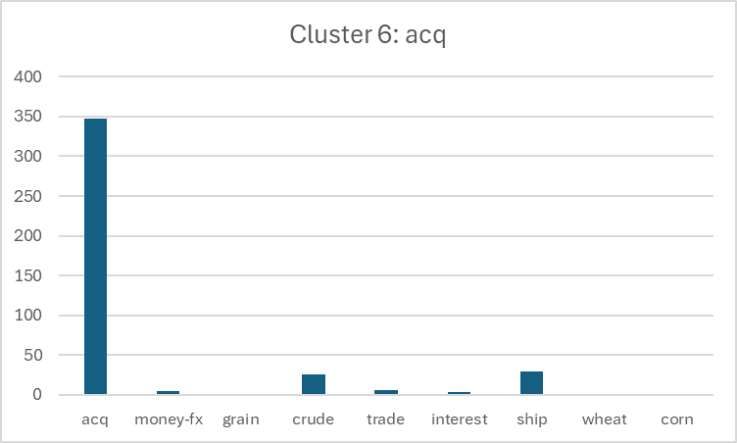

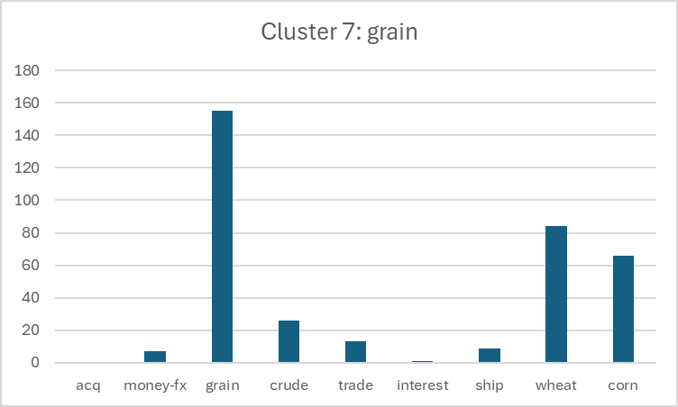

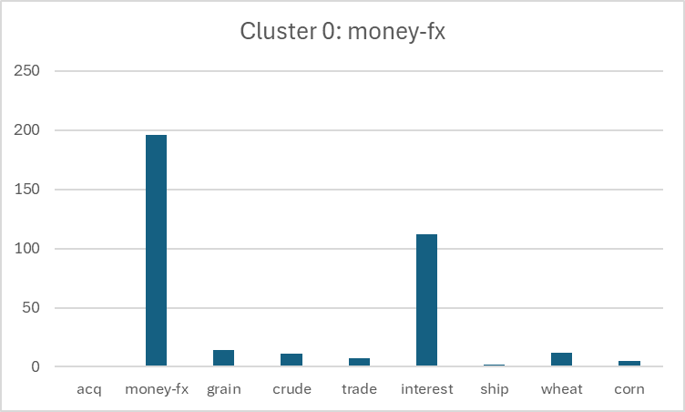

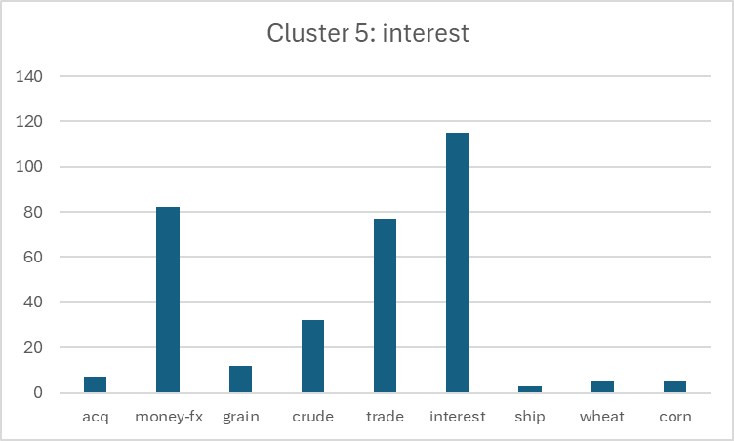

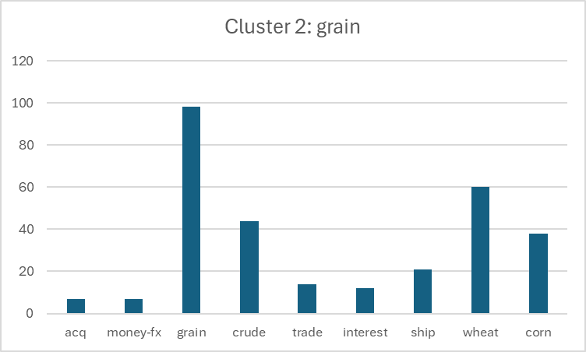

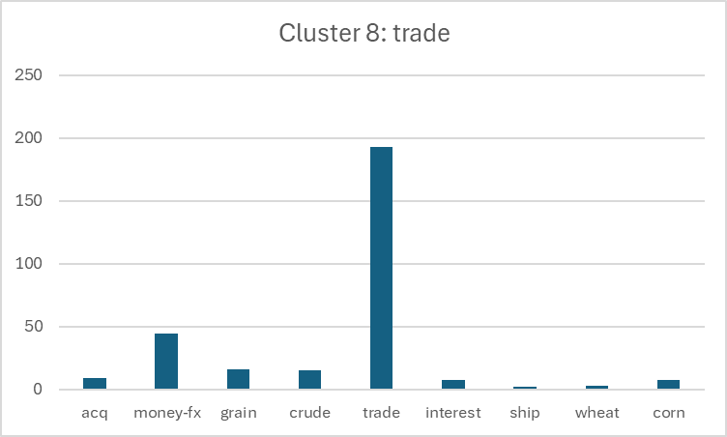

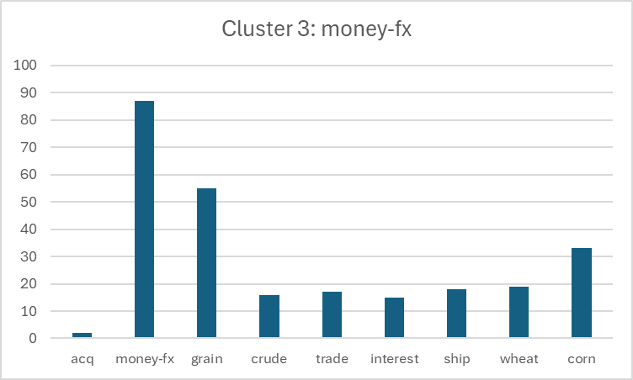

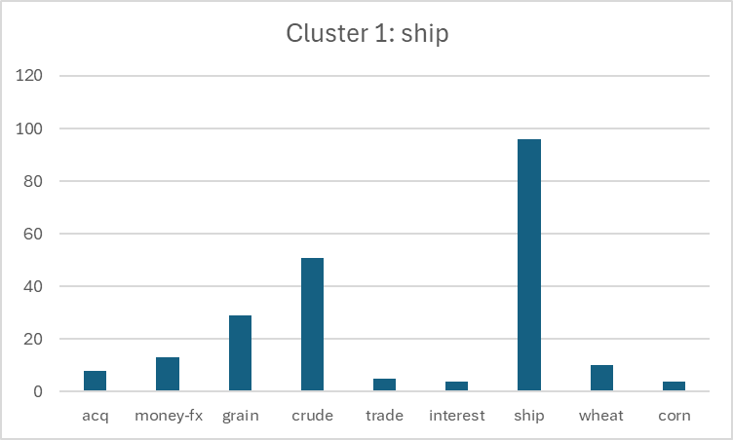

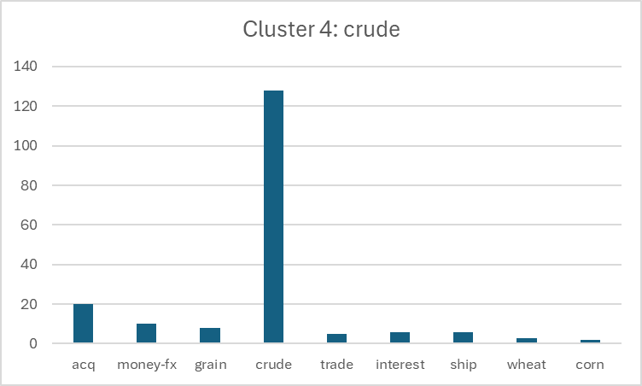

## Part 5

Model accuracy: **66.62%**

## Part 6

We tested many lambdas values and λ=0.1 returned the minimum perplexity so we chose it

|  |  |
| --- | --- |
| K | 10 |
| vocabulary size after filtering | 6800 |
| λ | 0.1 |