Table 1: Description and summary of calibration simulations.
No. | Anchor | Sampling | Template | Scoring function | Kolmogorv – Smirnov p-value by scoring scheme
 |  |  |  |  | Peptide score | Interface score | Reweighted score
1 | Peptide: Acetyl-K3  Receptor: F194 | - Perturbation size = 6 (defualt)  - 200 decoys per peptide. | 2v5w | Default | 0.2 | 0.03 | 0.69
2 | Peptide: Acetyl-K3  Receptor: F194 | - Perturbation size = 15  - 200 decoys per peptide | 2v5w | hack_elec = 0.5 | 0.2 | 0.03 | 0.69
3 | Peptide: Acetyl-K3  Receptor: F194 | - Perturbation size = 15  - 200 decoys per peptide  - low resolution step (centroid mode) | 2v5w | Default | 0.2 | 0.2 | 0.697
4 | Peptide: Acetyl-K3  Receptor: F194 | - Perturbation size = 20  - 200 decoys per peptide | 2v5w | Default | 0.2 | 0.03 | 0.2
5 | Peptide: Acetyl-K3  Receptor: F194 | - Perturbation size = 30  - 200 decoys per peptide | 2v5w | Default | 0.2 | 0.2 | 0.2
6 | Peptide: Acetyl-K3  Receptor: F194 | - Perturbation size = 30  - 500 decoys per peptide | 2v5w | Default | 0.2 | 0.03 | 0.69
7 | Peptide: Acetyl-K3  Receptor: F194 | - Perturbation size = 60  - 500 decoys per peptide | 2v5w | Default | 0.2 | 0.03 | 0.69
8 | Peptide: Acetyl-K3  Receptor: F194 | - Perturbation size = 90  - 900 decoys per peptide | 2v5w | Default | 0.69 | 0.69 | 0.03
9 | Peptide: Acetyl-K3  Receptor: F194 | - Perturbation size = 15  - 200 decoys per peptide | 3f07 | Default | 0.997 | 0.2 | 0.69
10 | Peptide: Acetyl-K3  Receptor: F194 | - Perturbation size = 15  - 200 decoys per peptide | 1t67 | Default | 0.69 | 0.69 | 0.69
11 | acetyl-K3 | - Perturbation size = 15 | 2v5w | hack_elec = 0.25 | 0.2 | 0.2 | 0.69
12 | Peptide: Acetyl-K3  Receptor: F194 | - Perturbation size = 15  - 200 decoys per peptide | 2v5w | Score 12 (Rosetta's default scoring function) | 0.2 | 0.03 | 0.2
13 | Peptide:  X4 – (variable position – CA atom. Chosen by default.)  Receptor:  (default: center of mass) | - Perturbation size = 20  - 200 decoys per peptide | 2v5w | Default | 0.2 | 0.2 | 0.2
14 | Peptide: acetyl-K3 (anchor was CH atom, instead of CA) Receptor: anchor was residue G289 | - Perturbation size = 15  - 200 decoys per peptide | 2v5w | Default | 0.2 | 0.03 | 0.2
15 | Peptide: acetyl-K3 , Receptor: anchor was G289 | - Perturbation size = 15  - 200 decoys per peptide | 2v5w | Default | 0.2 | 0.2 | 0.009
16 | Peptide: Acetyl-K3  Receptor: F194 | - Perturbation size = 15  - 200 decoys per peptide | 2v5w | SD of constraints was 0.15 Å | 0.2 | 0.2 | 0.005
17 | Peptide: Acetyl-K3  Receptor: F194 | - Perturbation size = 15  - 200 decoys per peptide | 2v5w | SD of constraints is 0.25 Å | 0.2 | 0.03 | 0.2
18 | Peptide: Acetyl-K3  Receptor: F194 | - Perturbation size = 8  - 200 decoys per peptide | 2v5w (threaded) | Default | 0.2 | 0.003 | 0.69

Table 2: Training set - score vs. activity box plots for the short calibration phase
No. | Reweighted score | Peptide score | Interface score
1 | 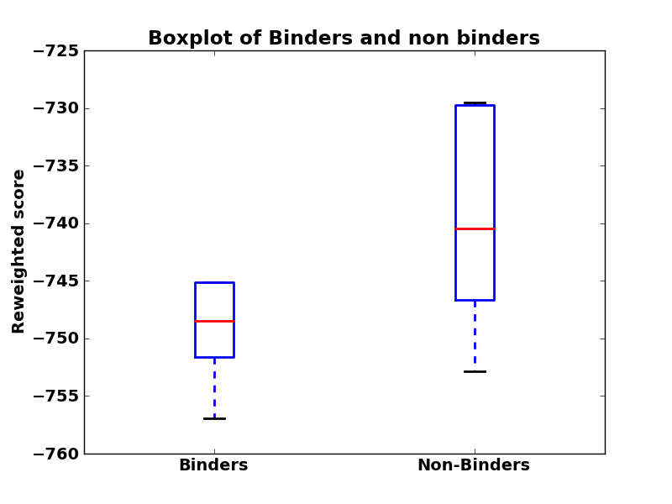 | 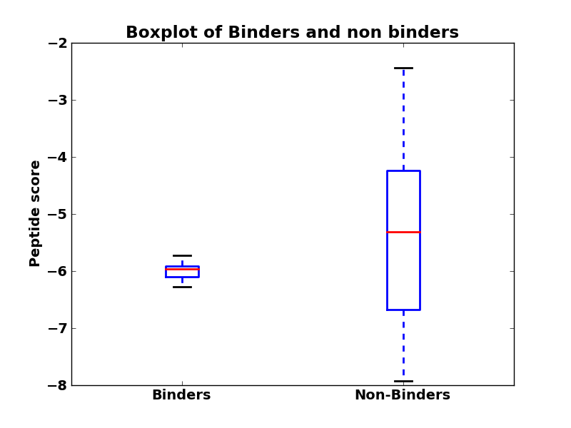 | 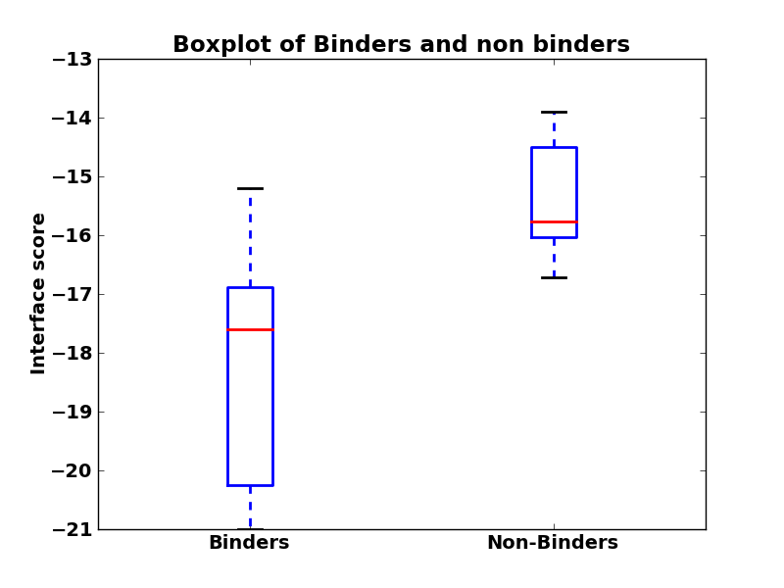
2 | 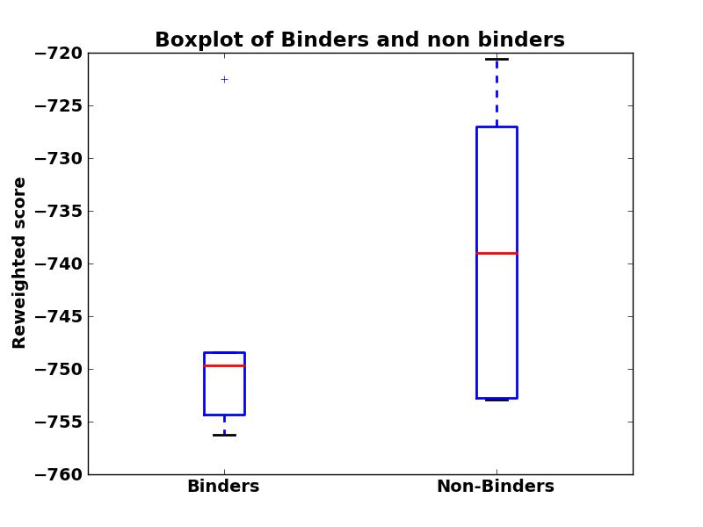 | 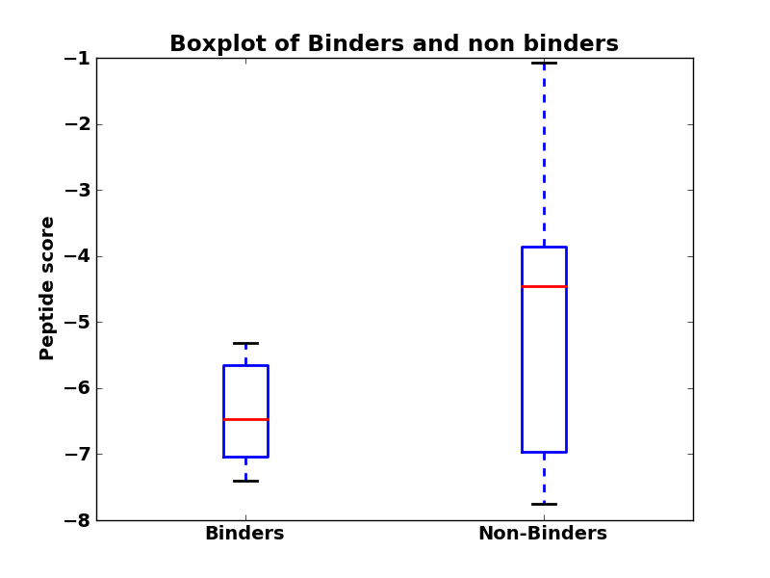 | 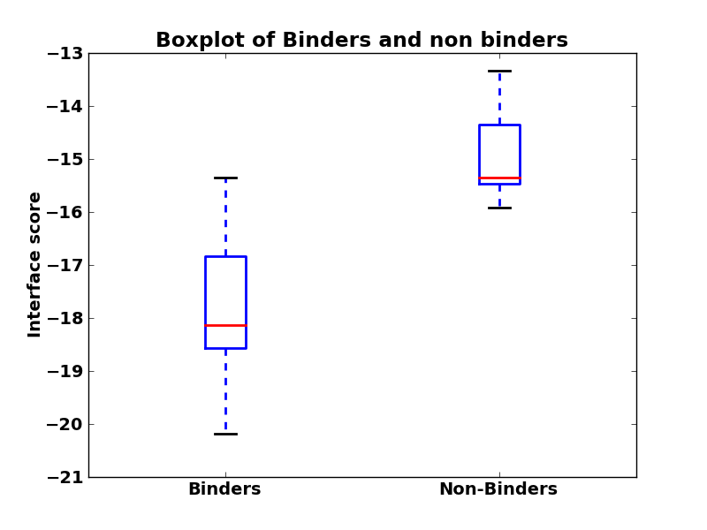
3 | 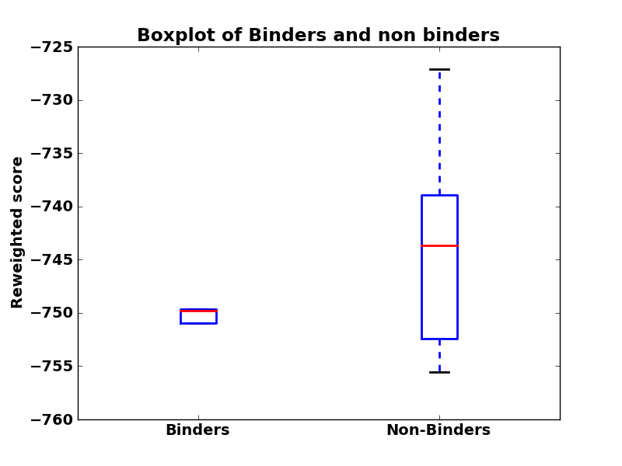 | 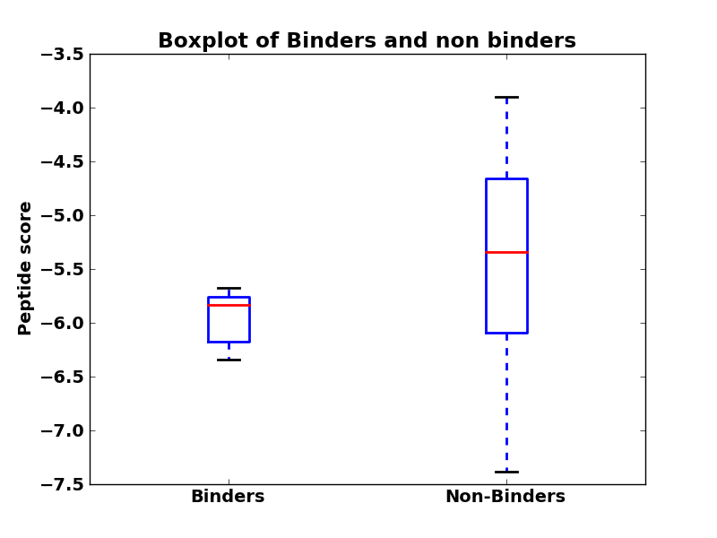 | 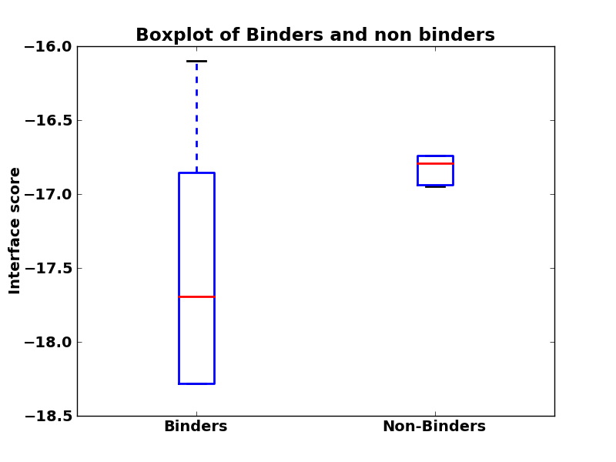
4 | 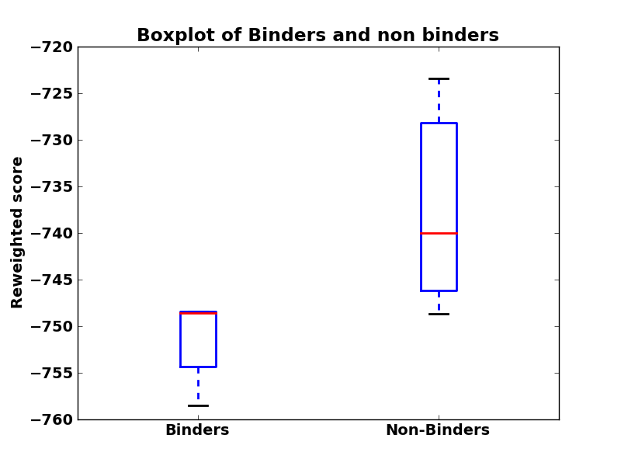 | 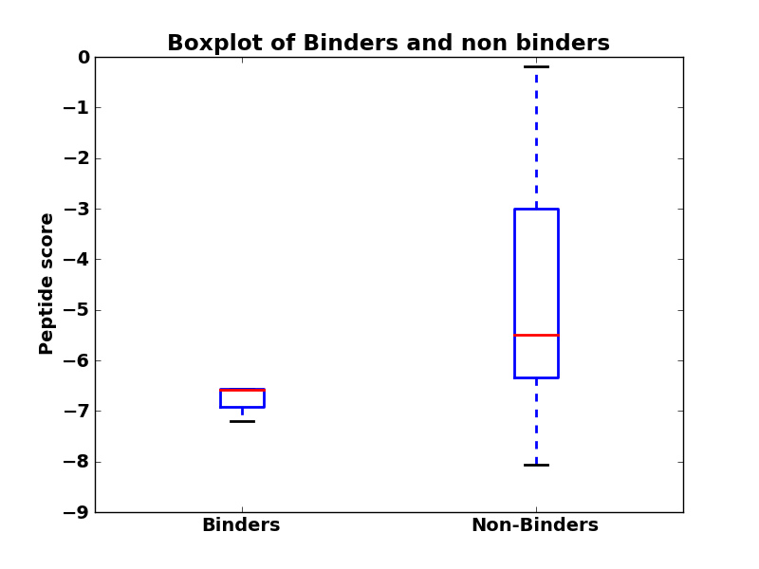 | 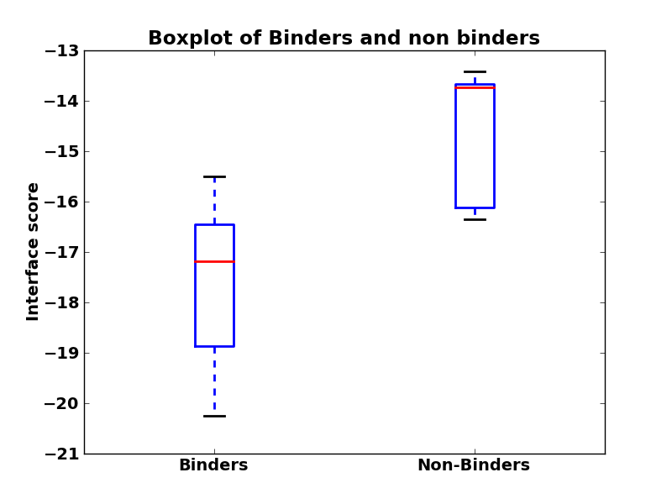
5 | 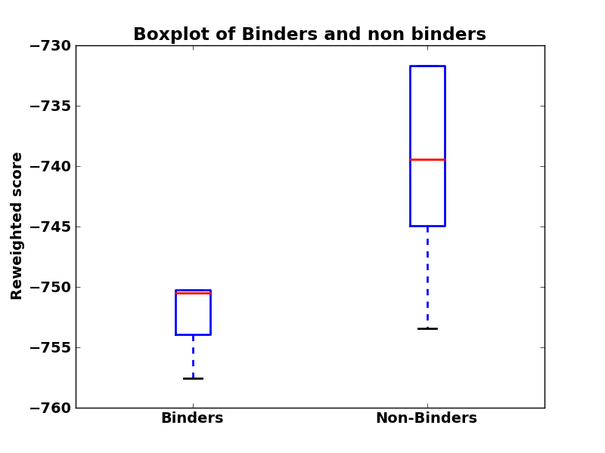 | 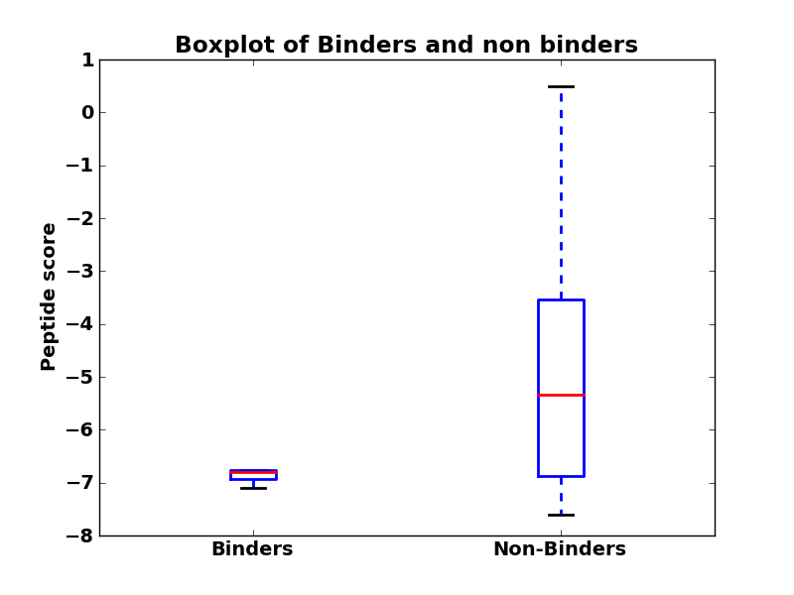 | 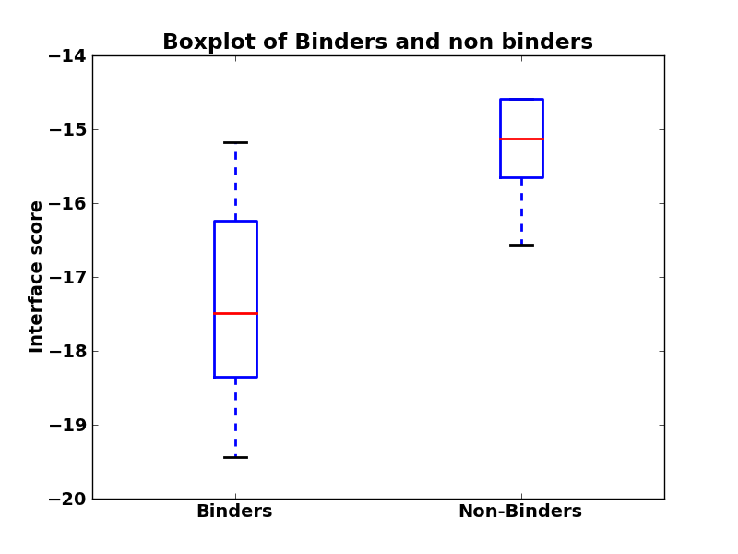
6 | 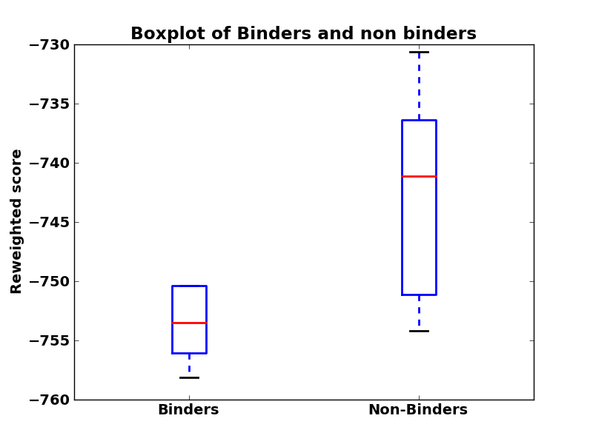 | 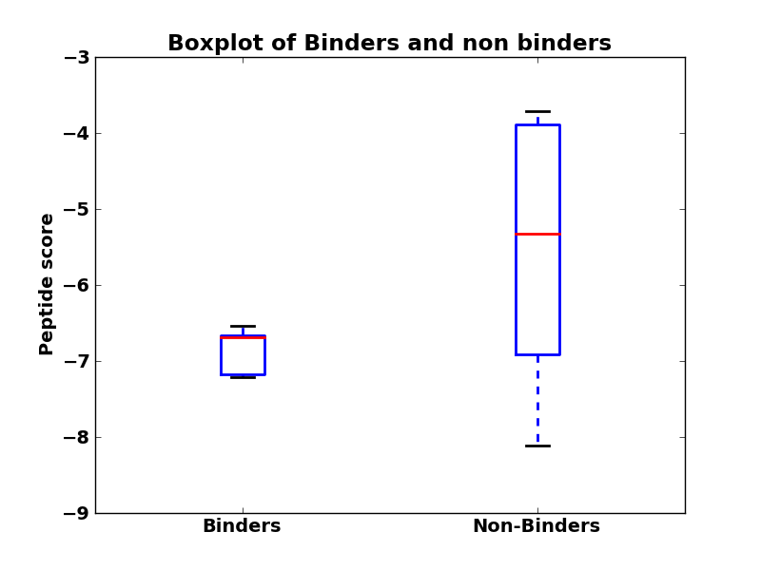 | 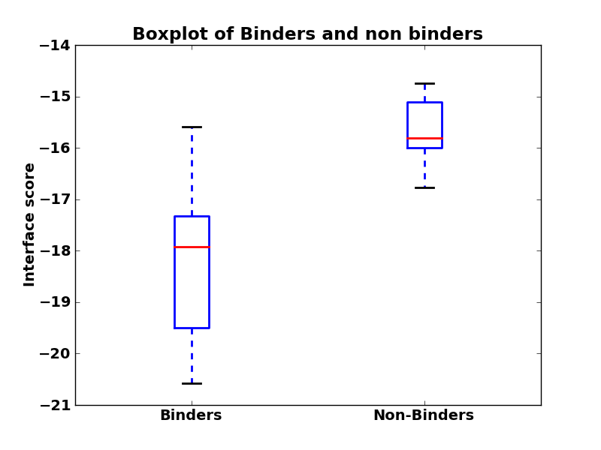
7 | 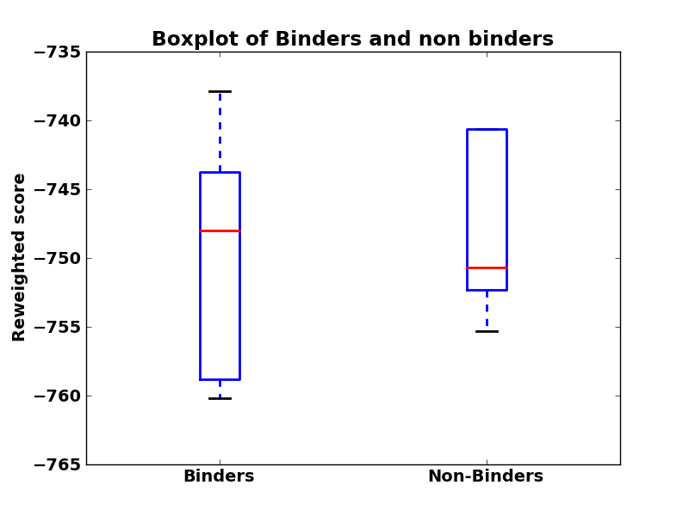 | 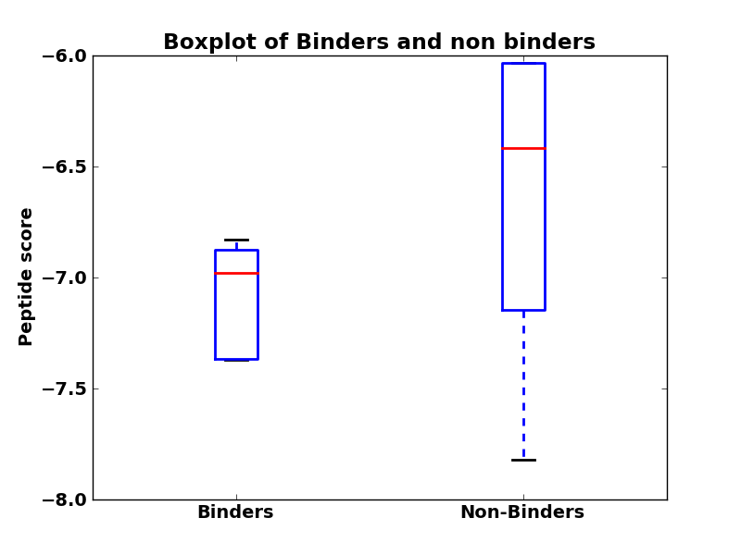 | 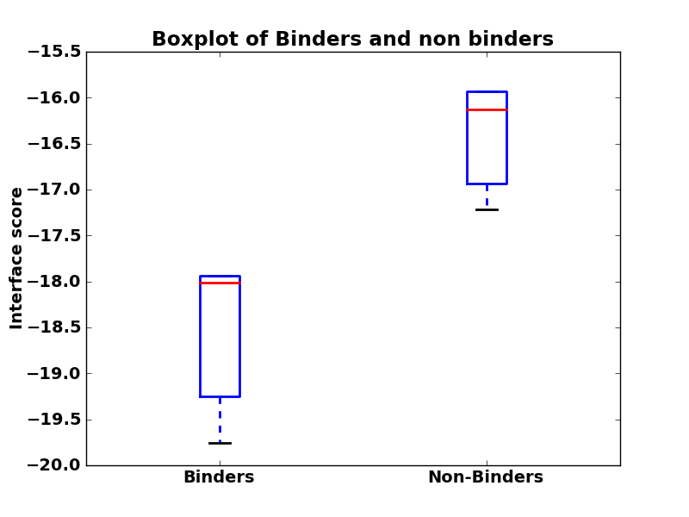
8 | 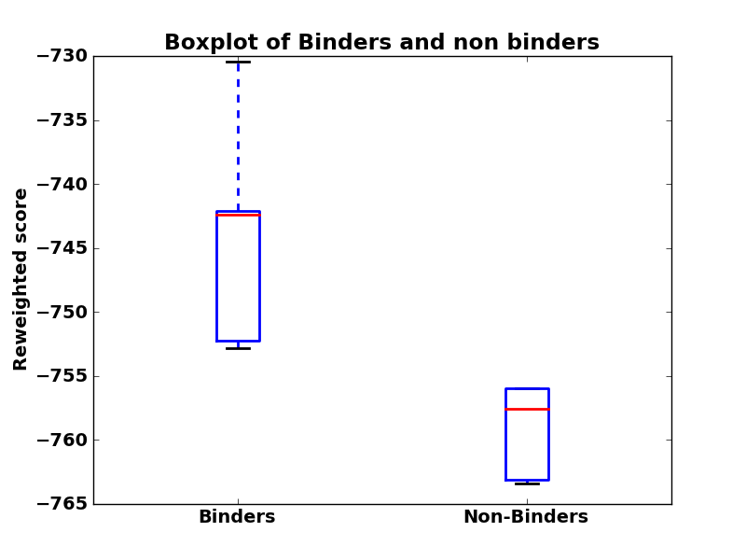 | 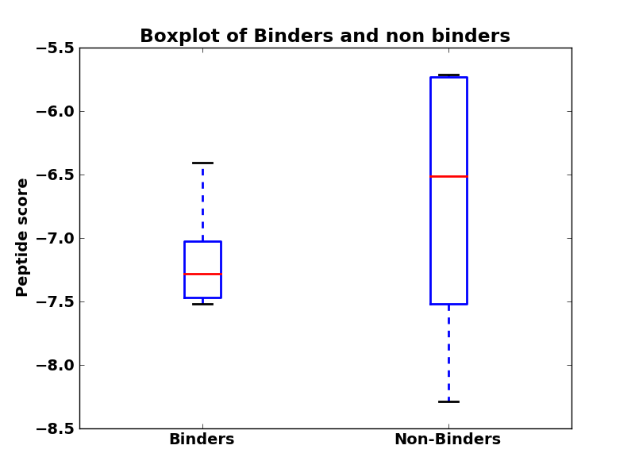 | 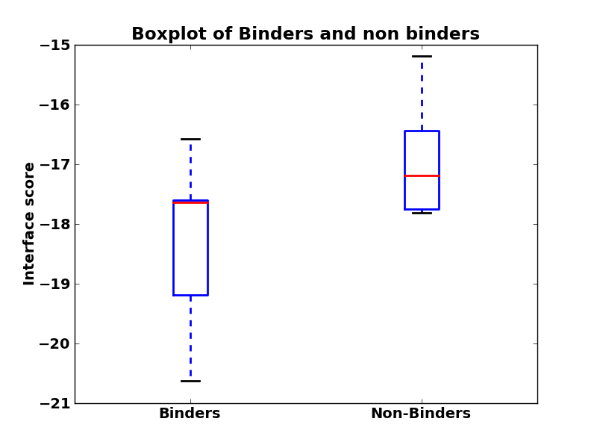
9 | 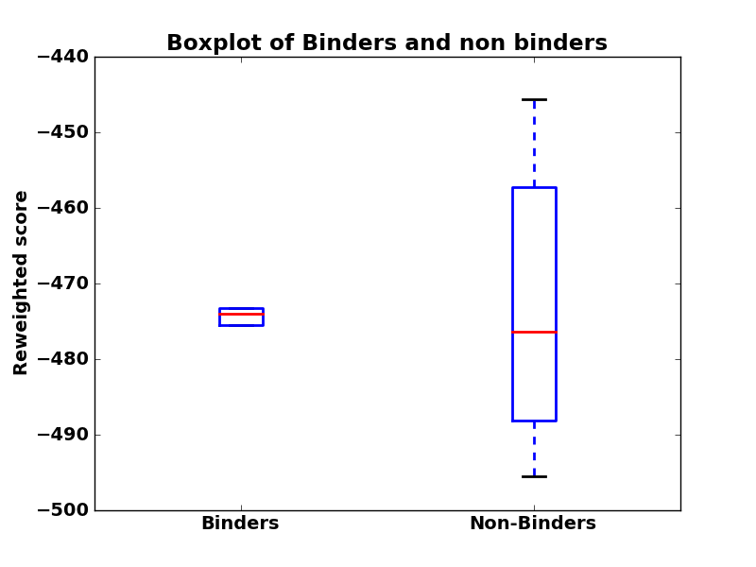 | 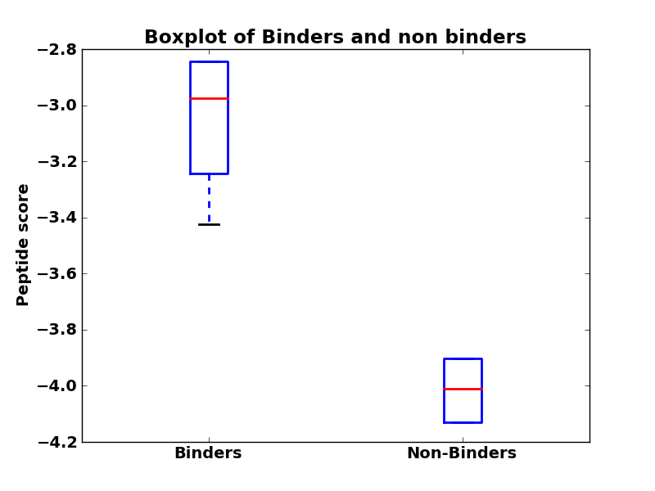 | 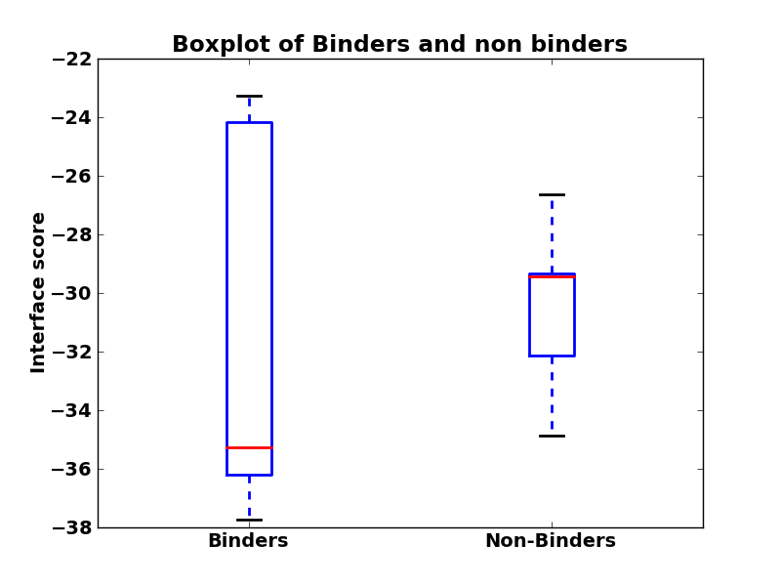
10 | 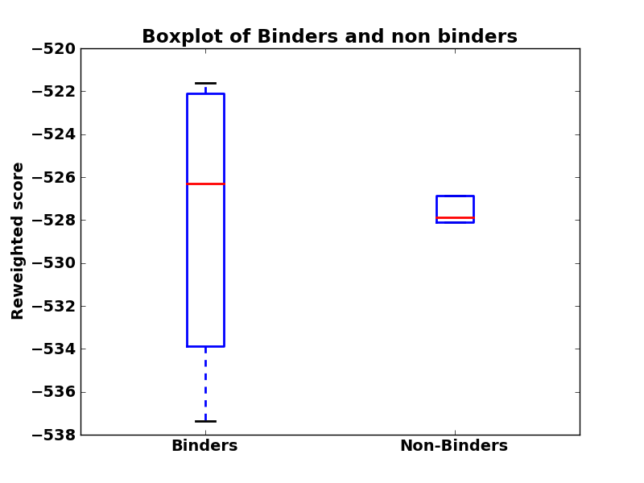 | 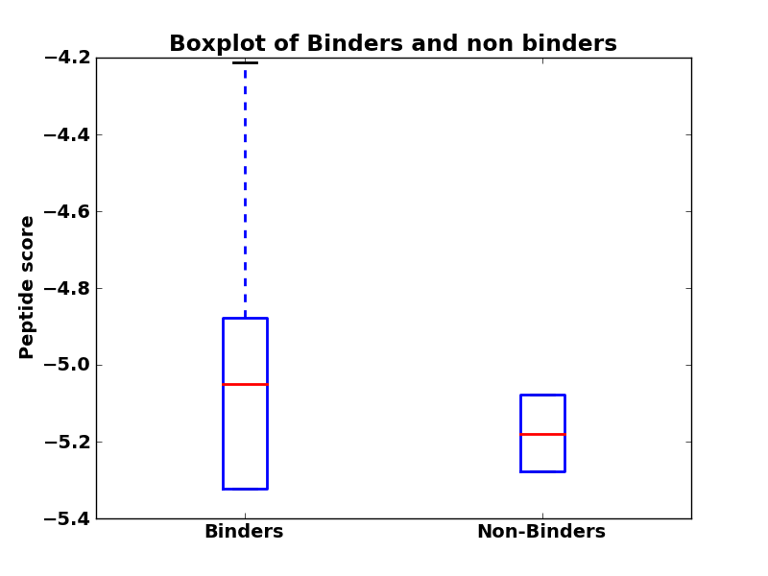 | 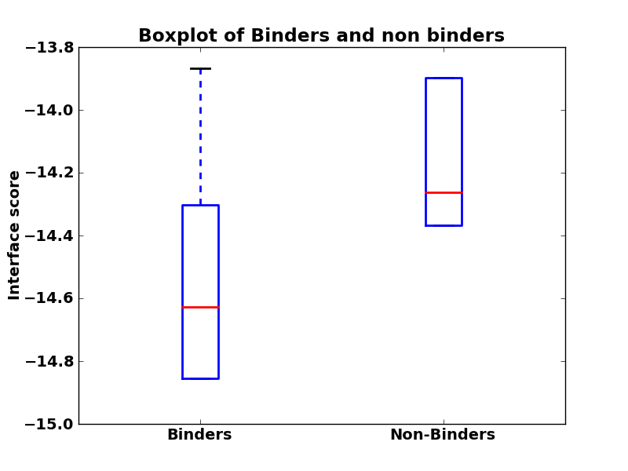
11 | 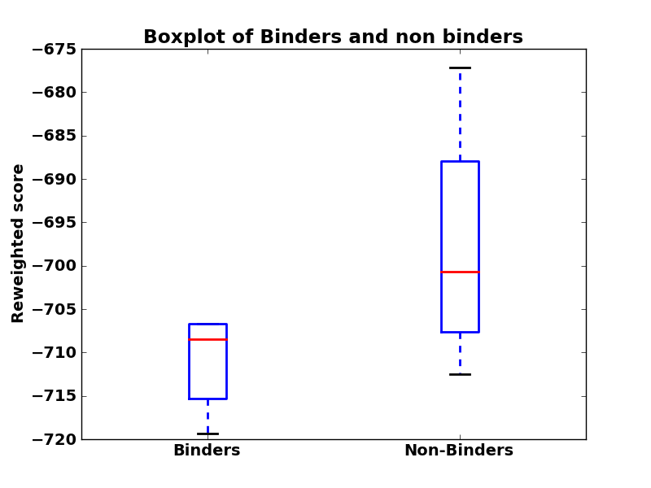 | 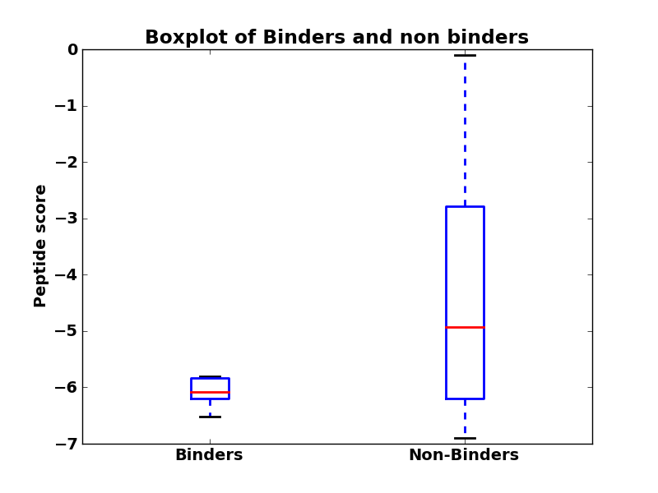 | 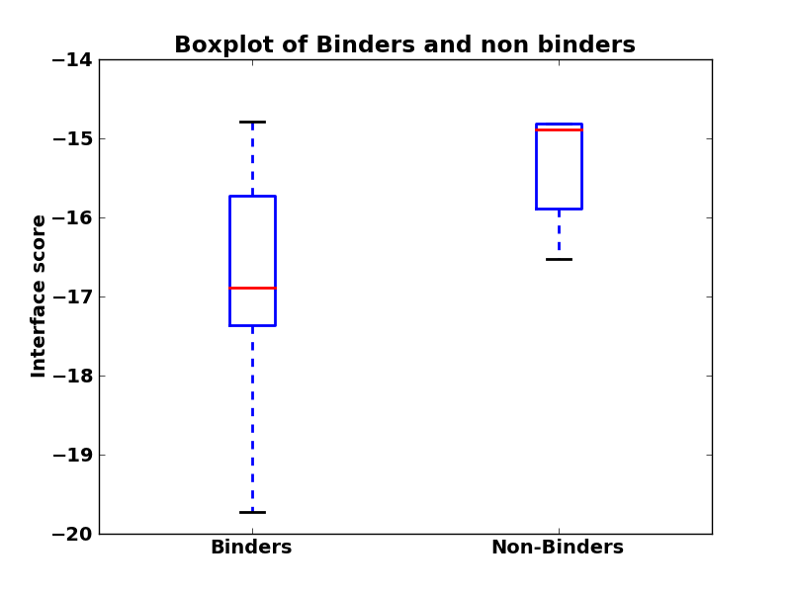
12 | 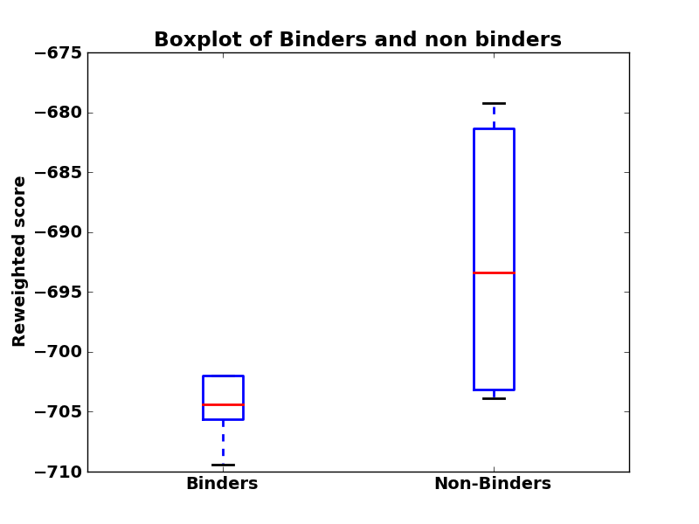 | 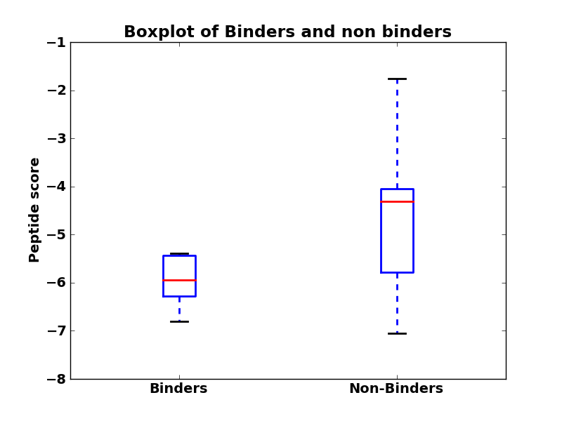 | 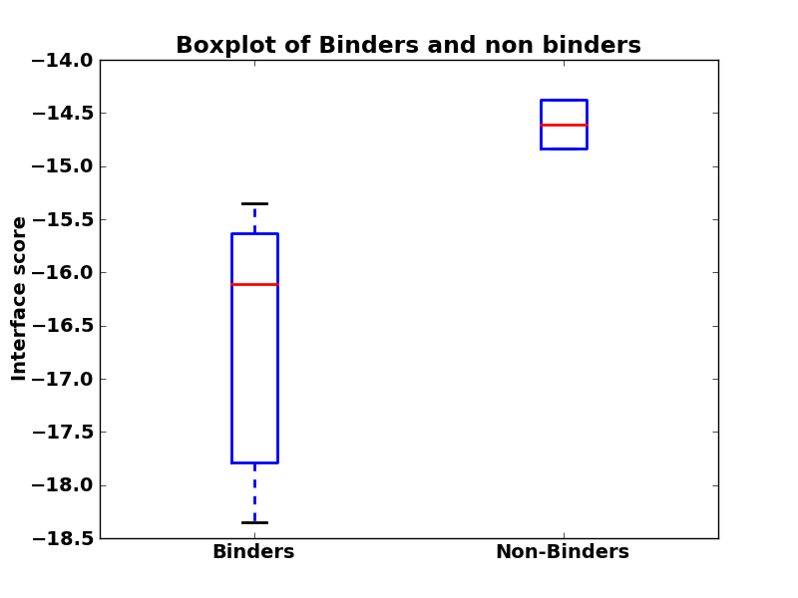
13 | 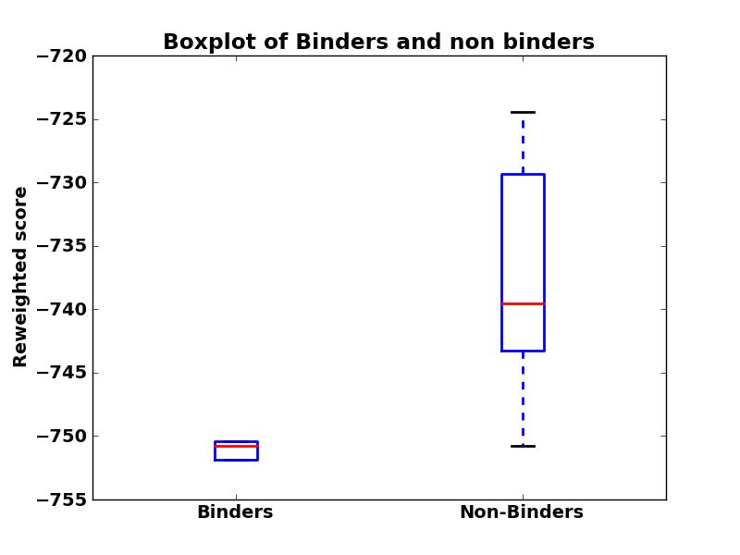 | 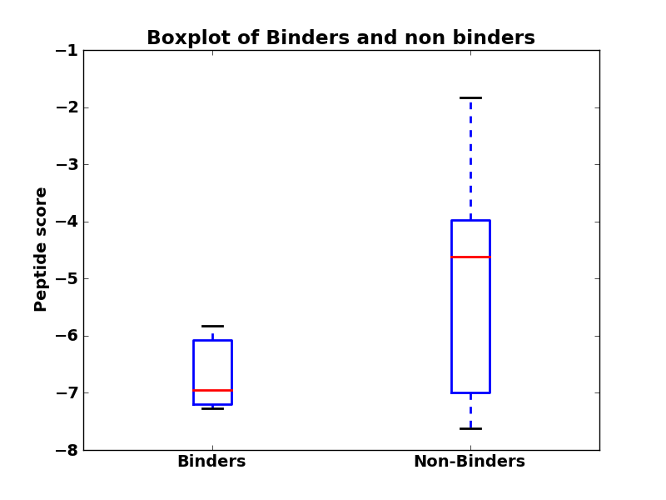 | 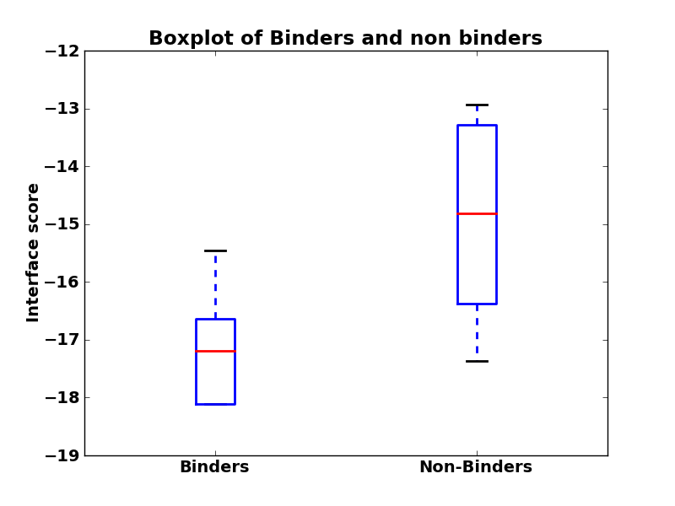
14 | 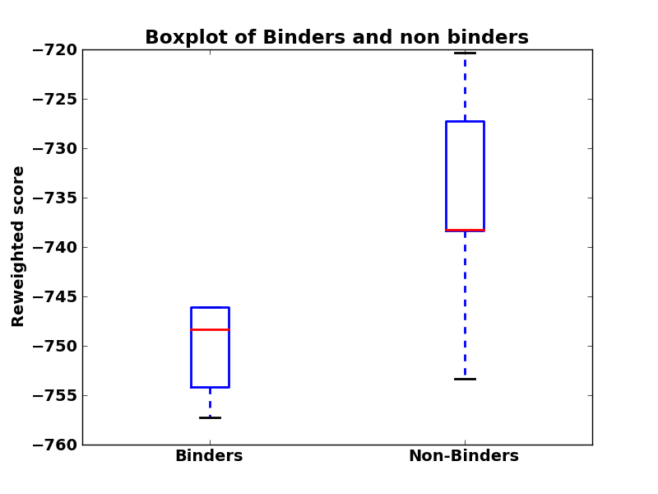 | 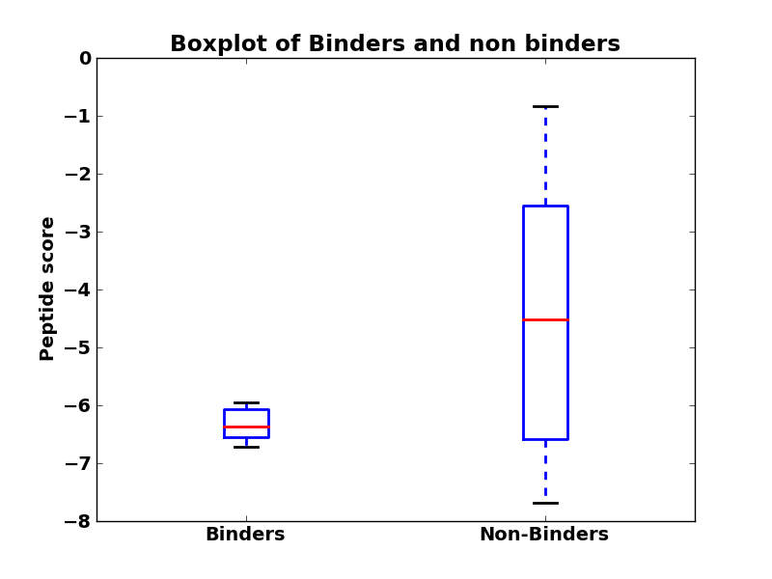 | 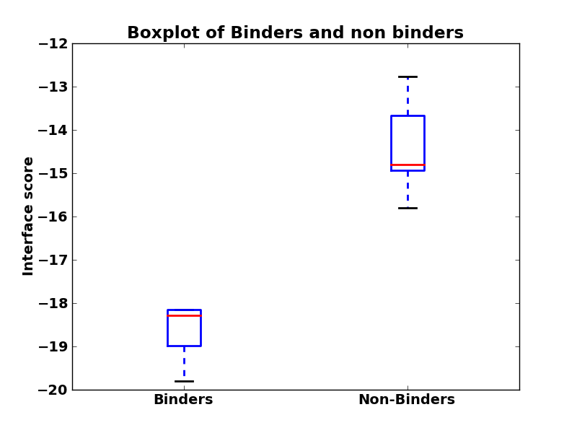
15 | 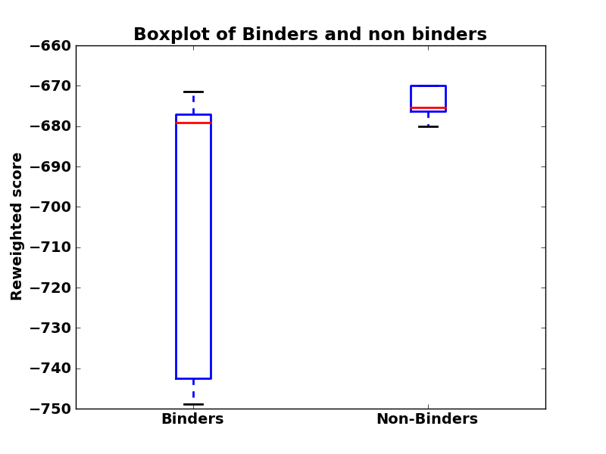 | 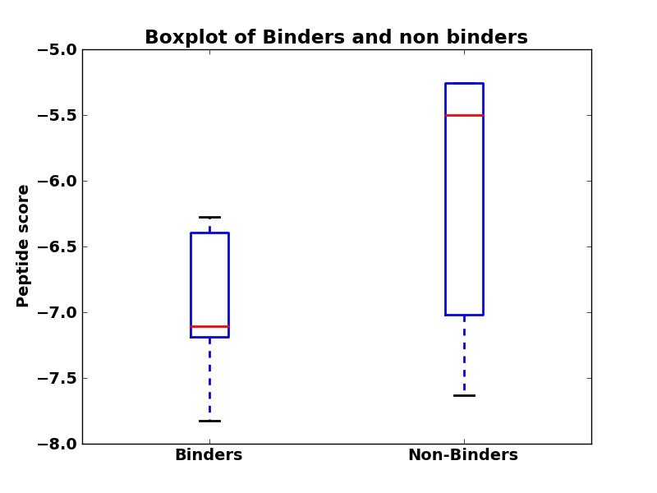 | 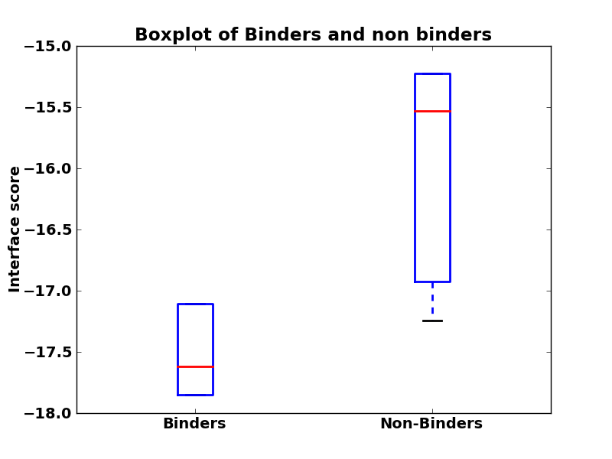
16 | 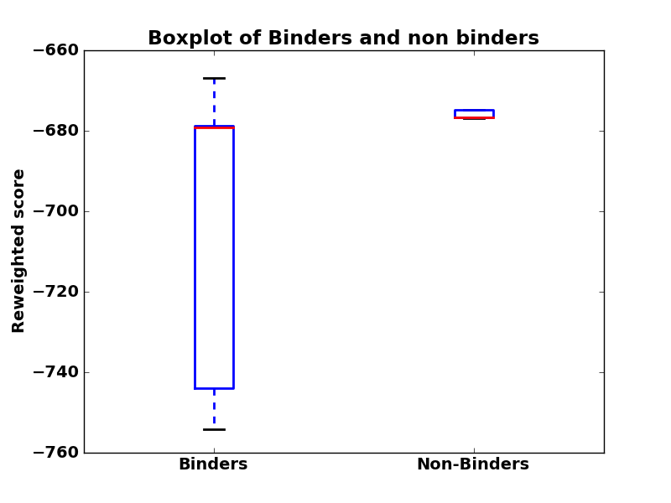 | 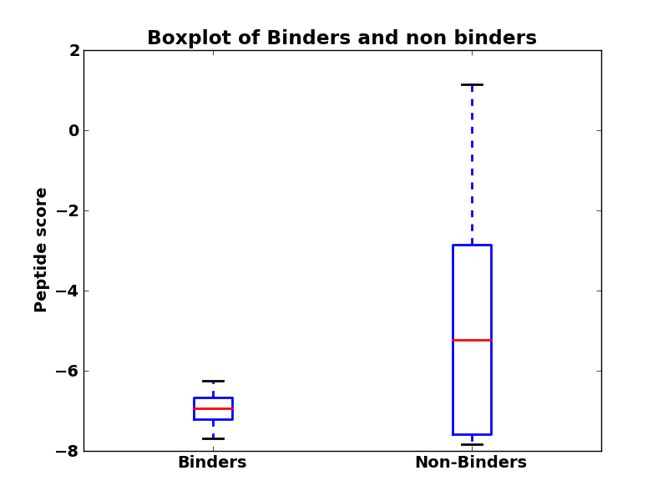 | 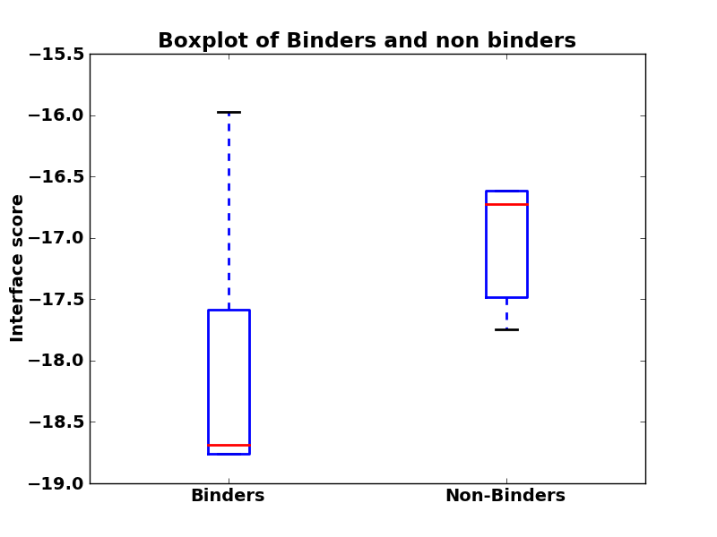
17 | 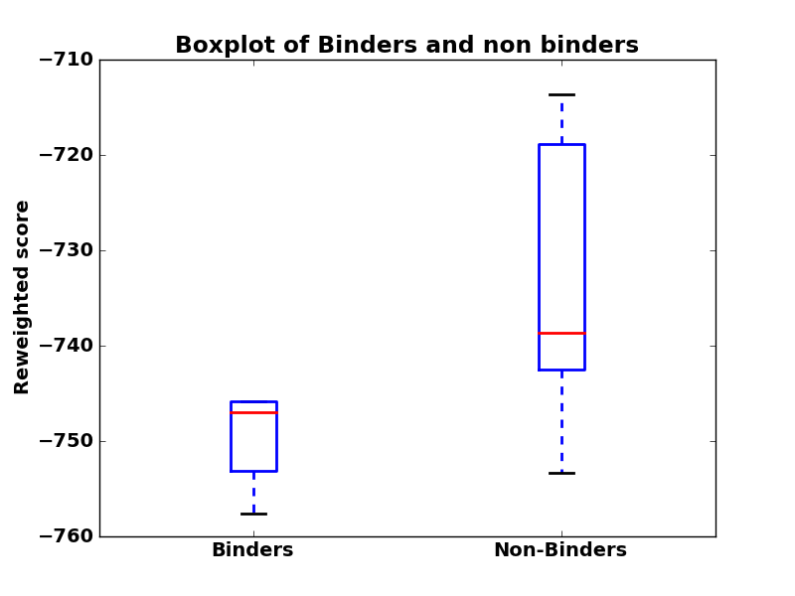 | 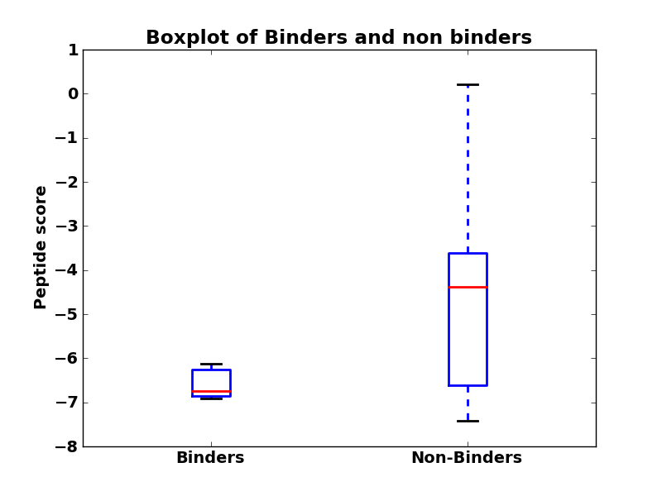 | 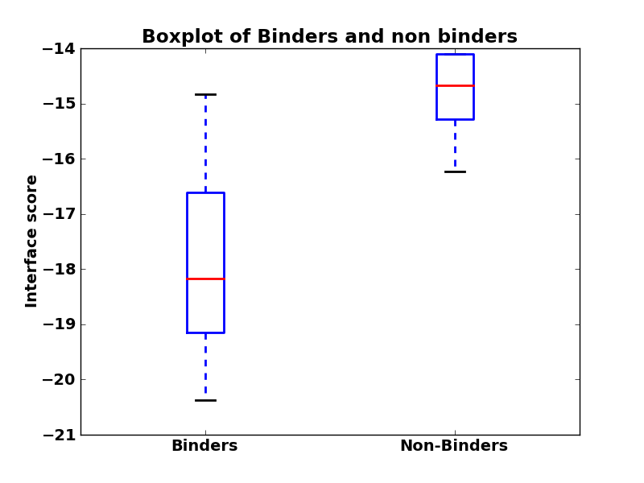
18 | 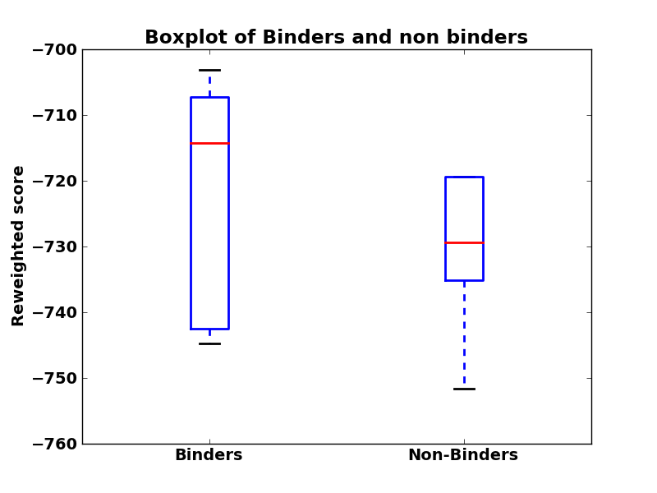 | 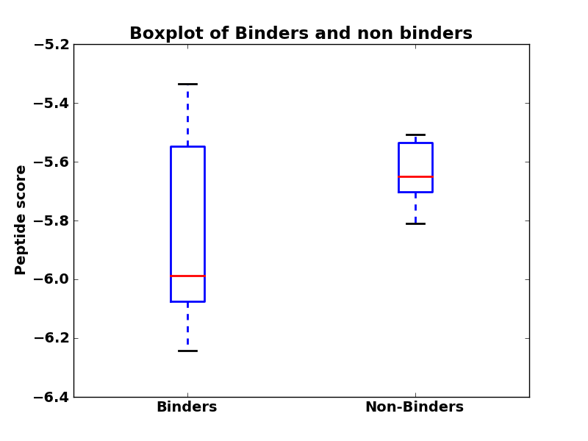 | 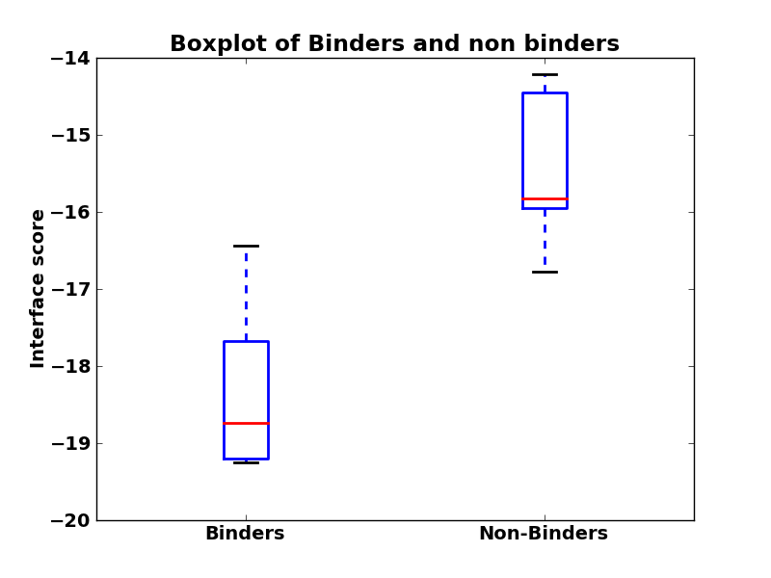

Table 3: Training set - score vs. activity plots
No. | Reweighted score | Peptide score | Interface score
2(a) | 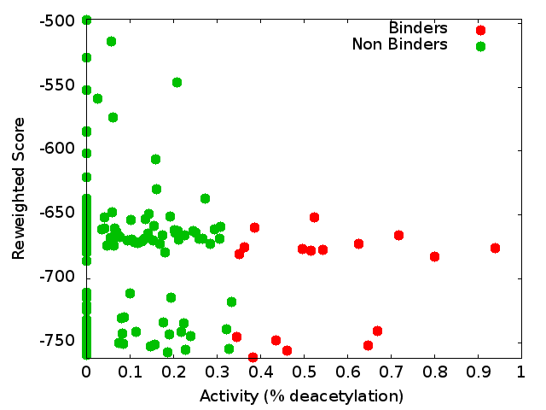 | 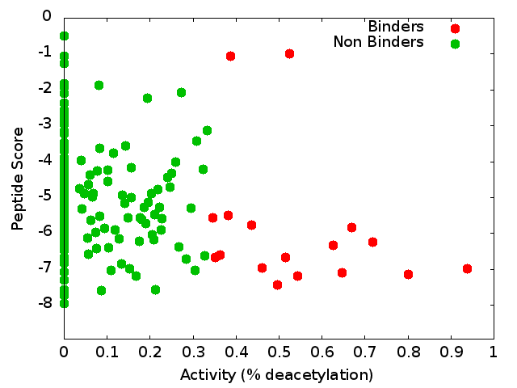 | 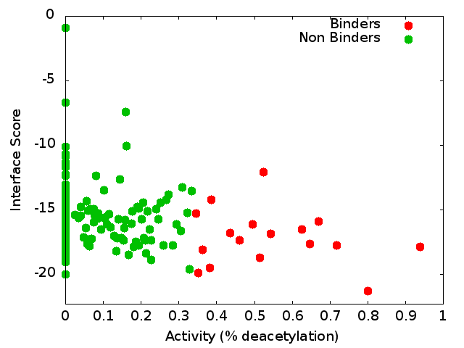
3(a) | 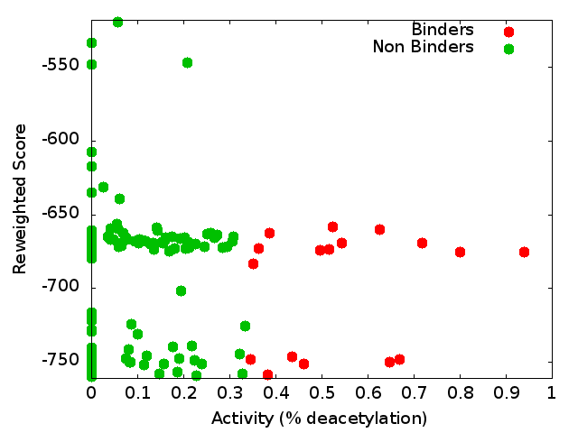 | 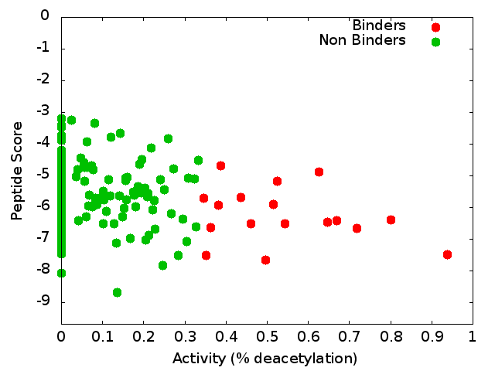 | 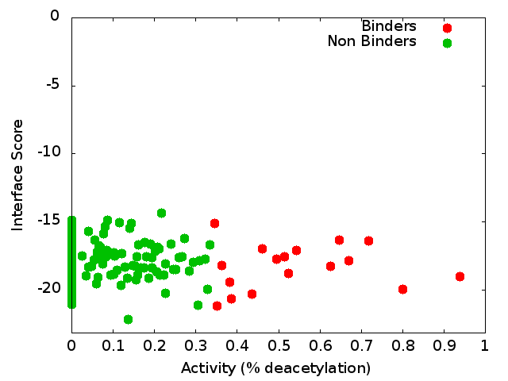
9(a) | 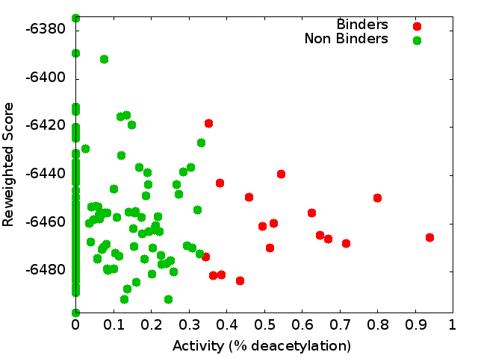 | 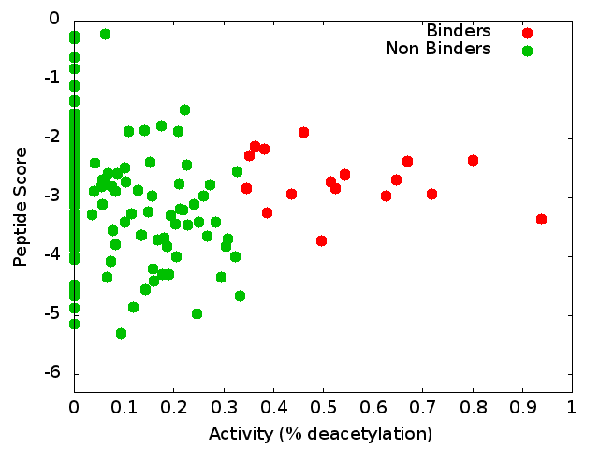 | 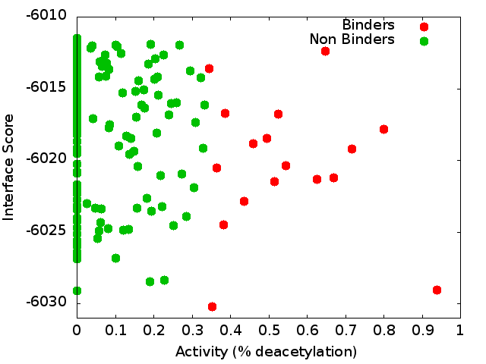
14(a) | 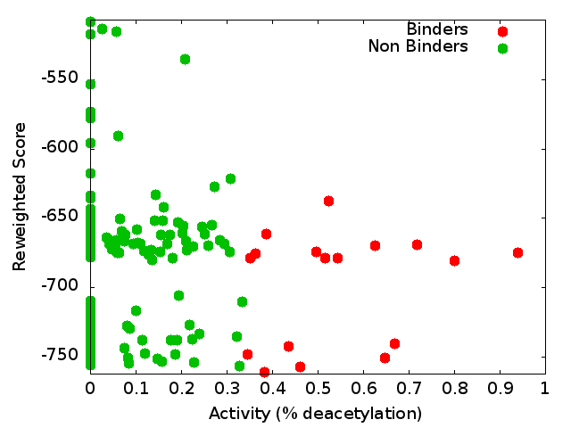 | 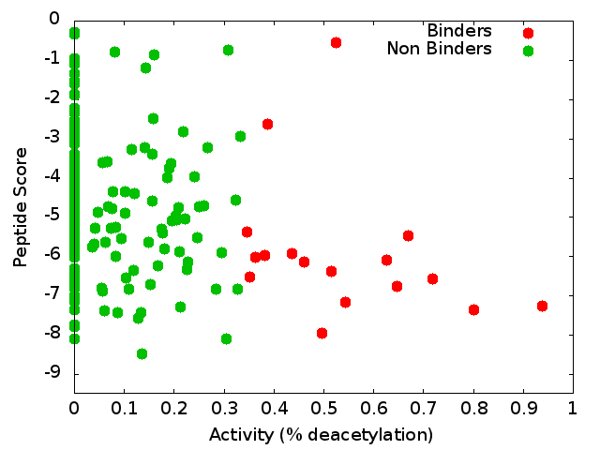 | 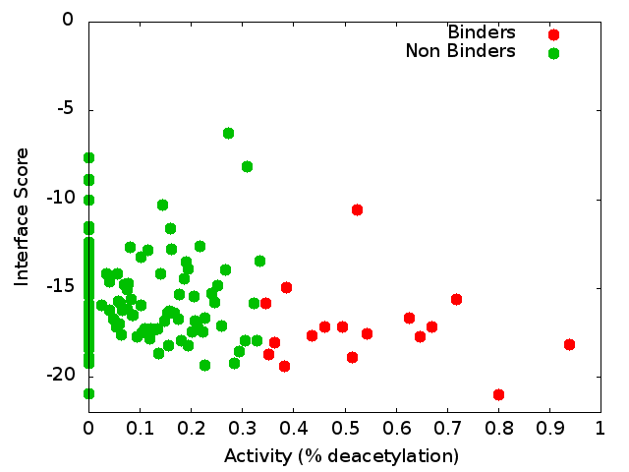
16(a) | 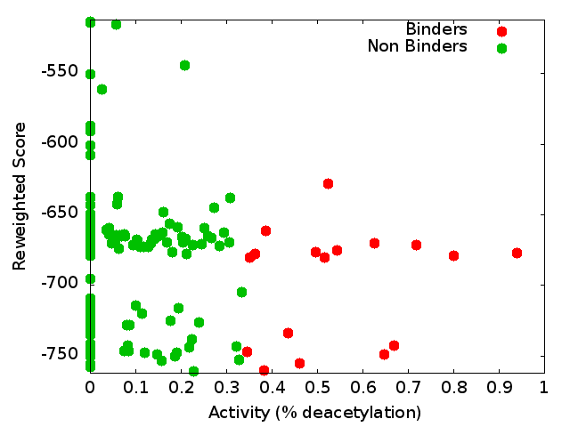 | 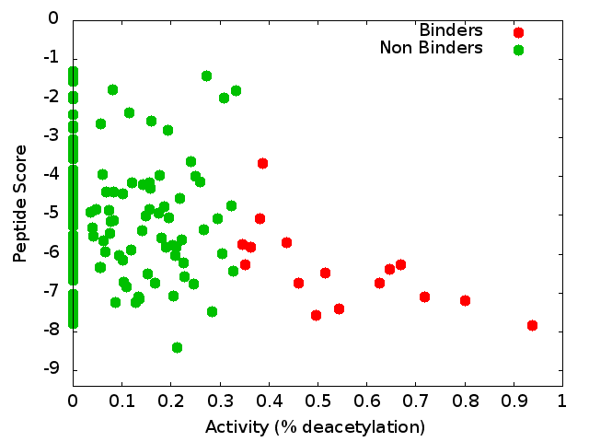 | 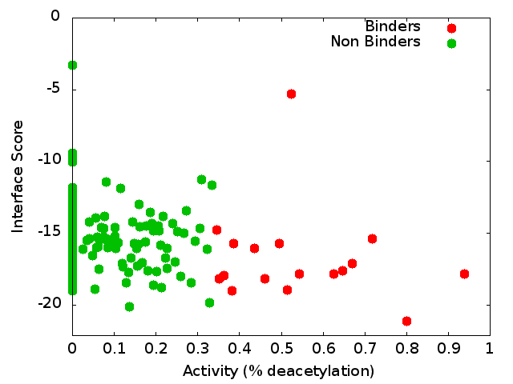
17(a) | 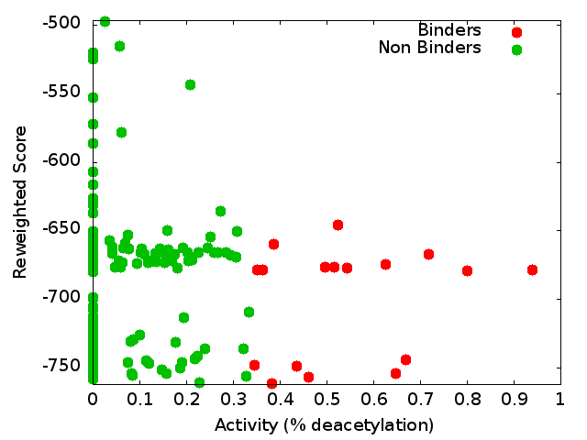 | 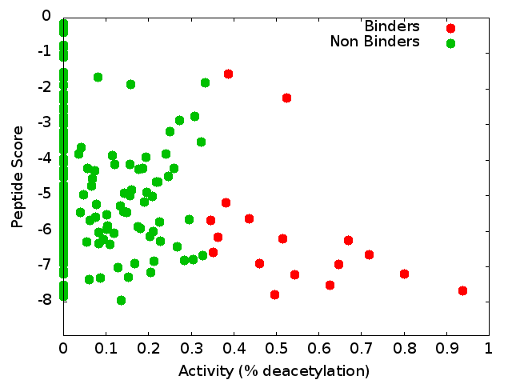 | 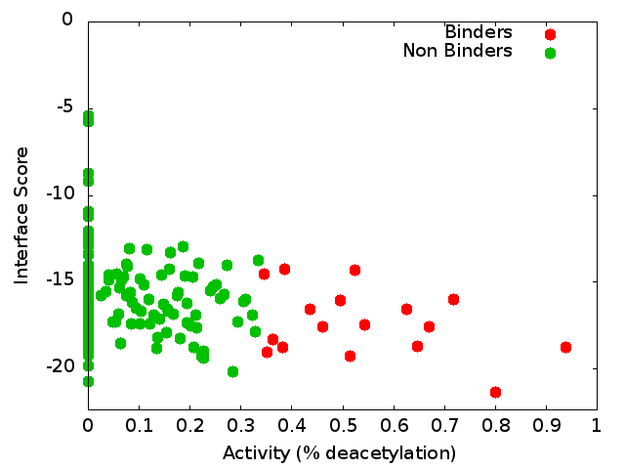
18(a) | 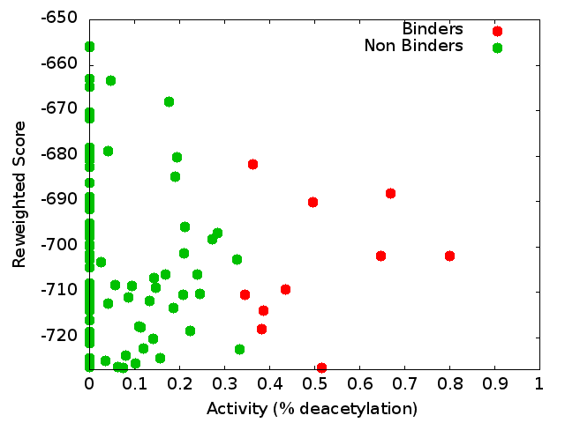 | 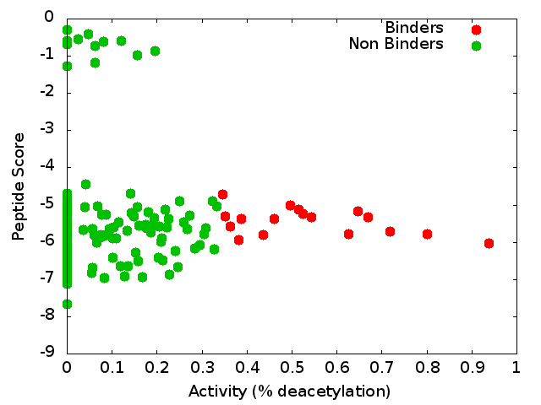 | 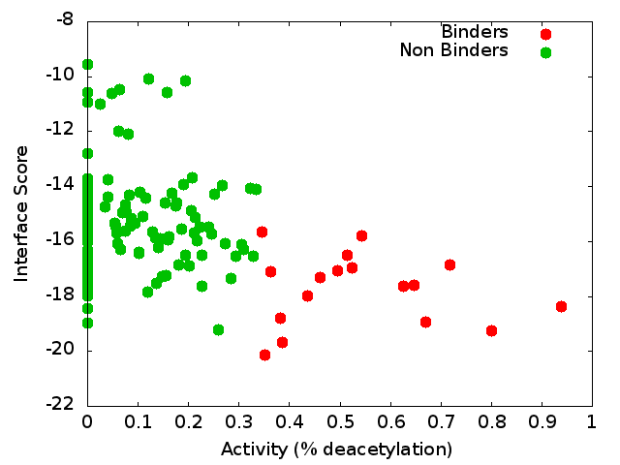

Table 4: Training set - score vs. activity plots after clustering
No. | Reweighted score | Peptide score | Interface score
2(a) | 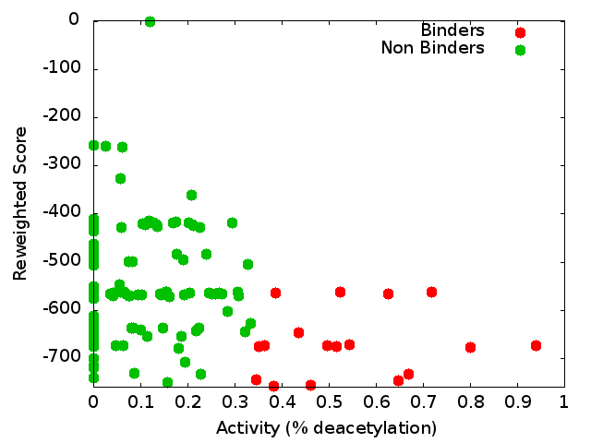 | 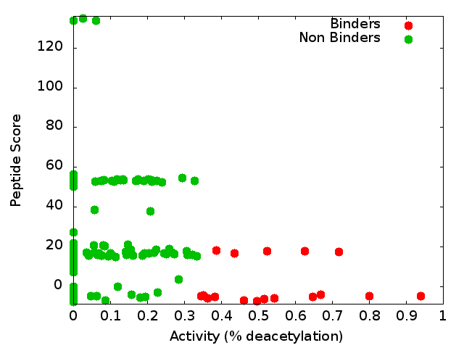 | 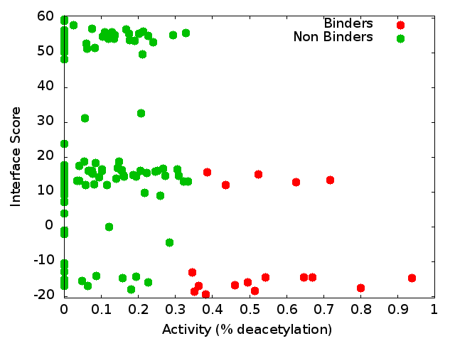
3(a) | 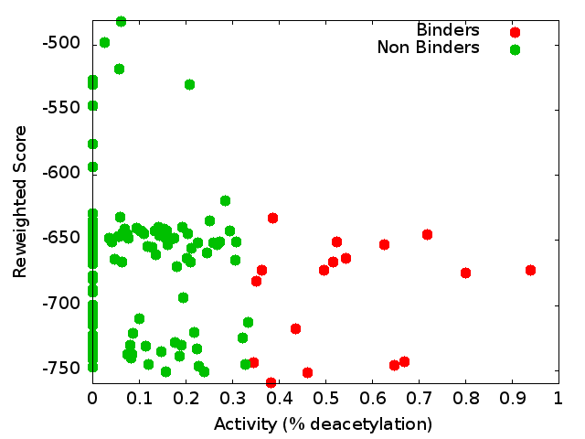 | 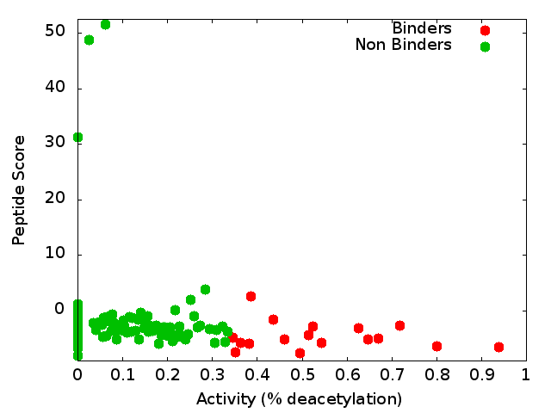 | 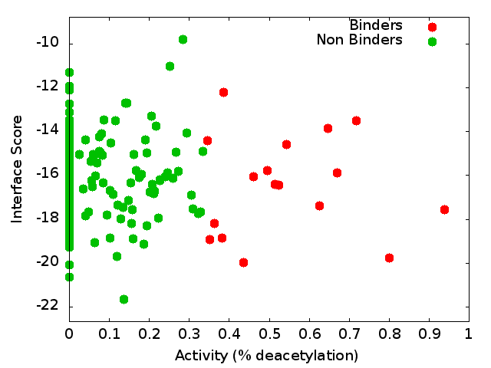
9(a) | 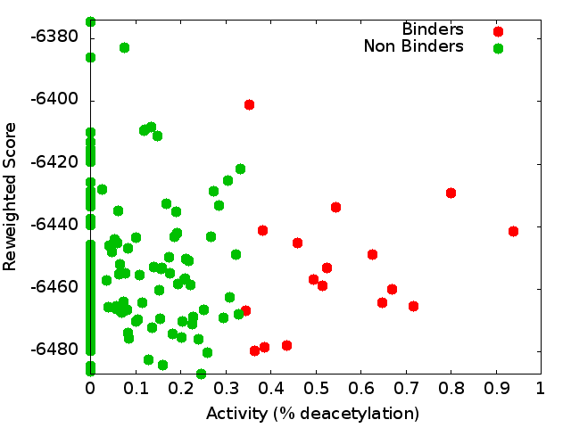 | 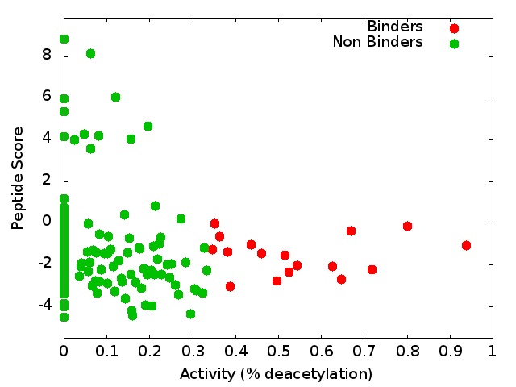 | 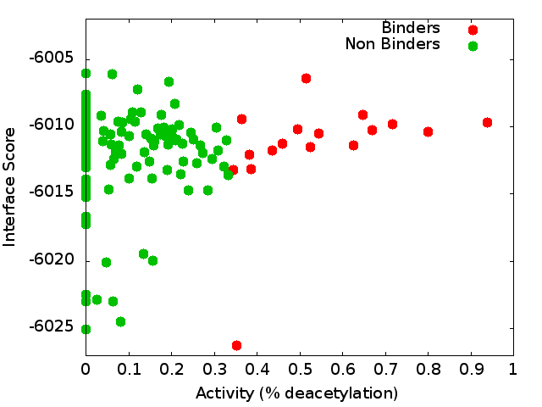
14(a) | 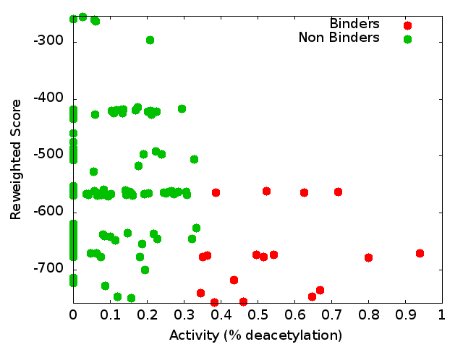 | 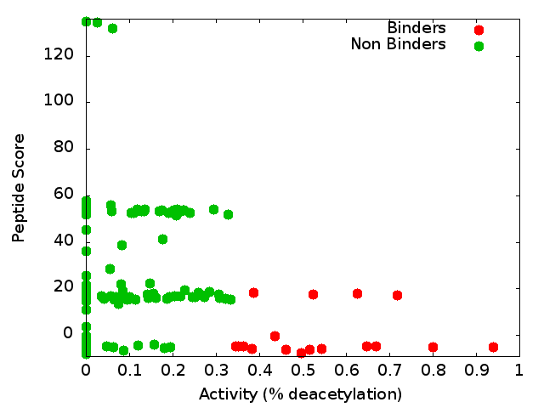 | 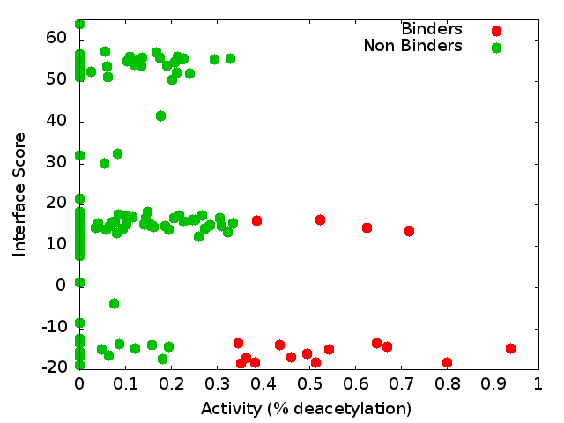
16(a) | 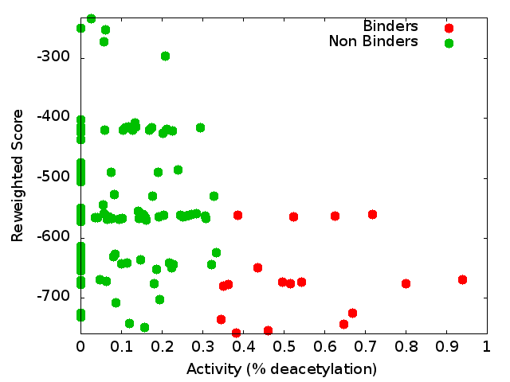 | 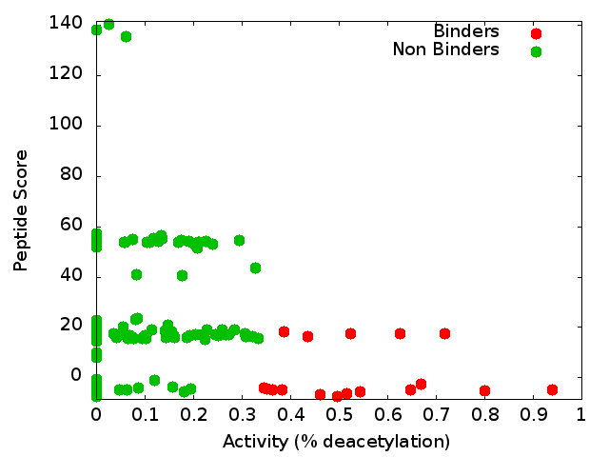 | 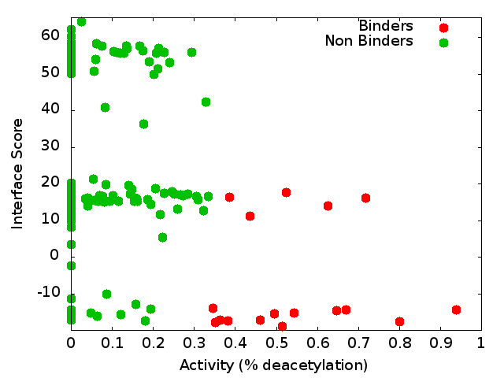
17(a) | 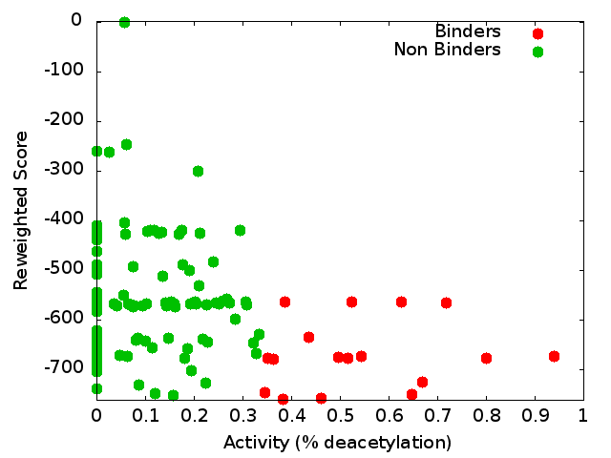 | 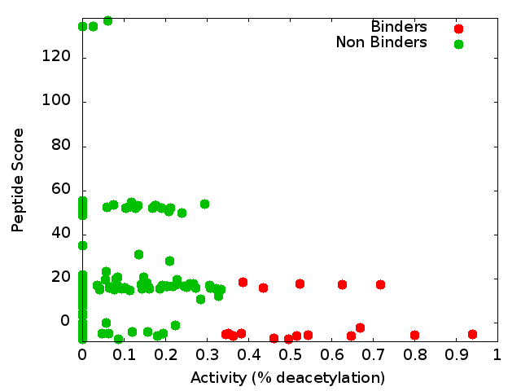 | 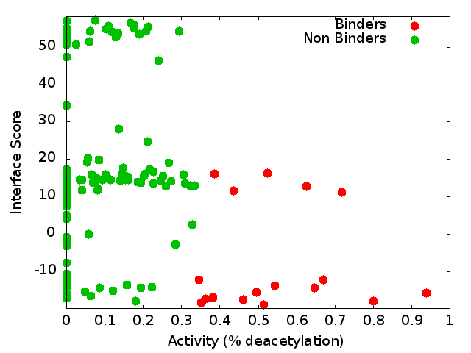
18(a) | 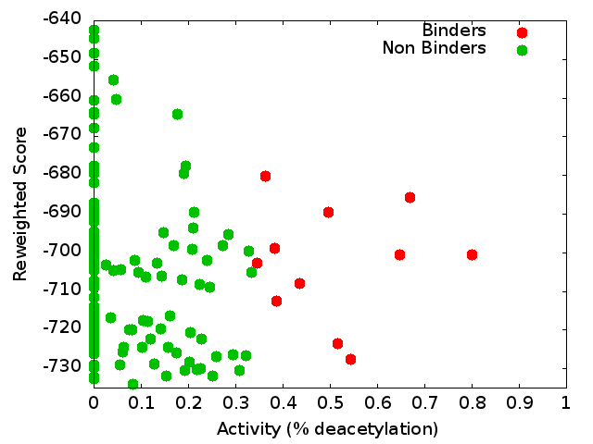 | 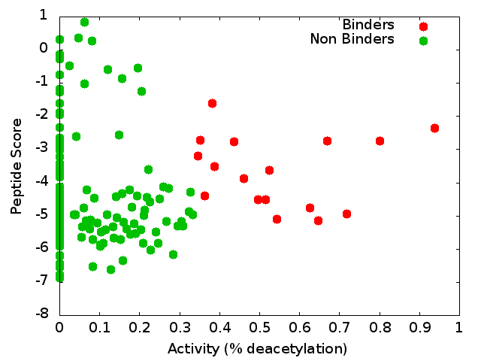 | 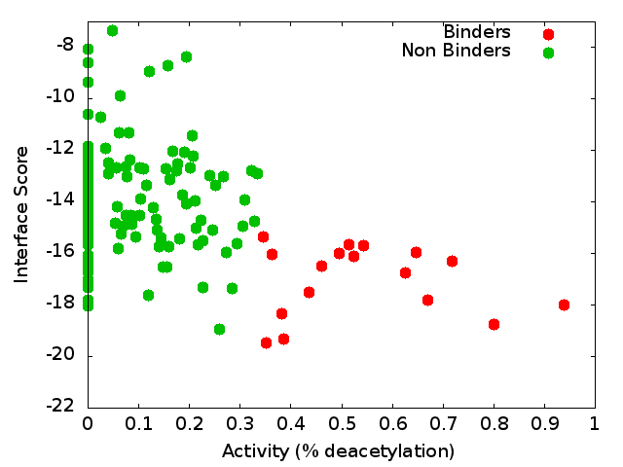

The default scoring function is described in the methods section. In a simulation where a modified version of this scoring function was used, we included a description of what was modified.
The sequence was threaded on the peptidic substrate backbone in the 2v5w crystal. Since this peptidic substrate was only 4 amino acid long (the train/test sequences were 6 residues long), the backbone of the 2 extra residues was modeled in an extended conformation.
Setting the receptor anchor to be the 289 residue , creating an axis that aligns with the Lysine residue side-chain. This axis is directed inside the pocket, and allowed the peptide to rotate while the Lysine residue stays fixed (see Figure 9)

