**TEST 3**

1.

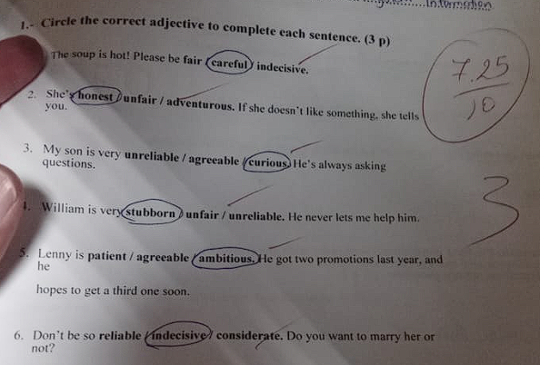



1. We **haven't lived** (not/live) in Canada **for** a long time.
2. My friend **has studied** (study) Chinese **since** 2007.
3. He **has been** (be) in Mexico **for** a month.

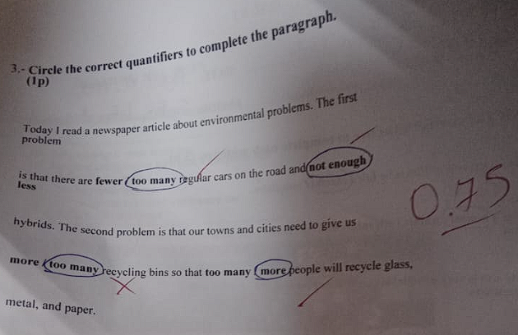

RESPUESTAS:

* Too many
* Not enough
* More
* More

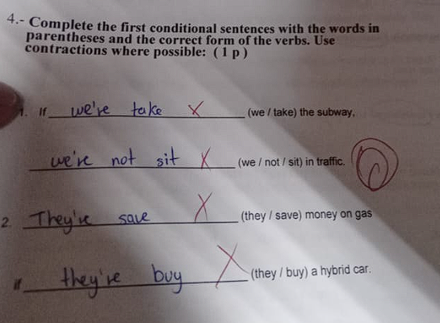

1. If **we take** (we/take) the subway, **we won’t sit** (we/not/sit) in traffic.
2. **They’ll save** (they/save) money on gas if **they buy** (they/buy) a hybrid car.

