Storage account – sa1lipsa

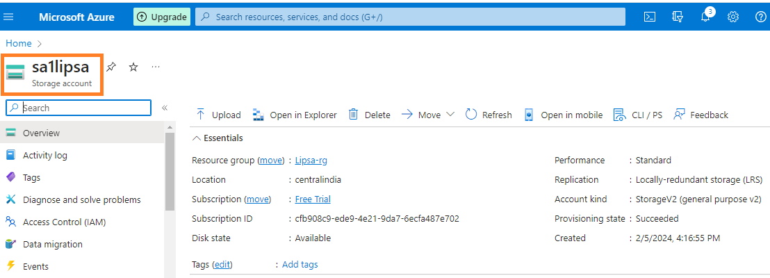

Container name – ordersdata

There is a file orders.csv inside the container

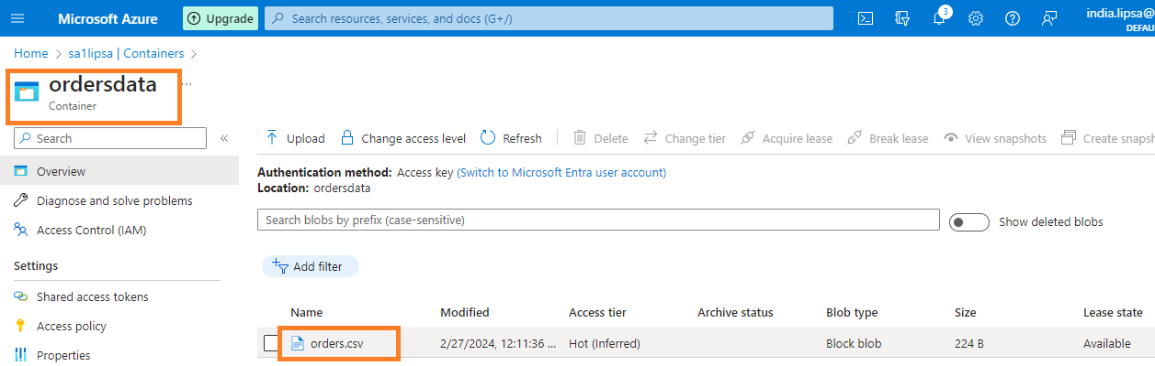

Copy the access key of the storage account

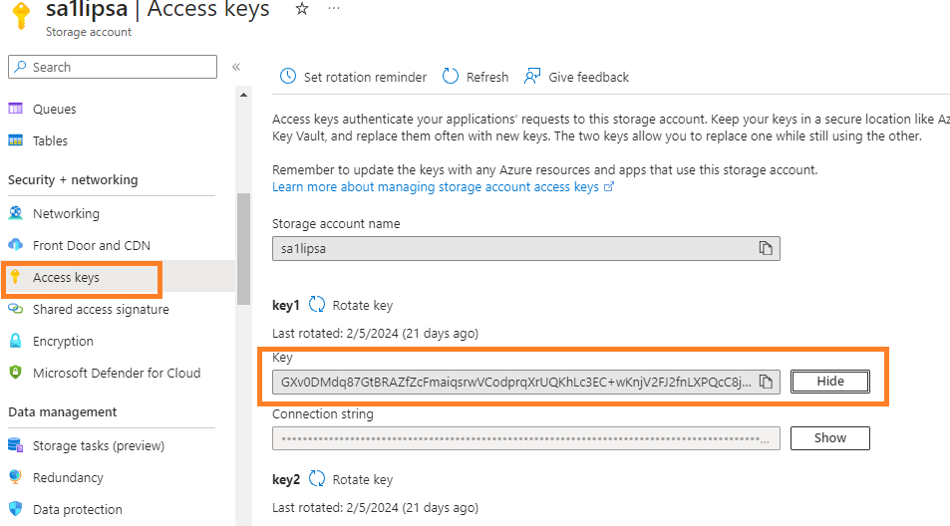

**Launch Databricks workspace**

**Create a cluster, and a notebook**

Create a mount point in Azure databricks notebook

dbutils.fs.mount(

    source ='wasbs://ordersdata@sa1lipsa.blob.core.windows.net' ,

    mount_point ='/mnt/retaildb' ,

    extra_configs = {'fs.azure.account.key.sa1lipsa.blob.core.windows.net':'GXv0DMdq87GtBRAZfZcFmaiqsrwVCodprqXrUQKhLc3EC+wKnjV2FJ2fnLXPQcC8jkfQVfCeONs1+AStsfDiJQ=='}

)

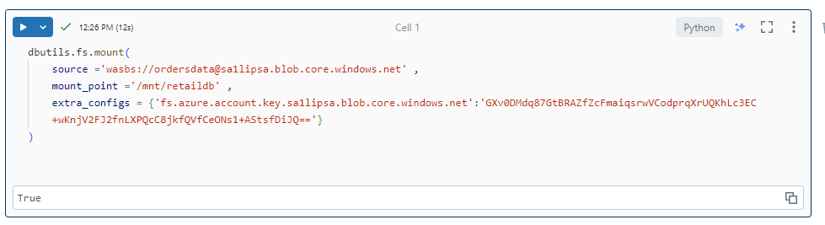

**Create a dataframe using the file in mount point**

df1 = spark.read.csv("/mnt/retaildb/orders.csv", header=True)

df1.show()

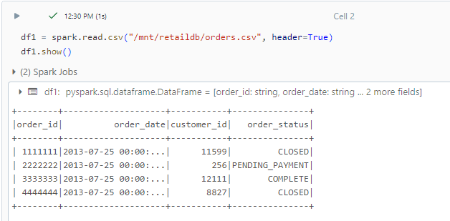

**Use secret scope to avoid hard coding of access key**

1. **Azure Key-vault (Recommended , other azure services can use it)**
2. **Databricks secret scope – encrypted daatbase**

**Key vault**

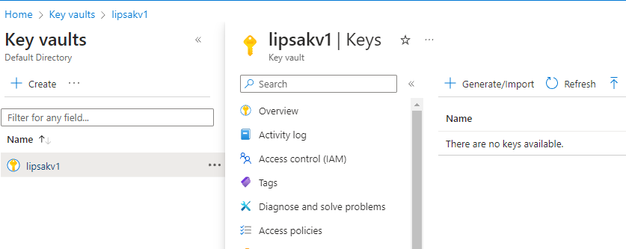

**Add role assignment**

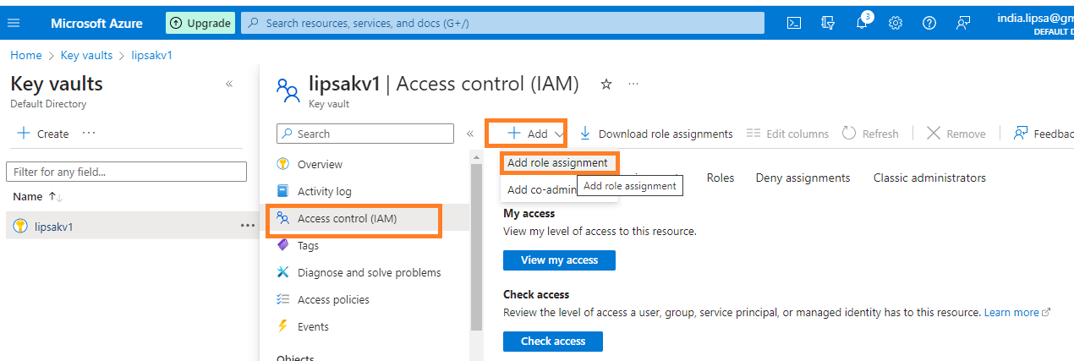

**Add role**

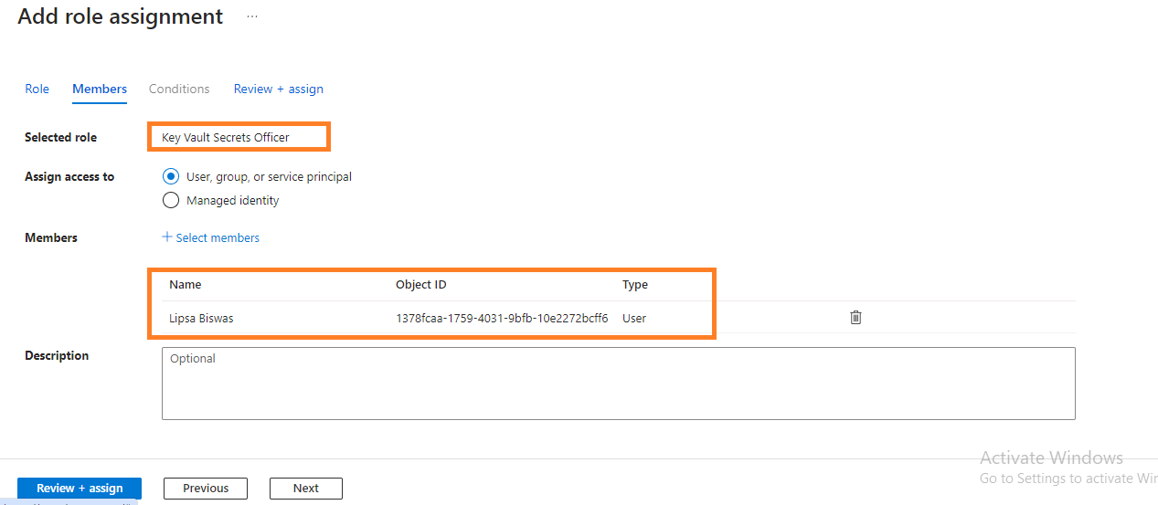

**Give access to Databricks**

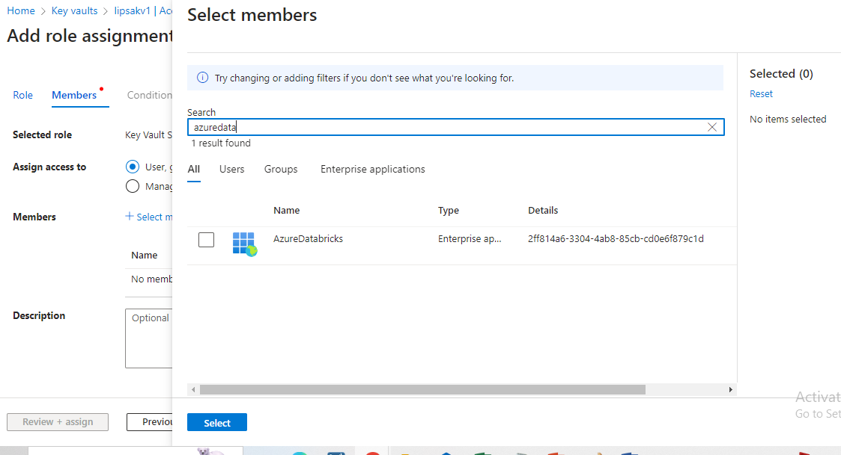

**We have given two sets of persmissions**

**1. To us, to add new secrets to our key vaults**

**2. To databricks , to access key vaults**

**Add secrets**

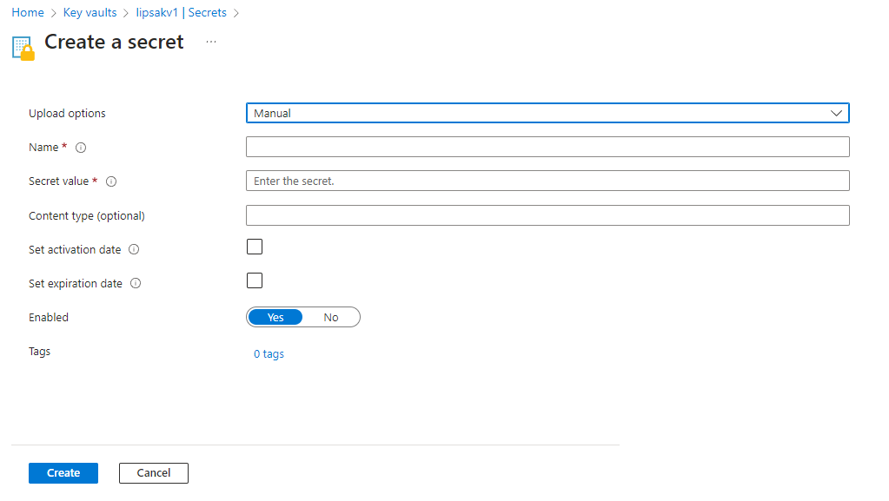

**storageAccountAccessKey**

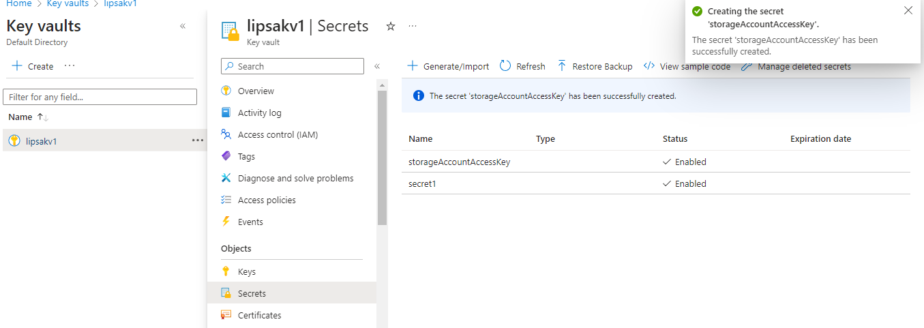

**Create a secret scope**

[**https://adb-3382143768421777.17.azuredatabricks.net/?o=3382143768421777#secrets/createScope**](https://adb-3382143768421777.17.azuredatabricks.net/?o=3382143768421777#secrets/createScope)

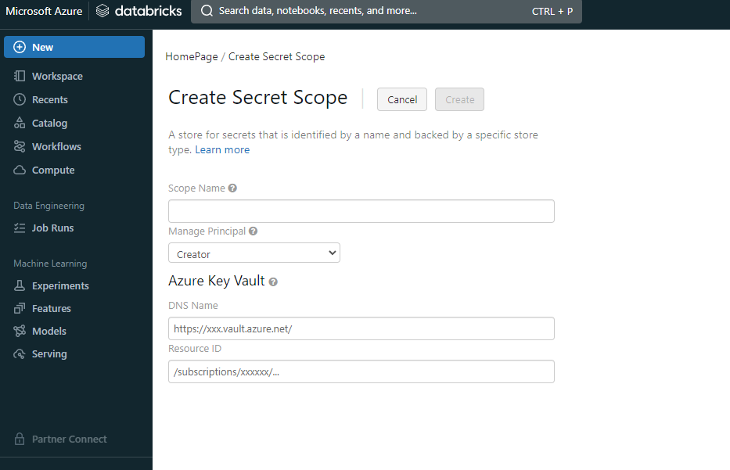

**DNS Name**

**Go to key vault > properties**

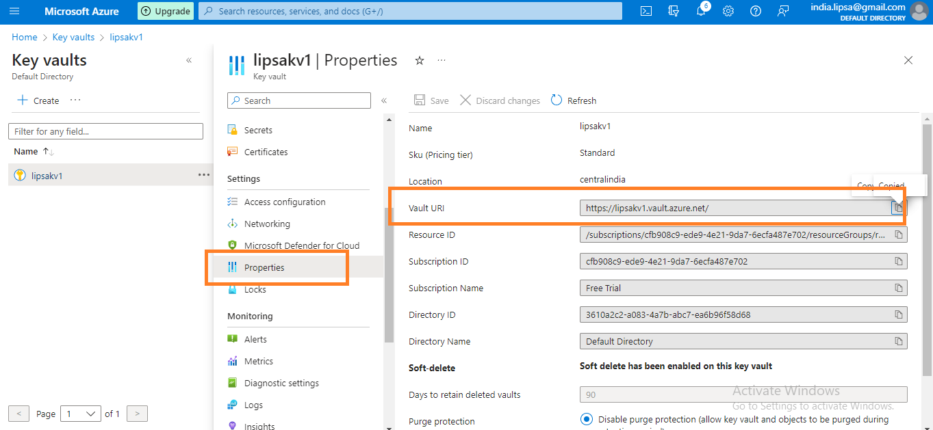

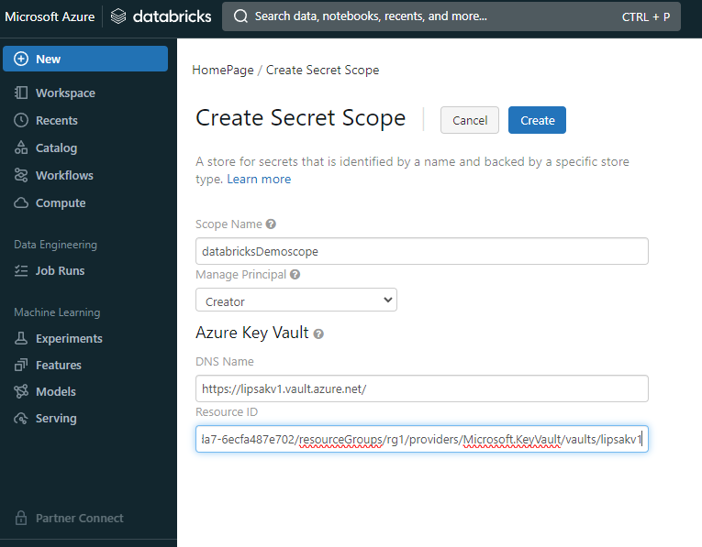**s**

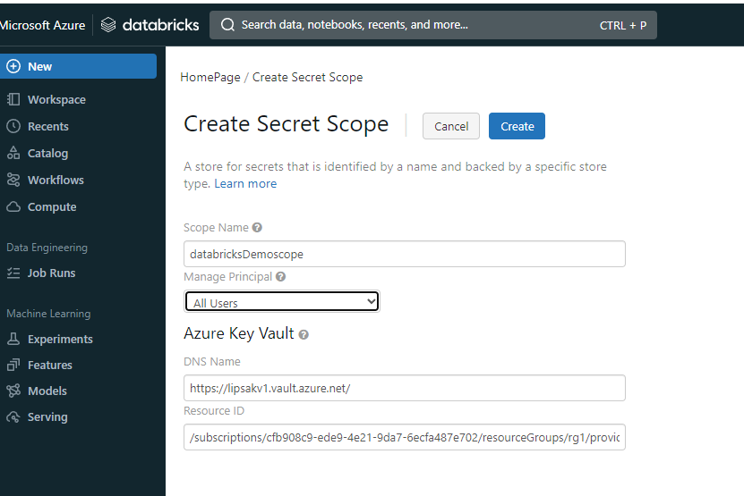

**So, we created a secret scope in Databricks which internally connects to Key vault**

dbutils.fs.mount(

    source ='wasbs://ordersdata@sa1lipsa.blob.core.windows.net' ,

    mount_point ='/mnt/retaildb1' ,

    extra_configs = {'fs.azure.account.key.sa1lipsa.blob.core.windows.net': dbutils.secrets.get('databricksDemoscope' , 'storageAccountAccessKey')}

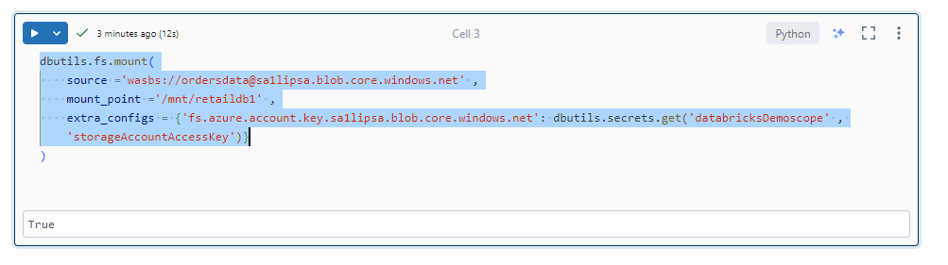

df2 = spark.read.csv("/mnt/retaildb1/orders.csv", header=True)

df2.show()

