How to push your project to GitHub

1.Open a GitHub account.

<https://github.com/>

2.Create a new repository . Go to top right and click on the + sign and expand.Then click on ‘New repository’.

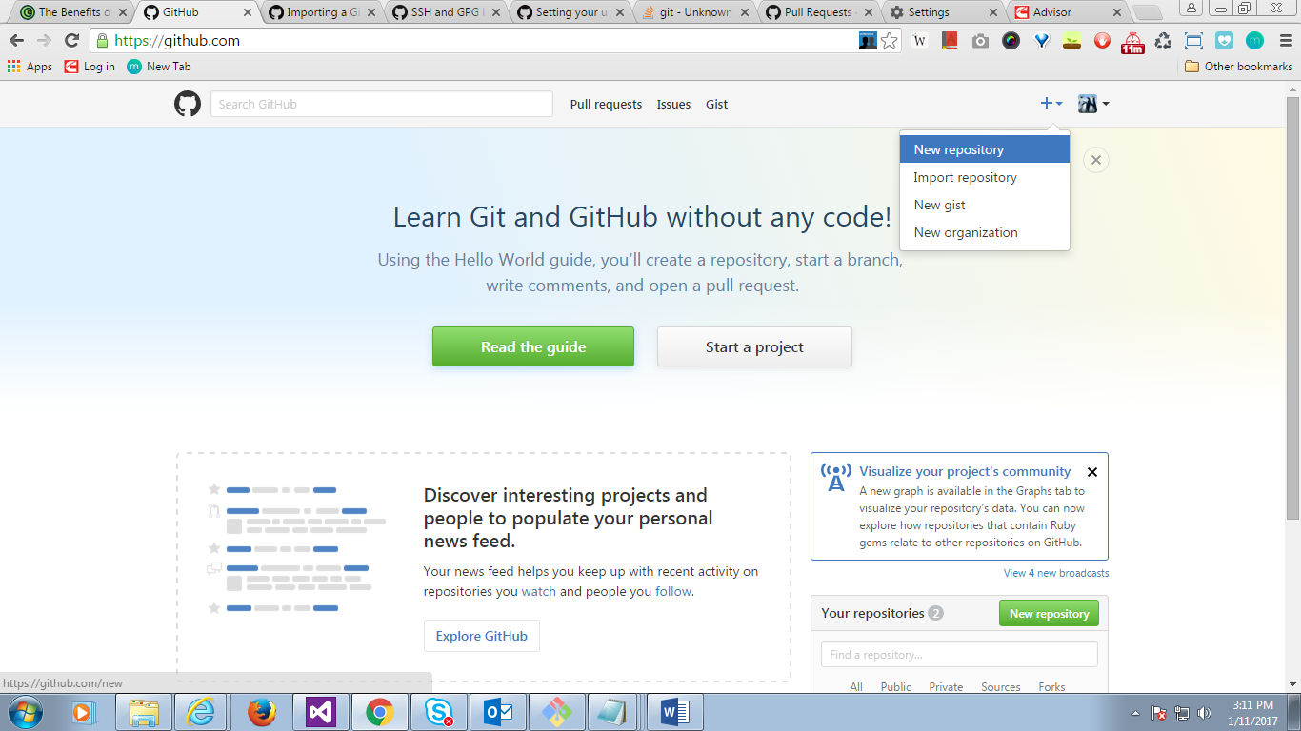

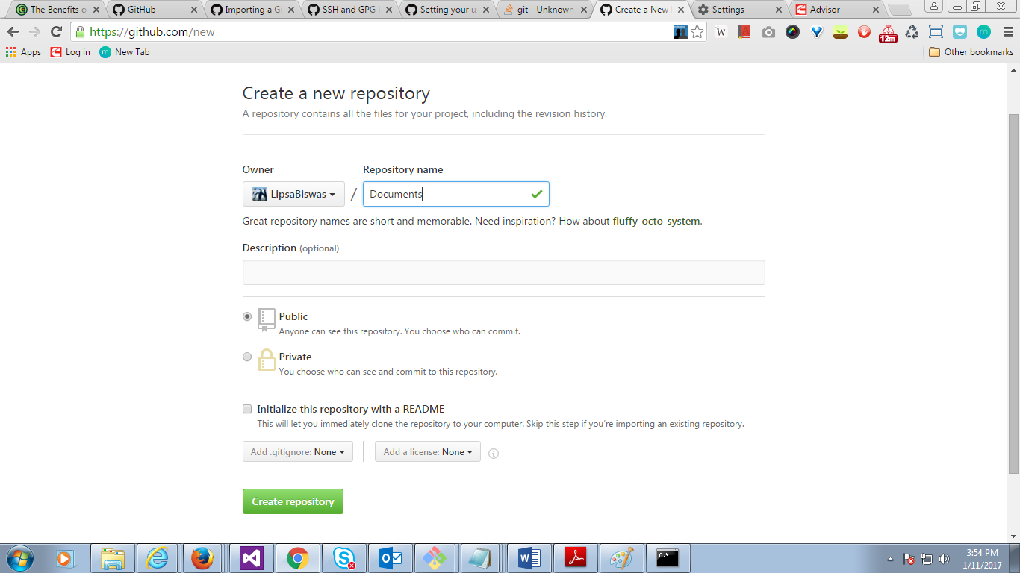

I named it as Documents

3.Install Git in your local machine

Follow instructions here <https://help.github.com/articles/set-up-git>

4.Open command prompt and check git version

$ git –version

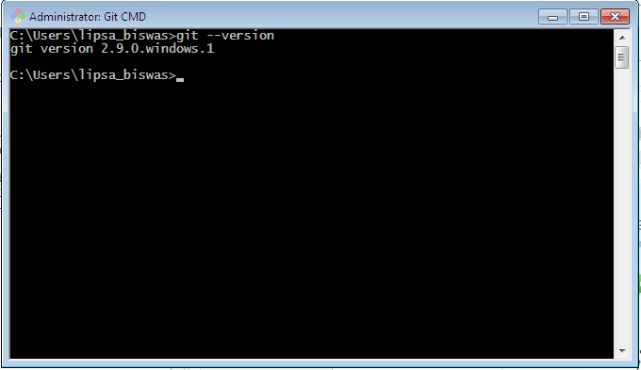

5.Now create a small project to be pushed or simply create a folder and add a textfile .When we will maintain this file changes in Git

I created a folder “MyGitApp” and added a new text file named “readme”.Now add some text like “hi Git” in textfile

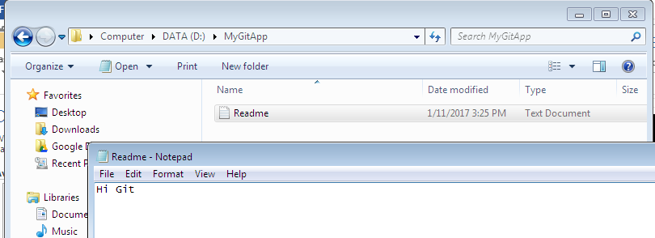

6.Now open command prompt

And type in following commands

1. Change directory to the project folder we created in step #5

$ d:

$ cd D:\MyGitApp

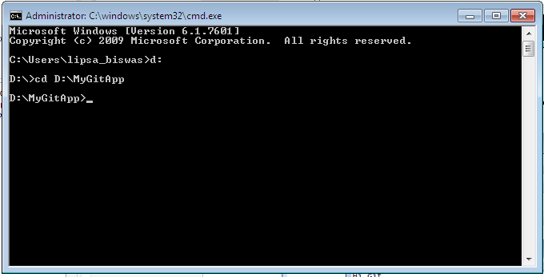

b)check the git version (optional)

$ git –version

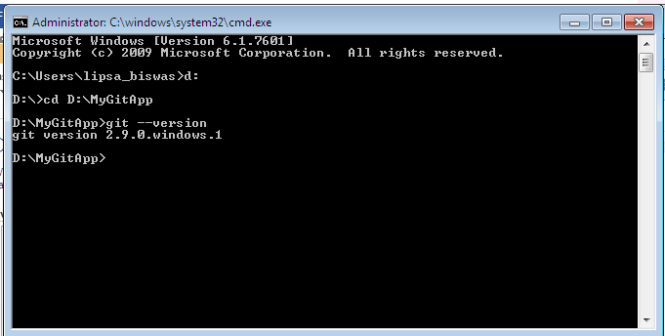

c)Initialize an empty git repository with the command

$ git init

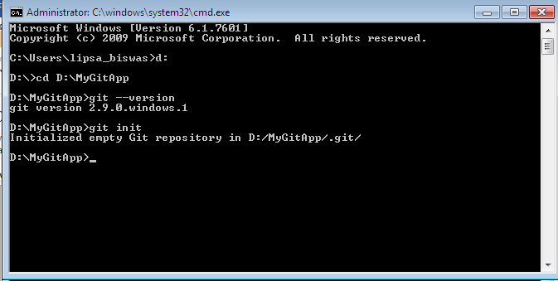

d)git add .

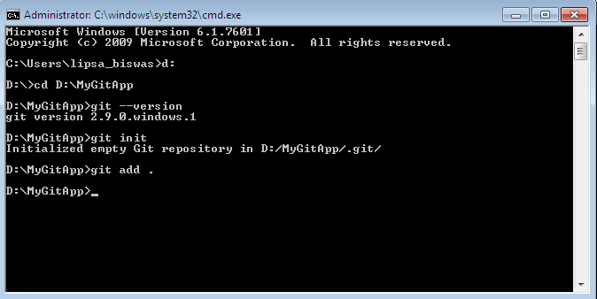

e)commit the changes to the proj to the master branch

$ git commit –m “readmeedits”

The highlight portion is git commit comment

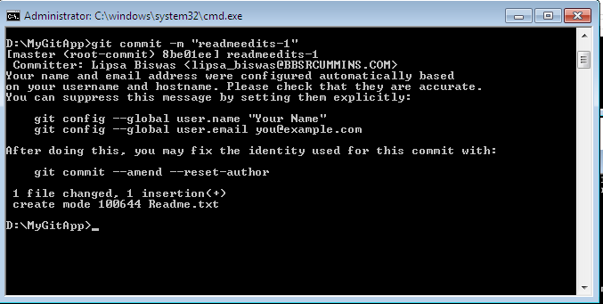

f) Now push the git commit changes to GitHub .Before that set proxy in config if there is firewall

git config --global HOST:PROXY

i.e. git config --global http.proxy fw1.cummins.com:80

g)Push the changes to the new Github repository (“Documents”) we create din step#2

$ git push <https://github.com/LipsaBiswas/Documents> master

Highlighted section is your repository path in github

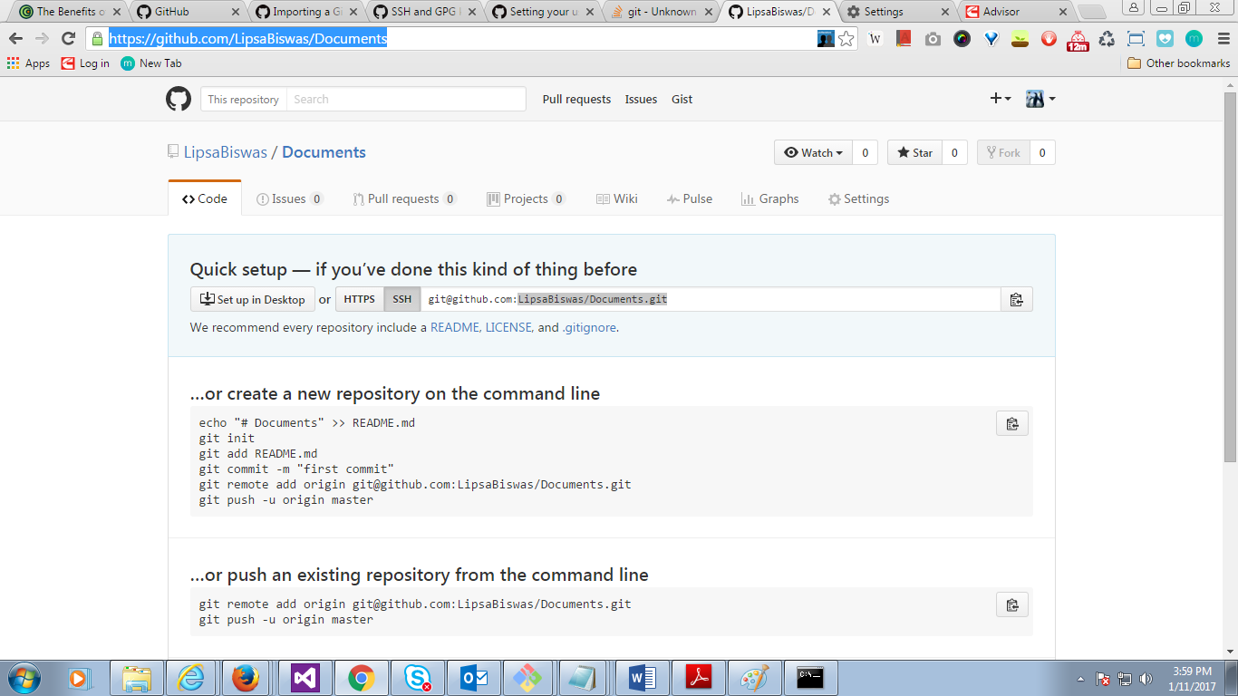

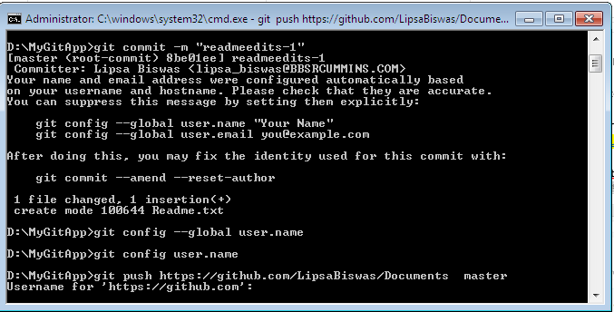

h) Now provide your github credentials

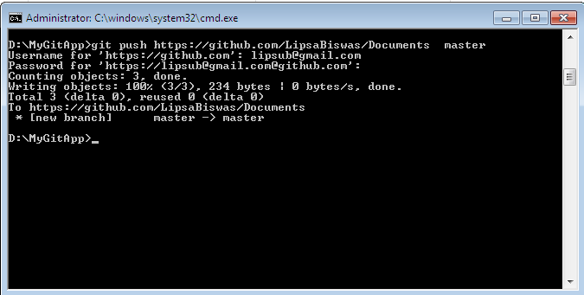

1. Now go to Github account and see your changes pushed.

<https://github.com/LipsaBiswas/Documents>

