Using Deep Learning Techniques to Classify Photographs: Milestone Report

# Problem and Client

The problem I have chosen for this capstone project, is to use deep learning techniques to assign photographs to one of four categories, i.e. landscape, animals, people, plants. One potential application for this type of model is applicable for a stock photography company. By allowing a trained model to classify photographs, the company could either supplement human-classified photos or, if photos have no classification attached to them, provide those classifications. This could reduce the workload for employees as well as ensure that photographs received from disparate sources are all classified similarly. As another application, this type of model could be used by individual photographers. With the rise of digital photography, photographers have the ability to take and store large numbers of photos. The ability to tag, or classify these photos becomes more and more important so that when a photographer needs to find a photo they can. A model like this could help individual photographers automatically tag large numbers of photos. A task that could take hours, days, or weeks if done by hand could be accomplished automatically.

# Data Wrangling and Cleaning

The photographs that I will use to train my model will come from my personal collection. I have selected 200 photos in each of the four categories for a total of 800 photographs. These photos span at least 10 years of photography and consist of images taken on multiple cameras including digital and film cameras. The images taken on film have been previously printed and then scanned into digital format. I tried not to select too many photographs from the same shooting sessions. I have chosen both black and white as well as color photographs in each of the four categories. I did not do any resizing or cropping of the images during the selection process. All photographs are JPGs and are in RGB color format.

I randomly split my photos into training and validation sets. I originally copied all photos to their respective category folders then randomly selected 20% from each category to move to a validation folder. This left me with 640 training photos (160 photos x 4 categories) and 160 validation photos (40 x 4). The code I used to randomly select these photos can be found [HERE](https://github.com/Liptoni/Springboard/blob/master/Photo_Classification_Capstone/python/Randomly_Sort_Images.py):

If I determine that I do not have enough photographs for training the model, I will reach out to other photographers to bolster my training and validation sets. This could provide two-fold benefit: one being a larger sample to use for training, and the other benefit being photographs with a potentially different artistic aesthetic. Both benefits should contribute to a more robust model.

# Initial Data Exploration

Since photographs don’t lend themselves to traditional summary statistics, I decided to take a slightly different tack. I first wanted to look at the frequency of color values for each of the color channels. I thought that this might be a way to determine how similar color patterns are for each of the different photo categories. Each pixel in and RGB image is represented by three values (channels), one each representing red, green, and blue. Each channel is represented by an integer value between 0 and 256. For example, a pixel with values (0, 0, 0) would display black, (256, 0, 0) red, (0, 256, 0) green, and (0, 0, 256) blue. I looped over each photograph in a particular category (i.e. landscape, animals, people, plants) and for each photo I then looped through each color channel and pixel. I summed the number of times a color value appeared and stored those sums in a dictionary before plotting them. The results are shown in figure 1.

Figure 1. Category Color Channel Values

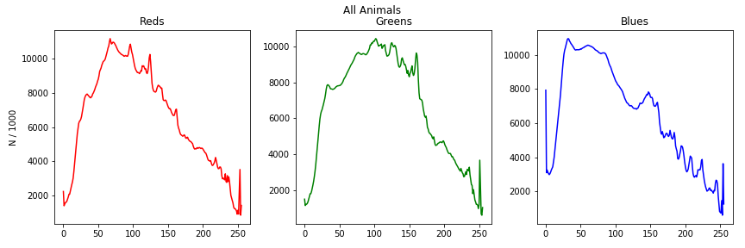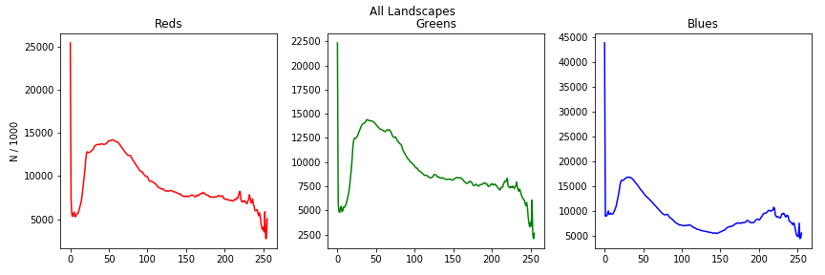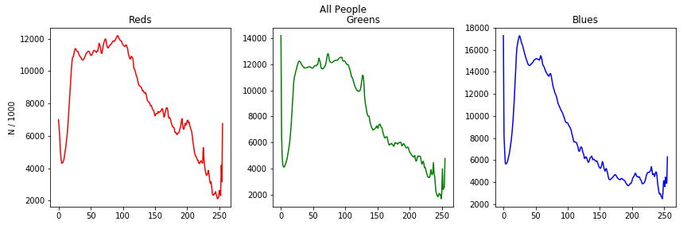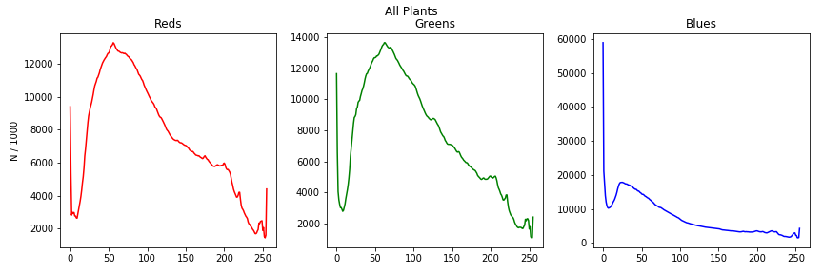

It looks to me like each of the four categories are somewhat unique. Animals and people are probably the most similar while the landscapes and plants seem to have fairly unique color profiles. The code I used to generate these plots, as well as plots for the training and validation sets individually can be found in the Jupyter Notebook [HERE](https://github.com/Liptoni/Springboard/blob/master/Photo_Classification_Capstone/Jupyter_Notebooks/Color_Channel_Plots.ipynb).

Another way to visualize the differences, or similarities, in the categories would be to plot an *average* image. This can be done by taking the average RGB color value for each pixel across every image in a category. The images in my dataset are not of a standardized aspect ratio, so first I needed to get all images into the same format. To do this, I first resized each image so that the smaller edge was 256 pixels. I then took a 224 x 224 center crop of the image. I then looped through each image and added 1/200th of the pixel color values of each image together. The resulting images are displayed in figure 2.

Figure 2. Average Images

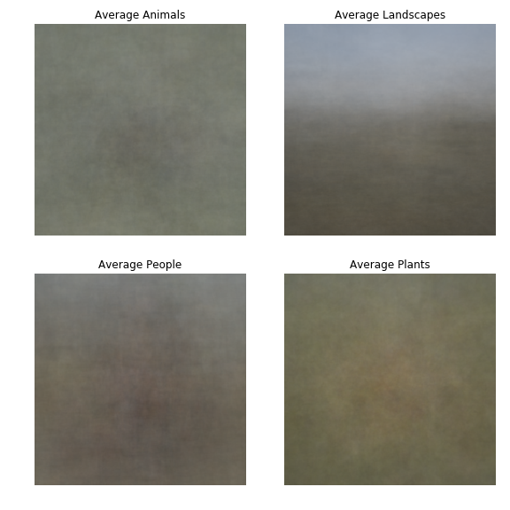

While you can’t see any distinct features, except maybe the sky in the landscape photographs, the colors of each category are slightly different. It seems to me that the animals tent to have a darker spot in the center of the frame, surrounded by more earth tones, i.e. greens and browns. The people photographs also tend to have a darker mass in the center but that mass is warmer, consisting of more reds potentially from varying skin tones. Finally, the plants tend to be more green and yellow overall which upon seems appropriate. The code that I used to generate these images can be found in the Jupyter Notebook [HERE](https://github.com/Liptoni/Springboard/blob/master/Photo_Classification_Capstone/Jupyter_Notebooks/Average_Images.ipynb).