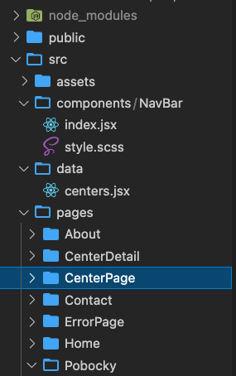

**Main.jsx**

import React from 'react'

import ReactDOM from 'react-dom/client'

import { createBrowserRouter, RouterProvider } from "react-router-dom"

import './index.scss'

import App from './App.jsx'

import Home from "./pages/Home"

import Contact from "./pages/Contact"

import About from "./pages/About"

import Pobocky from './pages/Pobocky'

import CenterPage from './pages/CenterPage'

import CenterDetail from './pages/CenterDetail'

import ErrorPage from './pages/ErrorPage'

import centers from './data/centers'

const router = createBrowserRouter([

{

element: <App />,

errorElement: <ErrorPage />,

children: [

{

path: "/",

element: <Home />

},

{

path: "/about",

element: <About />

},

{

path: "/contact",

element: <Contact />

},

{

path: "/pobocky",

element: <Pobocky />,

children: [

{

path: "/pobocky/:id",

element: <CenterDetail />

}

]

},

]

}

])

ReactDOM.createRoot(document.getElementById('root')).render(

<React.StrictMode>

<RouterProvider router={router} />

</React.StrictMode>,

**App.jsx**

const c = console.log.bind(document)

import { Outlet } from 'react-router-dom'

import './app.scss'

import NavBar from './components/NavBar'

const App = () => {

return (

<>

<NavBar />

{/* <Outlet /> */}

</>

)

}

export default App

**NavBar.jsx**

const c = console.log.bind(document);

import { Link, Outlet } from "react-router-dom";

import "./style.scss";

const NavBar = () => {

return (

<>

<header>

<nav>

<Link to="/">Home</Link>

<Link to="/about">About</Link>

<Link to="/contact">Contact</Link>

<Link to="/pobocky">Pobočky</Link>

</nav>

</header>

<Outlet />

</>

);

};

export default NavBar;

**Pobocky.jsx**

const c = console.log.bind(document);

import "./style.scss"

import { Outlet } from "react-router-dom";

import CenterPage from "../CenterPage";

const Pobocky = () => {

return (

<>

<CenterPage />

<Outlet />

</>

)

}

export default Pobocky

**CenterPage.jsx**

const c = console.log.bind(document);

import { Link } from "react-router-dom";

import centers from "../../data/centers";

import { getAllCenters } from "../../data/centers";

const centerDetails = getAllCenters();

import "./style.scss";

const CenterPage = () => {

return (

<>

<ul>

{

centers.map( center =>

<li key={center.id}>

<Link to={`/pobocky/${center.id}`}> {center.name}, {center.address} </Link>

</li>

)}

</ul>

</>

);

};

export default CenterPage;

**CenterDetail.jsx**

const c = console.log.bind(document)

import React from "react"

import { useParams, Outlet } from "react-router-dom"

import "./style.scss"

import centers from "../../data/centers"

import CenterPage from "../CenterPage"

const CenterDetail = (props) => {

const { id } = useParams()

const centerInfo = centers.find( oneCenter => oneCenter.id === id )

return (

<div>

<p>

About: {centerInfo.info}

</p>

</div>

)

}

export default CenterDetail