Hack The Box
Machine: Soccer
Difficulty: Easy
Report By: LiquidFlame
Date: 9/26/24


Enumeration

Nmap
Scanning Options | Description
10.129.231.22 | Scans the specified target
-p- | Scans all ports
-sS | Performs SYN scan on specified ports
-Pn | Disables ICMP Echo requests
--min-rate 5000 | Sets the minimum number of packets sent per second

Results
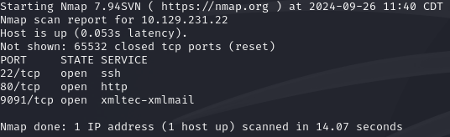

HTTP

Browsed 10.129.231.22, but it couldn’t find the site, so we edit our /etc/hosts file.
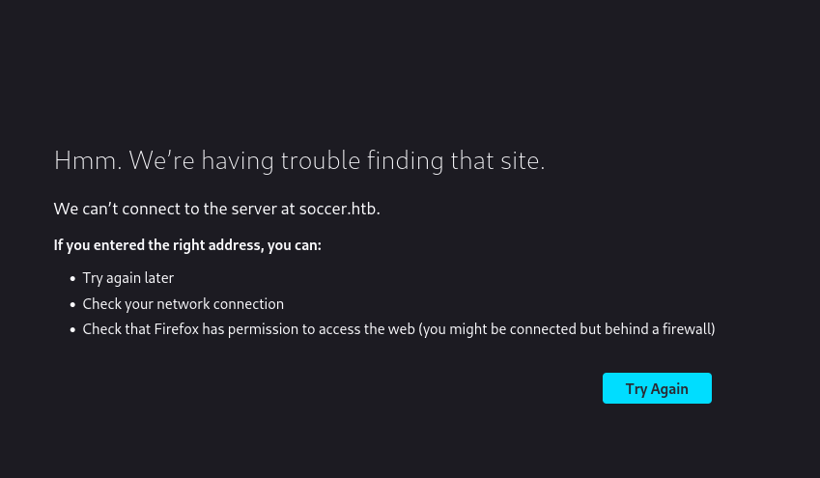
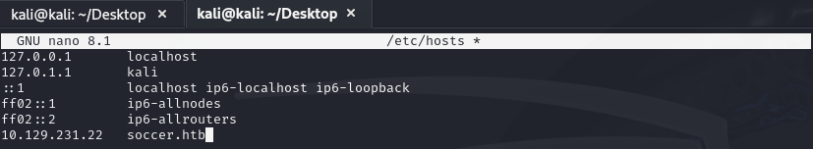
After refreshing we are able to now access the stie. First glance at the site, there’s nothing interesting, no links, no inputs, no dropdowns.

Gobuster
Since I didn’t seeing anything on the site decided it was time to see if we could find any directories.

