**Visualizing the changes on Earth due to the impacts of Global Warming**

As far we know, global warming does have an impact on Earth and will continue to do so. We decided to dig further and analyze how big of an impact it really has by looking at different factors such as the Arctic Sea Ice Volumes, Temperatures throughout specific years, and water levels.

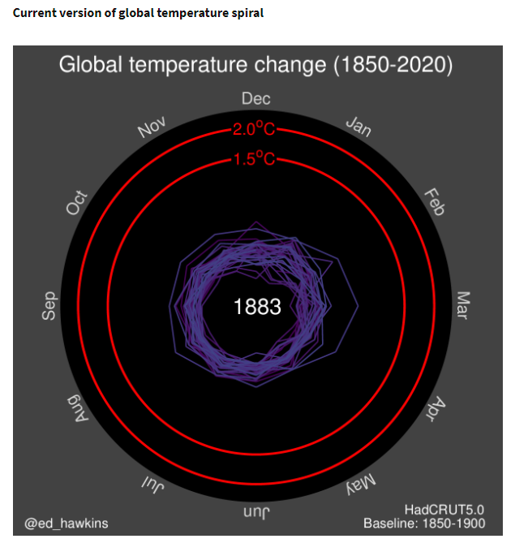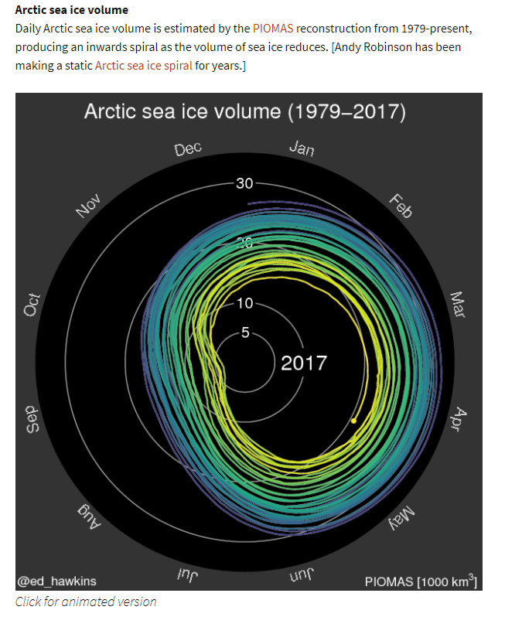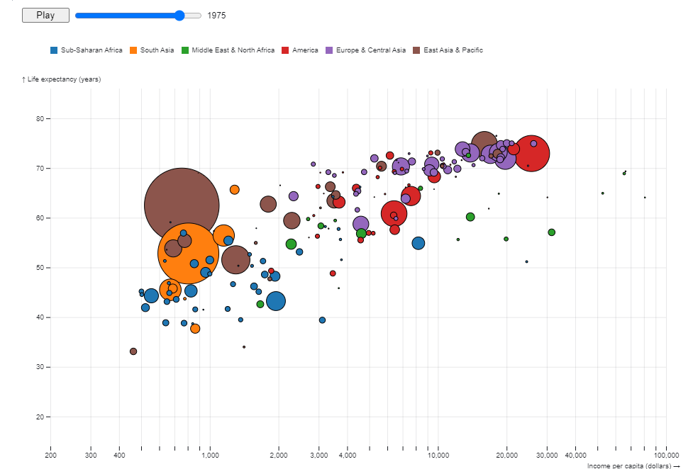

<https://github.com/LiquidRonnie/Project-2>

Mission: Visualizing the changes on Earth due to the impacts of Global Warming

Global Warming

* Obtain Data Sources by Sunday 8/1/21
  + <https://www.globalchange.gov/browse/datasets>
  + <https://data.world/datasets/global-warming>
    - <https://data.world/data-society/global-climate-change-data>
  + <https://www.climate.gov/maps-data/datasets/formats/json>
  + <https://datahelpdesk.worldbank.org/knowledgebase/articles/902061-climate-data-api>

* Visualization:
  + Water Levels (Annie/Drew)
    - Stack offset Wiggle graph
    - Wrap Map to visualize water levels on countries
      * <https://observablehq.com/@d3/streamgraph-transitions>
      * Water levels in Inches

* Climate Spiral (Moe/Drew)
  + <https://pstblog.com/2016/10/26/climate-change>
  + <http://www.climate-lab-book.ac.uk/spirals/>
  + Arctic Sea Ice volume
  + Ice caps

* Scatter plot for temperature (Ronnie/Drew)
  + Continents or countries vs. Avg temperate throughout the months by year
  + <https://observablehq.com/@mbostock/the-wealth-health-of-nations>
    - <https://climateknowledgeportal.worldbank.org/download-data>
  + Create climate spiral for different view

Next steps:

Put data together

* Annie/Drew

Build website

* Ronnie/Moe

JS visualizations

* Scatter - Ronnie
* Wiggle graph - Annie
* Arctic Ice spiral - Drew
* Temperature - Moe