Abstract
Minority-carrier diffusion length and surface recombination velocity set the upper bound on the performance of photovoltaic and light-emitting devices, making their quantitative, non-destructive characterization essential for developing new materials and device architectures. In this work we introduce a method for extracting the minority-carrier diffusion length and ranking surface recombination velocity directly from wavelength-dependent steady-state photoluminescence maps combined with ellipsometry-based optical modeling. We derive a closed-form analytical expression for the photoluminescence signal as a function of excitation and emission wavelength, reflecting how the excitation wavelength sets the depth at which carriers are generated within the sample. Fitting this expression to full excitation–emission photoluminescence maps, we show that a single diffusion length parameter consistently reproduces the measured wavelength dependence across wafers of different semiconductor materials. A complementary surface recombination velocity index, derived from the ratio of the photoluminescence signal at a shallow and a deep excitation wavelength, is shown analytically to retain sensitivity to surface recombination independent of the bulk transport parameters. As a demonstration, the index is applied to track the evolution of a freshly etched semiconductor surface, capturing the gradual passivation associated with native oxide regrowth. Both quantities follow from how the photoluminescence signal varies with wavelength rather than from its absolute magnitude, so the method requires no auxiliary current, voltage, lifetime, or doping measurement.

Introduction
Minority-carrier diffusion length and surface recombination velocity set the upper bound on photovoltaic and light-emitting device efficiency. This performance ceiling arises because only carriers that reach a device’s collecting junction before recombining contribute to its output: the diffusion length sets how far carriers can travel before recombining in the bulk, and the surface recombination velocity sets how quickly they are lost at an interface. Rapid, non-destructive, low-overhead characterization of these parameters is essential for developing new materials and device architectures.
Under operating conditions, photo-generated carriers that are not extracted as current instead recombine — through bulk or surface defect states, or radiatively — and the resulting photons are either reabsorbed within the material (photon recycling) or escape as photoluminescence (PL) [16]. Photoluminescence is therefore the emitted counterpart of the same recombination processes that limit a device’s collected photocurrent, making it a natural, contactless optical probe of those processes.
The literature offers several routes to extract diffusion length or surface recombination velocity from photoluminescence and related optical measurements. One method measures the ratio of PL intensities excited at two different wavelengths and converts it into diffusion length through a PL-efficiency relation parametrized by the sample’s doping and trap density [1]. The formula’s coefficients are parametrized by doping: the PL-efficiency relation used to convert the measured ratio into a diffusion length depends on the sample’s known doping level. A related technique instead obtains an effective diffusion length from the ratio of photoluminescence signals measured under open-circuit and short-circuit conditions on a solar cell [2]. A different class of methods forms the ratio not from two excitation wavelengths but from two luminescence images taken with different spectral filters, giving spatially resolved diffusion length maps that are also less sensitive to lateral voltage variations than single-image techniques [3]. A related approach avoids taking a ratio altogether: a single steady-state PL image is inverted directly for the excess-carrier density profile using known front- and back-surface recombination velocity boundary conditions, from which the diffusion length is extracted [4]. A related, PL-only technique instead infers the diffusion length from how PL efficiency depends on doping density, using a beveled or angle-lapped sample to obtain a depth profile rather than a wavelength-resolved measurement [5]. Outside PL, surface photovoltage methods extract the diffusion length from a single linear-intercept extrapolation of the photovoltage spectrum ‎[6], and spatial micro-photoluminescence profiling versus excitation position, rather than excitation wavelength, similarly yields diffusion length ‎[7].A comparable two-wavelength PL intensity ratio has also been converted into a surface recombination velocity by combining the PL and reflectance signals with a known bulk diffusion length, independently verified by surface photovoltage measurement [8],[9]. Other work applies a continuity-equation model with two independently characterized surfaces on the same wafer — passivated and unpassivated regions of the same die — taking the ratio of their integrated PL at several discrete excitation wavelengths and solving the resulting system of equations for multiple surface recombination velocities [10]. Surface recombination has also been compared across differently prepared surfaces using steady-state and time-resolved PL ‎[11], and a surface recombination velocity has been measured by combining photoluminescence with an independently measured minority-carrier lifetime ‎[12]. Other related studies address doping- and growth-temperature-dependent PL efficiency ‎[13] and photoemission yield in photocathodes ‎[14].
The physical treatment underlying much of this literature is that of Duggan and Scott, who solved the continuity equation for the PL efficiency of a finite-thickness layer bounded by two surfaces, each with its own surface recombination velocity, under localized excitation ‎[15]. Their simulated, single-wavelength curves show that thin-layer efficiency is nearly insensitive to diffusion length unless the length is short and the surface recombination velocity is known a priori — motivating a wavelength-swept measurement instead.
Duggan and Scott’s equation is for a layer of finite thickness with a single, localized excitation wavelength and two separate surfaces (front and back), each with its own recombination velocity. This thesis’s equation is the same physical setup but for an infinitely thick sample illuminated with a continuous sweep of excitation wavelengths rather than one fixed point, so only one surface (front) needs a boundary condition instead of two.
A different class of optical methods varies the excitation wavelength itself: because the absorption coefficient rises with photon energy, short wavelengths are absorbed near the surface and long wavelengths penetrate into the bulk, and a PL spectrum swept across excitation wavelengths encodes both in one compact measurement. Yeshurun et al. used this principle to introduce the spatial external luminescence efficiency (SELE): the probability that a carrier generated at a given depth contributes to the measured photoluminescence, extracted from two-dimensional, excitation-wavelength-dependent PL maps ‎[16].
In this work, we develop a methodology that extracts the diffusion length and ranks surface recombination velocity from wavelength-dependent steady-state PL maps . we apply the theory developed in [15] on samples where the thickness is much greater than the characteristic absorption depth, where a distributed Beer–Lambert absorption profile can be assumed, yielding a closed-form expression for the PL signal as a function of excitation and emission wavelength that is fit directly against a continuous excitation-wavelength sweep, rather than evaluated at a handful of discrete conditions. The model parameters are estimated by fitting this expression to a full excitation–emission PL map, leaving the diffusion length and a transport weighting parameter as the only two fitted unknowns. The extracted diffusion length follows directly from this fit to the full excitation-wavelength dependence, rather than from a single linear extrapolation evaluated at one operating point [6]. We define a surface recombination ranking index that lets surface recombination velocity be compared across samples or over time, without requiring its absolute value. The index is derived from the ratio of the closed-form expression evaluated at two excitation wavelengths. The transport weighting parameter is shown analytically not to cancel in this ratio, establishing algebraically that the index retains sensitivity to surface recombination independent of bulk transport. The same closed-form model underlies both quantities. Diffusion length is obtained by fitting the model to the measured PL maps and is demonstrated across different material systems. The surface recombination velocity index is computed directly from the model. The method requires only a standard photoluminescence setup capable of a continuous sweep of the excitation wavelength spanning the absorption edge of the material under study, together with the sample’s wavelength-dependent absorption coefficient. Unlike methods that compare PL at a fixed pair of wavelengths or require an absolute intensity calibration, this method sweeps the excitation wavelength continuously and recovers both diffusion length and surface recombination sensitivity from the shape of a single measurement. It complements prior approaches that already have absolute calibration or independent lifetime data in place, offering a lighter-weight alternative where those aren’t available. We demonstrate the method by extracting the minority-carrier diffusion length in InP and GaAs wafers, and by using the surface recombination velocity index to track the progressive passivation of a freshly etched GaAs surface as its native oxide regrows. The same model and procedure apply to any semiconductor whose wavelength-dependent optical constants are known and whose thickness substantially exceeds the optical absorption depth, since these constants enter through the ellipsometry-derived absorption coefficient rather than through material-specific fitting constants. This combination of standard instrumentation and material-general applicability makes the approach a practical screening tool for semiconductor material quality.

An analytic solution to the SELE and closed-form representation of the photoluminescence signal
The analysis assumes a uniformly doped wafer whose thickness is much larger than both the optical absorption depth at the relevant photoluminescence wavelengths and the carrier diffusion length. Electric fields are neglected, such that carrier transport is governed solely by diffusion. Photon transmission from the wafer to the ambient is approximated by a step-function behavior, $T_{f}=T\left(θ<θ_{c}\right)$ and 0 otherwise. Photon recycling effects are neglected.
The calculation proceeds by first determining the excess electron concentration $Δn_{δ}$ in response to a localized excitation of the form $δ\left(x-x_{0}\right)G_{0}$. Based on this carrier distribution, the radiative recombination rate is then evaluated as a function of energy and position,
$$R_{rad}\left(E,x,x_{0}\right)=B^{'}\left(E\right)⋅\left(n\left(x,x_{0}\right)⋅p-n_{0}p_{0}\right)≈B^{'}\left(E\right)p_{0}Δn_{δ}\left(x,x_{0}\right)$$ | (1)
where the approximation follows from low-level injection. The photon generation coefficient under the non-degenerate approximation is given by ‎[17]:
 | $$B^{'}\left(E\right)≈\frac{1}{π^{2}ℏ^{3}c_{0}^{2}n_{i}^{2}}α_{b}\left(E\right){n\left(E\right)}^{2}E^{2}\exp\left(-\frac{E-{(E}_{F_{C}}(z)-E_{F_{V}}(z))}{k_{B}T}\right)$$ | (2)

Which yields –
$$R_{rad}\left(E,x,x_{0}\right)≈p_{0}Δn\left(x,x_{0}\right)\frac{α_{b}\left(E\right){n\left(E\right)}^{2}E^{2}\exp\left(-\frac{E}{k_{B}T}\right)}{π^{2}ℏ^{3}c_{0}^{2}n_{i}^{2}}$$ | (3)
The depth-dependent escape probability, $P(x)$, is then evaluated, and the total photoluminescence flux at energy $E$resulting from excitation at position $x_{0}$is obtained by integrating the product of the radiative recombination rate and the escape probability over depth,
$$Φ\left({E,x}_{0}\right)=\int_{0}^{∞}{R_{rad}\left(E,x,x_{0}\right)P\left(x\right)}dx$$ | (4)

The excess electron concentration $Δn$
The differential equation:
 | $$\frac{d^{2}Δn}{dx^{2}}=\frac{G_{0}}{D}δ\left(x-x_{0}\right)-\frac{Δn}{L_{n}^{2}}$$ | (5)
Where $L_{n}=\sqrt{τD}$, $τ$is the effective minority carrier lifetime. The boundary condition at $x=0$ is $D\frac{dΔn}{dx}=S\left(n-n_{0}\right)$. Under the assumed conditions the sample can be considered infinitely thick.
The resulting solution is:
 | $$Δn=\frac{L_{n}G_{0}}{2D}\left\{\begin{matrix}A_{0}e^{-\frac{{x+x}_{0}}{L_{n}}}+e^{\frac{{x-x}_{0}}{L_{n}}} & x<x_{0} \\ A_{0}e^{-\frac{x+x_{0}}{L_{n}}}+e^{-\frac{x-x_{0}}{L_{n}}} & x>x_{0}\end{matrix}\right.$$ | (6)

Where $A_{0}= \frac{D-SL_{n}}{D+SL_{n}}$ .

Depth dependent escape probability
We assume that the transmission through the surface follows: $T_{f}=T\left(θ<θ_{c}\right)$ and 0 other wise.
If at the wavelengths considered the wafer thickness is significantly higher than the absorption depth, second order reflections do not have to be considered. Thus:
 | $$P_{esc}\left(x\right)=\frac{T}{4π}\int_{0}^{θ_{c}}{\int_{0}^{2π}{e^{-\frac{αx}{\cos\left(θ\right)}}\sin\left(θ\right)dθdϕ}}=\frac{T}{2}\int_{0}^{θ_{c}}{e^{-\frac{αx}{\cos\left(θ\right)}}\sin\left(θ\right)dθ}$$ | (7)
The solution is:
 | Pesc'x=Te-αx-cosθce-αxcosθc-αx-αxcosθc-αxe-zzdz | (8)

Photon emission
The PL photon flux now follows:
 | $$Φ\left(x_{0},E\right)=\int_{0}^{∞}{R_{rad}\left(x,x_{0},E\right)P\left(x,E\right)}dx$$ | (9)
The depth-dependent escape probability and excess electron concentration are inserted into Eq. (9). $\cos\left(θ\right)≈1$$\sin\left(θ\right)≈θ$Assuming first order , we obtain:
 | $$Φ\left(x_{0},E\right)=K\left[\left(\left(\frac{1}{α^{-}}+\frac{1}{α^{+}}\right)e^{{-αx}_{0}}+\left(\frac{A_{0}}{α^{+}}-\frac{1}{α^{-}}\right)e^{-\frac{x_{0}}{L_{n}}}\right)\right]$$ | (10)
Where $α^{-}=\frac{1-αL_{n}}{L_{n}}$, $α^{+}=\frac{1+αL_{n}}{L_{n}}$, and $K=\frac{TB^{'}\left(E\right)p_{0}L_{n}G_{0}\left(1-\cos\left(θ_{c}\right)\right)}{4D}$ .
The spatially resolved ELE is $S_{p}\left(x_{0},E\right)=\frac{Φ\left(x_{0},E\right)}{G_{0}}$:
 | $$S_{p}\left(x_{0},E\right)=K_{1}\left(2e^{{-αx}_{0}}+A_{1}e^{-\frac{x_{0}}{L_{n}}}\right)$$ | (11)
Noting:
 | $$A_{1}=\left(\left(A_{0}-1\right)-L_{n}α\left(A_{0}+1\right)\right)$$ | (12)

 | $$K_{1}=\frac{TB^{'}\left(E\right)p_{0}τ_{eff}\left(1-\cos\left(θ_{c}\right)\right)}{4\left(1-{\left(αL_{n}\right)}^{2}\right)}$$ | (13)

The excitation wavelength dependent PL spectrum
Assuming a sample illuminated with wavelength $λ_{ex}$ which corresponds to aborption coefficient $α_{ex}$. The optical generation normalized by the absorbed photon flux is:
 | $$G(λ_{ex},x)=α_{ex}e^{-α_{ex}x}$$ | (14)
Thus, the PL spectrum resulting from this illumination is:
 | $Φ_{PL}\left(λ_{ex},E\right)=\int_{0}^{∞}{G\left(λ_{ex},x\right)S_{p}\left(E,x\right)dx}$ | (15)
Finally, the analytical formulation results in a closed-form representation of the photoluminescence signal:
 | $$Φ_{PL}\left(λ_{ex},E\right)=α_{ex}K_{1}\left(\frac{2}{α+ α_{ex}}+\frac{A_{1}}{\frac{1}{L_{n}}+α_{ex}}\right)$$ | (16)

Methods

Diffusion Length Extraction from Depth-Resolved SELE Photoluminescence

PL and Ellipsometry Measurements
For each excitation wavelength $λ_{ex}$, the photoluminescence (PL) spectrum is measured across all emission wavelengths $λ_{em}$ - $PL\left(λ_{em},λ_{ex}\right).$

Incident wavelength-dependent PL measurements were conducted in an integrating sphere-based setup, illustrated in Figure 1. A tunable Xe lamp source produced quasi-monochromatic illumination with a 20 nm bandwidth, focused onto the sample port of the integrating sphere. The emitted PL signal was collected through the sphere output, passed through a long-pass filter to reject excitation light, and routed via an optical fiber to a spectrometer. The incident photon flux was measured using a calibrated detector placed at the sample port, and the system transfer function was calibrated using NIST-traceable diffuse reflectance standards ‎[16].

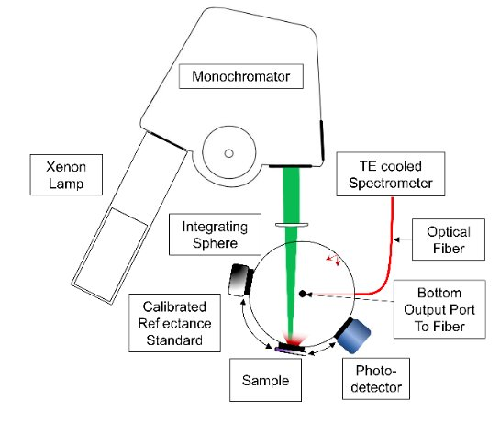
Figure 1 - Excitation wavelength-dependent PL measurements setup using an integrating sphere. The photo-detector and reflectance standard are used for incident photon-flux measurements and calibration.
The wavelength-dependent complex refractive index$n(λ)+ik(λ$) of the sample is measured using spectroscopic ellipsometry. The extinction coefficient $k(λ)$ was used to extract the absorption coefficient $α(λ)$ according to -
$$α\left(λ\right)= \frac{4πk(λ)}{λ}$$ | (17)
The absorption coefficients at the excitation and emission wavelengths, denoted $α_{ex}≡α(λ_{ex})$ and $α_{em}≡α(λ_{em})$, are both obtained from the same ellipsometry measurement and treated as known inputs to the analysis.

Analytical Closed-Form Expression for PL
Within the SELE framework, the PL intensity is derived by treating carrier generation, diffusion, surface recombination, and photon escape probability analytically, and integrating the resulting carrier distribution over depth. The full derivation, including the excess-carrier profile and closed-form escape-probability integral, is presented in the Analytic Solution, section ‎3. This procedure yields the following closed-form expression for the detected PL signal as a function of excitation and emission wavelength

 | $$PL\left(λ_{em},λ_{ex} \right)=α_{ex}K_{1}\left(λ_{em}\right) \left(\frac{2}{α_{em}+ α_{ex}}+\frac{A_{1}}{\frac{1}{L_{n}}+α_{ex}}\right)$$ | (18)
$A₁$ and $K₁$ are defined in the Analytic Solution chapter (Eqs. 12 -13).

Practical Extraction of the Diffusion Length
The diffusion length is extracted by fitting the closed-form analytical expression given in Eq. (18) to the measured photoluminescence data $PL(λ_{em},λ_{ex})$.
Prior to fitting, a constant background level is removed from the measured PL data. The PL data are then normalized by a single global scaling factor, taken as a representative maximum of the signal across the map, applied uniformly to all excitation and emission wavelengths. This is a purely numerical step that stabilizes the optimization while preserving the relative variation of the PL signal across all excitation and emission wavelengths.
The fitting procedure treated the diffusion length $L_{n}$ and the transport weighting parameter $A_{1}$ as global parameters shared across all excitation wavelengths. For a given trial pair of global parameters $\left(L_{n} , A_{1}\right)$, the analytical expression in Eq. (18) is first evaluated across all excitation wavelengths. At this stage, and for each emission wavelength $λ_{em}$, the emission-dependent prefactor $K_{1}(λ_{em})$was obtained by a one-parameter least-squares fit over all excitation wavelengths, with $L_{n}$ and $A_{1}$ held fixed. This step determines the optimal prefactor, $K_{1}(λ_{em})$, for each emission wavelength.

Emission Window Selection
The range of emission wavelengths used for fitting is selected based on the coefficient of determination R², computed between the measured PL data and the analytical model prediction at each emission wavelength independently. At short emission wavelengths the PL intensity is low as the spectrum rises toward its peak, and at long emission wavelengths the emission intensity decays past the bandgap. In both cases the weak absolute signal level causes R² to drop, reaching negative values at the spectral edges where the fit quality breaks down. The appropriate window is identified individually for each material and measurement configuration.
Once the set of prefactors $\left\{K_{1}(λ_{em})\right\}$ is determined, the overall quality of the fit is quantified using the total residual sum of squares, $RSS\left(L_{n},A_{1}\right),$ defined in Eq. (19), which accumulates the squared differences between the measured and modeled PL values over all emission and excitation wavelengths. The optimal values of $L_{n}$ and $A_{1}$ are obtained by minimizing this residual sum of squares, yielding the transport parameters that best reproduce the measured wavelength-resolved PL data.
 | $$RSS(L_{n},A_{1})=\sum_{λ_{em}}{\sum_{ex}{{\left[PL_{meas}(λ_{em},λ_{ex})-PL_{model}(λ_{em},λ_{ex};L_{n},A_{1})\right]}^{2}}}$$ | (19)

Optimization Algorithm
Minimization of the RSS objective is carried out using the Nelder–Mead algorithm, a derivative-free direct-search method that does not require gradient information. This choice is appropriate for the present problem because the RSS landscape, while possessing a well-defined global minimum, contains a flat plateau at large values of $L_{n}$ where gradient-based methods become unreliable, as detailed below. The low dimensionality of $L_{n}$ and $A_{1}$ makes this method both efficient and reliable. The algorithm iteratively updates its set of trial parameter vectors by reflection, expansion, and contraction steps until a convergence tolerance is reached.
Figure 2 summarizes this procedure. Given a trial pair $(Lₙ, A₁)$, the model shape $Sⱼ(αₑₓ)$ is constructed for each emission wavelength in the fit window. Because the model is linear in $K₁$ for any fixed $(Lₙ, A₁)$, the corresponding prefactor $K₁$ follows directly from a closed-form least-squares solution rather than a separate search, and the resulting residual $yⱼ$ $- K₁Sⱼ$ — where $yⱼ$ is the measured PL data at that emission wavelength — is accumulated into the RSS. The optimizer therefore searches only the two-dimensional space $(Lₙ, A₁)$: at every trial it proposes, the matching $K₁$ is computed automatically as part of the RSS evaluation, and is never itself an independent search variable.
Because the RSS landscape contains a structurally flat ridge at large values of $L_{n}$ — arising from the fact that when $L_{n}≫ \frac{1}{α_{ex}}$ the model becomes insensitive to $L_{n}$ — a single optimization run starting from an arbitrary initial point may stall on the ridge rather than converge to the true minimum. To guard against this, a multi-start strategy was employed: 45 independent Nelder–Mead runs are initiated from a grid of starting points consisting of 15 values of $L_{0}$ (the initial guess for $L_{n}$) logarithmically spaced across several orders of magnitude, each combined with 3 different initial values of the transport parameter $A_{1}$. The global optimum is taken as the result of the run achieving the lowest final RSS across all 45 runs.
The profiled RSS landscape shows no additional local minima beyond the flat ridge described above: this follows because the objective function is a sum of squared residuals in which the prefactor $K_{1}$ is resolved analytically at each evaluation, so the only non-convex feature is the flat plateau at large $L_{n}$. Any run that stalls has done so on this flat ridge, not at a spurious local minimum. A run is classified as converged if its final RSS falls within 1% of the global best value; matching RSS values do not necessarily imply identical ($Lₙ, A₁$) pairs, since the flat ridge produces near-equal RSS over a wide range of $Lₙ$. For the InP dataset, 30 of the 45 runs (67%) converged by this criterion. This confirms that the true global minimum is consistently identified.

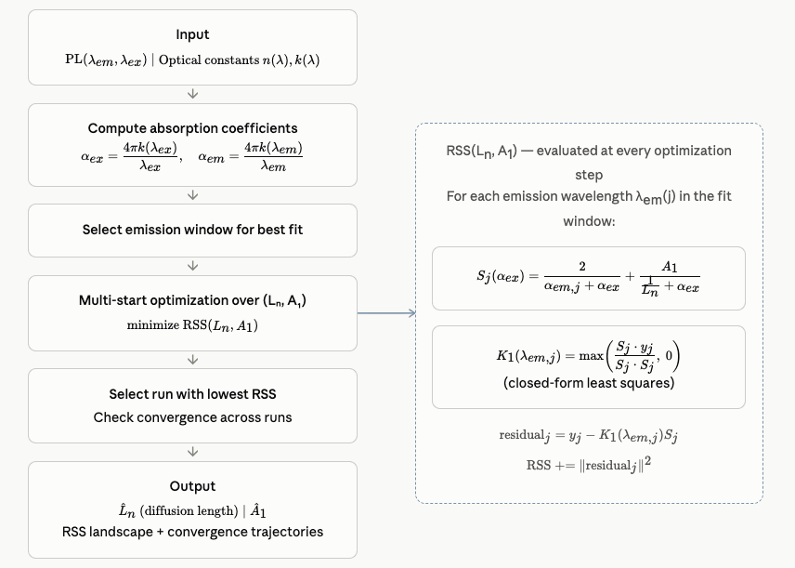
Figure 2 - Algorithm flow for SELE diffusion length extraction

Surface Recombination Velocity Ranking from SELE Photoluminescence

Wavelength Selection for Surface Sensitivity
This section introduces a metric that ranks surface recombination velocity (SRV) across samples or measurement time points, based on how the PL signal responds to shallow versus deep excitation.
Two excitation-wavelength conditions are defined as follows: a shallow excitation wavelength, at which strong absorption concentrates carrier generation near the surface, making the detected PL signal more responsive to surface recombination, denoted as $λ_{ex_sh}$. A deep excitation wavelength, corresponding to weaker absorption and deeper carrier generation, denoted as $λ_{ex_dp}$.
To maximize the sensitivity of the detected PL signal to surface recombination, the analysis is restricted to emission wavelengths drawn from the low-wavelength tail of the emission spectrum. At shorter emission wavelengths, the absorption coefficient $α_{em}$ is higher, so emitted photons originate from recombination events closer to the surface. This is compounded by stronger self-absorption and lower photon escape probability at these wavelengths, further concentrating the detected signal to near-surface emission events. Since these carriers are generated closer to the surface, they are more likely to recombine there rather than radiatively, as the relative likelihood of each pathway is depth-dependent. As a result, variations in surface recombination more directly affects Shorter emission wavelengths therefore carry more near-surface information, while longer wavelengths increasingly reflect deeper, bulk-dominated recombination; restricting the analysis to emission wavelengths below the PL peak sharpens this contrast between samples with different surface recombination.

SRV Index Definition
For each sample, a ratio between PL at the shallow excitation wavelength $λ_{ex_sh}$ and the deep excitation wavelength $λ_{ex_dp}$ signals is constructed for each emission wavelength -
$$R_{srv}\left(λ_{em}\right)= \frac{PL(λ_{em},λ_{ex_sh}) }{PL(λ_{em},λ_{ex_dp})}$$ | (20)
Another way to obtain $R_{srv}$ is by substituting the closed-form expression for the PL signal given in Eq. (18). Because $K_{1}\left(λ_{em}\right)$ is fit once for each emission wavelength, independent of the excitation wavelength, it cancels exactly in $R_{srv}$ :

$R_{srv}\left(λ_{em}\right)=\frac{α_{ex_sh}\left(\frac{2}{α_{ex_sh}+α_{em}}+\frac{A_{1}}{α_{ex_sh}+\frac{1}{L_{n}}}\right)}{α_{ex_dp}\left(\frac{2}{α_{ex_dp}+α_{em}}+\frac{A_{1}}{α_{ex_dp}+\frac{1}{L_{n}}}\right)}$ | (21)

Unlike $K_{1}\left(λ_{em}\right)$, the parameter $A_{1}$does not cancel — it remains in $R_{srv}$. Since $A_{1}$is the model's carrier of surface-recombination information, this confirms that $R_{srv}$ retains genuine sensitivity to the surface recombination velocity, rather than reducing to a purely instrumental or geometric quantity. As SRV index computed directly from $R_{srv}\left(λ_{em}\right)$, this sensitivity carries through to the reported index as well.

A single SRV index is obtained by computing the median of the quantity $1-R_{srv}(λ_{em})$ over the surface-sensitive emission range –
$$SRV_index= median(1-R_{srv}\left(λ_{em}\right))$$ | (21)
The quantity (1 − $R_{srv}$) is used rather than $R_{srv}$ itself so that larger values correspond directly to stronger surface recombination, yielding an intuitively ordered metric in which increased surface losses produce higher indices. The median is chosen as the aggregation operator to obtain a representative value that is insensitive to occasional anomalous ratios arising from spectral noise, residual non-ideal surface sensitivity at specific emission wavelengths, or deviations from the assumptions underlying the proxy. This choice ensures that the SRV index reflects the dominant surface-recombination behavior across the selected emission range, rather than being influenced by a small number of outlying wavelengths.
Samples are ranked in descending order of SRV index, such that higher values correspond to stronger effective surface recombination.

The excitation pair ($λ_{ex_sh}$, $λ_{ex_dp}$) is selected empirically by searching over all available excitation wavelength pairs in the data. For each candidate pair, the SRV index is computed across all samples or time points in the dataset, and the Pearson correlation coefficient r between the SRV index and the scan number is evaluated. The pair that maximizes r is taken as the optimal pair, as it yields the highest Pearson correlation with the expected ordering of surface recombination across the dataset.

Results and Discussion
PL was measured on the n-type InP and p-type GaAs wafers as a two-dimensional dataset spanning emission wavelength and excitation wavelength. For each excitation wavelength $λ_{ex}$, a full photoluminescence spectrum as a function of emission wavelength $λ_{em}$ is acquired, collectively forming a PL map ${PL(λ}_{em},λ_{ex})$. These maps serve as the experimental basis for the extraction of the minority carrier diffusion length.
αexEach excitation wavelength has an associated absorption coefficient αex, which sets the characteristic depth at which carriers are generated. Photons with short excitation wavelengths are strongly absorbed near the surface, making the detected PL signal more sensitive to surface recombination; longer wavelengths penetrate deeper into the bulk, where the PL reflects predominantly bulk recombination processes.
The excitation-wavelength-dependent PL map experimental setup used to acquire the PL map is schematically illustrated in Figure 1 and PL was measured as described in the methods section.

Diffusion Length Extraction – n-type InP
The SELE analysis was applied to a 1.31–1.48×10¹⁷ cm⁻³ Sulphur doped (n-type) InP wafer. The optical constants that were obtained from spectroscopic ellipsometry are shown in Figure 3.
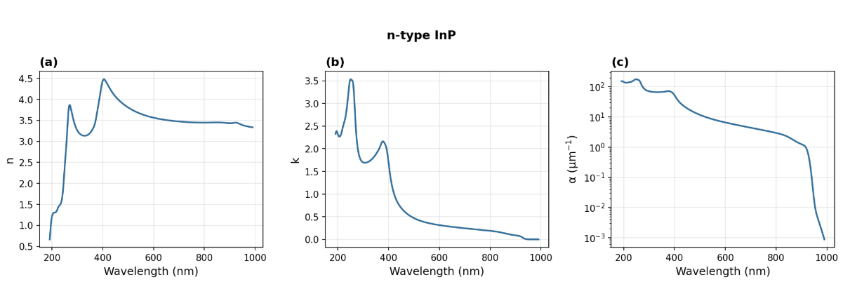
Figure 3 - Optical constants of the n-type InP wafer: (a) refractive index n, (b) extinction coefficient k, (c) absorption coefficient α
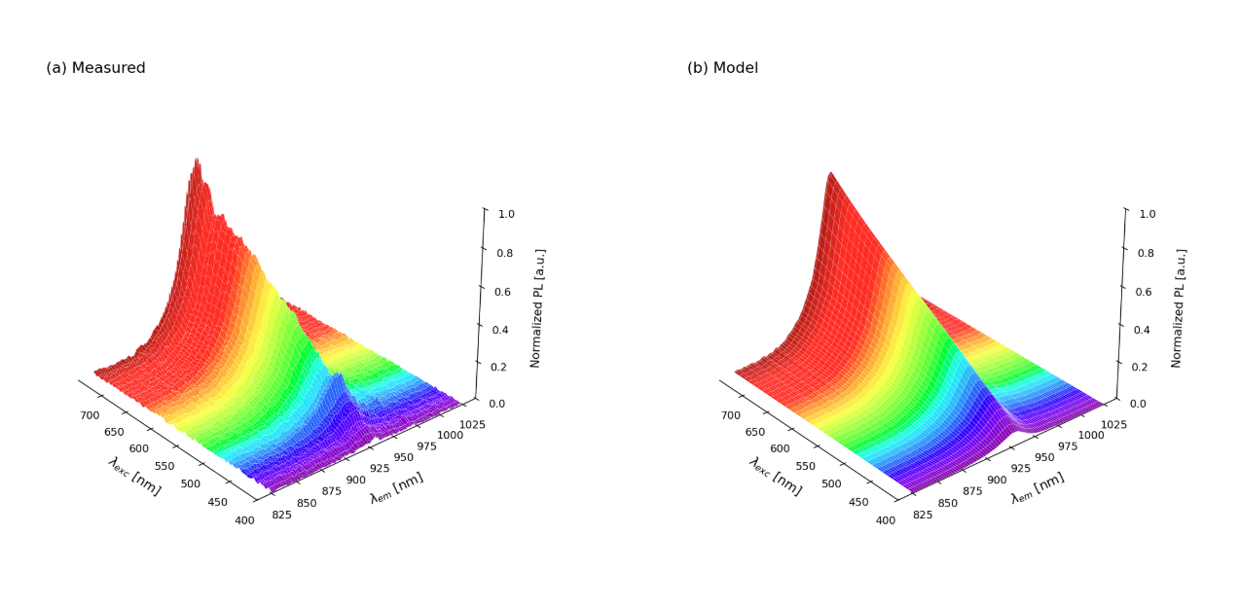Figure 4 - Incident-wavelength-dependent PL map of the n-type InP wafer, color-coded by excitation wavelength. (a) Measured. (b) Model, using the extracted diffusion length and transport parameter.
Figure 4a shows the photoluminescence map of the n-type InP wafer. The map exhibits a smooth and reproducible dependence on excitation wavelength across the entire emission spectrum. This behavior is consistently described by Eq. (18). Figure 4b shows the corresponding model prediction using the extracted diffusion length and transport parameter, closely reproducing the measured map.
Next, we evaluated the applicability of the model to the measured data. Figure 5 shows the measured PL signals at specific emission wavelengths as a function of the absorption coefficient of the incident wavelength. It can be easily noticed that the model reproduces the measured trend closely within the fitted emission window of 910–940 nm.

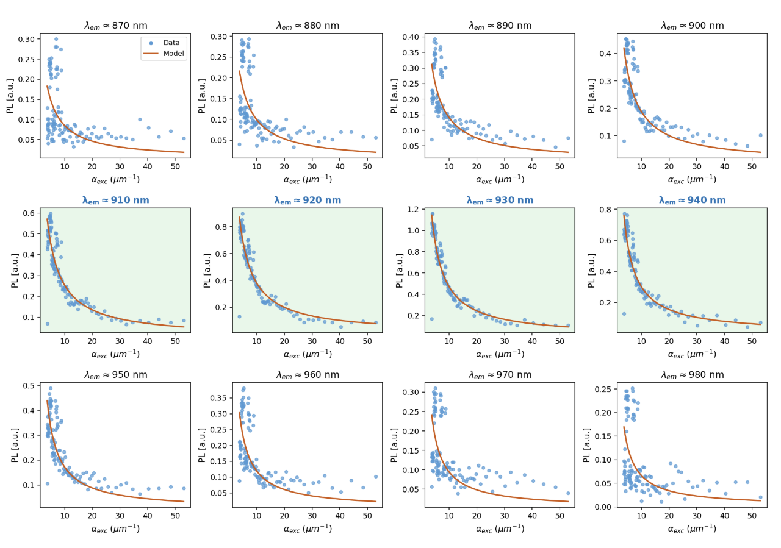
Figure 5 - PL intensity as a function of excitation absorption coefficient $α_{ex}$ at twelve emission wavelengths, for n-type InP. Blue dots: measured data; orange curve: best-fit analytical model. All panels share the same normalization, so PL magnitudes are directly comparable across emission wavelengths. Green panels indicate the emission window (910–940 nm) selected for fitting; white panels show the model prediction outside this window.

The PL signal depends on the excitation absorption coefficient $α_{ex}$. Fitting across multiple excitation wavelengths isolates Lₙ as the single transport parameter governing the excitation-wavelength dependence. The quality of the fit across all emission wavelengths is quantified by the coefficient of determination R², shown in Figure 6.
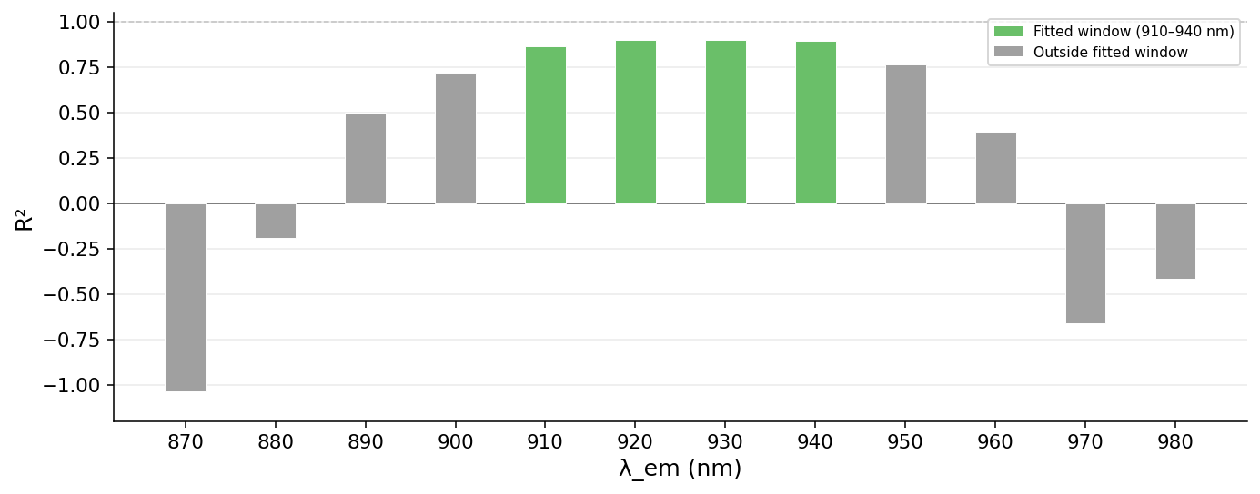

Figure 6 - Coefficient of determination (R²) of the analytical model fit at each emission wavelength shown in Figure 5 . Green bars correspond to emission wavelengths within the fitted window (910–940 nm); gray bars correspond to wavelengths outside the window. The fitted window systematically yields the highest R² values, confirming that the emission range selection is justified by fit quality. The R² is lower at emission wavelengths away from the fitted window because the absolute PL signal is weak there — rising toward the spectral peak at short wavelengths and decaying past the band edge at long wavelengths — so measurement noise dominates the residual rather than any breakdown of the model itself.
Figure 7a shows the normalized RSS as a function of diffusion length Lₙ, evaluated at discrete values on a logarithmic grid. Figure 7b shows the convergence trajectories of the 45 independent Nelder–Mead optimization runs, color-coded by their initial Lₙ value. Outside this window, deviations between the model and data are larger, reflecting the influence of spectral features not captured by the analytical expression.

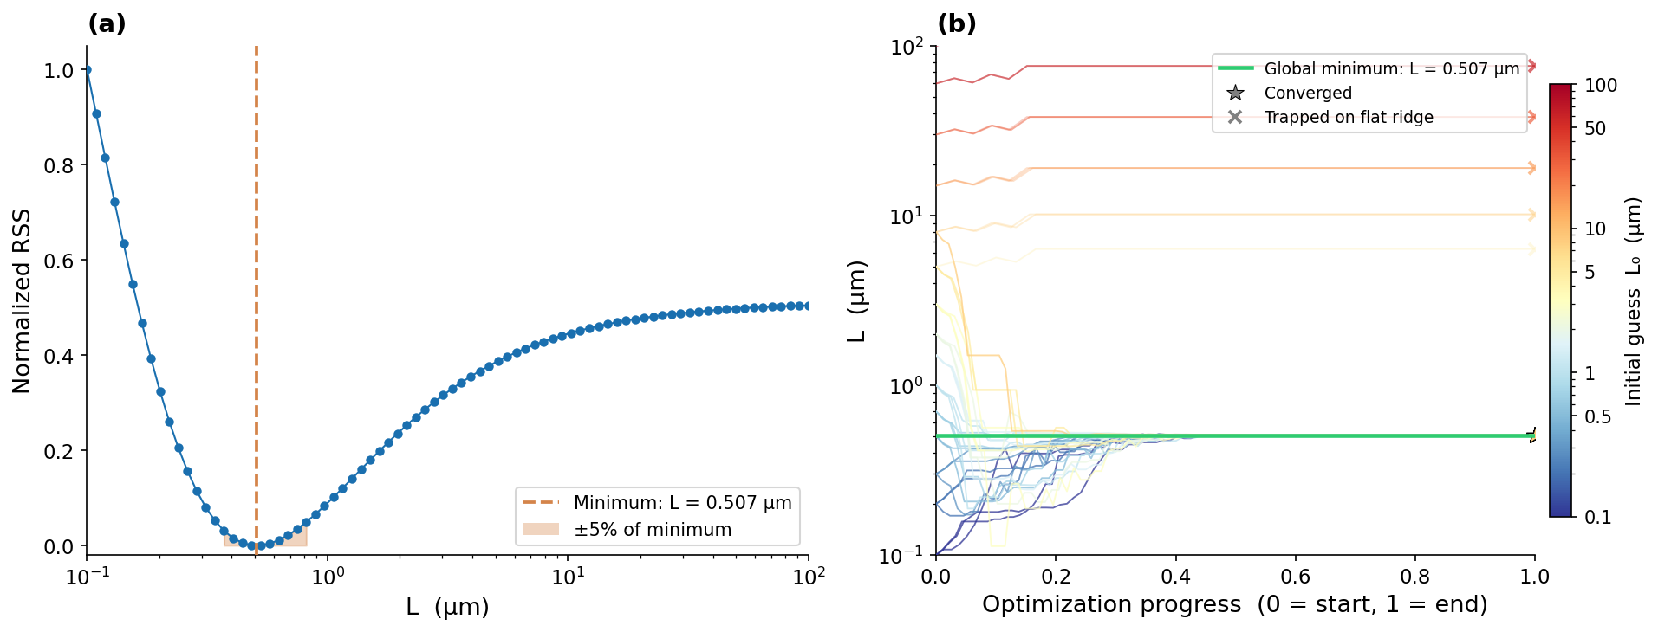
Figure 7 - SELE fit results for n-type InP. (a) Normalized RSS as a function of diffusion length Lₙ, evaluated at discrete values of Lₙ on a logarithmic grid. The orange dashed line marks the global minimum at Lₙ = 0.507 μm. (b) Convergence trajectories of the Nelder–Mead optimization from 45 different initial values of Lₙ₀ (color-coded by L₀ from blue to red). The horizontal axis shows normalized optimization progress from start (0) to end (1).

Diffusion Length Extraction – p-type GaAs wafer
The SELE fitting procedure described in the Optimization Algorithm section was applied to a p-type GaAs wafer. The wafer is doped with zinc (Zn, p-type) with a carrier concentration of 1.70–2.26×10¹⁹ cm⁻³. The optical constants were obtained from spectroscopic ellipsometry ‎[16] and are are shown in Figure 8.. Figure 9a shows the raw PL map acquired from this sample, Figure 9b shows the corresponding model prediction using the extracted diffusion length and transport parameter. The emission wavelengths used for fitting were selected in the range of 870–920 nm, where the model best reproduces the data as shown in Figure 10.
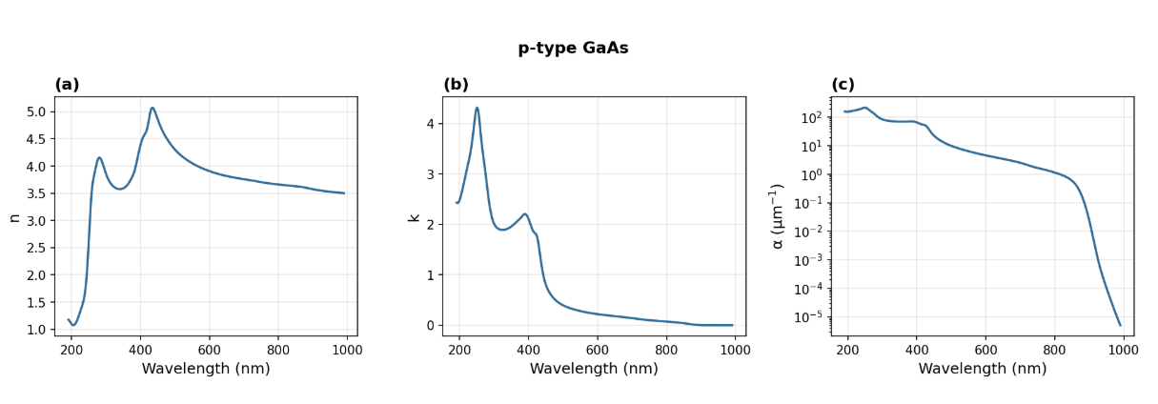
Figure 8 - Optical constants of the p-type GaAs wafer: (a) refractive index n, (b) extinction coefficient k, (c) absorption coefficient α.
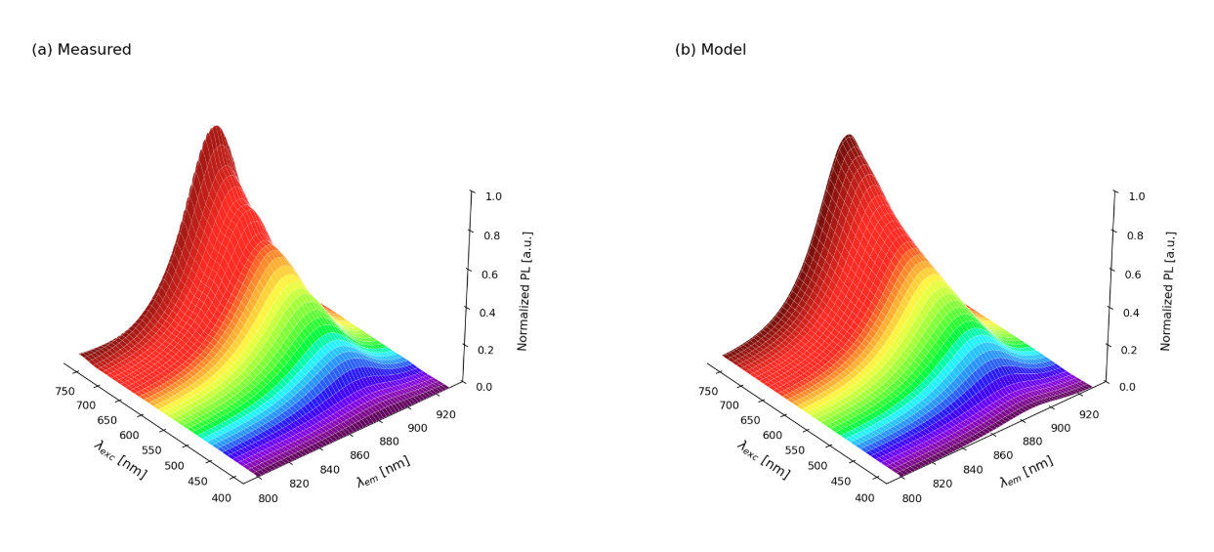
Figure 9 - Photoluminescence map of the p-type GaAs wafer, color-coded by excitation wavelength. (a) Measured. (b) Model, using the extracted diffusion length and transport parameter.

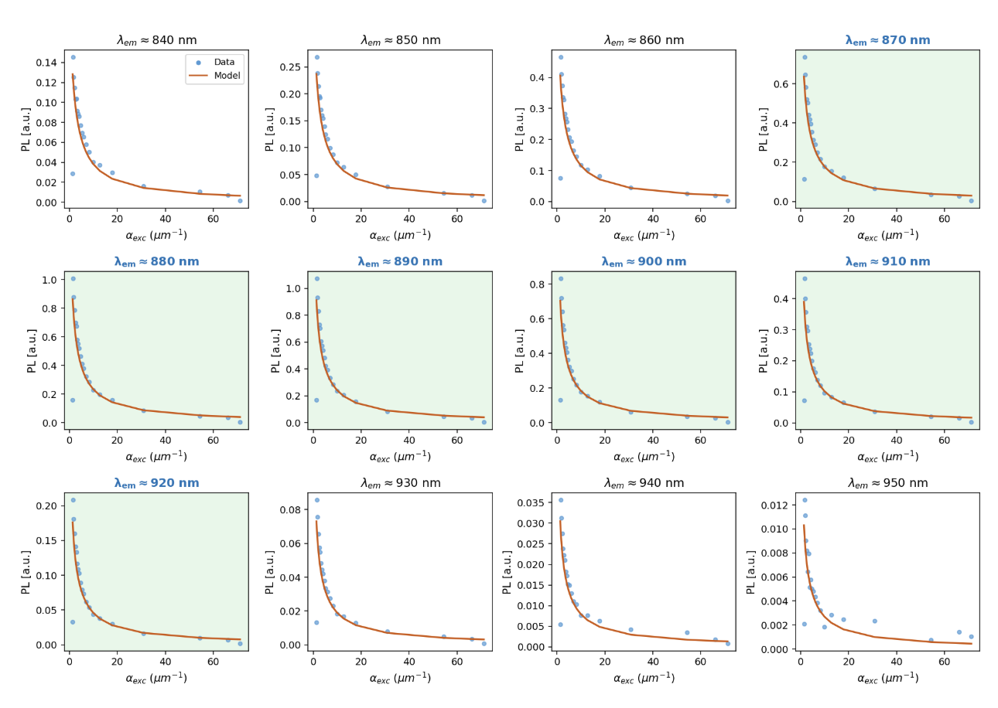
Figure 10 - PL intensity as a function of excitation absorption coefficient $α_{ex}$ at twelve emission wavelengths, for p-type GaAs. Blue dots: measured data; orange curve: best-fit analytical model. All panels share the same normalization, so PL magnitudes are directly comparable across emission wavelengths. Green panels indicate the emission window (870–920 nm) selected for fitting; white panels show the model prediction outside this window.
The fit yields a diffusion length of $Lₙ$ = 0.319 μm. The RSS landscape and convergence trajectories are shown in Figure 11a and Figure 11b respectively. The RSS minimum is well-defined and the optimization converges robustly. The same flat-ridge behavior at large $Lₙ$ values is present, confirming it is a structural feature of the analytical model.
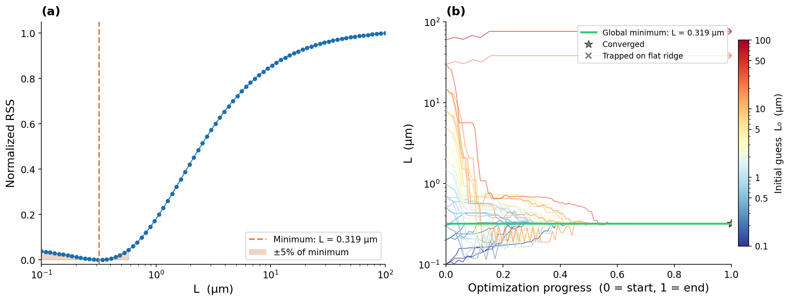
Figure 11 - SELE fit results for p-type GaAs wafer. (a) Normalized RSS as a function of diffusion length Lₙ, evaluated at discrete values on a logarithmic grid. The global minimum is at Lₙ = 0.319 μm. (b) Convergence trajectories of the Nelder–Mead optimization from 45 initial values of L₀ (color-coded by L₀ from blue to red).

Time-resolved surface evolution – GaAs post-etch
To demonstrate the ability of the SRV ranking method to track surface state changes over time, a p-type GaAs wafer was etched in a 1:1 mixture of HCl and DI water for 60 seconds to remove the native surface oxides. Etching exposes a high density of unpassivated surface states. As the surface subsequently re-oxidizes on exposure to air, these states are progressively passivated, and the surface recombination velocity decreases accordingly. The wafer was then rinsed in DI water, dried with N₂, and immediately transferred to the PL measurement setup. The sample was then measured in 28 consecutive incident wavelength scans, each consisting of 34 excitation wavelengths (400–730 nm, 10 nm steps), measured sequentially.
To reduce spectrometer noise while preserving the scan-to-scan time ordering, the PL spectra were smoothed along the emission wavelength axis using a 1D Gaussian filter. The SRV ranking method described above was then applied to each of the 28 post-etch scans. The optimal excitation pair was identified as $λ_{ex_sh}$ = 420 nm and $λ_{ex_dp}$ = 700 nm, selected by maximising the Pearson correlation coefficient (r) between $R_{srv}$ and scan number over all possible pairs. The obtained Pearson correlation coefficient r = 0.86 indicates a strong monotonic trend.
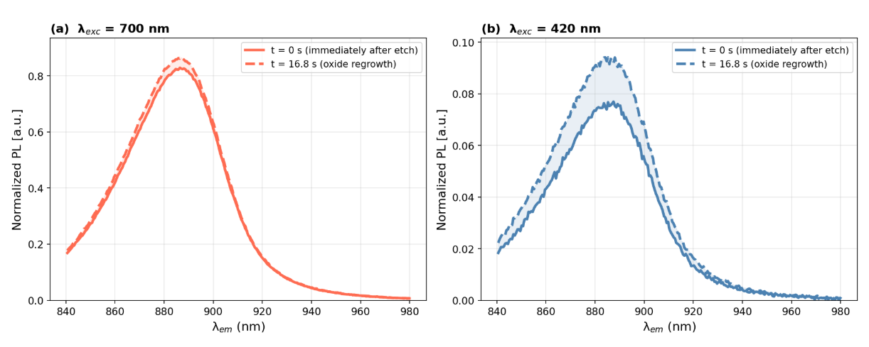
Figure 12 - PL intensity as a function of emission wavelength and at t = 0 s and t = 16.8 s for the two selected excitation wavelengths: $λ_{ex_sh}$ = 420 nm and $λ_{ex_dp}$ = 700 nm. The difference in PL amplitude between the two surfaces at each emission wavelength and scan forms the basis of the SRV index.
SELE at the surface is defined as the probability that a carrier generated there contributes to PL. Figure 13 shows the SRV index together with the surface SELE value Yeshurun et al. report for this same wet-etch experiment, both plotted against elapsed time across the 28 post-etch measurements. Over the 28 post-etch measurements, the SRV index decreases monotonically (Pearson r = −0.86 with elapsed time) while the SELE at the surface increases monotonically, following a logarithmic oxide-regrowth model. Both describe the same underlying process, and their opposing trends are consistent with one another.
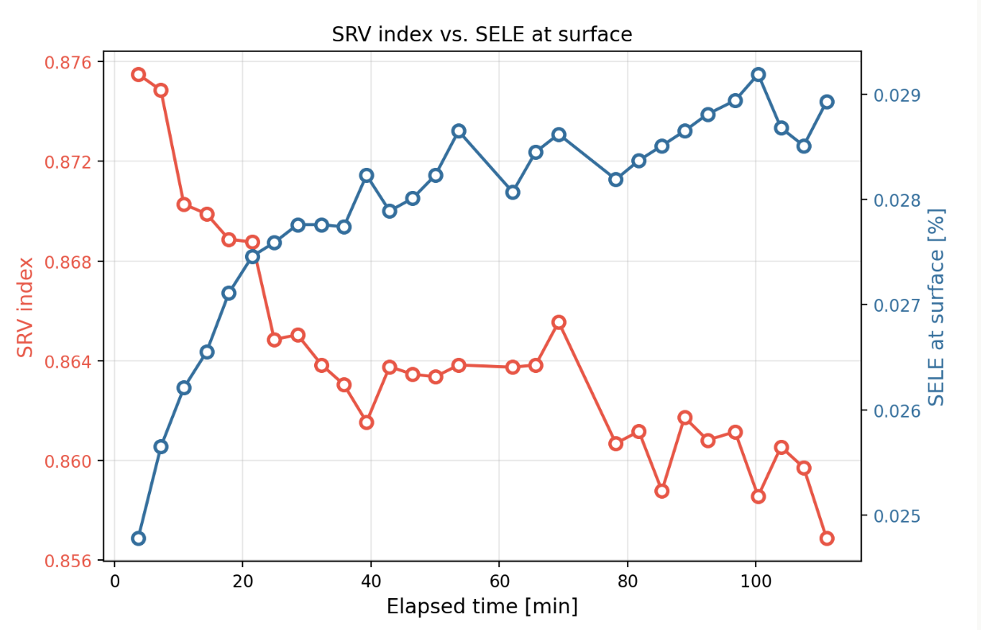

Figure 13 - SRV index and surface SELE value (Reproduced from ‎‎[18]) as a function of elapsed time after wet etching of a p-type GaAs wafer.

Extension to Thin Films
While the present work focuses on bulk wafers, thin-film solar cells are a natural next target for the method ‎[15]. The motivation goes back to the foundational treatment this thesis builds on: under a single steady-state measurement, a thin absorber’s efficiency is only sensitive to diffusion length once L becomes comparable to or shorter than the optical absorption depth 1/α [15]. A wavelength-swept measurement is best suited to exactly this regime, where one measurement alone can't pin down the material quality.
Two assumptions in the present model hold for bulk wafers but would break down for thin films. The first is that carriers are optically generated according to a simple exponential absorption profile, which holds when the film absorbs the incoming light before any of it reaches the back surface. In a thin film, interference between the incident and reflected light instead produces a generation profile that rises and falls with depth rather than decaying smoothly. The fit would then run against this closed-form generation profile in place of the exponential profile in a modified Eq. (18), with the same two-parameter search over Lₙ and A₁.
The second assumption is that photons generated deep in the sample are reabsorbed before they can reach the back surface, so only photon escape from the front surface needs to be considered. This is also where the present derivation departs from its own theoretical starting point. It imposes a surface recombination boundary condition at the front surface only, so back-surface recombination is not accounted for. It also treats the wafer as semi-infinite, so photon emission from the back surface is not considered. Both of these correspond to the thick-sample limit of Duggan and Scott’s original two-surface, finite-thickness problem [15]. Extending the treatment to thin films therefore requires reinstating the full two-surface formulation — both a two-surface boundary condition on the carrier concentration and a two-surface photon escape probability, since carriers and photons alike can reach either face. This two-surface treatment has already been used elsewhere to extract surface recombination velocity and diffusion length from measured photoluminescence in thin epitaxial layers [4],[10],[12],[13]. Several of the methods already discussed in the Introduction were developed for samples thin enough to require a two-surface treatment — Ito and Ishibashi [12], Scott et al. [13], and Baek et al. [5] all work in the same thin-film regime this extension targets. Each avoids a wavelength sweep by treating one of diffusion length or surface recombination velocity as a known input from an auxiliary photocurrent, lifetime, or doping measurement, and solving for the other; none recovers both quantities from a single optical measurement the way the present method does for bulk samples. Extending the closed-form, wavelength-swept fit developed here to thin films would offer that same single-measurement advantage — both parameters recovered together, without an auxiliary electrical or doping-dependent measurement — but at the cost of added model complexity: a thin film’s two surfaces and internal reflections require the closed-form two-surface generation profile discussed above, rather than the simpler single-surface treatment sufficient for the bulk case. The front-and-back photon-recycling optical model already built and used on this same experimental platform [16] could be adapted to provide the optical side of this extension, giving a natural next step for applying the present method to thin films.
Together, a numerically computed generation profile and a full two-surface treatment would let the same wavelength-swept fitting procedure developed here apply directly to thin absorbers. The SRV ranking method would require a similar adjustment: in a thin film, deep excitation generates carriers close enough to the back surface that the deep-excitation signal also reflects back-surface recombination, unlike in a bulk sample. This additional contribution would need to be accounted for to keep the ranking meaningful. Reflection- and transmission-mode measurements — short and long excitation wavelength from the front, and short and long excitation wavelength from the back — would separate the two surfaces experimentally.

Summary
The results from both materials and the post-etch experiment illustrate complementary aspects of what wavelength-dependent PL maps can reveal.
In both the InP and GaAs wafers, the PL intensity varies systematically with excitation wavelength, and this variation is well described by the analytical model through a single diffusion length. This agreement, obtained for two distinct materials using the same closed-form model, validates the model and the diffusion-length extraction method.
The post-etch GaAs experiment addresses a different goal: rather than extracting a bulk transport parameter, it uses the same wavelength-dependent PL measurement to track how the surface changes over time. Following the etch, the native oxide regrows gradually during the measurement series, and the SRV index decreases monotonically across consecutive scans in response. This trend is consistent with progressive surface passivation as the oxide forms, and demonstrates that the method can track surface dynamics in real time using a standard steady-state measurement.

References
- D. Baek, J. Lee, and B. Choi, “Diffusion length and resistivity distribution characteristics of silicon wafer by photoluminescence,” Mater. Res. Bull., vol. 58, pp. 157–163, 2014.
- D. Hinken, K. Bothe, K. Ramspeck, S. Herlufsen, and R. Brendel, “Determination of the effective diffusion length of silicon solar cells from photoluminescence,” J. Appl. Phys., vol. 105, no. 10, Art. no. 104516, May 2009.
- P. Würfel, T. Trupke, T. Puzzer, E. Schäffer, W. Warta, and S. W. Glunz, “Diffusion lengths of silicon solar cells from luminescence images,” J. Appl. Phys., vol. 101, no. 12, Art. no. 123110, Jun. 2007.
- J. Giesecke, M. Kasemann, M. C. Schubert, B. Michl, M. The, W. Warta, and P. Würfel, “Determination of local minority carrier diffusion lengths in crystalline silicon from luminescence images,” J. Appl. Phys., vol. 106, no. 1, Art. no. 014907, Jul. 2009.
- D. H. Baek, S. B. Kim, and D. K. Schroder, “Epitaxial silicon minority carrier diffusion length by photoluminescence,” J. Appl. Phys., vol. 104, no. 5, Art. no. 054503, Sep. 2008.
- J. Lagowski, A. M. Kontkiewicz, L. Jastrzebski, and P. Edelman, “Method for the measurement of long minority carrier diffusion lengths exceeding wafer thickness,” Appl. Phys. Lett., vol. 63, no. 21, pp. 2902–2904, Nov. 1993.
- R. Heilmann, G. Oelgart, R. Mitdank, and B. Jacobs, “Diffusion length determination on indirect-gap AlGaAs by means of microphotoluminescence,” Phys. Status Solidi A, vol. 123, no. 2, pp. 539–548, 1991.
- D. Baek, J. Lee, and B. Choi, “Surface recombination evaluation of a silicon wafer by using the photoluminescence intensity ratio method for solar cell applications,” J. Korean Phys. Soc., vol. 65, no. 3, pp. 336–341, Aug. 2014.
- D. Baek, S. Rouvimov, B. Kim, T.-C. Jo, and D. K. Schroder, “Surface recombination velocity of silicon wafers by photoluminescence,” Appl. Phys. Lett., vol. 86, no. 11, Art. no. 112110, Mar. 2005.
- O. M. Braga et al., “Investigation of InGaAs/InP photodiode surface passivation using epitaxial regrowth of InP via photoluminescence and photocurrent,” Mater. Sci. Semicond. Process., vol. 154, Art. no. 107200, Feb. 2023.
- K. Onuma et al., “Comparative study of surface recombination in hexagonal GaN and ZnO surfaces,” Appl. Phys. Lett., vol. 101, Art. no. 181605, 2012.
- K. Ito and T. Ishibashi, “Surface recombination velocity in p-type GaAs,” Jpn. J. Appl. Phys., vol. 33, no. 1, pp. 88–91, 1994.
- G. B. Scott, G. Duggan, P. Dawson, and G. Weimann, “A photoluminescence study of beryllium-doped GaAs grown by molecular beam epitaxy,” J. Appl. Phys., vol. 52, no. 11, pp. 6888–6894, Nov. 1981.
- K. Sahasrabuddhe, J. W. Schwede, I. Bargatin, J. Jean, R. T. Howe, Z.-X. Shen, and N. A. Melosh, “A model for emission yield from planar photocathodes based on photon-enhanced thermionic emission or negative-electron-affinity photoemission,” J. Appl. Phys., vol. 112, no. 9, Art. no. 094907, Nov. 2012.
- G. Duggan and G. B. Scott, “The efficiency of photoluminescence of thin epitaxial semiconductors,” J. Appl. Phys., vol. 52, no. 1, pp. 407–411, Jan. 1981 (Erratum, J. Appl. Phys., vol. 52, no. 9, p. 5873, Sep. 1981).
- T. Yeshurun, M. Fiegenbaum-Raz, and G. Segev, “Mapping losses through empirical extraction of the spatial external luminescence efficiency,” ACS Appl. Energy Mater., vol. 7, no. 15, pp. 6116–6122, Jul. 2024.
- P. Würfel, Physics of Solar Cells: From Principles to New Concepts. John Wiley & Sons, 2008.
- T. Yeshurun, "Mapping losses through empirical extraction of the spatial external luminescence efficiency," Ph.D. dissertation, School of Electrical Engineering, Tel Aviv University, Tel Aviv, Israel, 2026.

