Exercise 1:

1. IPv4 address: 65.8.134.9、65.8.134.89、65.8.134.70 和 65.8.134.47

what is the reason for having several IP addresses as an output?

This is similar to the Frequency Division Multiplexing mentioned in Lecture1

(FDM) has the same concept of resource allocation and utilization.

The output of multiple IP addresses is usually because the website

uses load balancing technology. Load balancing technology is used to

distribute network traffic to different servers to improve performance,

reliability, and scalability.

2.The name of IP address 127.0.0.1 is localhost.

What's special about this IP address is that it is the local loopback

address used to route network traffic back to the local computer.

Exercise 2:

www.google.co.uk Yes. We Can Ping.

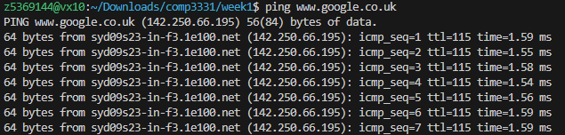

www.columbia.edu Yes. We Can Ping.

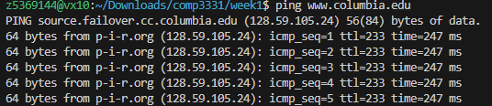

www.wikipedia.org Yes. We Can Ping.

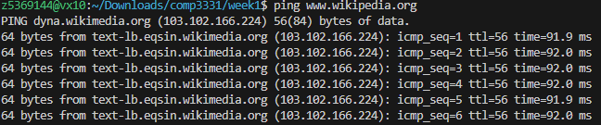

ec.ho No, we cant ping because Host/Web address does not exist.



hhh.gs Yes. We Can Ping.

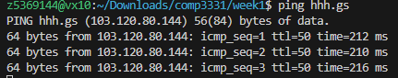

defence.gov.au No, we cant ping because firewall doesnt allow us to access.



yes.no Yes. We Can Ping.

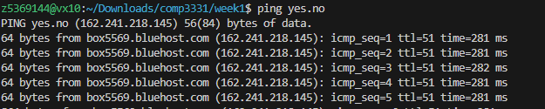

1. 一.一.一 No, we cant ping because Host/Web address is https://one.one.one.one/ (we can acess from web) not 一.一.一.一



theguardian.com Yes. We Can Ping.

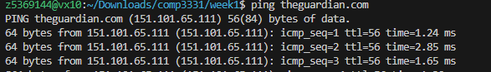

xn--i-7iq.ws Yes. We Can Ping.

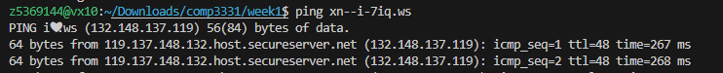

Exercise 3:

1.

1.

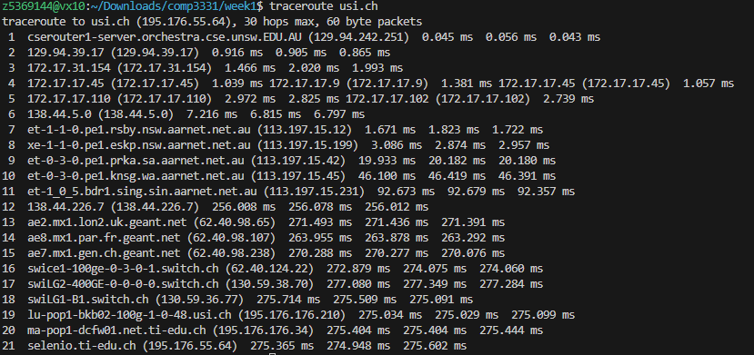

There are 21 routers between workstation and usi.ch.

There are 5 routers along the way that are part of the UNSW network. (we can use whois host command to check).

2. ae2.mx1.lon2.uk.geant.net (62.40.98.65) is the first router outside AU.

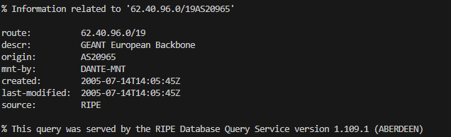

1. ae2.mx1.lon2.uk.geant.net (62.40.98.65) is the first router in Europe.





jhu.edu

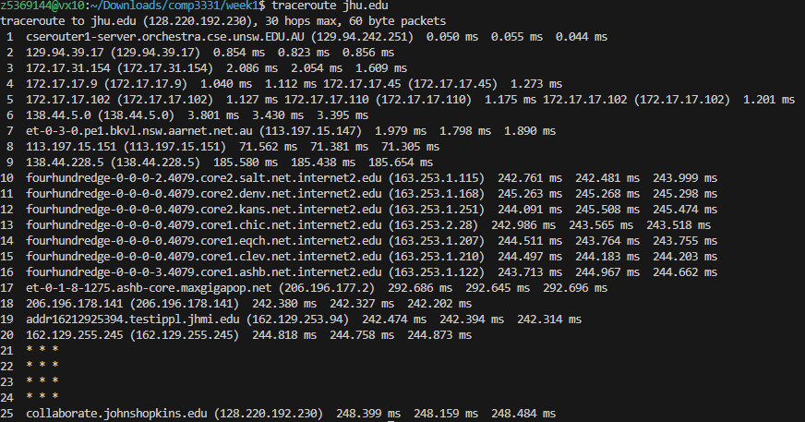

usp.br

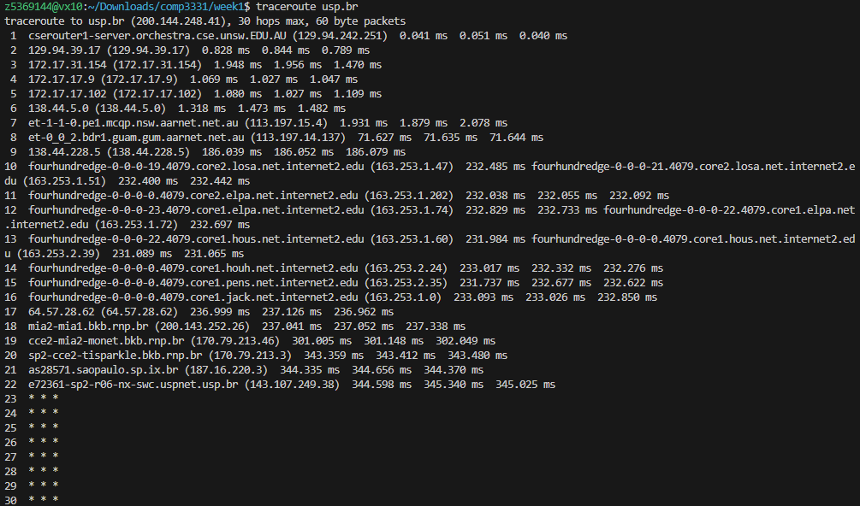

ed.ac.uk

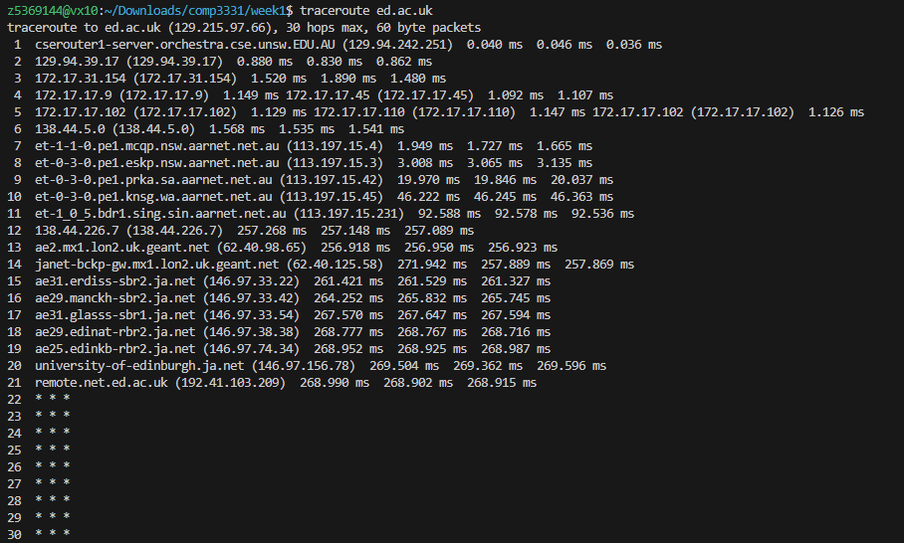

138.44.5.0

It’s Australian Academic and Research Network，AARNet 's IP address

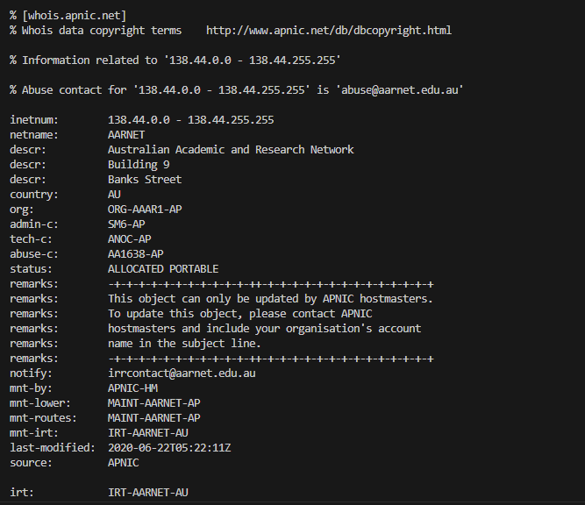

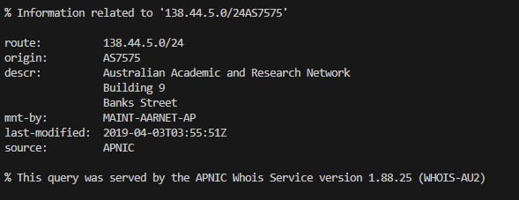

2. The relationship between hop count and physical distance is not a simple proportional relationship

Network topology, routing policies, traffic optimization and other factors will affect path selection,

so the relationship between hop count and physical distance is not linear. In some cases,

due to network optimization or other factors, the hop count may decrease rather than increase,

even as the physical distance increases.

3.

1. www.linkwan.com [www.telstra.net](http://www.telstra.net)

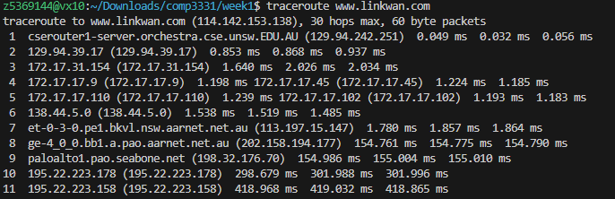

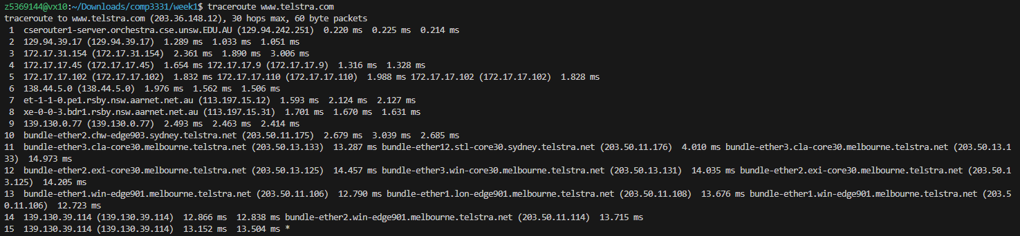

2. Both forward and reverse paths go through the same router node 138.44.5.0

3. The same IP address 138.44.5.0 was observed on both forward and reverse paths.

This indicates that packets pass through the same router nodes as they enter and leave your network.

Exercise 4:



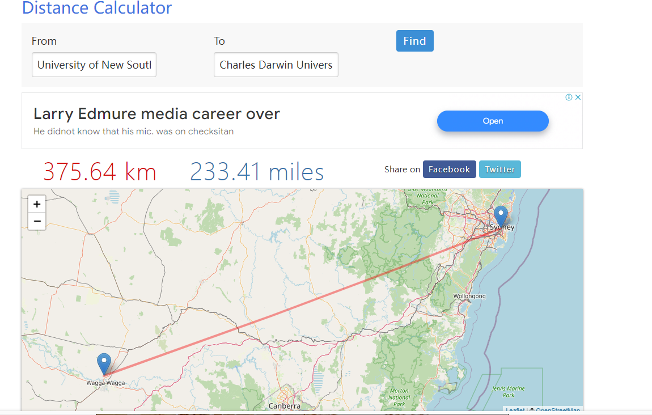

Physical distance from UNSW to Charles Darwin University, Darwin, Australia: 375.64 km 233.41 miles

time cost is : distance / speed of light = 375640 / (3*10^8) = 1.2521ms

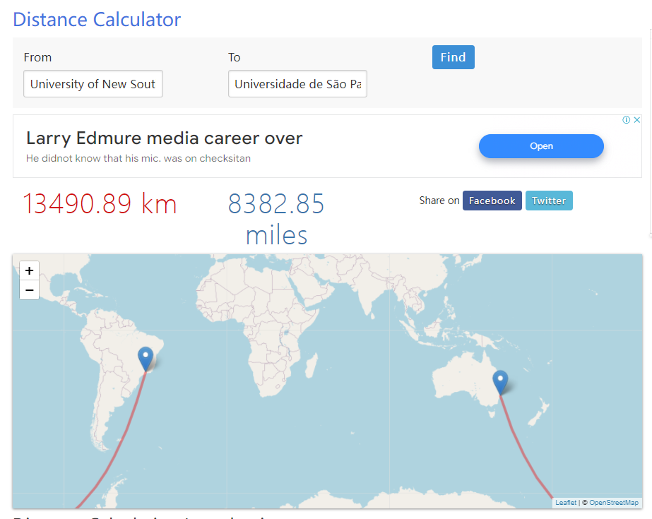

Physical distance from UNSW to Universidade de São Paulo (USP),Sao Paulo,Brazil: 13490.89 km 8382.85 miles

time cost is : distance / speed of light = 13490890 / (3*10^8) = 44.963ms

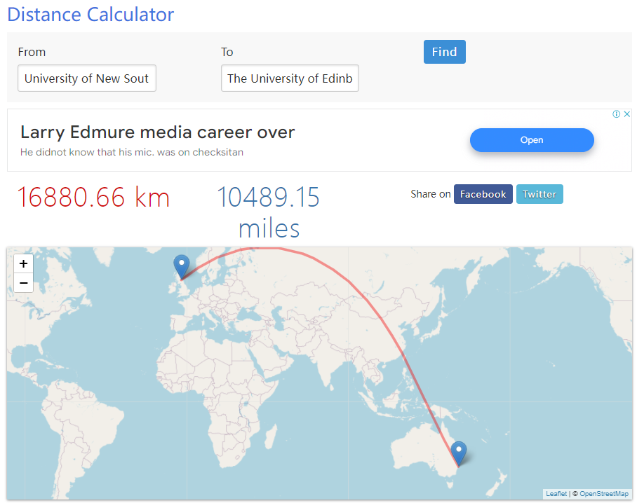

Physical distance from UNSW to The University of Edinburgh - Edinburgh, Scotland, UK: 16880.66 km10489.15 miles

time cost is : distance / speed of light = 16880660 / (3*10^-8) = 56.269ms

2.

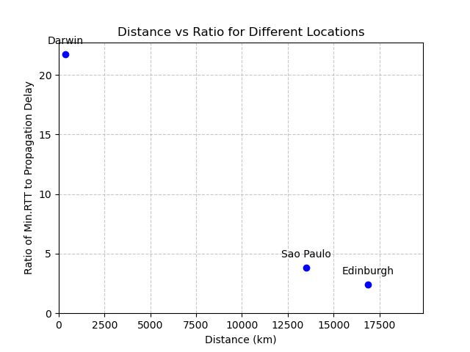

3. Network congestion: During times of high network load, packets may take longer

to reach their destination and return, resulting in increased latency.

Network routing selection: Data packets may pass through multiple routing nodes

during transmission. If the selected routing path is long or there is congestion,

the transmission time of the data packet will be increased.

4. Delays to destinations often vary over time.

Network congestion: When traffic in a network increases, such as during peak hours or during network outages,

packets may experience longer wait times to reach their destination.

Routing: Routers in a network may choose different paths to transmit packets based

on current network conditions. Some paths may be more efficient than others, while others may cause

increased latency.

5. depend on the packet size: Transmission Delay Processing Delay

not depend on the packet size: Propagation Delay Queueing Delay