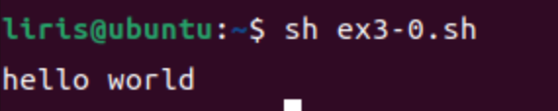

**코드**

#!/bin/sh

echo "hello world"

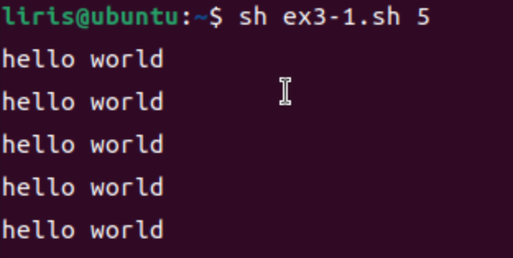

**코드**

#!/bin/sh

i=1

while [ $i -le $1 ]

do

echo "hello world"

i=$((i+1))

done

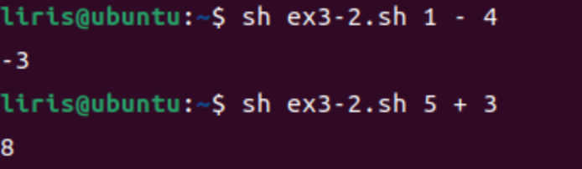

**코드**

#!/bin/sh

n1=$1

oper=$2

n2=$3

if [ "$oper" = "+" ]; then

result=$(expr "$n1" + "$n2")

elif [ "$oper" = "-" ]; then

result=$(expr "$n1" - "$n2")

fi

echo "$result"

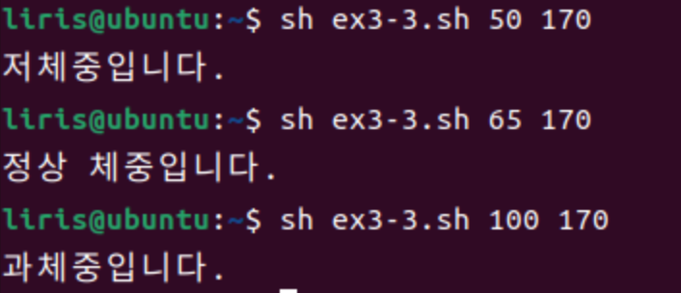

**코드**

#!/bin/sh

w=$1

h=$2

bmi=$(echo "scale=2; $w / (($h / 100) * ($h / 100))" | bc)

bmi_check=$(echo "$bmi < 18.5" | bc)

if [ "$bmi_check" -eq 1 ]; then

echo "저체중입니다."

else

bmi_check=$(echo "$bmi >= 18.5 && $bmi < 23" | bc)

if [ "$bmi_check" -eq 1 ]; then

echo "정상 체중입니다."

else

echo "과체중입니다."

fi

fi

exit 0

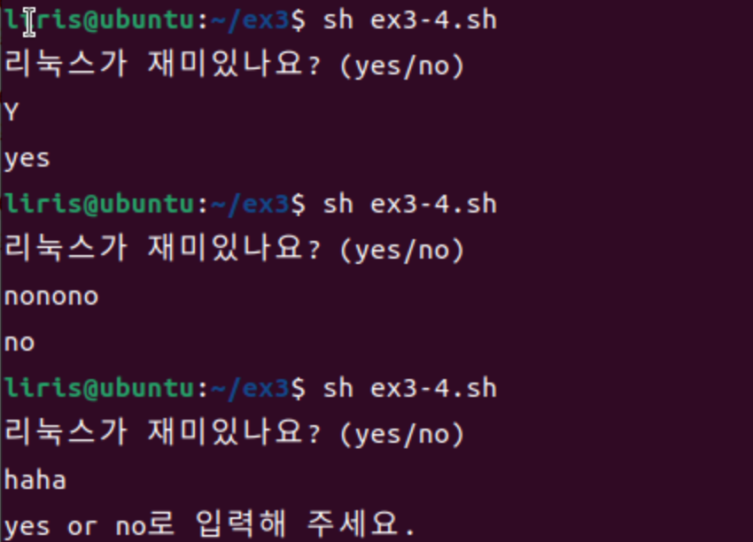

**코드**

#!/bin/sh

echo "리눅스가 재미있나요? (yes/no)"

read answer

answer=$(echo "$answer" | sed 's/\(no\)\+$/no/' | sed 's/\(yes\)\+$/yes/')

case $answer in

yes|y|Y)

echo "yes"

;;

no|n|N)

echo "no"

;;

*)

echo "yes or no로 입력해 주세요."

;;

Esac

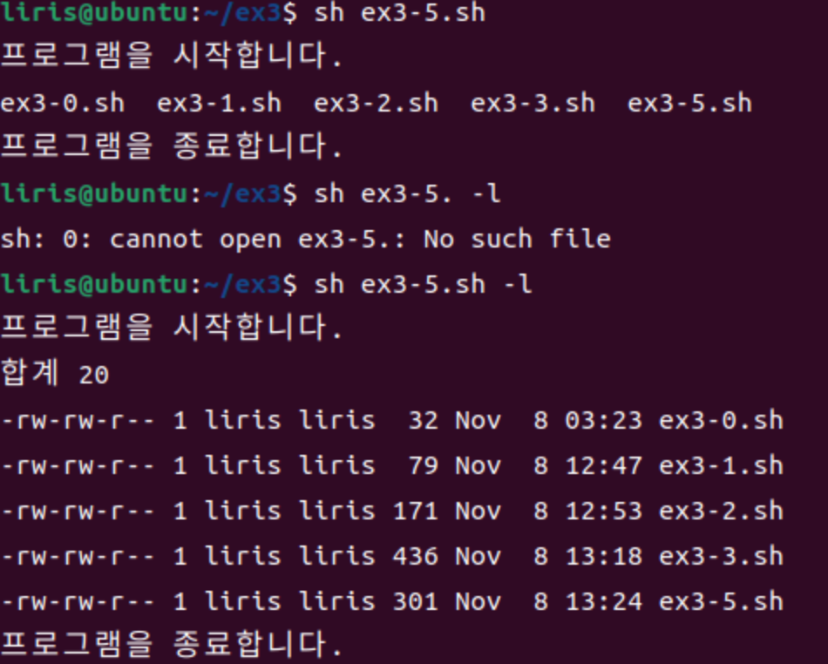 **코드**

#!/bin/sh

run_ls() {

echo "프로그램을 시작합니다."

ls $1

echo "프로그램을 종료합니다."

}

run_ls $1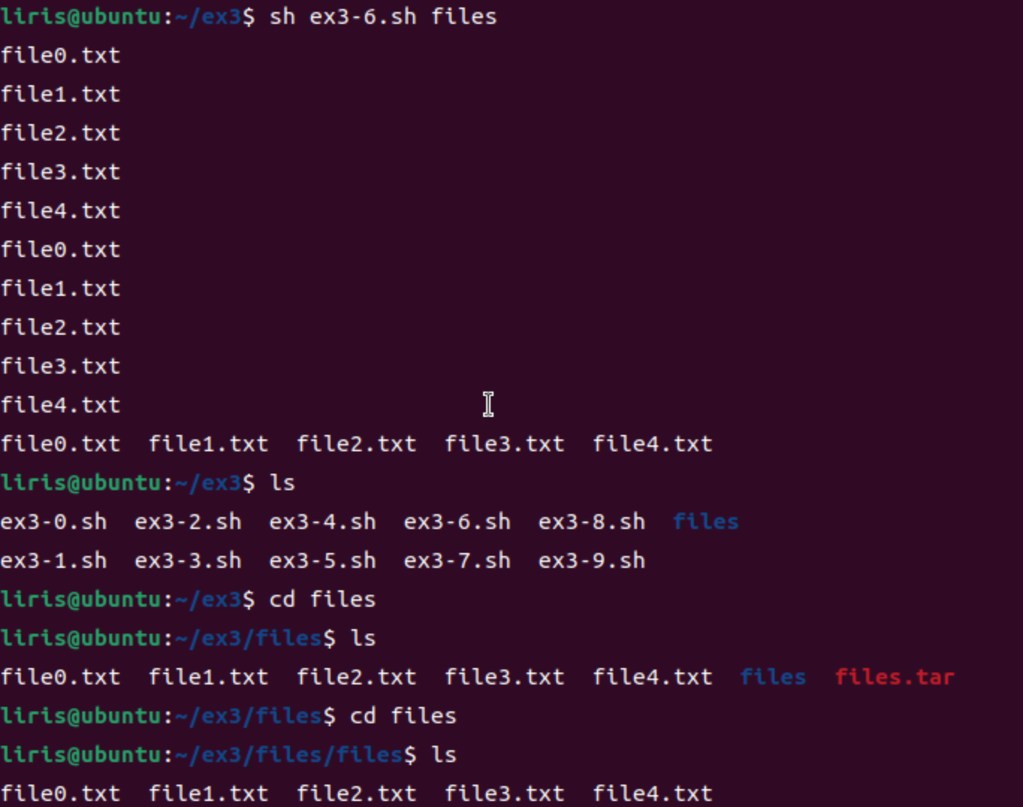

**코드**

#!/bin/sh

if [ ! -d "$1" ]; then

mkdir "$1"

fi

cd "$1"

touch file0.txt file1.txt file2.txt file3.txt file4.txt

tar -cvf files.tar file0.txt file1.txt file2.txt file3.txt file4.txt

mkdir files && tar -xvf files.tar -C files/

ls files/

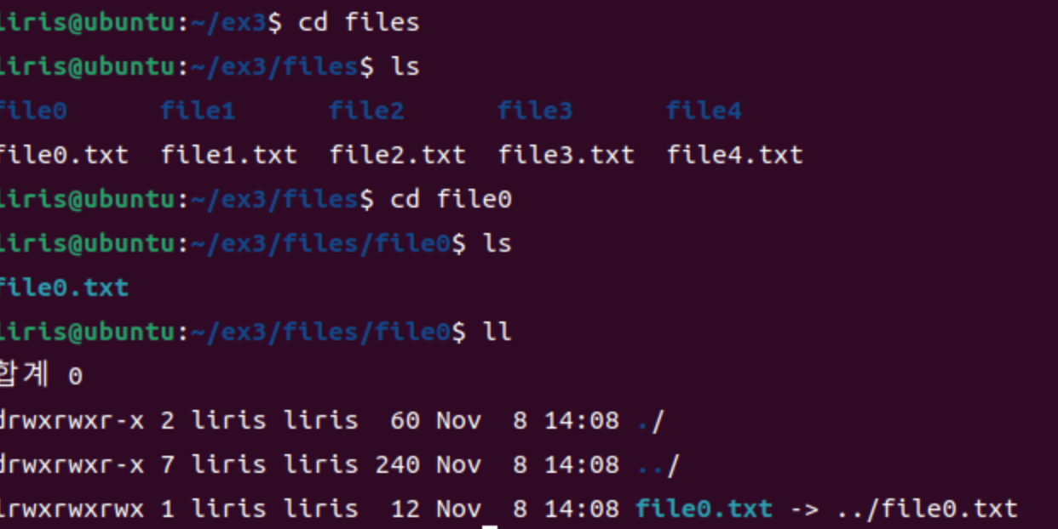

**코드**

#!/bin/sh

mkdir "$1"

cd "$1"

for i in 0 1 2 3 4; do

touch "file$i.txt"

done

for i in 0 1 2 3 4; do

mkdir "file$i"

ln -s "../file$i.txt" "file$i/file$i.txt"

done

ls -R

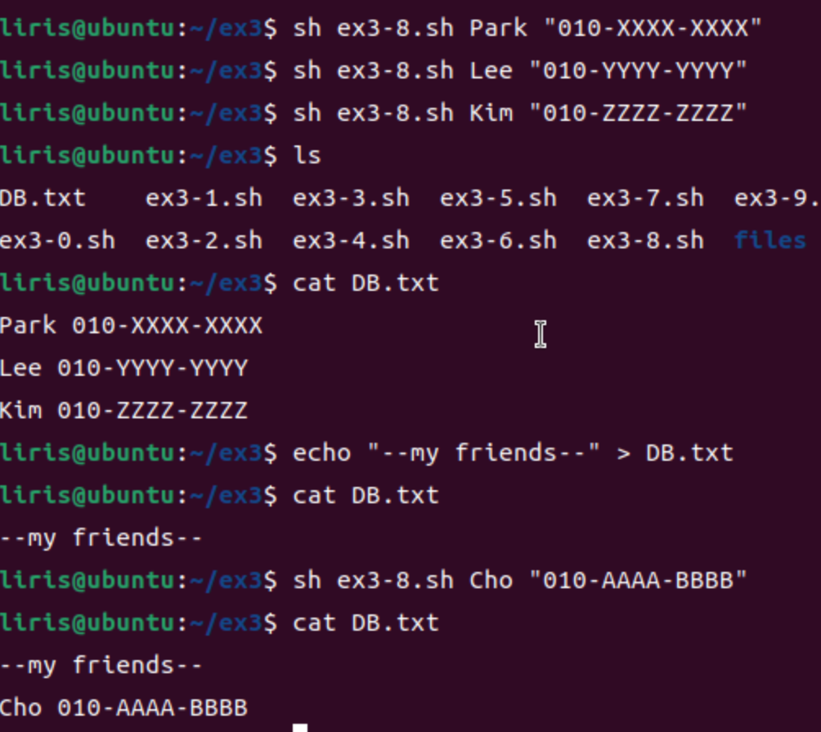

**코드**

#!/bin/sh

echo "$1 $2" >> DB.txt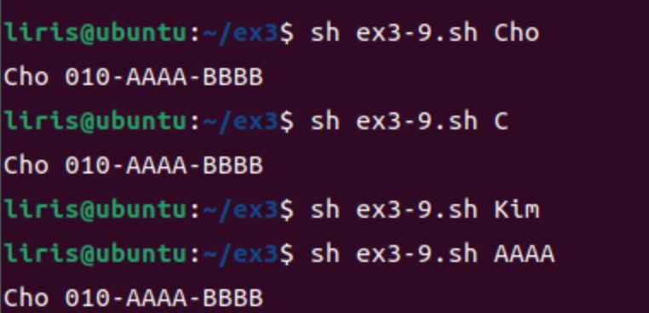

**코드**

#!/bin/sh

grep "$1" DB.txt