# SWOT Analysis for 404WEAR

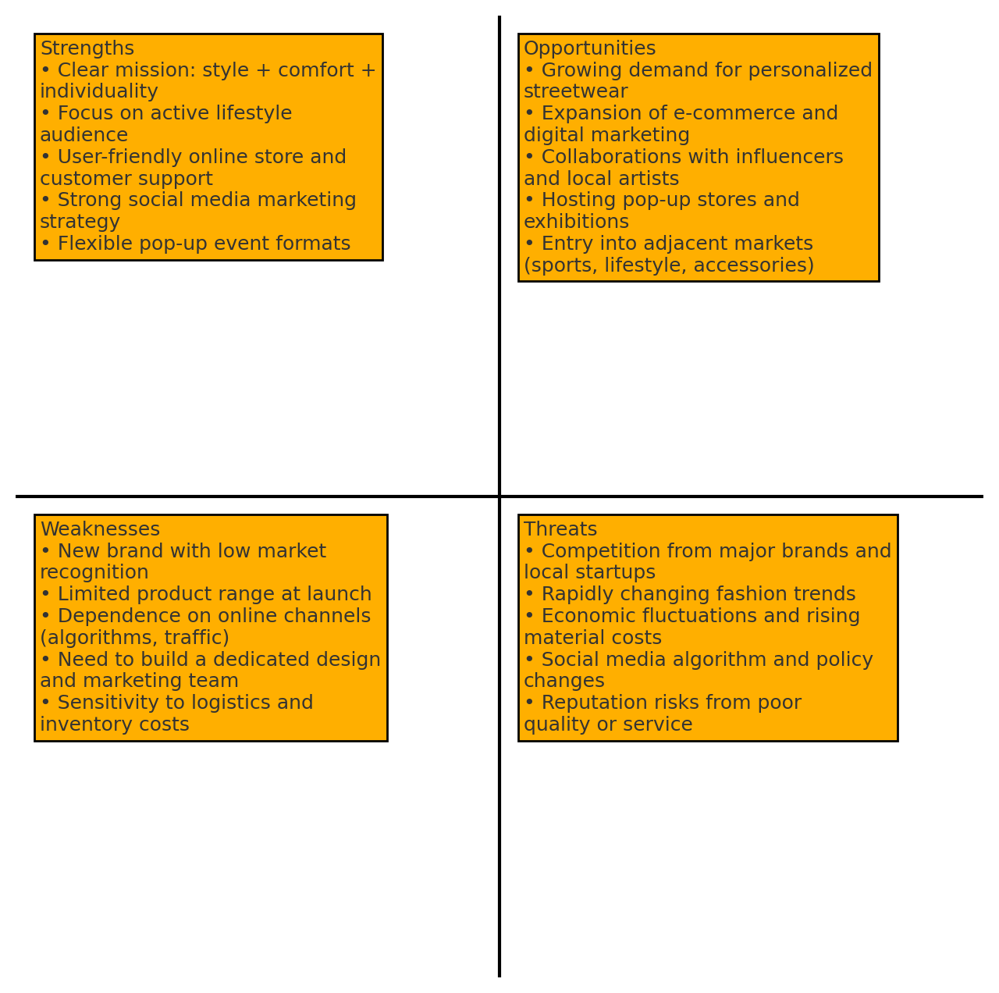

## Strengths

* Clear mission: style + comfort + individuality.
* Focus on active lifestyle audience.
* User-friendly online store and customer support.
* Strong social media marketing strategy.
* Flexible pop-up event formats.

## Weaknesses

* New brand with low market recognition.
* Limited product range at launch.
* Dependence on online channels (algorithms, traffic).
* Need to build a dedicated design and marketing team.
* Sensitivity to logistics and inventory costs.

## Opportunities

* Growing demand for personalized streetwear.
* Expansion of e-commerce and digital marketing.
* Collaborations with influencers and local artists.
* Hosting pop-up stores and exhibitions.
* Entry into adjacent markets (sports, lifestyle, accessories).

## Threats

* Competition from major brands and local startups.
* Rapidly changing fashion trends.
* Economic fluctuations and rising material costs.
* Social media algorithm and policy changes.
* Reputation risks from poor quality or service.

# Recommended Strategies

## SO Strategies

1. Promote the brand’s individuality through collaborations with local artists and influencers.
2. Launch limited capsule collections and pop-up events to emphasize uniqueness.

## WO Strategies

1. Expand product range with accessories and limited releases based on social media feedback.
2. Invest in SEO and targeted advertising to reduce dependence on organic reach.

## ST Strategies

1. Maintain high customer service standards to stand out against larger brands.
2. Use social media analytics to quickly adapt to platform algorithm changes.

## WT Strategies

1. Implement multi-stage quality control and flexible return policies to build trust.
2. Diversify market channels: develop offline touchpoints via strategic pop-ups in key cities.