**Creating Chess Variations  
Implementing Different Ways to Play Chess into a Standard Chess Program**

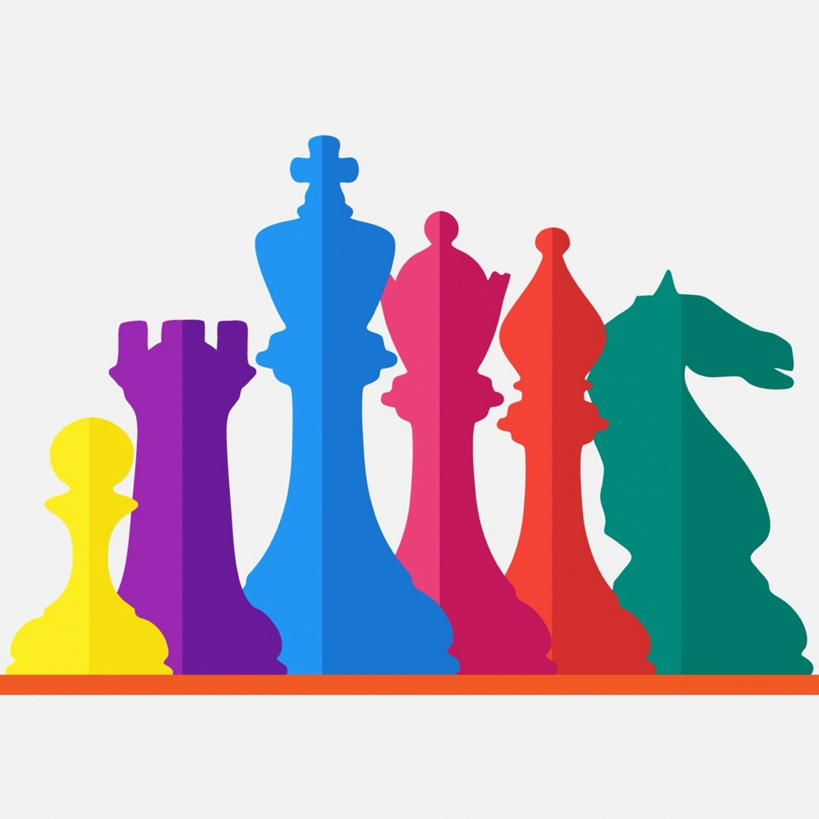

**Matura Paper, Kantonsschule Sargans**

Attila Vizhanyo, 4bNP

**Supervisor:**Herr Lukas Fehr

**Submitted on:**  
8 January 2024

# Preface

In the pursuit of finding a subject for my Matura project, my objective was to combine two of my passions: chess and computer programming.

I have been playing chess for an extended period. My grandfather first introduced me to chess when I was young. I was captivated by the strategic and tactical elements of chess.

My second interest is programming, also called coding. Despite not having much programming experience, I find it interesting for its logical way of thinking and clear structure. Subsequently, I was eager to enhance my coding skills with a suitable coding project.

My idea was to program different versions, or variations of chess by changing the rules of the original game. I was inspired by a website called chess.com that published such variations, and consequently I was excited to come up with my own ideas of ways to play chess. By changing the rules, my goal was to make chess more enjoyable for people who may not appreciate its strategic complexity and memorization.

I also took inspiration from a quote of the famous Chess Grandmaster Bobby Fisher, whose response was the following to an interview question:

Figure 1 Chess 960

Figure 1 Chess 960

„**Interviewer**: Why do you hate Chess? Being the be… probably, possibly, the best Chess player ever?

**Bobby**: Because I know what Chess all is about! It’s all about memorization. It’s all about pre-arrangement…” (algekalipso, 2022)

In this statement, Fisher emphasized that a significant part of playing chess revolves around memorizing the opening sequences. He heavily criticizes this aspect of the game because it does not involve creative thinking but rather focuses on recalling information. In response Fischer came up with an alternative way of playing chess, where the pieces on the first and last row are shuffled at random. Therefore, the player cannot prepare for the starting position.

This chess variant, known as Fischer Random Chess or Chess960, was introduced in 1996.

Fisher inspired me to mitigate the memorization aspect of the game and focus on creativity.

# Table of Contents

[Preface II](#_Toc155279394)

[Table of Contents III](#_Toc155279395)

[1 Introduction 1](#_Toc155279396)

[1.1 Objectives and Guiding Questions 1](#_Toc155279397)

[1.2 Procedure and Method 1](#_Toc155279398)

[1.3 Structure of the Paper 3](#_Toc155279399)

[2 Initial Chess Code 4](#_Toc155279400)

[2.1 Concepts 4](#_Toc155279401)

[2.1.1 Figure (or Piece) 4](#_Toc155279402)

[2.1.2 Chessboard 6](#_Toc155279403)

[2.1.3 Position 6](#_Toc155279404)

[2.1.4 Turn 7](#_Toc155279405)

[2.1.5 Capture 7](#_Toc155279406)

[2.1.6 Check 7](#_Toc155279407)

[2.1.7 Checkmate 7](#_Toc155279408)

[2.2 Overview 8](#_Toc155279409)

[2.3 Control Flow 10](#_Toc155279410)

[2.3.1 Error Handling 10](#_Toc155279411)

[2.4 GUI 11](#_Toc155279412)

[2.4.1 Overview 11](#_Toc155279413)

[2.4.2 Visualization of pieces 11](#_Toc155279414)

[2.4.3 Visualization of the chessboard 12](#_Toc155279415)

[2.4.4 Update screen before the move 13](#_Toc155279416)

[2.4.5 Update screen after the move 13](#_Toc155279417)

[2.5 Function catalog 14](#_Toc155279418)

[3 Color Chess 15](#_Toc155279419)

[3.1 Rules of Color Chess 15](#_Toc155279421)

[3.2 Implementation of Color Chess 16](#_Toc155279422)

[4 Chaotic chess 18](#_Toc155279423)

[4.1 Rules of chaotic chess 18](#_Toc155279426)

[4.1.1 Rules for Barrier 19](#_Toc155279427)

[4.1.2 Rules for Shield 19](#_Toc155279428)

[4.1.3 Rules for Coin 20](#_Toc155279429)

[4.1.4 Rules for Bomb 20](#_Toc155279430)

[4.2 Implementation of Chaotic Chess 21](#_Toc155279431)

[4.2.1 Overview 21](#_Toc155279432)

[4.2.2 Common code for items 21](#_Toc155279433)

[4.2.3 Barrier 23](#_Toc155279434)

[4.2.4 Shield 24](#_Toc155279435)

[4.2.5 Coin 24](#_Toc155279436)

[4.2.6 Bomb 24](#_Toc155279437)

[5 Summary 25](#_Toc155279438)

[Bibliography IV](#_Toc155279439)

[Table of Figures V](#_Toc155279440)

[Appendix VI](#_Toc155279441)

[A. Appendix 1 VI](#_Toc155279442)

[B. Appendix 2 VII](#_Toc155279443)

[C. Declaration of Authenticity VIII](#_Toc155279444)

# Introduction

## Objectives and Guiding Questions

With my project I aim to develop two games that are variations of the original chess game. The variations I came up with are called “Color Chess” and “Chaotic Chess”. The rules of these games are described later in this paper.

I will write a program for each of these game modes, utilizing an existing standard chess code as a foundation. The programs need to check that the players’ moves are legit i.e. do not break the rules of the game. This in turn requires computation of the valid moves for each chess piece.

The gameplay of the program should visually be represented using a GUI.

In general, chess programs come in two different forms: either they allow two players to play against each other, or one player to play against the computer. I chose the two-player model to avoid having to implement a chess engine capable of generating moves, which would be beyond my skills and experience.

## Procedure and Method

To realize the project, I took an existing chess program, and extended with additional functionality to implement the required rules of the chess variations.

First, I needed to choose a programming language for my project. Since I had little prior knowledge about programming, I opted for an easy to understand yet powerful programming language. Python is one of the most well-known programming languages, commonly used for many different applications, such as web development (server-side), desktop software development, mathematics, system scripting, etc. I started learning Python using a tutorial video I found on YouTube (Bro, 2021). The author explains the basic features of Python and reinforces the information with step-by-step projects. In addition, I also found it helpful to go through the Python Tutorial provided by W3 Schools (Data, Default, s.d.).

Next, I needed to find a chess program written in Python, which I could understand well and extend easily to create new chess variations. I found my way over to GitHub where thousands of programmers share their code with the world. After looking through dozens of chess programs, I finally found one which was easy to extend and covered my requirements (j00nas, 2020).

I decided to manage the source code of my project in GitHub. Using a version control tool, such as GitHub has many benefits: branching and merging for parallel development, detailed code history for tracking changes, and issue tracking for efficient project management. Program source files in GitHub are stored in so called repositories. I have created two new repositories for my project: one repository for each chess variation and imported the original chess code in each one. Now I was ready to make modifications to the original program code and store each developed version safely in the cloud during the entire course of the project.

Figure 7 GitHub Chaotic Chess History

Next, I needed to choose a development environment. Visual Studio Code (or simply Code) is a free integrated development environment, and I have made good experience with this tool previously in the school. It supports a wide range of programming languages with loads of extensions. Specifically, to use Code with Python, the Python extension must be used. I needed to install this Python extension, and the Python interpreter separately. Now I was ready to develop programs in Python, debug and execute the developed programs on my notebook, and also inspect my changes before committing and pushing them to the GitHub repository.

Figure 8 Debugging in VsCode

However, I needed to fully understand the original program code before making any changes. When I first inspected the code, it appeared very unclear and was difficult to understand. It contained a lot of variables and functions with a lot of code inside of them. To fully understand the program, I had to go line by line and understand what each variable and function is good for. This took me a long time since the code was written by a more experienced Python developer. Eventually I started understanding the code better and I got ideas how I could adapt it to my needs.

For example, I made use of modules to encapsulate all data and functionality that are logically related in separate source code files. I started with the implementation of one item, the Shield, by creating a module called *shield.py*, and implemented its functionality step-by-step. After several coding and testing iterations, I have managed to make the Shield work completely, and committed the changes to the GitHub repository. I repeated this process for the rest of the items in the same iterative manner. Using modules and developing in small program increments at a time allowed me to limit my attention to a small portion of the whole program, which greatly helped manage the increasing number of interactions in the program.

I made the figures illustrating the various chess positions with the help of chess.com.

## Structure of the Paper

In this paper I will discuss two chess variations that I invented. To implement these variations, I took an existing standard chess program and extended them.

[Chapter 2](#_Initial_Chess_Code) explains the logic and the key concepts used in the standard chess program. It also describes how the game is visualized on the screen.

[Chapter 3](#_Color_Chess) starts with an explanation of the first variation, called “Color Chess”. It continues with description of the implemented solution, i.e. how the rules of the games have been implemented into code.

[Chapter 4](#_Chaotic_Chess) covers the second variation, called "Chaotic Chess". Similarly, to the previous chapter, the first part covers the rules of the game, while the second part focuses on the implementation.

[Chapter 5](#_Summary)

…Bibliography, List of figures, appendix.

# Initial Chess Code

## Concepts

In software engineering, various programming constructs are used to model real world objects, their behavior, and the relationships between them. Programs make use of abstractions to represent the inherent concepts (i.e. “things”) of the problem domain in which they operate. In the context of this paper, the problem domain is that of the chess game, thus the program works with those concepts inherent in chess.

A chess set consists of black and white chess *pieces* and a *chessboard* (hereafter simply referred to as the *board*). Keeping track of the progress of the game requires knowing the *position* of each piece and their *possible moves* in each *turn*, according to the rules of chess. This in turn requires recognizing if a piece has been *captured*, and whether the king has been attacked (*check*). Finally, it must be detected if the king cannot escape the check (*checkmate*).

### Figure (or Piece)

The first key concept that needs to be modeled in any chess program is the concept of the chess pieces, also called the figures. There are sixteen pieces of each color, black and white: one king, one queen, two rooks, two bishops, two knights, and eight pawns. Each piece has a type and a position. Each piece has a defined starting position at the beginning of the game. During the game, the players move the white and black pieces in alternate turns, thus the position of the pieces need to be updated. The pieces can move to a square that is either unoccupied or occupied by the opponent’s piece. Each figure needs to know which squares it can move to, based on its type.

In the program, the pieces are modeled with the Figure class.

„A Class is like an object constructor, or a "blueprint" for creating objects.” (Data, Python Classes, s.d.)

|  |  |  |
| --- | --- | --- |
| Member name | Description | Example |
| name | Represents the type of the figure. | WB |
| object\_name | Unique identifier of the figure. | B1 |
| color | Black or White |  |
| position | The current position of the piece on the board (zero-indexed). | e.g. (0,4) – see Section 0 |
| possible\_moves | The positions to which the piece can move. |  |

The following table describes the valid names (i.e. types), counts (i.e. how many objects of that type exists in the program) and the associated object names:

|  |  |  |  |
| --- | --- | --- | --- |
| Figure Name | Description | Count | Object Names |
| WB | White Pawn  (German: Weisser Bauer) | 8 | B1,B2,B3,B4,B5,B6,B7,B8 |
| WT | White Rook (German: Weisser Turm) | 2 | T1,T2 |
| WS | White Knight (German: Weisser Springer) | 2 | S1,S2 |
| WL | White Bishop (German: Weisser Läufer) | 2 | L1,L2 |
| WD | White Queen (German: Weisse Dame) | 1 | D1 |
| WK | White King (German: Weisser König) | 1 | K1 |
| BB | Black Pawn  (German: Schwarzer Bauer) | 8 | B9-B16 |
| BT | Black Rook (German: Schwarzer Turm) | 2 | T3,T4 |
| BS | Black Knight (German: Schwarzer Springer) | 2 | S3,S4 |
| BL | Black Bishop (German: Schwarzer Läufer) | 2 | L3,L4 |
| BD | Black Queen (German: Schwarze Dame) | 1 | D2 |
| BK | Black King (German: Schwarzer König) | 1 | K2 |

The pieces are laid out on the chess board the following way:

Figure 9 The name of the pieces

In summary, while using the *name* enables the developer to compose logic that depends on the type of the figure, the *object\_name* enables him to reference individual figures unambiguously by a unique name.

### Chessboard

Chess is played on a square board of eight rows and eight columns. The board is divided into 64 fields, also called squares.

In the program the squares are represented by buttons. Using a grid, the buttons are aligned in the structure of the eight-by-eight board.

### Position

The squares of the board and the chess pieces are both arranged into an eight-by-eight grid. However, while the square positions use one-based indexing for the rows and columns (1..8), the pieces use zero-based indexing (0..7). So, when comparing the two grids, one must be subtracted from the row and column position of the squares to correspond to the position of the pieces.

Figure 10 Squares use one-based indexing

Figure 11 Pieces use zero-based indexing

Finally, the buttons representing the squares also have names. These button names are consistent with the names of the squares, as defined in chess, e.g. “a8”.

Throughout the program, conversion routines are used to convert between the various position representations:

1. From square position to piece position, and vice versa. E.g. (6,4) 🡨🡪 (5,3)
2. From square position to button name, and vice versa. E.g. (6,4) 🡨🡪 “d3”

### Turn

In the game of chess, each player makes a move one after each other in alternate turns.

Turn is a variable that the program uses to determine which player is making the next move. This variable is important to check whether the move played is legitimate. The turn variable can be set to “W” (for white) or “B” (for black). If a legit move has been played, the Turn must change to the other value. If the player does not make a valid move, the program must not change the value of this variable.

### Capture

When a figure has been captured in chess it is removed from the broad.

In the program, captured pieces are given the position (-1,-1). The user can no longer interact with pieces that are in this position, and they are not considered in further interactions during the game.

### Check

A check is given when a piece directly attacks the king. If the program finds a legit move that can capture the king with the next move, it detects a check. When a player is in check, they are asked to play a move that escapes the check.

### Checkmate

Once a king is in check and the program cannot find a legitimate move to escape the check, it is checkmate, and the game is over.

## Overview

This section provides a general model of the standard chess game process.

First, the board and the pieces are initialized in a preparation step. Then, the program waits for input from the user. The white player needs to make the first move by selecting a white piece on the board. The program checks if the user selected a white piece – if not, the user is asked to try again. Next, the user is asked to select a square to which they would like to move their piece. If the piece is allowed to move to the selected square according to the rules of chess, the move is granted, otherwise the user needs to start again and select a piece. Then, the program updates the position of the selected piece. If the selected square was occupied by an opponent piece, it will be removed from the board. The program then calculates the possible moves of every piece on the board and verifies the check and checkmate conditions. In case of checkmate, the game ends. Otherwise the turn is switched to black, and the process starts again. This process continues by alternating the turn until one checkmate is detected.

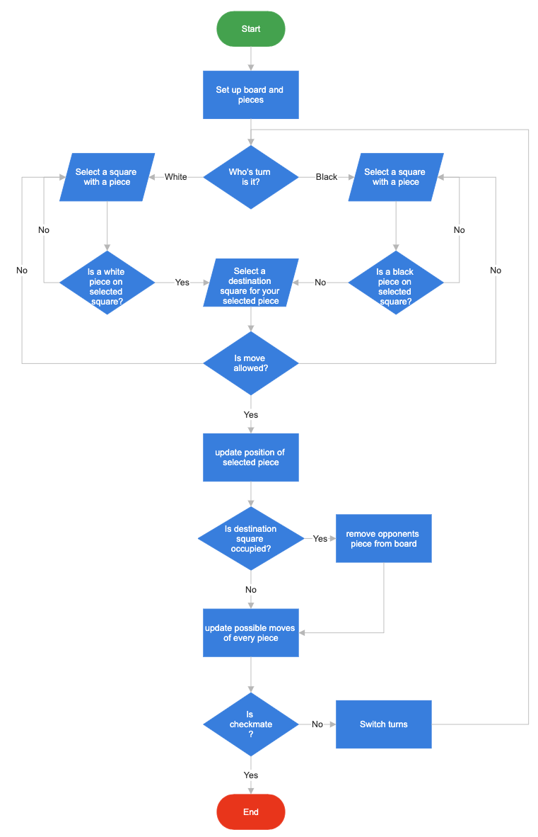

Figure 12 Inital Chess Code Process

## Control Flow

Figure 13 Process of functions

The entire chess program is operated from the main function. This function is responsible for executing the program in the correct sequence, by calling every other function.

Get\_positions function is called at first. This function gets the correct position index of both white and black pieces ([See positions](#_Position)). It also examines the positions of both kings.

Check\_if\_move\_legit determines if the selected piece can move to its chosen destination square.

Checkinput is the next function that is called. It examines if the provided move puts the player in check. Therefore it needs to include the positions of the king, to decide if a move is legal.

Check\_chosen\_move…

Check\_if\_move\_legit…

Figure.update\_position

Figure.return\_position…

Figure.update\_possible\_moves is tasked with calculating every move that can be played from the newly created chess position.

### Error Handling

A well-written code must deal with its errors. If an error occurs, the program freezes and the user can no longer interact with it. This leaves the user with no idea what caused the problem. To prevent this, the original chess code introduces a variable called “error”. This variable is used to tell the user what problem occurred while interacting with the program. The program continues to run and since the user is informed about the problem, he can avoid it. The error variable can have one of the following four values:

1. the provided move was invalid.
2. the game is over.
3. the king is in check.
4. there is a checkmate.

## GUI

### Overview

To display the current position of the board a GUI is used. Through this GUI, the user can submit his move, by clicking on the corresponding squares.

„A graphical user interface (GUI) is a digital interface in which a user interacts with graphical components such as icons, buttons, and menus. In a GUI, the visuals displayed in the [user interface](https://blog.hubspot.com/website/ui-design?hubs_content=blog.hubspot.com/website/what-is-gui&hubs_content-cta=user%20interface" \t "_blank) convey information relevant to the user, as well as actions that they can take.” (Juviler, 2023)

The program uses Tkinter for visualization of the board and the pieces.

„Tkinter is an open source, portable graphical user interface (GUI) library designed for use in Python scripts.” (Dufour, s.d.)

A library is code written by other people that you can import and use in your program. One can create an graphical element by simply using a class in the tkinter library. For instance, to create a button, use the Button class and define its properties.

In the guide that I used to learn Python, I have already met this library, so it was relatively straightforward to use it in my code.

Figure 14 GUI of chess program

### Visualization of pieces

The symbols of the pieces are represented with Unicode Characters.

“Unicode is a universal character set that defines all the characters needed for writing the majority of living languages in use on computers.” (Data, Charsets, s.d.)

Chess symbols are part of Unicode. In the program, the Unicode characters are stored within string variables. Every identical chess piece of the same color has the same Unicode. Therefore, a total of twelve Unicode characters were needed to visualize all black and white pieces: pawn, knight, bishop, rook, queen and king, for both colors.

To put a chess piece on a square, the underlying button text must be configured with the Unicode character of the piece.

Figure 15 '|u265C' Unicode character for a black rook

BR = '\u265C'

a8 = Button(tk, text=BR, font='Times 20 bold', bg='white', height=2, width=5, command=lambda: [btnClick(a8), btnID('a8')])

### Visualization of the chessboard

The chessboard is made up of an eight-by-eight field of squares. A square on the board is represented by a button in the program. “A button is a tk widget which is designed for the user to interact with, i.e. if the button is pressed by mouse click, some action might be started. They can also contain text and images like labels.” (Klein, 2022). A grid is used to arrange the buttons horizontally and vertically into a table format, where each button has its own coordinates. Each button is stored in a variable. To create a button, a class named “Button” from the tkinter library is used. To display our button on the board, we must attach it to the grid by specifying its row and column.

a8.grid(row=1, column=1)

In chess the squares of the board are colored in gray and white tile pattern, as shown in Figure 12.

To represent the pattern, the program assigns a background color of either white or gray to the relevant squares when the buttons are set up.

Button(tk, bg='white') or Button(tk, bg='grey')

Figure 16 Chess board set up by buttons

### Update screen before the move

The program displays the possible moves of the selected piece so that the player can see which moves are available for that piece. The available moves are visualized by placing green dots on each valid target square. This is implemented by setting the text of the buttons representing the valid target squares with the Unicode character of the dot.

Figure 17 Visualization of available moves

### Update screen after the move

After the move has been validated, the selected piece is moved to the target square, and the program displays the updated board. Displaying the move is implemented in two steps:

1. Clear the text of the button representing the source square (where the piece is moving away from)
2. Set the text of the button with the figure symbol representing the target square (where the piece is moving to)

It is necessary to save the text of the source button when the user selects a piece, so that the program can reference this text in the second step when setting the text of the target button. The program saves this text in a dedicated program variable, called…

## Function catalog

„A function is a block of code which only runs when it is called. You can pass data, known as parameters, into a function. A function can return data as a result.” (Data, Python Functions, s.d.)

|  |  |
| --- | --- |
| Function Name | Description |
| btnClick |  |
| undo\_coloring | Inverts the highlighting of squares that can be moved to when a figure is selected. |
| btnClick |  |
| btnID |  |
| main | Regulates the entire process of the chess program, besides setting up variables, buttons and the pieces. |
| update\_position |  |
| convert\_to\_figure\_position | Subtracts one from the row and column of the coordinate |
| check\_if\_move\_legit |  |
| update\_all\_possible\_moves | Use the current board to see which moves can be played according to the rules of chess. |
| Try\_helping\_white\_king\_in\_check |  |
| checkinput | Checks whether the move played puts the player who made the move in check. |
| check\_chosen\_move |  |
| print\_board | Prints the current state of the board to the terminal. |
| get\_position | Stores position of each piece on the board. |

# Color Chess

Figure 18 GUI Color chess

## Rules of Color Chess

In Color Chess, players are assigned an individual color. When their chess pieces move to a square, that square is highlighted with the player's distinctive color. The goal of the game is to color in more squares with your own color than your opponent does with theirs. Only occupied squares are colored. If a piece moves away from a square, the square remains colored. If a piece captures the opponent’s piece, it will overtake its color. Since each game of chess starts with the same position, the first two rows on each side will be colored in at the beginning. The game ends after 30 moves. The player who has colored in more squares during this period wins. Alternatively, victory can be attained by checkmating the opponent within these 30 moves.

Figure 19 Starting position in Color Chess

Figure 20 Capturing pieces in Color Chess

## Implementation of Color Chess

At the start of the game, the user is asked to choose two different colors from a color panel. These two colors are then stored within variables. The first color selected is used to color the squares where the white pieces move to, and the second color is used for the black player.

Afterwards, the starting position of color chess is set up [see figure 7]. Chess always begins with the same setup: white pieces on rows one and two, and black pieces on rows seven and eight. Coloring the squares on the board at the start is implemented the following way:

* If a button is in row one or two, set its background to white’s color.
* If a button is in row seven or eight, set its background to black’s color.
* Otherwise, leave the button background unchanged.

Next, I needed to make sure that the squares on which the pieces move are colored with the right color. Using “button.config” once again, I can color the selected square. To determine which player is making the move, I created a variable that counts the turns. The turn variable I set to zero at the beginning and increases by one after every legitimate move. So, if the number of the count of turns is odd the blacks color is used. If it is even, whites color is used to color in the squares.

To display the score on the screen the Label class in the tkinter library is used. This Label requires two variables to show the score: The score of white and the score of black.

The following cases can occur if a piece moves to a square:

|  |  |  |
| --- | --- | --- |
| Condition | Own Score | Opponents Score |
| The piece moves to an uncolored square | +1 | +0 |
| The piece moves to his own-colored square | +0 | +0 |
| The piece moves to opponents colored square | +1 | -1 |

To determine what color square the piece steps on, we can use “endbutton\_color". The endbutton\_color is the color of the square the user wants to move his piece to.

Since I only want the coloring and scoring the happen if the move was legit, I put everything within the condition of check\_chosen\_move.

Here is the code from white’s side:

if check\_chosen\_move(startbutton\_position, endbutton\_position):

      if count\_turn % 2 == 0:

        if endbutton\_color == "white" or endbutton\_color == "grey":

          WHITE\_SCORE += 1

        elif endbutton\_color == BLACK\_COLOR:

          BLACK\_SCORE -=1

          WHITE\_SCORE += 1

        endbutton\_color = WHITE\_COLOR

      count\_turn +=1

To display the round that have been played so far, I created a Label that displays the count\_turn variable as a string.

I implemented a newly create variable called “count\_turn”. This variable is needed to end the game after a maximum of 40 moves have been played. That is why it is also convenient to use this variable to check which player made the move.

# Chaotic chess

Figure 21 GUI Chaotic chess

## Rules of chaotic chess

Chaotic Chess introduces four different types of items that appear randomly on the board and the pieces can pick up, granting the pieces special abilities. To make the game balanced, the items are equally distributed on empty fields on the white side (rows one to four) and on the black side (rows five to eight). A piece can pick up an item by stepping on the square occupied by the item.

The four items are called the bomb, the shield, the coin and the barrier. At the beginning of the game, there are no items on the board. After the first move, two shields appear on the board – one shield on the white side, and one shield on the black side. After the second move, two bombs appear. After the third move, tow coins appear. After the fourth move, two barriers appear. Afterwards the items change their positions every four rounds, successively until the end of the game. The game ends if either king is in checkmate.

Through the progression of the game, the items appear in the following sequence with two moves appart: shield, bomb, coin, barrier. All items remain in their position for four rounds, after which they change their position successively. This process goes on until the game ends through checkmate (or draw).

Figure 22 Example of an occurring position in Chaotic Chess

The following sections describe the behavior of each item and the rules governing them.

### Rules for Barrier

The square that the barrier is placed on, prevents pieces to step onto that square. Only the square that the barrier is placed on is affected, pieces can jump over the barrier.

Figure 23 Use case Barrier

In this case, white plays a tactical move that traps black’s queen. Since pieces cannot move onto the barrier, black has no way of defending their queen. Followingly black plays pawn to a6, and is forced to give up their queen.

### Rules for Shield

The shield makes the piece that steps on it “protected”, i.e. the piece on the shield cannot be captured. When the shield changes its position, the piece can be captured again. Anchored to its square, the shield does not move with the piece that picked it up.

Figure 24 Use case Shield

This case shows how the white queen picks up the shield in order to be protected from black knight.

### Rules for Coin

The coin can resemble three different pieces: Knight, bishop and rook. The piece that steps onto the coin, is swaped with the piece that is resembled on it.

Figure 25 Use case Coin

This case demonstrates white picking up the coin with one of his pawns. Thus swapping out the weaker piece for a bishop.

### Rules for Bomb

Picking up the bomb triggers an explosion in a three-by-three area. Pieces within that area are destroyed and removed (captured) from the board. The piece that initially stepped on the bomb is eliminated as well. If a bomb is near the edges or corners of the board, the explosion radius gets limited to the edge of board. The bomb explodes only after the 3rd move, after a piece picked it up. This gives both players an opportunity to move one or two pieces outside the explosion area, thus “rescue” them.

Figure 26 Use case Bomb

In this case white decides to pick up the bomb in the center of the board. Consequently, the explosion area is triggered, surrounding blacks pawn and bishop.

## Implementation of Chaotic Chess

### Overview

#### Modules

“Consider a module to be the same as a code library. A file containing a set of functions you want to include in your application.” (Data, Python Modules, s.d.)

To make my program easier to maintain and easier to read, I have put the code of each item into a separate module.

Importing the four modules (barrier.py, bomb.py, coin.py, shield.py) into the initial chess code allows you to use the functions contained in the modules. However, it is not allowed to use functions from the initial code in the modules.

import bomb

import coin

import shield

import barrier

#### Differences In Chess Code

#### Usage Of Initial Chess Code

### Common code for items

The different items have the same underlying mechanism for their generation. They differ in the code that they execute if a piece steps on to them.

#### Placing an item

To find a location where the item can be placed on, we need to randomly select a square on the board.

To generate the items equally on both sides of the board, I have split the board in half with the help of two buttons lists, representing the squares of the board on each side. Buttons on the white side (row: one to four) and buttons on the black side (row: five to eight).

Figure 27 White and black side buttons

Using these two lists, I was able to write a function that randomly selects a square on each side of the board. However, there is a problem if a square gets selected which is already occupied by a piece. This would lead to overwriting the button and destroying the piece. To prevent this, I needed to check if the selected square is occupied and tell the program to select a different button in such cases. To determine whether a square is occupied, I used a list that was already included in the original chess code. “Player\_pos\_list” contains the positions of all chess pieces on the board. I created a loop which runs until an unoccupied square is found.

Once a suitable square is found, the item is placed by setting the text property of the corresponding button to the item symbol ([see Section 4.2.2.2](#_Visualization_of_the)). Finally, the button is stored in a dedicated variable since we will need to reference it later.

def placeShield(button\_list, players\_pos\_list, endbutton\_pos, shieldText, shield\_button):

removeShieldIfExist(shield\_button)

# find an empty field to place the shield

while True:

shield\_button = random.choice(button\_list)

shield\_pos = getButtonPosition(shield\_button)

if shield\_pos not in players\_pos\_list and shield\_pos != endbutton\_pos:

shield\_button.config(text=shieldText, fg = "red")

break

return shield\_button

#### Visualization of the items

To let the user know where the item has been placed, it needs to be displayed on the screen.

For the visualization of the items, I chose to use Unicode characters. Displaying the item onto a square works the same way as with the pieces, i.e. by configuring the text of the relevant button. Another advantage of using Unicode is that it can be colorized. The following table summarizes the visualization properties of the items:

|  |  |  |  |
| --- | --- | --- | --- |
| Item | Color | Unicode | Symbol |
| Barrier | Purple | \U0001F5D9 |  |
| Shield | Red | \U0001F6E1 |  |
| Bomb | Green | \U0001F4A3 |  |
| Coin | Yellow | \* | \* |

\*The coin uses the Unicode character of the relevant chess piece

#### Picking up an item

Picking up an item means, that the player moves a piece to the square where the item is located.

Each time a player makes a move, the program needs to check if the piece is moved to a square occupied by an item and identify which type of item has been picked up, so that it can execute the pick-up logic of that specific item. To do this, the program simply compares the button found at the target position of the move with the dedicated button variables created earlier, when placing the items ([See Section 4.2.2.1](#_Placing_an_item)). If there is a match, the respective pick-up function is called for the matched item. Finally, the move is made, i.e. the position of the piece is updated, and all possible moves of all pieces are re-calculated.

#### Change position of an item

To change the position of an item, it must be first removed from the board, and then recreated in another position. To achieve this, I had to delete the item first and then find a new position for it. An important detail to consider was that if the item has been already picked up it should not be removed, since the piece already removed the item by picking it up. However, this logic does not apply to the barrier since it is impossible to pick up a barrier. To delete the original item from the board, the text of the underlying button is set to empty. This is another place where the dedicated button variables created earlier are used.

### Barrier

The check\_chosen\_move function checks if the chosen move is valid.

If the endbutton and the barrier button are the same button, that means the user is trying to move a piece to the barrier. To prevent this, I used the “elif” statement inside of the check\_chosen\_move function.

“The elif keyword is pythons way of saying ‘if the previous conditions were not true, then try this condition’.” (Data, Python elif, s.d.). With this logic, we can tell our program if the user steps on the barrier it should set error to “1” and return check\_chosen\_move to be “False”. Subsequently, the check\_chosen\_move function will no longer be executed and the error variable is not overwritten by the rest of the function.

def check\_chosen\_move(ps, pe):

global error

if barrier.isBarrier1Set(pe) or barrier.isBarrier2Set(pe):

error = 1

return False

#rest of check\_chosen\_move code

### Shield

If a Shield is picked up, it should function similarly than the Barrier: Pieces cannot capture the piece protected by the Shield. Therefore, we can use the same logic that is used in the previous function, with the exception that pieces can move to the Shield if it has not been picked up.

### Coin

To make a random choice between knight, bishop and rook, the random library is used. The three pieces are put into a list, and we instruct the program to choose a list component with “random.choice()” function.

If we want to turn a piece into another, we not only have to change its Unicode, but also its behavior. At the same time it is needed to update the position and possible moves of the newly created piece.

### Bomb

# Summary

# Bibliography

Bro, C. (15. February 2021). *Python Full Course for free 🐍*. Von YouTube: https://www.youtube.com/watch?v=XKHEtdqhLK8&t=23528s&ab\_channel=BroCode abgerufen

Data, R. (kein Datum). *Python Functions*. Von W3Schools: https://www.w3schools.com/python/python\_functions.asp abgerufen

Data, R. (kein Datum). *Python Classes*. Von W3Schools: https://www.w3schools.com/python/python\_classes.asp abgerufen

Dufour, B. (kein Datum). *Tkinter Press*. Von McGill: https://www.cs.mcgill.ca/~hv/classes/MS/TkinterPres/ abgerufen

Juviler, J. (30. August 2023). *What is GUI*. Von HubSpot: https://blog.hubspot.com/website/what-is-gui abgerufen

Klein, B. (1. February 2022). *Buttons in Tkinter*. Von python-course: https://python-course.eu/tkinter/buttons-in-tkinter.php#:~:text=The%20Button%20widget%20is%20a,text%20and%20images%20like%20labels. abgerufen

Data, R. (kein Datum). *Charsets*. Von W3Schools: https://www.w3schools.com/charsets/ref\_html\_utf8.asp abgerufen

Data, R. (kein Datum). *Python Modules*. Von W3Schools: https://www.w3schools.com/python/python\_modules.asp abgerufen

Data, R. (kein Datum). *Default*. Von W3Schools: https://www.w3schools.com/python/default.asp abgerufen

Data, R. (kein Datum). *Python elif*. Von W3Schools: https://www.w3schools.com/python/gloss\_python\_elif.asp abgerufen

algekalipso. (25. July 2022). *Bobby Fischer (1972 World Chess Champion) On Why Chess is a Lousy Game and How to Save It*. Von Qualia Computing: https://qualiacomputing.com/2022/07/25/bobby-fischer-1972-world-chess-champion-on-why-chess-is-a-lousy-game-and-how-to-save-it/#:~:text=Bobby%20Fischer%3A%20No%2C%20no%2C,I%20don't%20need%20it. abgerufen

j00nas. (2020). *chess GUI*. Von GitHub: https://github.com/j00nas/python-chess-game-GUI/blob/master/chess\_GUI.py abgerufen

# Table of Figures

[Figure 1 Chess 960 Starting Positio II](/Users/attila/Documents/GitHub/matura-arbeit/matura-paper-template.docx" \l "_Toc155279559)

[Figure 2 Example of a Chess 960 Starting PositionFigure 1 Chess 960 Starting Positio II](/Users/attila/Documents/GitHub/matura-arbeit/matura-paper-template.docx" \l "_Toc155279560)

[Figure 2 Example of a Chess 960 Starting Position II](/Users/attila/Documents/GitHub/matura-arbeit/matura-paper-template.docx" \l "_Toc155279561)

[Figure 2 Example of a Chess 960 Starting PositionFigure 1 Chess 960 Starting Positio II](/Users/attila/Documents/GitHub/matura-arbeit/matura-paper-template.docx" \l "_Toc155279562)

[Figure 2 Example of a Chess 960 Starting PositionFigure 1 Chess 960 Starting Positio II](/Users/attila/Documents/GitHub/matura-arbeit/matura-paper-template.docx" \l "_Toc155279563)

[Figure 2 Example of a Chess 960 Starting Position II](/Users/attila/Documents/GitHub/matura-arbeit/matura-paper-template.docx" \l "_Toc155279564)

[Figure 2 Example of a Chess 960 Starting Position II](/Users/attila/Documents/GitHub/matura-arbeit/matura-paper-template.docx" \l "_Toc155279565)

[Figure 1 Chess 960Figure 2 Example of a Chess 960 Starting Position II](/Users/attila/Documents/GitHub/matura-arbeit/matura-paper-template.docx" \l "_Toc155279566)

[Figure 2 Example of a Chess 960 Starting Position II](/Users/attila/Documents/GitHub/matura-arbeit/matura-paper-template.docx" \l "_Toc155279567)

[Figure 7 GitHub Chaotic Chess History 2](#_Toc155279568)

[Figure 8 Debugging in VsCode 2](#_Toc155279569)

[Figure 9 The name of the pieces 6](#_Toc155279570)

[Figure 10 Squares use one-based indexing 6](#_Toc155279571)

[Figure 11 Pieces use zero-based indexing 7](#_Toc155279572)

[Figure 12 Inital Chess Code Process 9](#_Toc155279573)

[Figure 13 Process of functions 10](#_Toc155279574)

[Figure 14 GUI of chess program 11](#_Toc155279575)

[Figure 15 '|u265C' Unicode character for a black rook 12](#_Toc155279576)

[Figure 16 Chess board set up by buttons 13](#_Toc155279577)

[Figure 17 Visualization of available moves 13](#_Toc155279578)

[Figure 18 GUI Color chess 15](#_Toc155279579)

[Figure 19 Starting position in Color Chess 15](#_Toc155279580)

[Figure 20 Capturing pieces in Color Chess 16](#_Toc155279581)

[Figure 21 GUI Chaotic chess 18](#_Toc155279582)

[Figure 22 Example of an occurring position in Chaotic Chess 19](#_Toc155279583)

[Figure 23 Use case Barrier 19](#_Toc155279584)

[Figure 24 Use case Shield 20](#_Toc155279585)

[Figure 25 Use case Coin 20](#_Toc155279586)

[Figure 26 Use case Bomb 21](#_Toc155279587)

[Figure 27 White and black side buttons 22](#_Toc155279588)

# Appendix

## Appendix 1

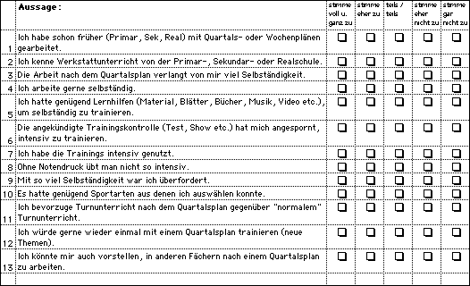

## Appendix 2

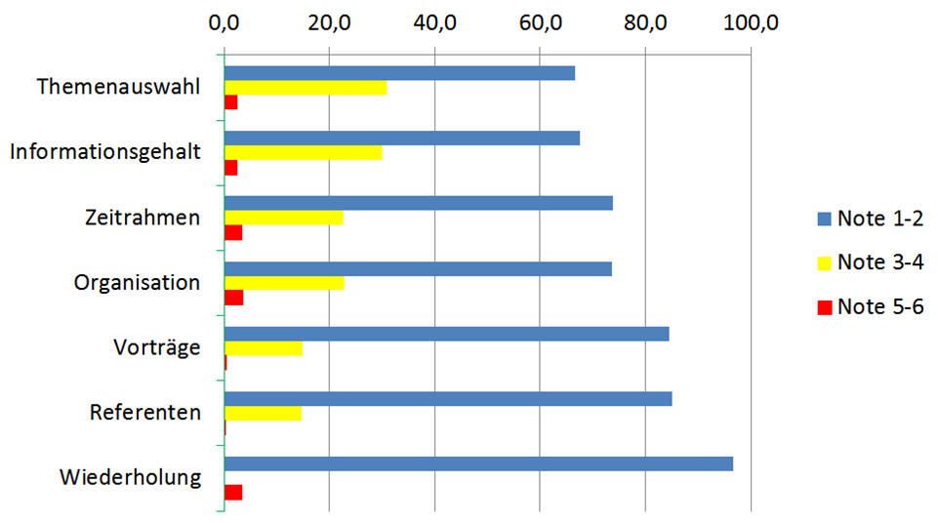

## Declaration of Authenticity

I hereby declare that the work submitted is my own and that all passages and ideas that are not mine have been fully and properly acknowledged.

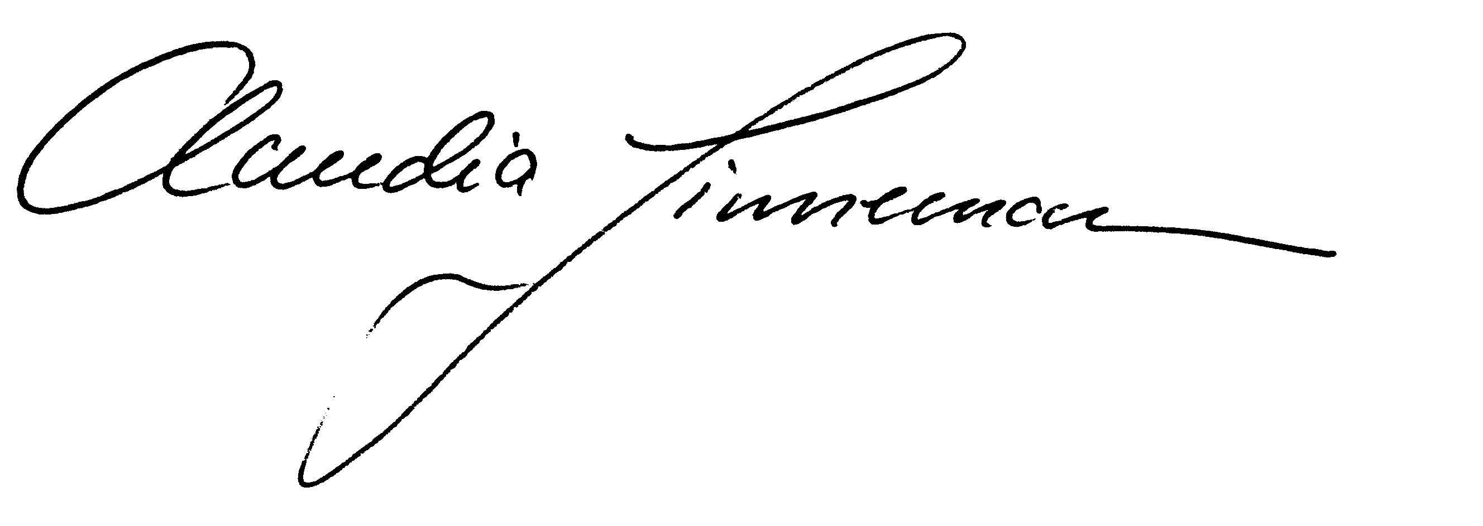

Mels, 6.1.2021