MARKET
Contents
1. Description 3
2. Instruction 3
3. Security Matrix 3
4. User Interface 4
1. Welcome page 4
2. User personal page 4
3. Market page 5
4. Easter egg 5
5. Security 6
1. Login form 6
2. Login form warnings 6
3. Logout page 6
4. Access denied 7
6. Admin page 8
7. Admin’s page notifications 9
1. Add new user validation 9
2. Add new user success message 9
3. Delete user success message: 9
4. Admin deleting validation 10

1. Description

Application based on Spring MVC framework. Also system uses next technologies:
  - Spring security.
  - Spring IoC.
  - Hibernate.
  - REST.
  - jQuery.
System allows managing users and roles (supporting several roles for one user). Market functionality isn’t implemented yet (was added implementation for viewing products).

2. Instruction

- Configure connection with database(e.g. MySQL):
  - Install database.
  - Run scripts from “/install/sql”. Firstly “tables.sql”, then “test_data.sql”.
  - Configure connection properties(“src/main/webapp/WEB-INF/mvc-configuration-servlet.xml”):
<bean id="dataSource" class="org.apache.commons.dbcp2.BasicDataSource" destroy-method="close">
<property name="driverClassName" value="com.mysql.jdbc.Driver"/>
<property name="url" value="jdbc:mysql://localhost:3306/market"/>
<property name="username" value="root"/>
<property name="password" value="root"/>
</bean>
- Configure/install application server (e.g. TomCat).
- Run application.

3. Security Matrix

Role/  Page | ROLE_USER | ROLE_SELLER | ROLE_ADMIN
Personal Page | + | + | +
Market Page | - | + | +
Admin Page | - | - | +

4. User Interface

1. Welcome page
--------------------------

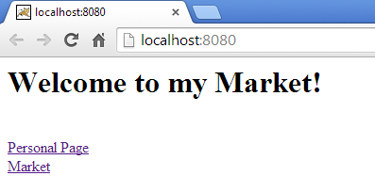
--------------------------

2. User personal page
--------------------------
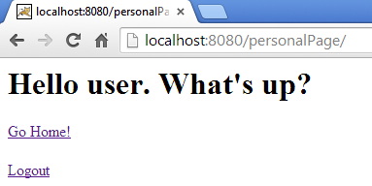

3. Market page
--------------------------
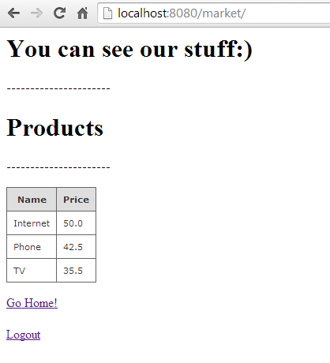
Probably functionality will be added in future.

4. Easter egg
--------------------------
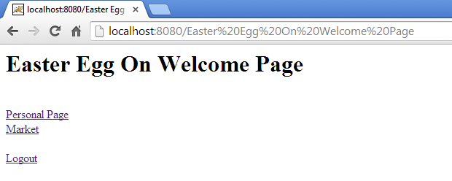
--------------------------

5. Security

Security can be switched-off for any reason (e.g. testing). It is simple configuration in web.xml file (see code for details).

1. Login form
--------------------------
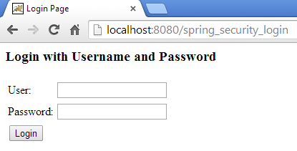
--------------------------

2. Login form warnings
--------------------------
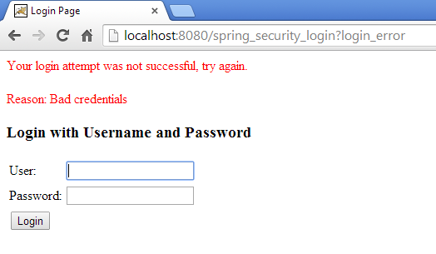

3. Logout page
--------------------------

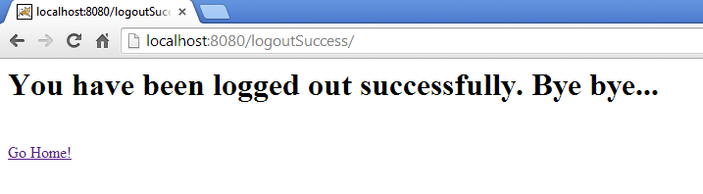
--------------------------

4. Access denied
--------------------------
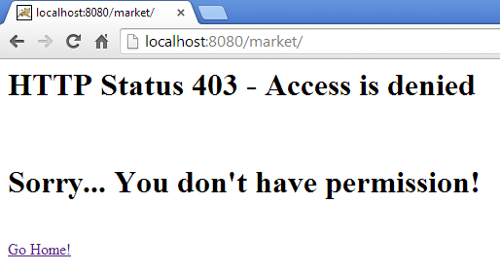

6. Admin page
--------------------------
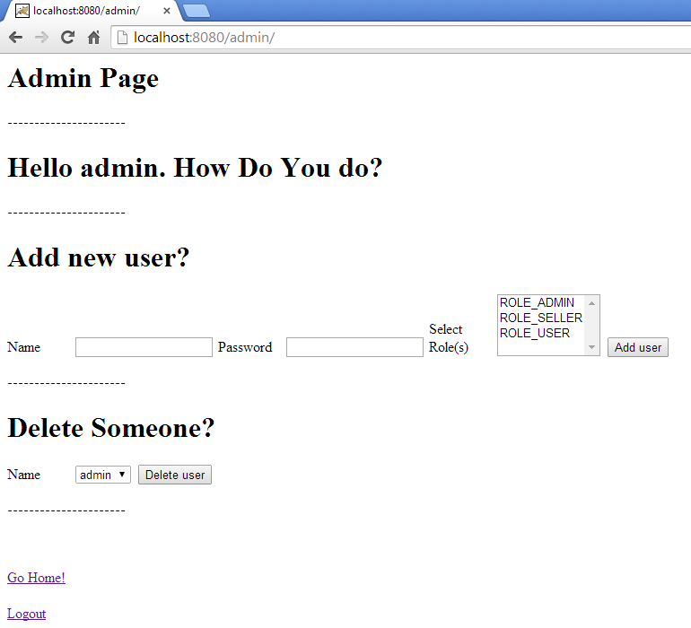

7. Admin’s page notifications

1. Add new user validation
--------------------------
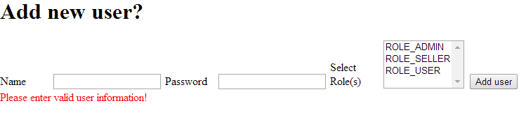
--------------------------
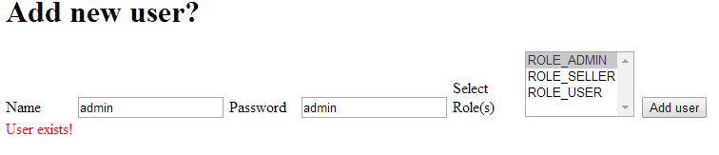
--------------------------

2. Add new user success message
--------------------------
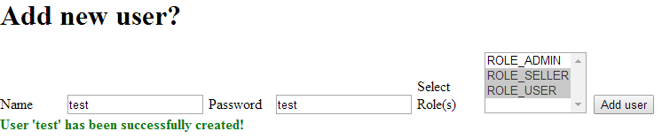
--------------------------

3. Delete user success message:
--------------------------
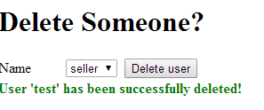

4. Admin deleting validation
--------------------------
