代理升级流程

升级传输之前
查询分布式版本
68,17,00,43,05,33,00,98,06,55,07,00,AF,DF,05,01,03,FF,FE,1E,00,00,0C,DE,16
查询分布式版本
68,18,00,43,05,33,00,98,06,55,07,00,E3,C3,07,01,03,FF,FE,30,00,00,00,21,80,16
记录分布式升级前版本信息

2、启动升级 F0 01 07 00 启动升级
68,3C,00,43,05,33,00,98,06,55,07,00,3C,7F,07,01,00,F0,01,07,00,02,03,02,06,0A,00,0A,00,06,00,04,35,63,04,03,E0,0A,04,76,31,2E,30,16,00,12,07,D0,02,02,16,00,09,04,7F,7E,D9,D2,00,54,24,16
启动升级响应，成功则继续往下一步
68,1A,00,C3,05,33,00,98,06,55,07,00,16,AC,87,01,00,F0,01,07,00,00,00,00,00,AE,11,16

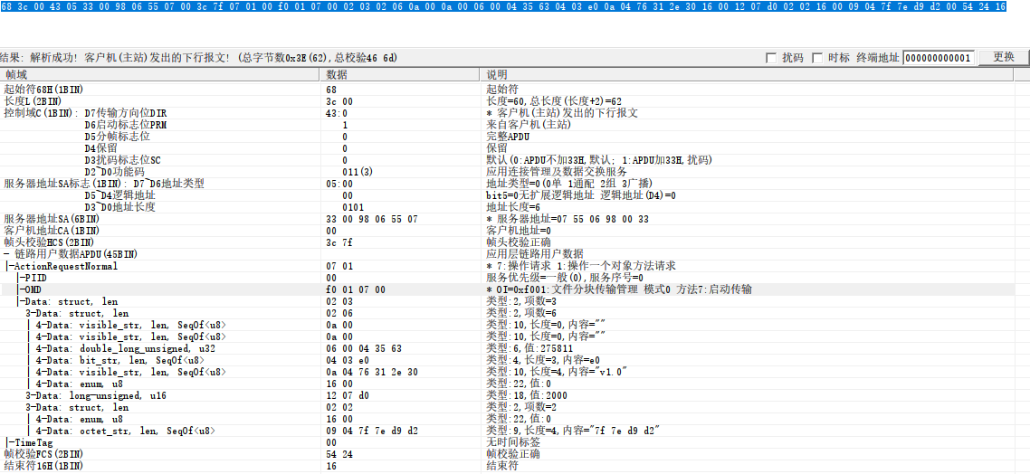
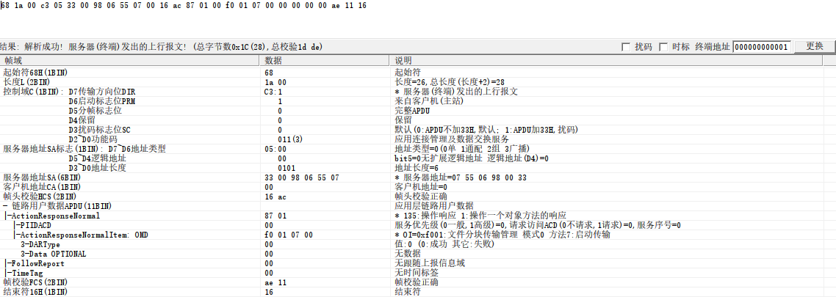

3、启动文件传输：F0 01 08 00 每包600字节
68,F0,07,43,05,33,00,98,06,55,07,00,28,06,07,01,01,F0,01,08,00,02,02,12,00,00,09,82,07,D0,4C,48,47,57,33,39,36,30,42,1B,22,18,29,00,00,00,0A,00,33,00,00,00,16,00,49,00,00,00,10,35,04,00,59,35,04,00,0A,BA,C5,41,24,13,57,02,00,00,00,C6,0A,BA,14,13,57,0E,00,02,00,01,00,02,00,4C,48,03,00,02,00,33,33,1E,32,F7,F9,55,AA,00,50,00,00,00,00,00,00,00,00,40,00,00,00,CD,34,04,00,00,00,00,00,00,00,00,00,00,00,00,00,00,00,00,00,00,00,00,00,00,00,00,00,00,00,00,00,00,00,00,00,00,00,00,00,00,00,00,00,6D,BF,8D,60,13,57,FF,D1,C1,34,04,00,E0,6C,01,20,F1,5D,04,08,3F,C5,03,08,41,C5,03,08,55,C5,03,08,57,C5,03,08,59,C5,03,08,00,00,00,00,00,00,00,00,00,00,00,00,00,00,00,00,5B,C5,03,08,5D,C5,03,08,00,00,00,00,5F,C5,03,08,61,C5,03,08,51,5F,04,08,55,5F,04,08,59,5F,04,08,63,C5,03,08,5D,.....................16
68,1A,00,C3,05,33,00,98,06,55,07,00,16,AC,87,01,01,F0,01,08,00,00,00,00,00,DA,61,16

4、查询升级后的分布式版本：
68,17,00,43,05,33,00,98,06,55,07,00,AF,DF,05,01,03,FF,FE,1E,00,00,0C,DE,16
若回复扩展版本查询失败，则启动标准查询升级版本
68,1A,00,C3,05,33,00,98,06,55,07,00,16,AC,85,01,03,FF,FE,1E,00,00,06,00,00,86,E2,16
ff fe 30 00
68,18,00,43,05,33,00,98,06,55,07,00,E3,C3,07,01,03,FF,FE,30,00,00,00,21,80,16
成功响应则升级成功：
68,1A,00,C3,05,33,00,98,06,55,07,00,16,AC,87,01,03,FF,FE,30,00,01,00,00,00,04,3F,16
失败响应则重新开始循环升级发包，5轮发包均失败，则停止发包，升级失败。

