Homework4

1. A brief outline of your method for finding the homography including relevant equations.

Homography matrix can be defined as H:

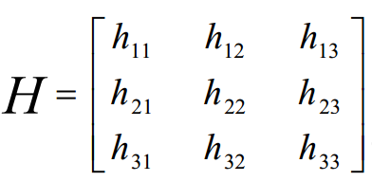

Suppose the corresponding coordinates of the corresponding points in the two images are (X 'Y', 1) and (X, Y, 1):

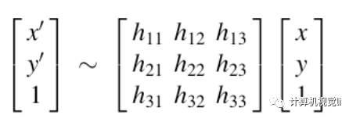

After the matrix is expanded, there are three equations, and the third equation is substituted into the first two equations:

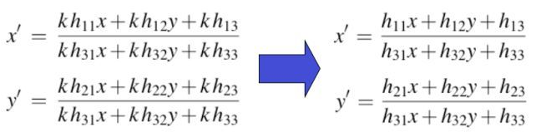

Directly set h33=1, then the above equation becomes:

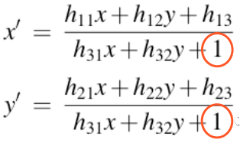

Written in the form of a linear system of equations or matrices

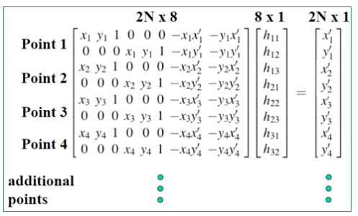

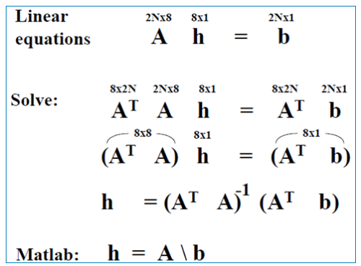

In this way ,H can be calculated.

2. A description and illustration of how you used the homography to transform an image to the world plane.



A\*H=b

Points (x1’,y1’), (x2’,y2’), (x3’,y3’), (x4’,y4’) are points on the plane, then we can determine a plane with 4 points.

3. A description and illustration of how you estimated the similarity transformation between a pair of images from which you removed the projective distortion.

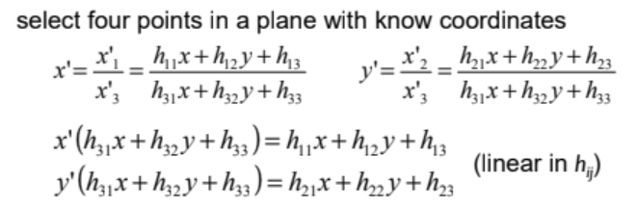

4. Your source code.

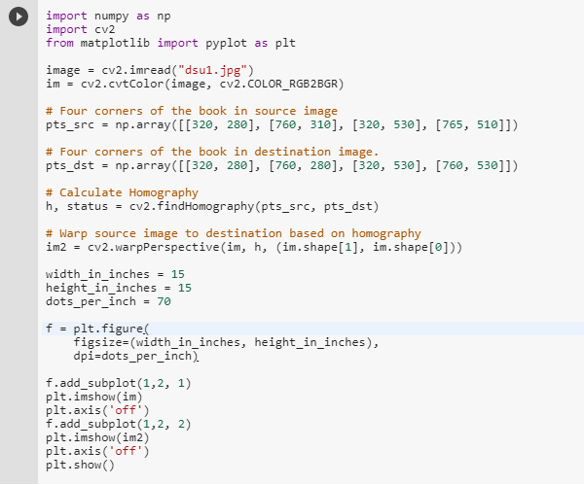

You are permitted to look at sample solutions form previous semesters available at http://cobweb.ecn.purdue.edu/~kak/courses-i-teach/ECE661.08/index. htm or https://engineering.purdue.edu/ece661/index.htm. However, the work you turn in must be your own!