External Applicant Quick Step Guide

Step | Action
Navigate to www.houstonmethodistcareers.org

Current employees: please see the Internal Applicant Quick Step Guide
Search for a job from the Job Search box
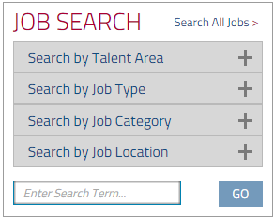
 | Click the name of the job opening.
 | Click the Apply button.
Enter your email address.



Sign In or register as a New User.


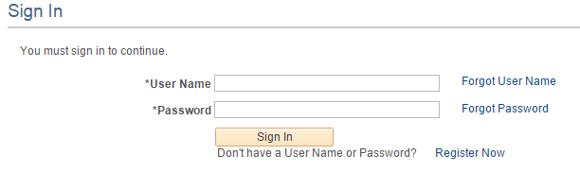

OR

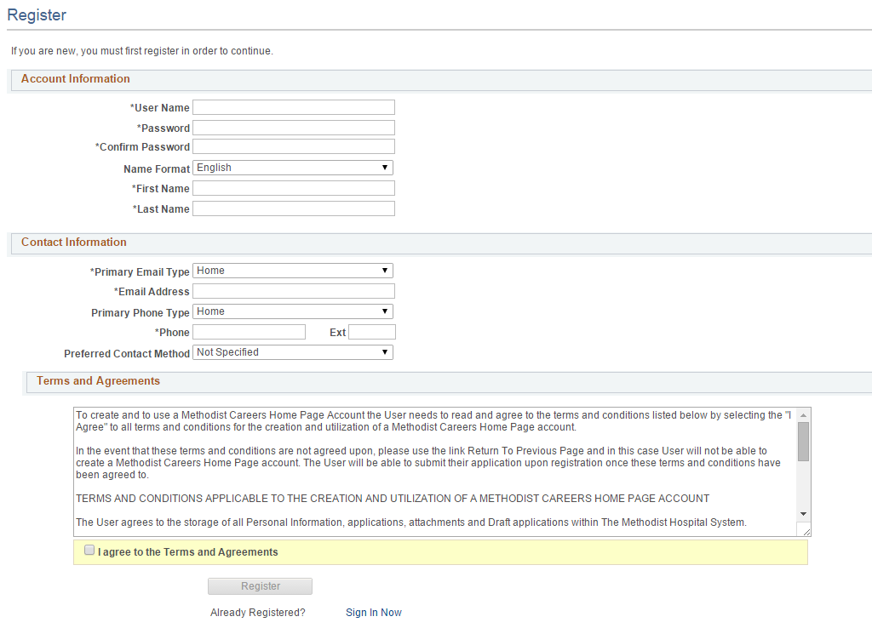

Answer all required questions beginning with the Start page and ending with the Application Confirmation page. Required questions are indicated by an asterisk, exclamation mark, or red highlight in the field.
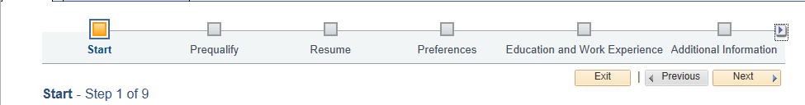


 | Check your email for any additional requests. See the Hiring Process webpage on at http://www.houstonmethodistcareers.org/hiring-process.html for information about our hiring process.
 | End of Procedure.

