Internal Applicant Quick Step Guide

Step | Action
Log in to the MARS Portal
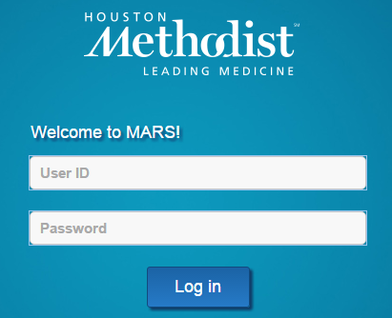

OR (if applying from home), go to http://www.houstonmethodistcareers.org/; Employee Resources



In the MARS Portal click Careers under My Career at Houston Methodist



In the Job Search page, search for a job opening by a Filter by criteria


OR Keyword

 | Click the name of the job opening.
Answer all required questions beginning with the Start page and ending with the Application Confirmation page. Required questions are indicated by an asterisk, exclamation mark, or red highlight in the field.
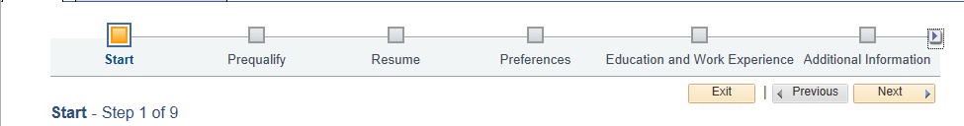


Check your email for any additional requests.

If you are applying for a clerical position, you will receive an additional email with a link to an additional clerical assessment.

See HR24 - Internal Application and Transfer Policy for information about the internal transfer process.
 | End of Procedure.

