A1035516 林怡瑄

HW3 P2

1. Development environment

IDE : spyder

Language : python

Liberary : opencv,numpy, os.listdir, os.path.join,math

1. The results of task 1~3
2. Show the mean face, top 5 eigenfaces and their corresponding eigenvalues in a descending order.

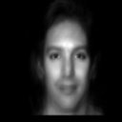

mean face

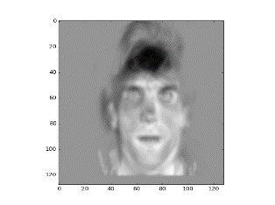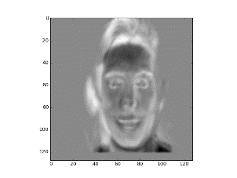

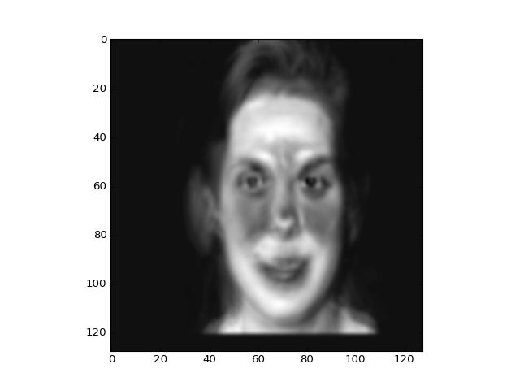

top 1 top 2 top 3

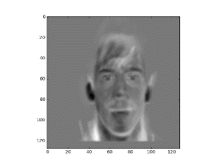

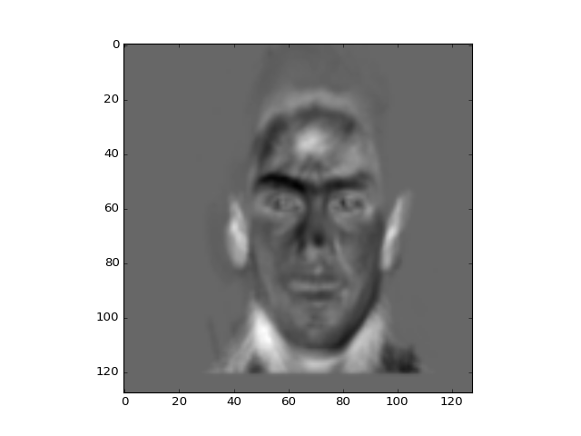

top 4 top 5

1. Given a test image, compute the top 10 eigenface coefficients.



1. Keep only first K (K=5,10,15,20, and 25) coefficients and use them to reconstruct the image in the pixel domain. Compare the reconstructed image with the original image by PSNR (Peak Signal to Noise Ration) value.

K=5 K=10 k=15

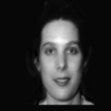

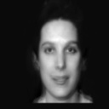

psnr: 28.28 psnr: 26.07 psnr: 30.04

k=20 k=25

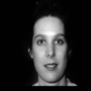

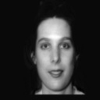

psnr: 29.06 psnr: 30.63

1. your observations
2. 在使用sklearn時如果有先減掉mean face，就算重建完再加回mean face，不知道為什麼結果會很奇怪。

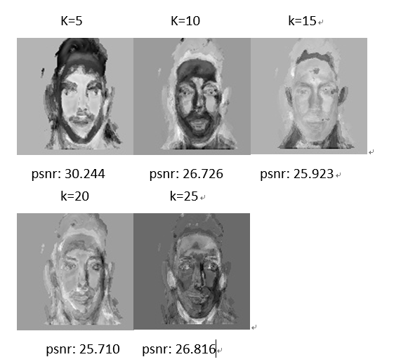

1. 用OPENCV印圖時似乎只要有小數印出時會自動變成只有黑白，需要先正規劃。
2. Reconstruct時用越多eigenface結果會越好。