P76074517 林怡瑄

1. PCA

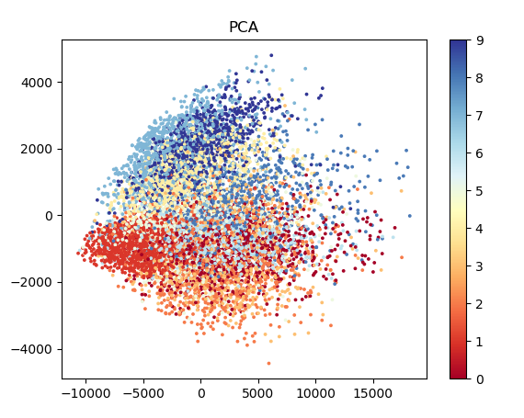

1. Visualize the reconstruction results and the filters.

Reconstruction:

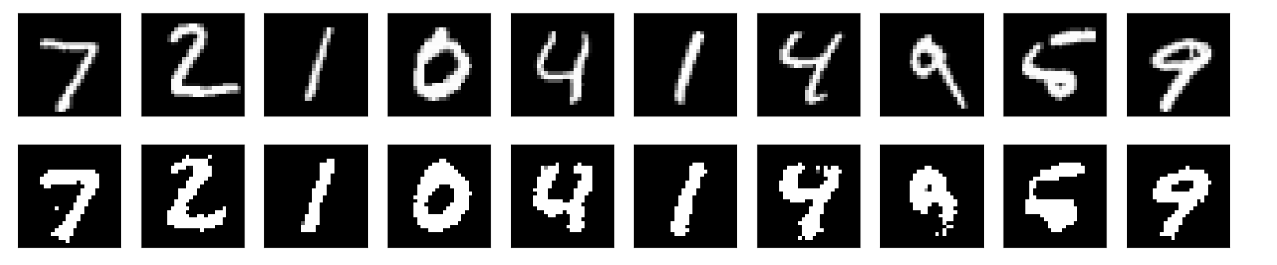

Filters:

