VBA of Wall Street

Multiple Year Stock, Screenshot of 2016 results

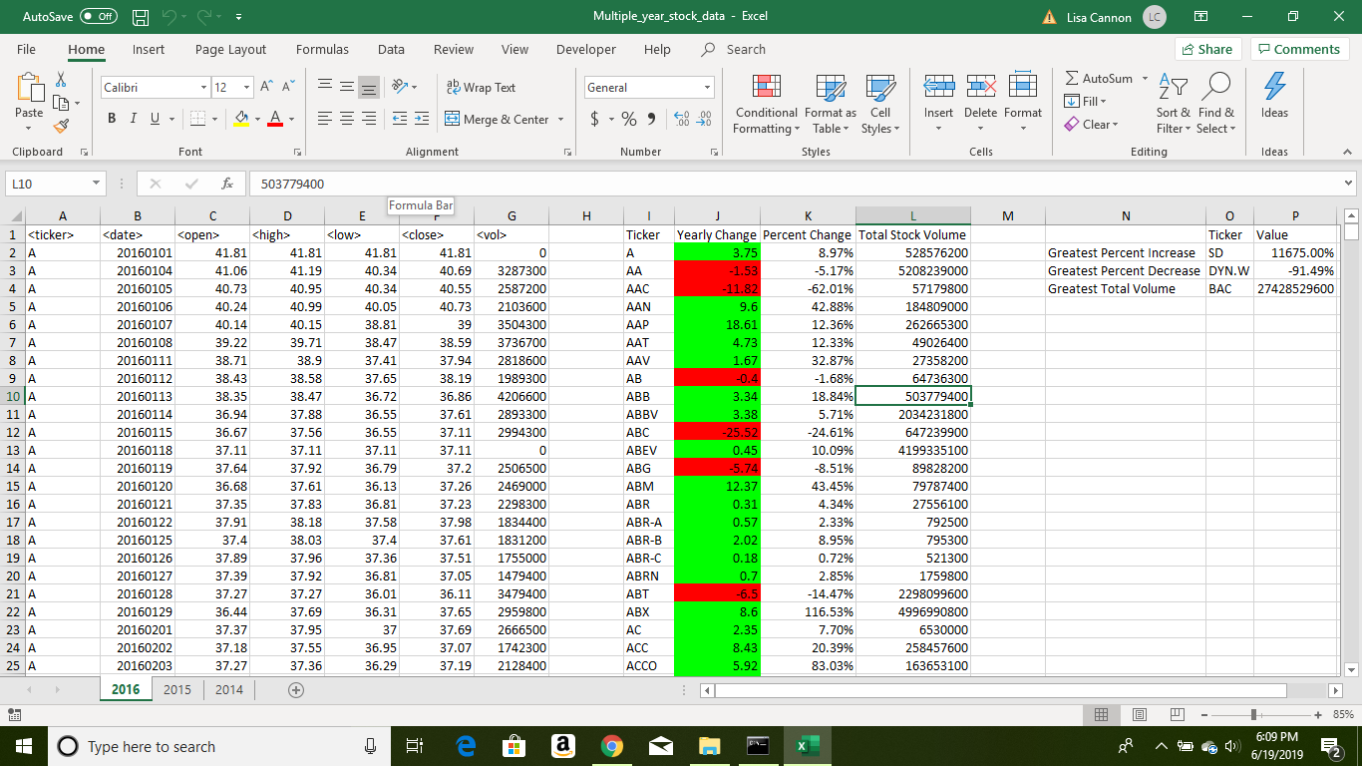

Multiple Year Stock, Screenshot of 2016 results

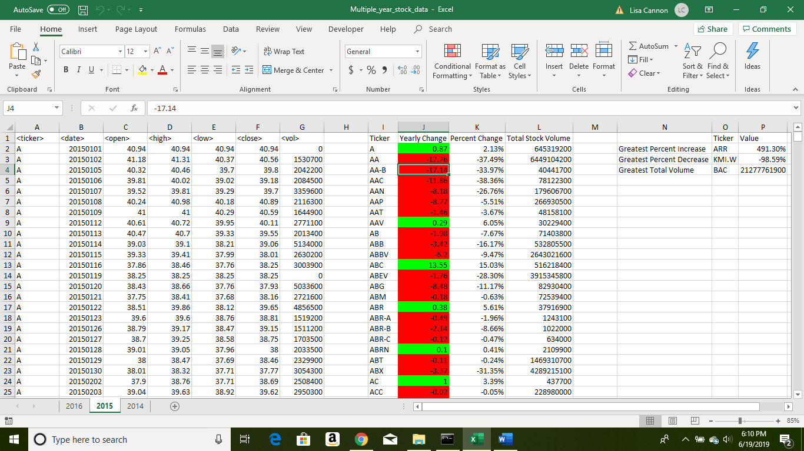

Multiple Year Stock, Screenshot of 2016 results

