Who we are  EE 482 Senior Design group is happy to present our Musculoskeletal  Assessment Device to the University of Alaska Fairbanks. Our hard work  and dedication brings a simple, easy device to test your strength and  push your muscles limits!  Thank you to Center ICE for funding this project! |  |  | MAD  Musculoskeletal Assessment Device  User Guide  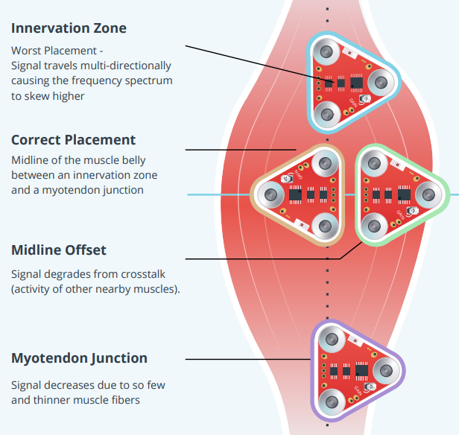

Contact us:
Email Sheridan Blasey: sablasey@alaska.edu
Email Lisa Jacklin: lmjacklin@alaska.edu
Email Daniel Kling: dwkling@alaska.edu
Email Elizabeth Lee: egoddeau@alaska.edu
Not intended to replace medical professionals  2023 - 2024 |  |  | [6] C. J. De Luca, “The Use of Surface Electromyography in Biomechanics,” Journal of Applied Biomechanics, vol. 13, no. 2, pp. 135–163, May 1997, doi: https://doi.org/10.1123/jab.13.2.135. Available: https://journals.humankinetics.com/view/journals/jab/13/2/article-p135.xml  - Device works by displaying an integer out of 100, where higher numbers represent stronger muscles  - EE 482 – Senior Design  - Sheridan Blasey, Lisa Jacklin, Daniel Kling, Elizabeth Lee

Step 1  - Place the cuff near the muscle to be assessed and turn on the device. Turn on the LED shield as well.  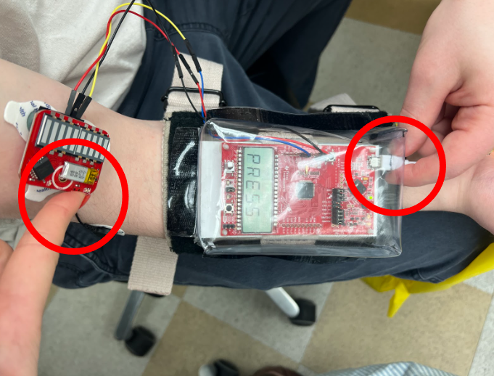 |  |  | Step 3  - View and record values presented on the LCD screen.  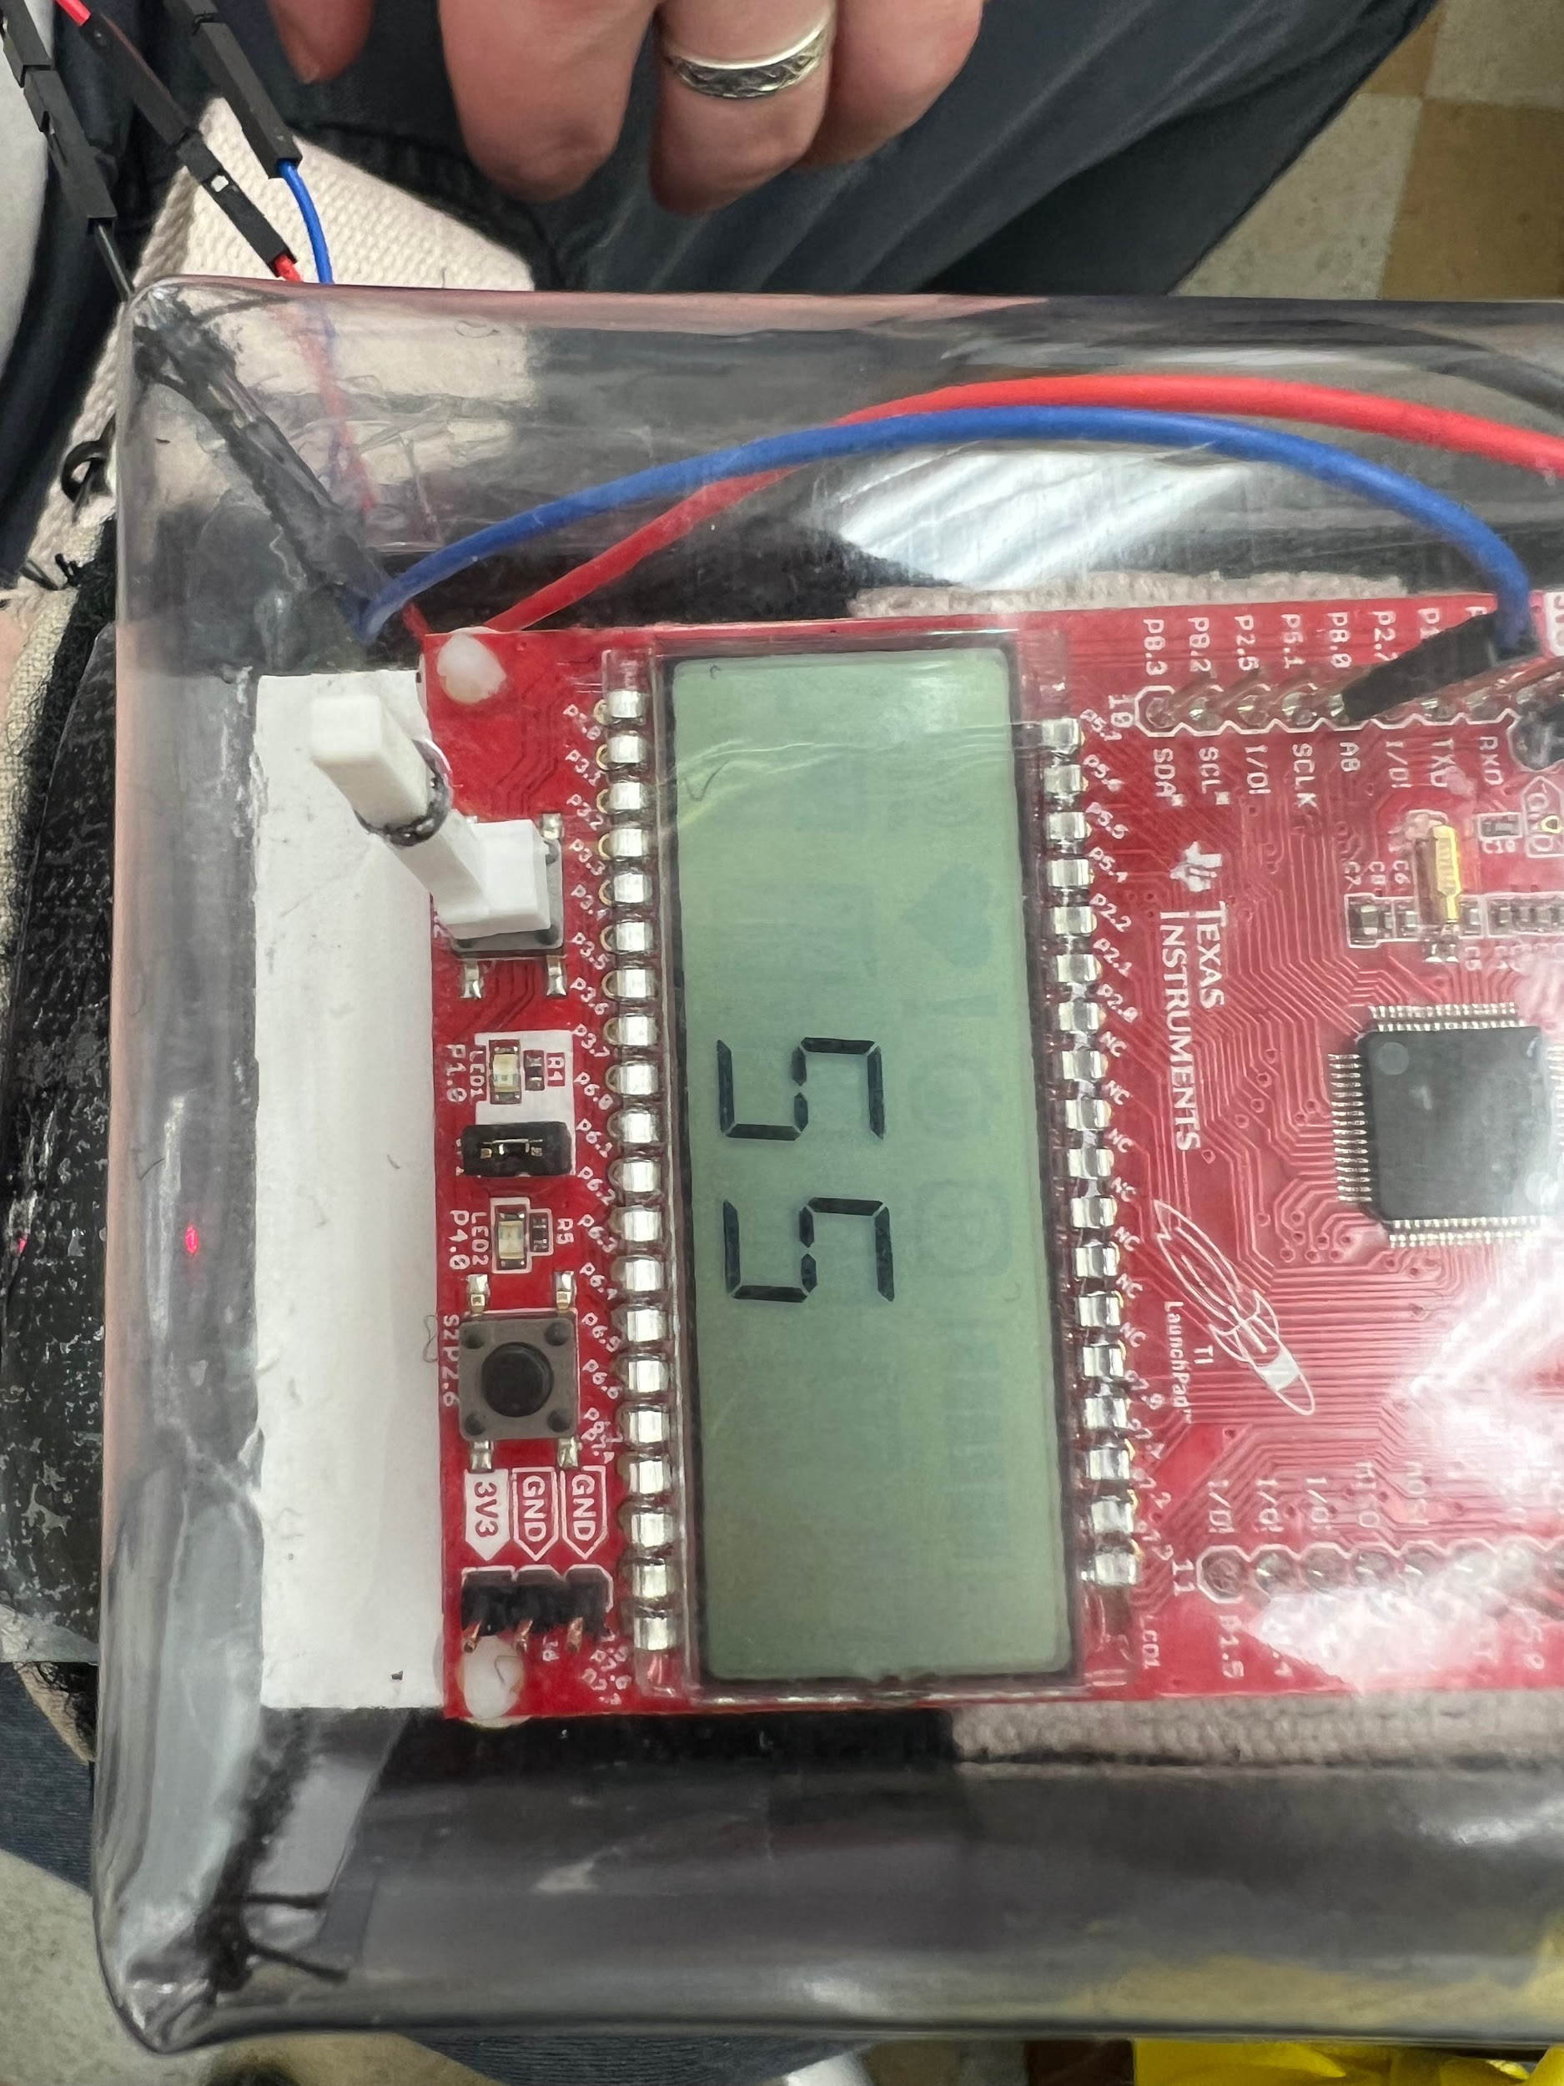
STEP 2  - Place the pads on the muscle of interest, with black reference node atop a bone/adjacent muscle. Firmly grasp resistance band, contract muscle, then start device sampling by pressing the button, located on the bottom left of the device.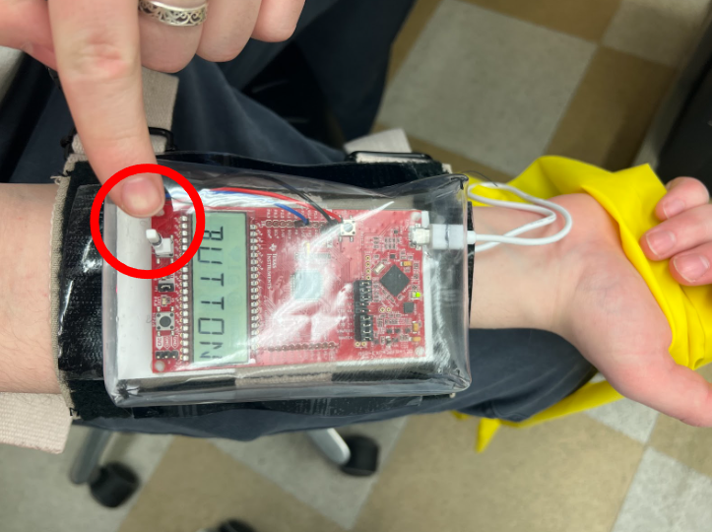 |  |  | STEP 4  - Turn off the device and LED shield. Or press the button again to return to Step 2.

