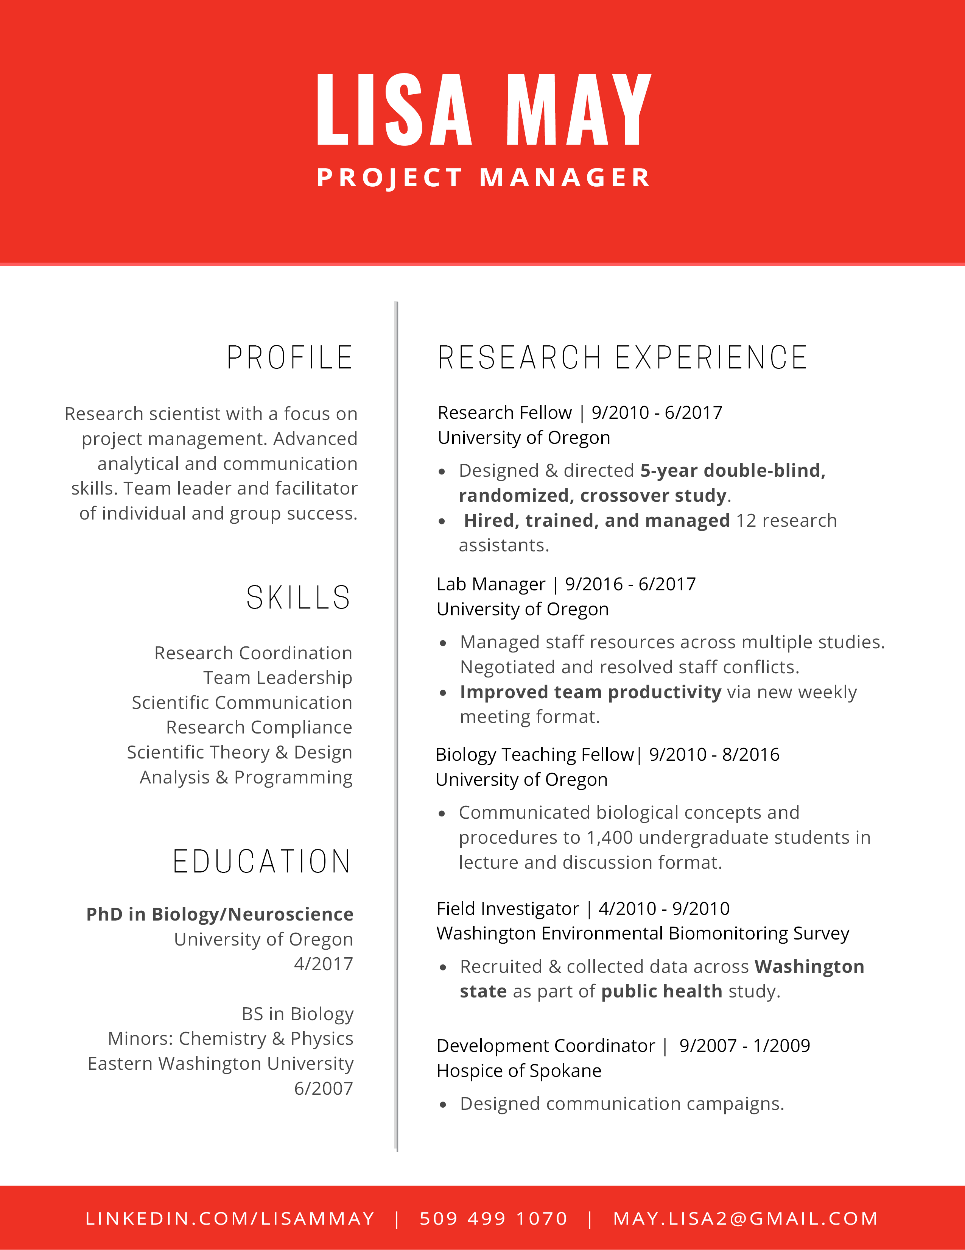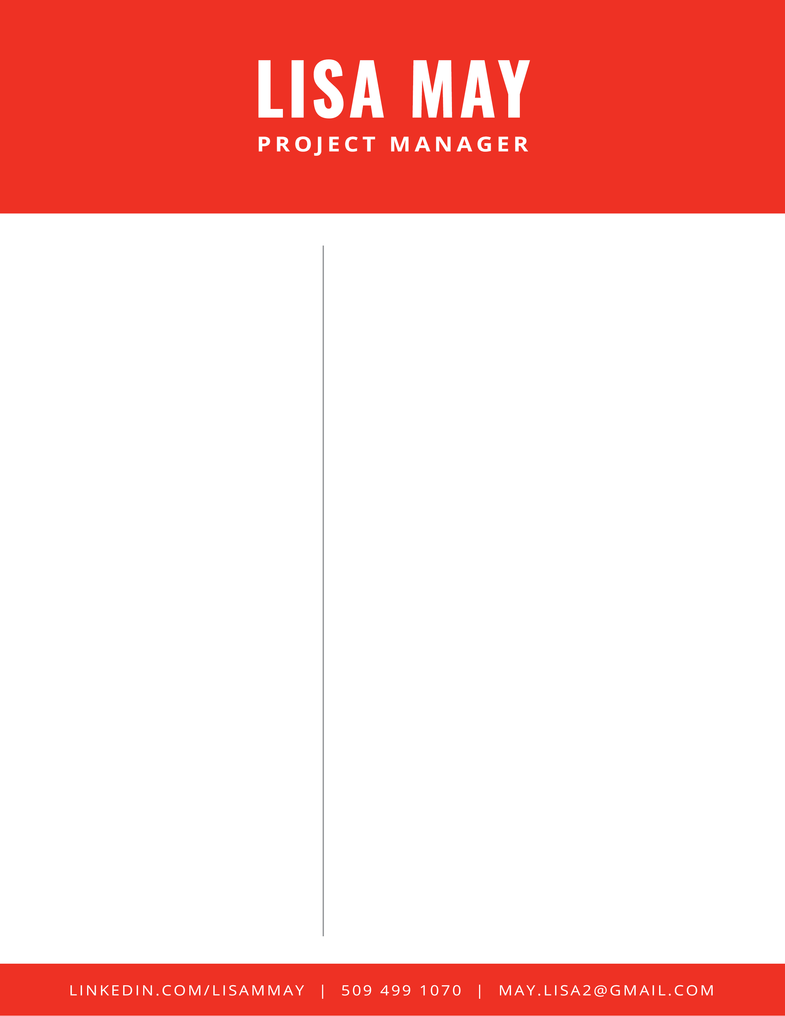

SKILLS

EDUCATION

PROFILE

RESEARCH EXPERIENCE

Research scientist with a focus on project management. Advanced analytical and communication skills. Team leader and facilitator of individual and group success.

Research Coordination

Team Leadership

Scientific Communication

Scientific Theory & Design

Analysis & Programming

**PhD in Biology/Neuroscience**

University of Oregon

4/2017

BS in Biology

Minors: Chemistry & Physics

Easter Washington University

6/2007

Research Fellow | 9/2010 – 6/2017

University of Oregon

* Designed & directed **5-year double-blind, randomized, crossover study.**
* Procured 2 research grants totally $40,000.
* **Hired, trained, and managed** 12 research assistants.

Lab Manager | 9/2016 – 6/2017

University of Oregon

* Managed staff resources across multiple studies. Negotiated and resolved staff conflicts.
* **Improved team productivity** via new weekly meeting structure.
* Implemented laboratory-wide version control.

Research Consultant | 10/2016 – present

Berkman Consultants

* Translated scientific principles into tailored business solutions.

Research Analyst | 1/2009 – 5/2010

Providence Medical Research Center

* Designed & implemented retrospective review of robotic mitral valve repair.

Field Investigator | 4/2010 – 9/2010

Washington Environmental Biomonitoring Survey

* Recruited participants and collected data