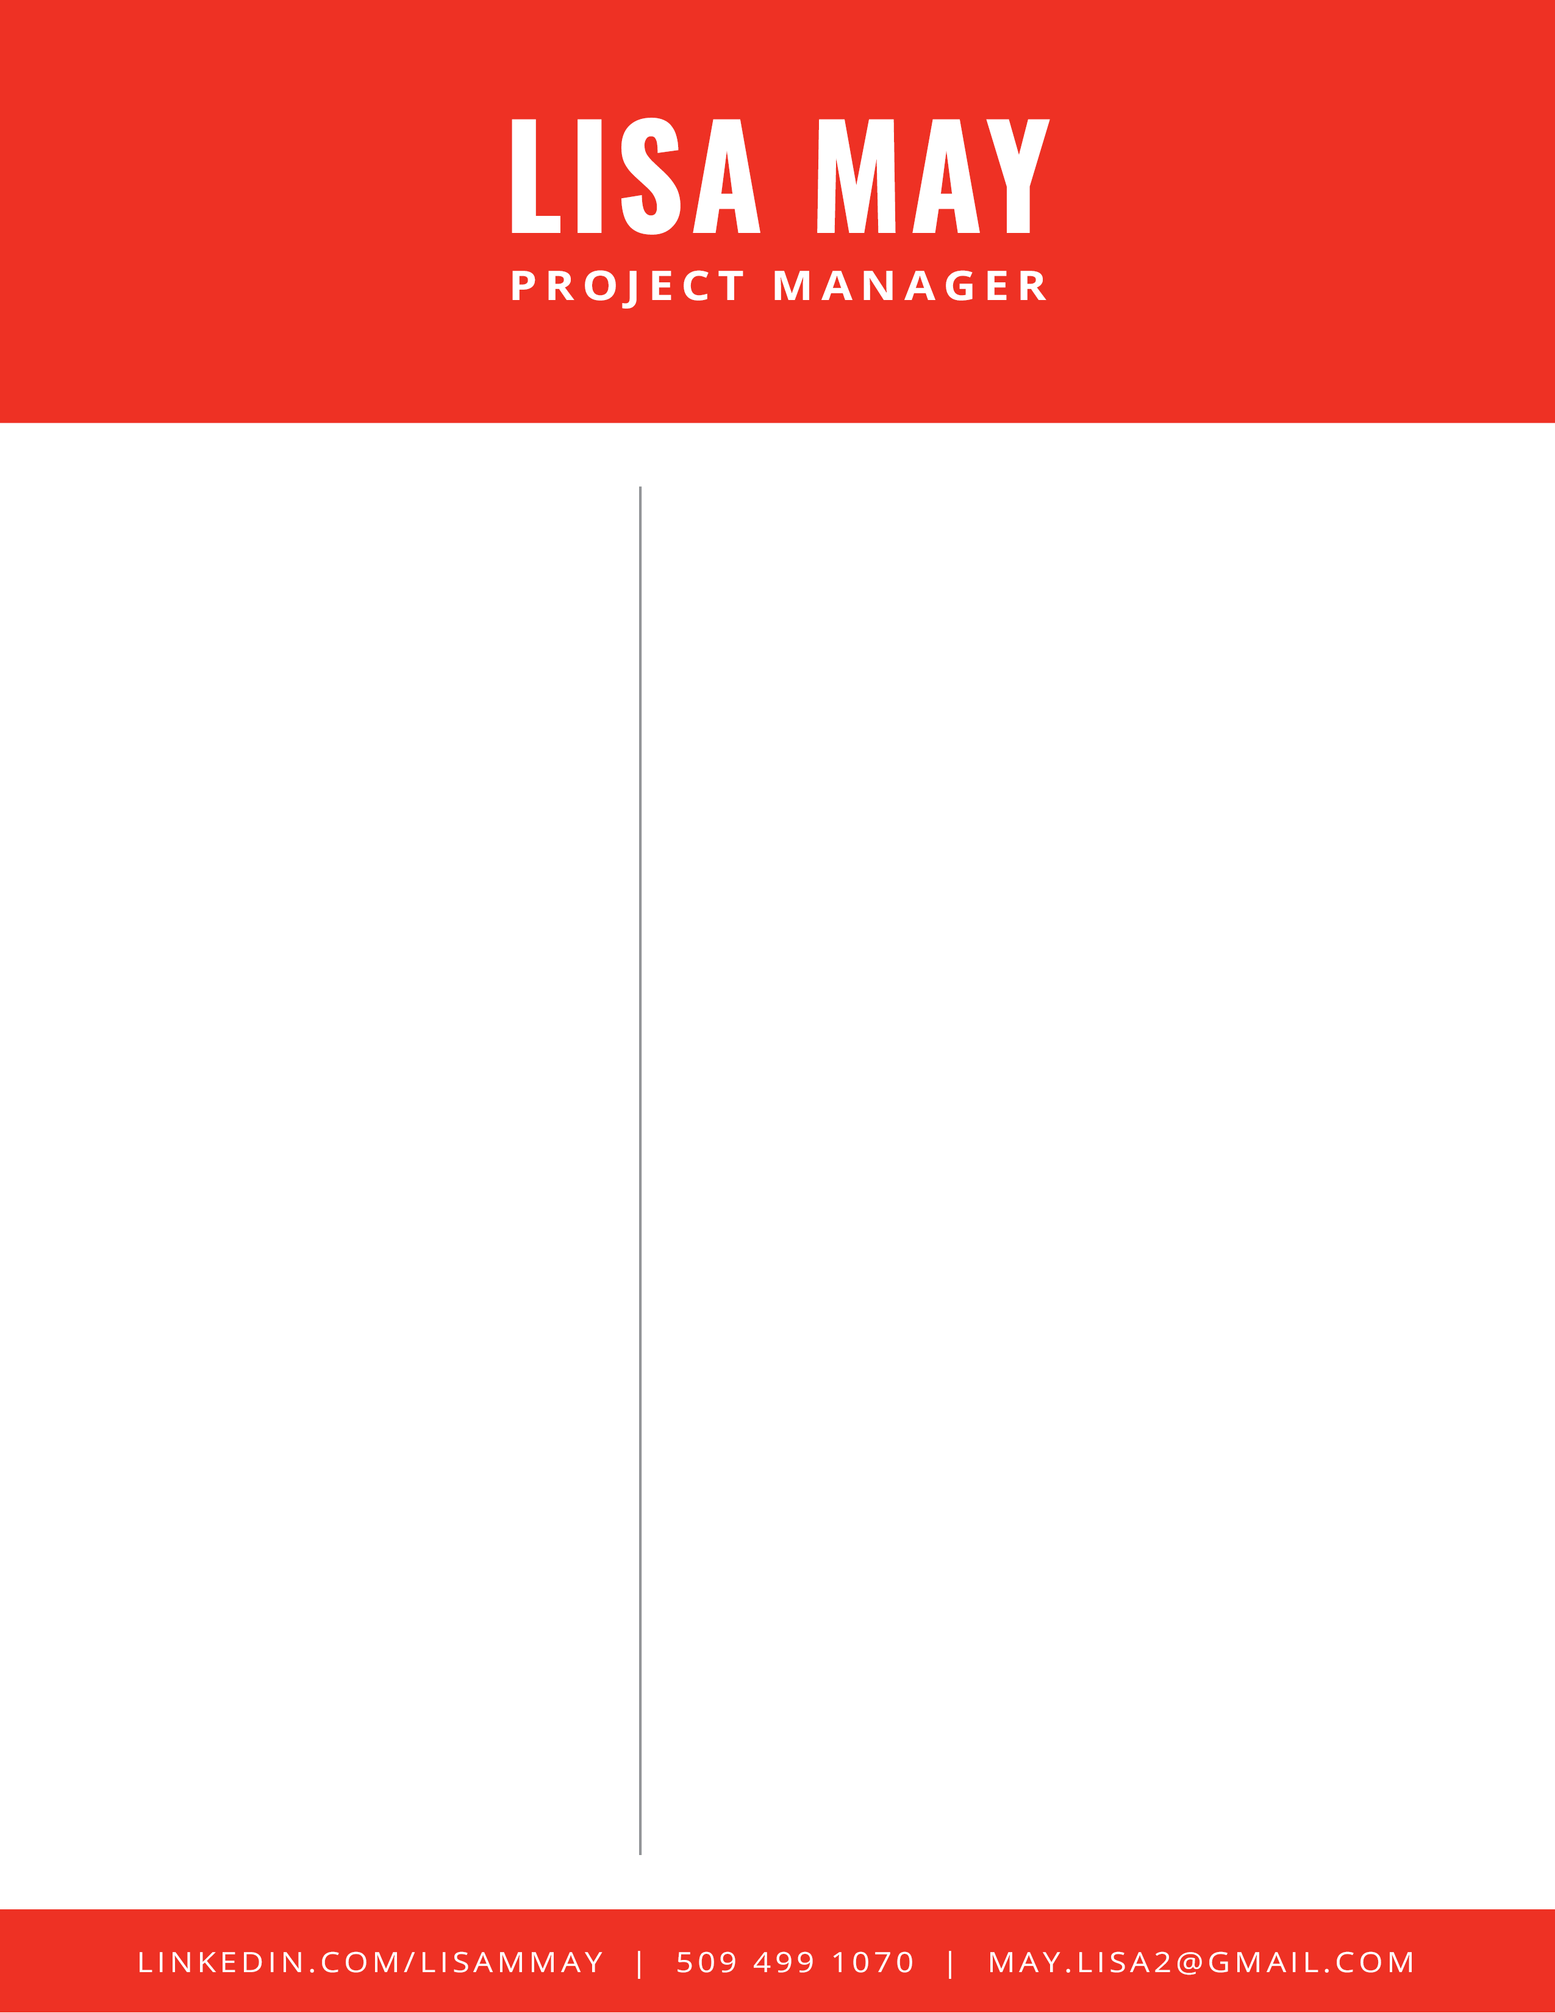

RESEARCH EXPERIENCE

PROFILE

**PhD in Biology/Neuroscience**

University of Oregon

4/2017

Bs in Biology

Minors: Chemistry & Physics

Easter Washington University

6/2007

Research Coordination

Team Leadership

Scientific Communication

Scientific Theory & Design

Analysis & Programming

Research scientist with a focus on project management. Advanced analytical and communication skills. Team leader and facilitator of individual and group success.

EDUCATION

SKILLS