

<http://image.cache.storm.mg/styles/smg-800x533-fp/s3/media/image/2017/11/14/20171114-040327_U9180_M347682_877a.jpg?itok=R0Z2gmrS>



<http://gcc.truevisionnews.com/wp-content/uploads/2017/11/sex-abuse.jpg>



<http://gcc.truevisionnews.com/wp-content/uploads/2017/11/sex-abuse.jpg>

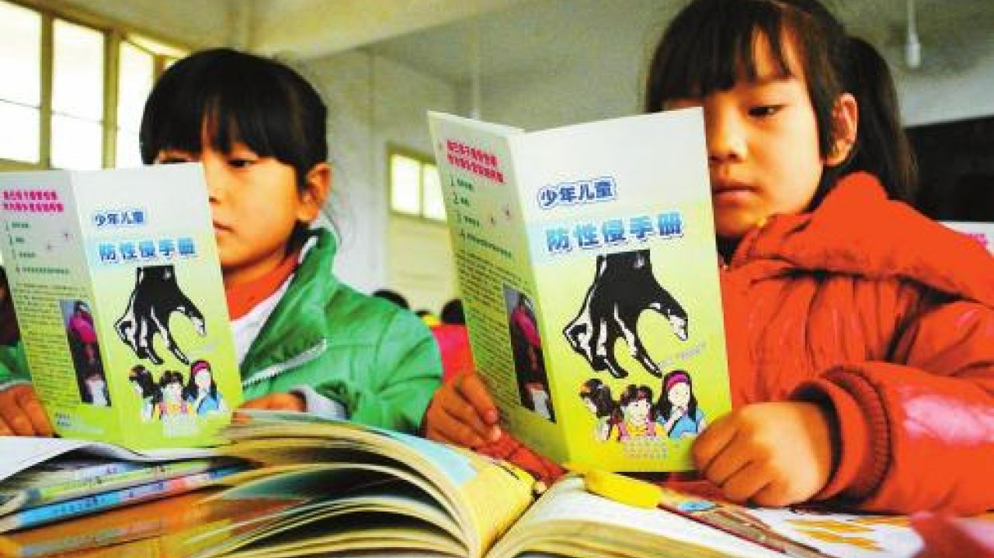<https://cdn.hk01.com/media/article/164645/thumbnail/e1be7084d8f87536f747c3d810da66f3.jpg>

## **神秘肌膚**

## http://pic.pimg.tw/endlessfly/73f6b54a64b92ebf390fc70b47730ec9_n.png



<http://img.123kubo.org/Uploads/vod/2017-12-28/5a4460a6c5ceb.jpg>

電影熔爐 海報

<http://img.hmv.co.jp/image/jacket/400/42/4/1/297.jpg#_ga=2.224510682.138103904.1521877221-1937490295.1521877221>