MOSAIC Learn
Identifying Drivers Using a
Causal Loop Diagram
Printable worksheet template for Policy Labs

Purpose of this worksheet
Use this template to identify the main drivers of a land-use challenge and map how they influence one another. The worksheet is designed for group work: first identify variables, then draw relationships, then look for feedback loops and leverage points.

Policy Lab / case: | ______________________________________________________________
Date: | ______________________________________________________________
Facilitator: | ______________________________________________________________
Participants: | ______________________________________________________________

Background: For a more theoretical explanation, read: Causal Loop Diagrams - Nexus Learn and use the Miro CLD template if you want to digitise the diagram afterwards.

How to use this template
In two sentences
A Causal Loop Diagram (CLD) helps stakeholders identify the factors influencing a land-use challenge and understand how those factors affect one another over time. Unlike a simple list of causes, a CLD reveals feedback loops, unintended consequences, and possible leverage points for change.

Land-use example: drought and soil resilience
A simple explanation might be: less rainfall -> lower yields.
A systems perspective becomes more useful when the group sees a reinforcing pattern: drought -> lower yields -> lower farm income -> reduced investment capacity -> lower soil quality -> even lower resilience to drought.

Gradual build-up example
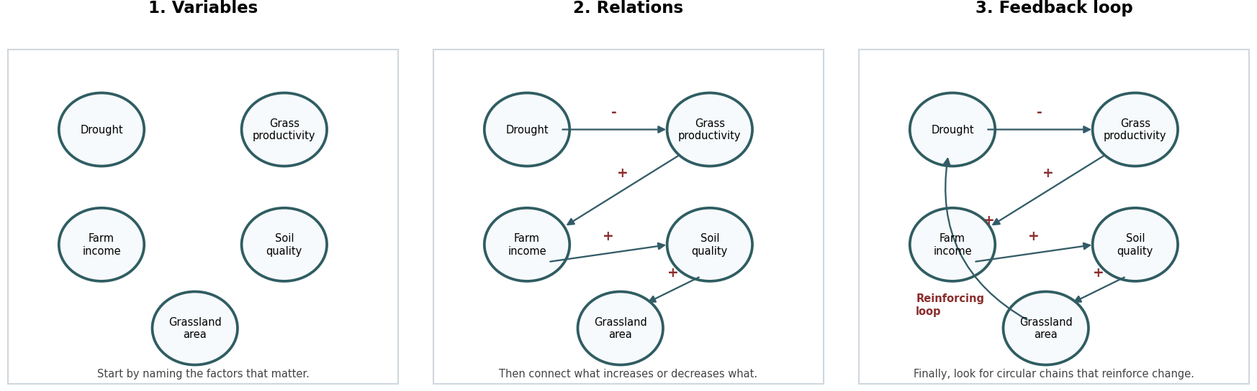
Use the same logic in your own case: first list variables, then draw causal relationships, then identify feedback loops. Do not start with the loop; let the loop emerge from the variables and relationships.

Step 1 - Define the focal land-use challenge
Start with one concrete question. The question should be specific enough to guide discussion, but broad enough to include different perspectives.
Examples: Why are grasslands disappearing? Why is afforestation adoption low? Why is water scarcity increasing?

Write your focal question
Focal question Example: Why are grasslands disappearing?
Geographical focus: | ______________________________________________________________
Land-use change considered: | ______________________________________________________________
Time horizon: | ______________________________________________________________
What would success look like? | ______________________________________________________________

Step 2 - Identify relevant stakeholders
Before identifying drivers, determine whose perspectives need to be represented. Different actors often perceive different drivers and barriers. This diversity is valuable and should be reflected in the CLD.
Optional: use the stakeholder analysis tool from the Policy Lab creation module first: Stakeholder analysis
Stakeholder group | Why relevant? | What knowledge/perspective do they bring? | How will they be involved?

Example: Belgian grasslands
Possible stakeholders could include livestock farmers, new grassland users, policymakers, nature organisations, local residents and researchers.

Step 3 - Generate potential drivers / variables
Ask stakeholders: "What factors influence this challenge?" Collect all responses first, without judging importance. In a CLD, these factors become variables.

Brainstorm variables
Variable brainstorm space Write one variable per sticky note or line. Avoid full sentences.

Classify drivers
Use the MOSAIC categories below to check whether important types of drivers are missing.
Driver category | Typical examples | Your variables
Economic drivers | Profitability; labour availability; access to capital; market prices
Policy drivers | Subsidies; regulations; administrative burden; policy uncertainty
Technology drivers | Irrigation systems; precision agriculture; solar technologies; automation
Climate drivers | Drought; floods; temperature increase; extreme weather
Social drivers | Trust; peer influence; social networks; institutional relationships
Values and motivations | Identity; heritage; stewardship; place attachment

Step 4 - Draw CLD 1: place the variables
Use this first drawing space to place your most important variables. Do not add too many arrows yet. Group related variables if helpful.
CLD drawing space 1 - variables only Tip: copy this page if you need more space.

Step 5 - Draw CLD 2: connect variables
Now add arrows. Ask: if variable A increases, what happens to variable B? Mark the relationship with + if both move in the same direction, and - if they move in opposite directions.
CLD drawing space 2 - variables and relationships Use + and - signs on the arrows.

Step 6 - Draw CLD 3: identify feedback loops
Look for circular chains of influence. A reinforcing loop amplifies change; a balancing loop counteracts change. Stakeholders often discover that a variable first seen as an outcome also influences another part of the system.
CLD drawing space 3 - feedback loops Circle loops and label them R or B.

Record the feedback loops
Loop name | Type | Variables involved | What does this explain?
 | R / B
 | R / B
 | R / B
 | R / B
 | R / B
 | R / B

Step 7 - Identify leverage points
Finally ask: which variables could be influenced by policy, collaboration or practical action? These become potential intervention points for the next Policy Lab discussion.
Possible leverage point | Driver category | Who can influence it? | Possible action | Risks / unintended effects

Summary for your next Policy Lab
Use the completed CLD as input for your next Policy Lab. Bring the diagram, the driver categories, the main feedback loops and the leverage points to the discussion.
Question | Your answer
Which drivers appear most important?
Which driver categories are most represented?
Which drivers are missing or uncertain?
Which feedback loop explains why the problem persists?
Which leverage point should be discussed first?
Who needs to be involved in the next Policy Lab?
Next step: Use these drivers as input for your next Policy Lab: Policy Labs as Methods for Policy Innovation
Facilitator tip
Keep the first version simple. A useful CLD is not the one with the most variables; it is the one that helps the group have a better conversation about why land-use change happens and where action may be possible.

