PA1_template

## Loading and preprocessing the data

We import the data, load the required packages and correct the variable category

setwd("C:/Users/310192577/Documents/Course/5_Reproducible_Research/week 2")  
activity<-read.csv2("activity.csv", sep=",", stringsAsFactors = FALSE)

activity$steps<-as.numeric(activity$steps)  
activity$date<-as.Date(activity$date)  
nona<-na.omit(activity)

## What is the mean total of steps taken per day?

Now we sum the steps per day and make a histogram out of it.

#prep data for plot  
datesum<-aggregate(nona$steps, by=list(nona$date), sum)  
names(datesum)<-c("Date", "Steps")  
datesum$Date<-as.Date(datesum$Date)  
#create plot  
hist(datesum$Steps)

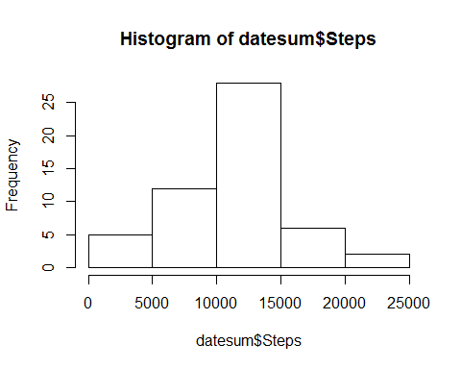

## What is the average daily activity pattern?

The following piece of code calculates the average number of steps for each interval and creates a time series plot. You will see that the highest average maximum number of steps per interval is shown by the last call (206).

#prep data for plot  
intmean<-aggregate(nona$steps, by=list(nona$interval), mean)  
names(intmean)<-c("interval", "steps")  
#get plot  
ggplot(intmean, aes(x=interval, y=steps)) + geom_line() +ylab("average steps per interval")

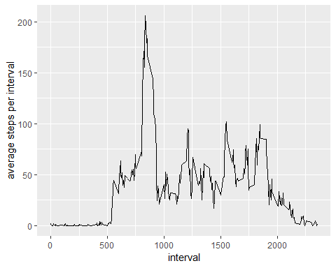

#get max  
max(intmean$steps)

## [1] 206.1698

## Imputing missing values

#number of missing values  
sum(is.na(activity$steps))

## [1] 2304

#impute missing values using predictive mean matching  
iris.impu <- mice(data=activity, m=5, method= "pmm", seed=500)  
completedData<-mice::complete(iris.impu,2)

#prep data for plot  
datesumcomplete<-aggregate(completedData$steps, by=list(completedData$date), sum)  
names(datesumcomplete)<-c("Date", "Steps")  
datesumcomplete$Steps<-as.numeric(datesumcomplete$Steps)  
datesumcomplete$Date<-as.Date(datesumcomplete$Date)  
#create plot  
hist(datesumcomplete$Steps)

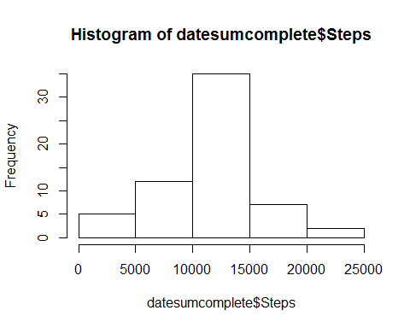

#get metrics  
mean(datesumcomplete$Steps)

## [1] 11016.85

median(datesumcomplete$Steps)

## [1] 11162

## Are there differences in activity patterns between weekdays and weekends?

Yes, on weekdays there is a higher maximym and activity starts earlier, activity remains more constantly high during the weekend.

#create weekdaytype variable  
weekdays <- c('Monday', 'Tuesday', 'Wednesday', 'Thursday', 'Friday')  
completedData$date<-as.Date(completedData$date)  
completedData$weekpart<-factor((weekdays(completedData$date) %in% weekdays), levels=c(FALSE, TRUE), labels=c('weekend', 'weekday') )  
daymean<-aggregate(completedData$steps, by=list(completedData$interval, completedData$weekpart), mean)  
names(daymean)<-c("interval","day", "meansteps")  
#create plot  
ggplot(daymean,aes(x=interval,y=meansteps,group=day))+geom_line()+facet_grid(day~.)

