**Ice Hockey Players Database**

Group members:

Hinduja Bikki(201601013)

Subhadeep Dash (201601021)

**TABLES USED:**  
**1. *ice\_hockey\_action\_participants***(id, ice\_hockey\_action\_play\_id, person\_id, participant\_role, point\_credit)

***2. ice\_hockey\_action\_plays***(id, ice\_hockey\_event\_state\_id, play\_type, score\_attempt\_type, play\_result, comment)

***3. ice\_hockey\_offensive\_stats***(id, goals\_game\_winning, goals\_game\_tying, goals\_power\_play, goals\_short\_handed, goals\_even\_strength, goals\_empty\_net, goals\_overtime, goals\_shootout, goals\_penalty\_shot, assists, points, power\_play\_amount, power\_play\_percentage, shots\_penalty\_shot\_taken, shots\_penalty\_shot\_missed, shots\_penalty\_shot\_percentage, giveaways, minutes\_power\_play, faceoff\_wins, faceoff\_losses, faceoff\_win\_percentage, scoring\_chances)

***4. ice\_hockey\_defensive\_stats***(id, shots\_power\_play\_allowed, shots\_penalty\_shot\_allowed, goals\_power\_play\_allowed, goals\_penalty\_shot\_allowed, goals\_against\_average, saves, save\_percentage, penalty\_killing\_amount, penalty\_killing\_percentage, shots\_blocked, takeaways, shutouts, minutes\_penalty\_killing, hits, goals\_empty\_net\_allowed, goals\_short\_handed\_allowed, goals\_shootout\_allowed, shots\_shootout\_allowed)

***5. ice\_hockey\_player\_stats***(id, plus\_minus)

***6. ice\_hockey\_event\_states***(id, evnet\_id, current\_state, sequence\_number, period\_value, period\_time\_elapse, period\_time\_remaining, context)

***7. stats***(id, stat\_repository\_type, stat\_repository\_id, stat\_holder\_type, stat\_holder\_id, stat\_coverage\_type, stat\_coverage\_id, context)

**SETTING DATABASE:**mysql> USE MINI\_PROJECT2;

Reading table information for completion of table and column names

You can turn off this feature to get a quicker startup with -A

Database changed

**CHANGE INDEX TYPE:**

**1. TO BTREE TYPE:**

mysql> ALTER TABLE `MINI\_PROJECT2`.`ice\_hockey\_action\_plays` DROP INDEX `id`, ADD INDEX `id` (`id`) USING BTREE;

Query OK, 51 rows affected (0.04 sec)

Records: 51 Duplicates: 0 Warnings: 0

mysql> ALTER TABLE `MINI\_PROJECT2`.`ice\_hockey\_action\_participants` DROP INDEX `id`, ADD INDEX `id` (`id`) USING BTREE;

Query OK, 138 rows affected (0.02 sec)

Records: 138 Duplicates: 0 Warnings: 0

mysql> ALTER TABLE `MINI\_PROJECT2`.`ice\_hockey\_defensive\_stats` DROP PRIMARY KEY, ADD PRIMARY KEY (`id`) USING BTREE;

Query OK, 46 rows affected (0.04 sec)

Records: 46 Duplicates: 0 Warnings: 0

mysql> ALTER TABLE `MINI\_PROJECT2`.`ice\_hockey\_event\_states` DROP PRIMARY KEY, ADD PRIMARY KEY (`id`) USING BTREE;

Query OK, 51 rows affected (0.03 sec)

Records: 51 Duplicates: 0 Warnings: 0

mysql> ALTER TABLE `MINI\_PROJECT2`.`ice\_hockey\_event\_states` DROP INDEX `FK\_ice\_hoc\_eve\_sta\_eve\_id\_\_eve\_id`, ADD INDEX `FK\_ice\_hoc\_eve\_sta\_eve\_id\_\_eve\_id` (`event\_id`) USING BTREE;

Query OK, 51 rows affected (0.04 sec)

Records: 51 Duplicates: 0 Warnings: 0

mysql> ALTER TABLE `MINI\_PROJECT2`.`ice\_hockey\_offensive\_stats` DROP PRIMARY KEY, ADD PRIMARY KEY (`id`) USING BTREE;

Query OK, 839 rows affected (0.03 sec)

Records: 839 Duplicates: 0 Warnings: 0

mysql> ALTER TABLE `MINI\_PROJECT2`.`ice\_hockey\_player\_stats` DROP PRIMARY KEY, ADD PRIMARY KEY (`id`) USING BTREE;

Query OK, 817 rows affected (0.04 sec)

Records: 817 Duplicates: 0 Warnings: 0

mysql> ALTER TABLE `MINI\_PROJECT2`.`stats` DROP PRIMARY KEY, ADD PRIMARY KEY (`id`) USING BTREE;

Query OK, 9398 rows affected (0.13 sec)

Records: 9398 Duplicates: 0 Warnings: 0

mysql> ALTER TABLE `MINI\_PROJECT2`.`stats` DROP INDEX `IDX\_stats\_1`, ADD INDEX `IDX\_stats\_1` (`stat\_repository\_type`) USING BTREE;

Query OK, 9398 rows affected (0.12 sec)

Records: 9398 Duplicates: 0 Warnings: 0

mysql> ALTER TABLE `MINI\_PROJECT2`.`stats` DROP INDEX `IDX\_stats\_2`, ADD INDEX `IDX\_stats\_2` (`stat\_repository\_type`) USING BTREE;

Query OK, 9398 rows affected, 1 warning (0.13 sec)

Records: 9398 Duplicates: 0 Warnings: 1

mysql> ALTER TABLE `MINI\_PROJECT2`.`stats` DROP INDEX `IDX\_stats\_3`, ADD INDEX `IDX\_stats\_3` (`stat\_repository\_type`) USING BTREE;

Query OK, 9398 rows affected, 1 warning (0.12 sec)

Records: 9398 Duplicates: 0 Warnings: 1

mysql> ALTER TABLE `MINI\_PROJECT2`.`stats` DROP INDEX `IDX\_stats\_4`, ADD INDEX `IDX\_stats\_4` (`stat\_repository\_type`) USING BTREE;

Query OK, 9398 rows affected, 1 warning (0.15 sec)

Records: 9398 Duplicates: 0 Warnings: 1

mysql> ALTER TABLE `MINI\_PROJECT2`.`stats` DROP INDEX `IDX\_stats\_5`, ADD INDEX `IDX\_stats\_5` (`stat\_repository\_type`) USING BTREE;

Query OK, 9398 rows affected, 1 warning (0.11 sec)

Records: 9398 Duplicates: 0 Warnings: 1

mysql> ALTER TABLE `MINI\_PROJECT2`.`stats` DROP INDEX `IDX\_stats\_6`, ADD INDEX `IDX\_stats\_6` (`stat\_repository\_type`) USING BTREE;

Query OK, 9398 rows affected, 1 warning (0.14 sec)

Records: 9398 Duplicates: 0 Warnings: 1

mysql> ALTER TABLE `MINI\_PROJECT2`.`stats` DROP INDEX `IDX\_stats\_7`, ADD INDEX `IDX\_stats\_7` (`stat\_repository\_type`) USING BTREE;

Query OK, 9398 rows affected, 1 warning (0.14 sec)

Records: 9398 Duplicates: 0 Warnings: 1

**2. TO HASH TYPE:**

mysql> ALTER TABLE `MINI\_PROJECT2`.`ice\_hockey\_action\_plays` DROP INDEX `id`, ADD INDEX `id` (`id`) USING HASH;

Query OK, 51 rows affected (0.02 sec)

Records: 51 Duplicates: 0 Warnings: 0

mysql> ALTER TABLE `MINI\_PROJECT2`.`ice\_hockey\_action\_participants` DROP INDEX `id`, ADD INDEX `id` (`id`) USING HASH;

Query OK, 138 rows affected (0.04 sec)

Records: 138 Duplicates: 0 Warnings: 0

mysql> ALTER TABLE `MINI\_PROJECT2`.`ice\_hockey\_defensive\_stats` DROP PRIMARY KEY, ADD PRIMARY KEY (`id`) USING HASH;

Query OK, 46 rows affected (0.03 sec)

Records: 46 Duplicates: 0 Warnings: 0

mysql> ALTER TABLE `MINI\_PROJECT2`.`ice\_hockey\_event\_states` DROP PRIMARY KEY, ADD PRIMARY KEY (`id`) USING HASH;

Query OK, 51 rows affected (0.03 sec)

Records: 51 Duplicates: 0 Warnings: 0

mysql> ALTER TABLE `MINI\_PROJECT2`.`ice\_hockey\_event\_states` DROP INDEX `FK\_ice\_hoc\_eve\_sta\_eve\_id\_\_eve\_id`, ADD INDEX `FK\_ice\_hoc\_eve\_sta\_eve\_id\_\_eve\_id` (`event\_id`) USING HASH;

Query OK, 51 rows affected (0.04 sec)

Records: 51 Duplicates: 0 Warnings: 0

mysql> ALTER TABLE `MINI\_PROJECT2`.`ice\_hockey\_offensive\_stats` DROP PRIMARY KEY, ADD PRIMARY KEY (`id`) USING HASH;

Query OK, 839 rows affected (0.04 sec)

Records: 839 Duplicates: 0 Warnings: 0

mysql> ALTER TABLE `MINI\_PROJECT2`.`ice\_hockey\_player\_stats` DROP PRIMARY KEY, ADD PRIMARY KEY (`id`) USING HASH;

Query OK, 817 rows affected (0.04 sec)

Records: 817 Duplicates: 0 Warnings: 0

mysql> ALTER TABLE `MINI\_PROJECT2`.`stats` DROP PRIMARY KEY, ADD PRIMARY KEY (`id`) USING HASH;

Query OK, 9398 rows affected (0.13 sec)

Records: 9398 Duplicates: 0 Warnings: 0

mysql> ALTER TABLE `MINI\_PROJECT2`.`stats` DROP INDEX `IDX\_stats\_1`, ADD INDEX `IDX\_stats\_1` (`stat\_repository\_type`) USING HASH;

Query OK, 9398 rows affected (0.13 sec)

Records: 9398 Duplicates: 0 Warnings: 0

mysql> ALTER TABLE `MINI\_PROJECT2`.`stats` DROP INDEX `IDX\_stats\_2`, ADD INDEX `IDX\_stats\_2` (`stat\_repository\_type`) USING HASH;

Query OK, 9398 rows affected, 1 warning (0.11 sec)

Records: 9398 Duplicates: 0 Warnings: 1

mysql> ALTER TABLE `MINI\_PROJECT2`.`stats` DROP INDEX `IDX\_stats\_3`, ADD INDEX `IDX\_stats\_3` (`stat\_repository\_type`) USING HASH;

Query OK, 9398 rows affected, 1 warning (0.11 sec)

Records: 9398 Duplicates: 0 Warnings: 1

mysql> ALTER TABLE `MINI\_PROJECT2`.`stats` DROP INDEX `IDX\_stats\_4`, ADD INDEX `IDX\_stats\_4` (`stat\_repository\_type`) USING HASH;

Query OK, 9398 rows affected, 1 warning (0.12 sec)

Records: 9398 Duplicates: 0 Warnings: 1

mysql> ALTER TABLE `MINI\_PROJECT2`.`stats` DROP INDEX `IDX\_stats\_5`, ADD INDEX `IDX\_stats\_5` (`stat\_repository\_type`) USING HASH;

Query OK, 9398 rows affected, 1 warning (0.11 sec)

Records: 9398 Duplicates: 0 Warnings: 1

mysql> ALTER TABLE `MINI\_PROJECT2`.`stats` DROP INDEX `IDX\_stats\_6`, ADD INDEX `IDX\_stats\_6` (`stat\_repository\_type`) USING HASH;

Query OK, 9398 rows affected, 1 warning (0.12 sec)

Records: 9398 Duplicates: 0 Warnings: 1

mysql> ALTER TABLE `MINI\_PROJECT2`.`stats` DROP INDEX `IDX\_stats\_7`, ADD INDEX `IDX\_stats\_7` (`stat\_repository\_type`) USING HASH;

Query OK, 9398 rows affected, 1 warning (0.14 sec)

Records: 9398 Duplicates: 0 Warnings: 1

**QUERIES:**

**1.Obtaining id, role, scroing attempt type and remaining time of all people associated with the ice hockey events.**

**WITH B TREE INDICES:**

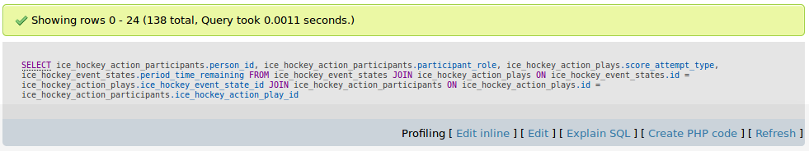**Query:**

**Query Plan:**

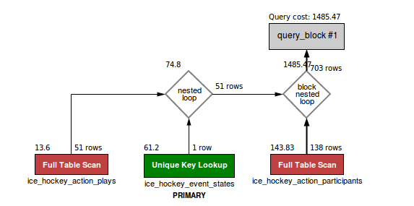

**Terminal:**

mysql> SELECT ice\_hockey\_action\_participants.person\_id, ice\_hockey\_action\_participants.participant\_role, ice\_hockey\_action\_plays.score\_attempt\_type, ice\_hockey\_event\_states.period\_time\_remaining FROM ice\_hockey\_event\_states JOIN ice\_hockey\_action\_plays ON ice\_hockey\_event\_states.id = ice\_hockey\_action\_plays.ice\_hockey\_event\_state\_id JOIN ice\_hockey\_action\_participants ON ice\_hockey\_action\_plays.id = ice\_hockey\_action\_participants.ice\_hockey\_action\_play\_id;

+-----------+------------------+--------------------+-----------------------+

| person\_id | participant\_role | score\_attempt\_type | period\_time\_remaining |

+-----------+------------------+--------------------+-----------------------+

| 1817 | goal | power-play | 7:54 |

| 1818 | assist | power-play | 7:54 |

| 1819 | assist | power-play | 7:54 |

| 1820 | goal | regular | 18:12 |

| 1821 | assist | regular | 18:12 |

| 1822 | assist | regular | 18:12 |

| 1823 | goal | regular | 11:40 |

| 1824 | assist | regular | 11:40 |

| 1825 | goal | regular | 14:30 |

| 1826 | assist | regular | 14:30 |

| 1827 | assist | regular | 14:30 |

| 1828 | goal | regular | 2:41 |

| 1829 | assist | regular | 2:41 |

| 1830 | assist | regular | 2:41 |

| 1862 | goal | power-play | 8:47 |

| 1863 | assist | power-play | 8:47 |

| 1864 | assist | power-play | 8:47 |

| 1865 | goal | regular | 15:02 |

| 1866 | assist | regular | 15:02 |

| 1867 | assist | regular | 15:02 |

| 1868 | goal | regular | 11:06 |

| 1869 | assist | regular | 11:06 |

| 1870 | assist | regular | 11:06 |

| 1871 | goal | regular | 17:31 |

| 1872 | assist | regular | 17:31 |

| 1873 | assist | regular | 17:31 |

| 1874 | goal | power-play | 6:41 |

| 1875 | assist | power-play | 6:41 |

| 1876 | assist | power-play | 6:41 |

| 1877 | goal | power-play | 1:52 |

| 1878 | assist | power-play | 1:52 |

| 1879 | assist | power-play | 1:52 |

| 1880 | goal | empty-net | 0:25 |

| 1924 | goal | power-play | 17:39 |

| 1925 | assist | power-play | 17:39 |

| 1926 | assist | power-play | 17:39 |

| 1927 | goal | regular | 14:32 |

| 1928 | assist | regular | 14:32 |

| 1929 | goal | regular | 9:22 |

| 1930 | assist | regular | 9:22 |

| 1931 | assist | regular | 9:22 |

| 1932 | goal | regular | 6:23 |

| 1933 | assist | regular | 6:23 |

| 2197 | assist | regular | 9:40 |

| 2196 | assist | regular | 9:40 |

| 2195 | goal | regular | 9:40 |

| 2199 | assist | short-handed | 8:06 |

| 2198 | goal | short-handed | 8:06 |

| 2202 | assist | power-play | 4:06 |

| 2201 | assist | power-play | 4:06 |

| 2200 | goal | power-play | 4:06 |

| 2205 | assist | regular | 18:44 |

| 2204 | assist | regular | 18:44 |

| 2203 | goal | regular | 18:44 |

| 2208 | assist | power-play | 14:54 |

| 2207 | assist | power-play | 14:54 |

| 2206 | goal | power-play | 14:54 |

| 2211 | assist | power-play | 6:35 |

| 2210 | assist | power-play | 6:35 |

| 2209 | goal | power-play | 6:35 |

| 2214 | assist | regular | 0:10 |

| 2213 | assist | regular | 0:10 |

| 2212 | goal | regular | 0:10 |

| 1972 | goal | power-play | 18:42 |

| 1973 | assist | power-play | 18:42 |

| 1974 | assist | power-play | 18:42 |

| 1975 | goal | regular | 3:14 |

| 1976 | assist | regular | 3:14 |

| 1977 | assist | regular | 3:14 |

| 1978 | goal | power-play | 17:27 |

| 1979 | assist | power-play | 17:27 |

| 1980 | assist | power-play | 17:27 |

| 1981 | goal | regular | 13:56 |

| 1982 | assist | regular | 13:56 |

| 1983 | assist | regular | 13:56 |

| 1984 | goal | power-play | 1:34 |

| 1985 | assist | power-play | 1:34 |

| 2169 | assist | regular | 15:25 |

| 2168 | assist | regular | 15:25 |

| 2167 | goal | regular | 15:25 |

| 2172 | assist | regular | 4:16 |

| 2171 | assist | regular | 4:16 |

| 2170 | goal | regular | 4:16 |

| 2174 | assist | short-handed | 12:19 |

| 2173 | goal | short-handed | 12:19 |

| 2177 | assist | regular | 5:20 |

| 2176 | assist | regular | 5:20 |

| 2175 | goal | regular | 5:20 |

| 2179 | assist | short-handed | 2:21 |

| 2178 | goal | short-handed | 2:21 |

| 2137 | goal | regular | 13:59 |

| 2134 | assist | regular | 13:59 |

| 2138 | assist | regular | 13:59 |

| 2139 | goal | regular | 13:26 |

| 2140 | assist | regular | 13:26 |

| 2141 | assist | regular | 13:26 |

| 3548 | goal | regular | 4:19 |

| 3549 | assist | regular | 4:19 |

| 3550 | assist | regular | 4:19 |

| 3551 | goal | regular | 1:51 |

| 3552 | assist | regular | 1:51 |

| 3553 | assist | regular | 1:51 |

| 3554 | goal | regular | 7:24 |

| 3555 | assist | regular | 7:24 |

| 3556 | assist | regular | 7:24 |

| 3746 | goal | regular | 18:37 |

| 3747 | assist | regular | 18:37 |

| 3748 | assist | regular | 18:37 |

| 3749 | goal | power-play | 16:39 |

| 3750 | assist | power-play | 16:39 |

| 3751 | assist | power-play | 16:39 |

| 3752 | goal | regular | 10:17 |

| 3753 | assist | regular | 10:17 |

| 3754 | assist | regular | 10:17 |

| 3755 | goal | regular | 1:39 |

| 3756 | assist | regular | 1:39 |

| 3757 | assist | regular | 1:39 |

| 3758 | goal | regular | 10:37 |

| 3759 | assist | regular | 10:37 |

| 3760 | goal | regular | 15:40 |

| 3761 | goal | power-play | 0:47 |

| 3776 | goal | regular | 15:47 |

| 3779 | assist | regular | 15:47 |

| 3780 | assist | regular | 15:47 |

| 3774 | goal | short-handed | 15:59 |

| 3781 | assist | short-handed | 15:59 |

| 3782 | assist | short-handed | 15:59 |

| 3925 | goal | regular | 7:31 |

| 3926 | assist | regular | 7:31 |

| 3927 | assist | regular | 7:31 |

| 3928 | goal | regular | 11:57 |

| 3929 | assist | regular | 11:57 |

| 3930 | assist | regular | 11:57 |

| 3937 | assist | power-play | 4:08 |

| 3936 | goal | power-play | 4:08 |

| 3933 | goal | power-play | 18:27 |

| 3934 | assist | power-play | 18:27 |

| 3935 | assist | power-play | 18:27 |

+-----------+------------------+--------------------+-----------------------+

138 rows in set (0.01 sec)

mysql> SHOW STATUS LIKE "last\_query\_cost"; +-----------------+-------------+

| Variable\_name | Value |

+-----------------+-------------+

| Last\_query\_cost | 1485.472635 |

+-----------------+-------------+

1 row in set (0.00 sec)

**WITH HASH INDICES:**

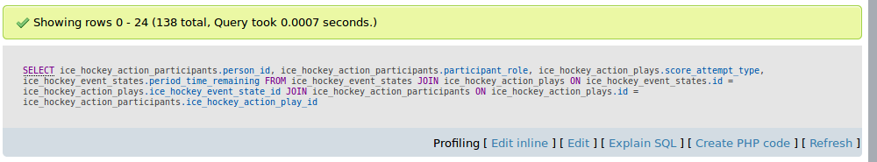**Query:**

**Query Plan:**

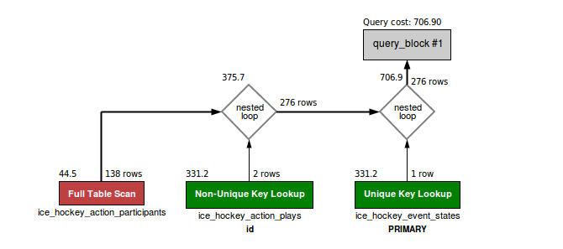

**Terminal:**

mysql> SELECT ice\_hockey\_action\_participants.person\_id, ice\_hockey\_action\_participants.participant\_role, ice\_hockey\_action\_plays.score\_attempt\_type, ice\_hockey\_event\_states.period\_time\_remaining FROM ice\_hockey\_event\_states JOIN ice\_hockey\_action\_plays ON ice\_hockey\_event\_states.id = ice\_hockey\_action\_plays.ice\_hockey\_event\_state\_id JOIN ice\_hockey\_action\_participants ON ice\_hockey\_action\_plays.id = ice\_hockey\_action\_participants.ice\_hockey\_action\_play\_id;

+-----------+------------------+--------------------+-----------------------+

| person\_id | participant\_role | score\_attempt\_type | period\_time\_remaining |

+-----------+------------------+--------------------+-----------------------+

| 1817 | goal | power-play | 7:54 |

| 1818 | assist | power-play | 7:54 |

| 1819 | assist | power-play | 7:54 |

| 1820 | goal | regular | 18:12 |

| 1821 | assist | regular | 18:12 |

| 1822 | assist | regular | 18:12 |

| 1823 | goal | regular | 11:40 |

| 1824 | assist | regular | 11:40 |

| 1825 | goal | regular | 14:30 |

| 1826 | assist | regular | 14:30 |

| 1827 | assist | regular | 14:30 |

| 1828 | goal | regular | 2:41 |

| 1829 | assist | regular | 2:41 |

| 1830 | assist | regular | 2:41 |

| 1862 | goal | power-play | 8:47 |

| 1863 | assist | power-play | 8:47 |

| 1864 | assist | power-play | 8:47 |

| 1865 | goal | regular | 15:02 |

| 1866 | assist | regular | 15:02 |

| 1867 | assist | regular | 15:02 |

| 1868 | goal | regular | 11:06 |

| 1869 | assist | regular | 11:06 |

| 1870 | assist | regular | 11:06 |

| 1871 | goal | regular | 17:31 |

| 1872 | assist | regular | 17:31 |

| 1873 | assist | regular | 17:31 |

| 1874 | goal | power-play | 6:41 |

| 1875 | assist | power-play | 6:41 |

| 1876 | assist | power-play | 6:41 |

| 1877 | goal | power-play | 1:52 |

| 1878 | assist | power-play | 1:52 |

| 1879 | assist | power-play | 1:52 |

| 1880 | goal | empty-net | 0:25 |

| 1924 | goal | power-play | 17:39 |

| 1925 | assist | power-play | 17:39 |

| 1926 | assist | power-play | 17:39 |

| 1927 | goal | regular | 14:32 |

| 1928 | assist | regular | 14:32 |

| 1929 | goal | regular | 9:22 |

| 1930 | assist | regular | 9:22 |

| 1931 | assist | regular | 9:22 |

| 1932 | goal | regular | 6:23 |

| 1933 | assist | regular | 6:23 |

| 2197 | assist | regular | 9:40 |

| 2196 | assist | regular | 9:40 |

| 2195 | goal | regular | 9:40 |

| 2199 | assist | short-handed | 8:06 |

| 2198 | goal | short-handed | 8:06 |

| 2202 | assist | power-play | 4:06 |

| 2201 | assist | power-play | 4:06 |

| 2200 | goal | power-play | 4:06 |

| 2205 | assist | regular | 18:44 |

| 2204 | assist | regular | 18:44 |

| 2203 | goal | regular | 18:44 |

| 2208 | assist | power-play | 14:54 |

| 2207 | assist | power-play | 14:54 |

| 2206 | goal | power-play | 14:54 |

| 2211 | assist | power-play | 6:35 |

| 2210 | assist | power-play | 6:35 |

| 2209 | goal | power-play | 6:35 |

| 2214 | assist | regular | 0:10 |

| 2213 | assist | regular | 0:10 |

| 2212 | goal | regular | 0:10 |

| 1972 | goal | power-play | 18:42 |

| 1973 | assist | power-play | 18:42 |

| 1974 | assist | power-play | 18:42 |

| 1975 | goal | regular | 3:14 |

| 1976 | assist | regular | 3:14 |

| 1977 | assist | regular | 3:14 |

| 1978 | goal | power-play | 17:27 |

| 1979 | assist | power-play | 17:27 |

| 1980 | assist | power-play | 17:27 |

| 1981 | goal | regular | 13:56 |

| 1982 | assist | regular | 13:56 |

| 1983 | assist | regular | 13:56 |

| 1984 | goal | power-play | 1:34 |

| 1985 | assist | power-play | 1:34 |

| 2169 | assist | regular | 15:25 |

| 2168 | assist | regular | 15:25 |

| 2167 | goal | regular | 15:25 |

| 2172 | assist | regular | 4:16 |

| 2171 | assist | regular | 4:16 |

| 2170 | goal | regular | 4:16 |

| 2174 | assist | short-handed | 12:19 |

| 2173 | goal | short-handed | 12:19 |

| 2177 | assist | regular | 5:20 |

| 2176 | assist | regular | 5:20 |

| 2175 | goal | regular | 5:20 |

| 2179 | assist | short-handed | 2:21 |

| 2178 | goal | short-handed | 2:21 |

| 2137 | goal | regular | 13:59 |

| 2134 | assist | regular | 13:59 |

| 2138 | assist | regular | 13:59 |

| 2139 | goal | regular | 13:26 |

| 2140 | assist | regular | 13:26 |

| 2141 | assist | regular | 13:26 |

| 3548 | goal | regular | 4:19 |

| 3549 | assist | regular | 4:19 |

| 3550 | assist | regular | 4:19 |

| 3551 | goal | regular | 1:51 |

| 3552 | assist | regular | 1:51 |

| 3553 | assist | regular | 1:51 |

| 3554 | goal | regular | 7:24 |

| 3555 | assist | regular | 7:24 |

| 3556 | assist | regular | 7:24 |

| 3746 | goal | regular | 18:37 |

| 3747 | assist | regular | 18:37 |

| 3748 | assist | regular | 18:37 |

| 3749 | goal | power-play | 16:39 |

| 3750 | assist | power-play | 16:39 |

| 3751 | assist | power-play | 16:39 |

| 3752 | goal | regular | 10:17 |

| 3753 | assist | regular | 10:17 |

| 3754 | assist | regular | 10:17 |

| 3755 | goal | regular | 1:39 |

| 3756 | assist | regular | 1:39 |

| 3757 | assist | regular | 1:39 |

| 3758 | goal | regular | 10:37 |

| 3759 | assist | regular | 10:37 |

| 3760 | goal | regular | 15:40 |

| 3761 | goal | power-play | 0:47 |

| 3776 | goal | regular | 15:47 |

| 3779 | assist | regular | 15:47 |

| 3780 | assist | regular | 15:47 |

| 3774 | goal | short-handed | 15:59 |

| 3781 | assist | short-handed | 15:59 |

| 3782 | assist | short-handed | 15:59 |

| 3925 | goal | regular | 7:31 |

| 3926 | assist | regular | 7:31 |

| 3927 | assist | regular | 7:31 |

| 3928 | goal | regular | 11:57 |

| 3929 | assist | regular | 11:57 |

| 3930 | assist | regular | 11:57 |

| 3937 | assist | power-play | 4:08 |

| 3936 | goal | power-play | 4:08 |

| 3933 | goal | power-play | 18:27 |

| 3934 | assist | power-play | 18:27 |

| 3935 | assist | power-play | 18:27 |

+-----------+------------------+--------------------+-----------------------+

138 rows in set (0.01 sec)

mysql> SHOW STATUS LIKE "last\_query\_cost"; +-----------------+------------+

| Variable\_name | Value |

+-----------------+------------+

| Last\_query\_cost | 706.899000 |

+-----------------+------------+

1 row in set (0.00 sec)

**DROPPING ALL INDICES:**

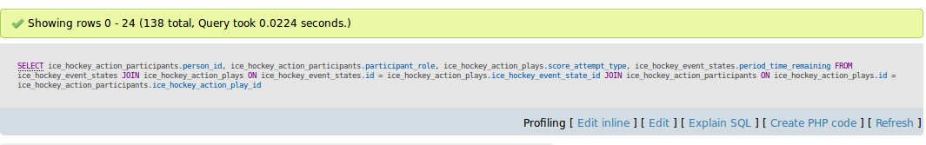**Query:**

**Query Plan:**

****

**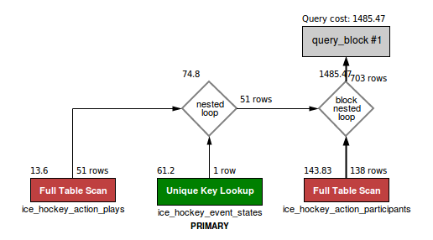**

**Terminal:**

mysql> SELECT ice\_hockey\_action\_participants.person\_id, ice\_hockey\_action\_participants.participant\_role, ice\_hockey\_action\_plays.score\_attempt\_type, ice\_hockey\_event\_states.period\_time\_remaining FROM ice\_hockey\_event\_states JOIN ice\_hockey\_action\_plays ON ice\_hockey\_event\_states.id = ice\_hockey\_action\_plays.ice\_hockey\_event\_state\_id JOIN ice\_hockey\_action\_participants ON ice\_hockey\_action\_plays.id = ice\_hockey\_action\_participants.ice\_hockey\_action\_play\_id;

+-----------+------------------+--------------------+-----------------------+

| person\_id | participant\_role | score\_attempt\_type | period\_time\_remaining |

+-----------+------------------+--------------------+-----------------------+

| 1817 | goal | power-play | 7:54 |

| 1818 | assist | power-play | 7:54 |

| 1819 | assist | power-play | 7:54 |

| 1820 | goal | regular | 18:12 |

| 1821 | assist | regular | 18:12 |

| 1822 | assist | regular | 18:12 |

| 1823 | goal | regular | 11:40 |

| 1824 | assist | regular | 11:40 |

| 1825 | goal | regular | 14:30 |

| 1826 | assist | regular | 14:30 |

| 1827 | assist | regular | 14:30 |

| 1828 | goal | regular | 2:41 |

| 1829 | assist | regular | 2:41 |

| 1830 | assist | regular | 2:41 |

| 1862 | goal | power-play | 8:47 |

| 1863 | assist | power-play | 8:47 |

| 1864 | assist | power-play | 8:47 |

| 1865 | goal | regular | 15:02 |

| 1866 | assist | regular | 15:02 |

| 1867 | assist | regular | 15:02 |

| 1868 | goal | regular | 11:06 |

| 1869 | assist | regular | 11:06 |

| 1870 | assist | regular | 11:06 |

| 1871 | goal | regular | 17:31 |

| 1872 | assist | regular | 17:31 |

| 1873 | assist | regular | 17:31 |

| 1874 | goal | power-play | 6:41 |

| 1875 | assist | power-play | 6:41 |

| 1876 | assist | power-play | 6:41 |

| 1877 | goal | power-play | 1:52 |

| 1878 | assist | power-play | 1:52 |

| 1879 | assist | power-play | 1:52 |

| 1880 | goal | empty-net | 0:25 |

| 1924 | goal | power-play | 17:39 |

| 1925 | assist | power-play | 17:39 |

| 1926 | assist | power-play | 17:39 |

| 1927 | goal | regular | 14:32 |

| 1928 | assist | regular | 14:32 |

| 1929 | goal | regular | 9:22 |

| 1930 | assist | regular | 9:22 |

| 1931 | assist | regular | 9:22 |

| 1932 | goal | regular | 6:23 |

| 1933 | assist | regular | 6:23 |

| 2197 | assist | regular | 9:40 |

| 2196 | assist | regular | 9:40 |

| 2195 | goal | regular | 9:40 |

| 2199 | assist | short-handed | 8:06 |

| 2198 | goal | short-handed | 8:06 |

| 2202 | assist | power-play | 4:06 |

| 2201 | assist | power-play | 4:06 |

| 2200 | goal | power-play | 4:06 |

| 2205 | assist | regular | 18:44 |

| 2204 | assist | regular | 18:44 |

| 2203 | goal | regular | 18:44 |

| 2208 | assist | power-play | 14:54 |

| 2207 | assist | power-play | 14:54 |

| 2206 | goal | power-play | 14:54 |

| 2211 | assist | power-play | 6:35 |

| 2210 | assist | power-play | 6:35 |

| 2209 | goal | power-play | 6:35 |

| 2214 | assist | regular | 0:10 |

| 2213 | assist | regular | 0:10 |

| 2212 | goal | regular | 0:10 |

| 1972 | goal | power-play | 18:42 |

| 1973 | assist | power-play | 18:42 |

| 1974 | assist | power-play | 18:42 |

| 1975 | goal | regular | 3:14 |

| 1976 | assist | regular | 3:14 |

| 1977 | assist | regular | 3:14 |

| 1978 | goal | power-play | 17:27 |

| 1979 | assist | power-play | 17:27 |

| 1980 | assist | power-play | 17:27 |

| 1981 | goal | regular | 13:56 |

| 1982 | assist | regular | 13:56 |

| 1983 | assist | regular | 13:56 |

| 1984 | goal | power-play | 1:34 |

| 1985 | assist | power-play | 1:34 |

| 2169 | assist | regular | 15:25 |

| 2168 | assist | regular | 15:25 |

| 2167 | goal | regular | 15:25 |

| 2172 | assist | regular | 4:16 |

| 2171 | assist | regular | 4:16 |

| 2170 | goal | regular | 4:16 |

| 2174 | assist | short-handed | 12:19 |

| 2173 | goal | short-handed | 12:19 |

| 2177 | assist | regular | 5:20 |

| 2176 | assist | regular | 5:20 |

| 2175 | goal | regular | 5:20 |

| 2179 | assist | short-handed | 2:21 |

| 2178 | goal | short-handed | 2:21 |

| 2137 | goal | regular | 13:59 |

| 2134 | assist | regular | 13:59 |

| 2138 | assist | regular | 13:59 |

| 2139 | goal | regular | 13:26 |

| 2140 | assist | regular | 13:26 |

| 2141 | assist | regular | 13:26 |

| 3548 | goal | regular | 4:19 |

| 3549 | assist | regular | 4:19 |

| 3550 | assist | regular | 4:19 |

| 3551 | goal | regular | 1:51 |

| 3552 | assist | regular | 1:51 |

| 3553 | assist | regular | 1:51 |

| 3554 | goal | regular | 7:24 |

| 3555 | assist | regular | 7:24 |

| 3556 | assist | regular | 7:24 |

| 3746 | goal | regular | 18:37 |

| 3747 | assist | regular | 18:37 |

| 3748 | assist | regular | 18:37 |

| 3749 | goal | power-play | 16:39 |

| 3750 | assist | power-play | 16:39 |

| 3751 | assist | power-play | 16:39 |

| 3752 | goal | regular | 10:17 |

| 3753 | assist | regular | 10:17 |

| 3754 | assist | regular | 10:17 |

| 3755 | goal | regular | 1:39 |

| 3756 | assist | regular | 1:39 |

| 3757 | assist | regular | 1:39 |

| 3758 | goal | regular | 10:37 |

| 3759 | assist | regular | 10:37 |

| 3760 | goal | regular | 15:40 |

| 3761 | goal | power-play | 0:47 |

| 3776 | goal | regular | 15:47 |

| 3779 | assist | regular | 15:47 |

| 3780 | assist | regular | 15:47 |

| 3774 | goal | short-handed | 15:59 |

| 3781 | assist | short-handed | 15:59 |

| 3782 | assist | short-handed | 15:59 |

| 3925 | goal | regular | 7:31 |

| 3926 | assist | regular | 7:31 |

| 3927 | assist | regular | 7:31 |

| 3928 | goal | regular | 11:57 |

| 3929 | assist | regular | 11:57 |

| 3930 | assist | regular | 11:57 |

| 3937 | assist | power-play | 4:08 |

| 3936 | goal | power-play | 4:08 |

| 3933 | goal | power-play | 18:27 |

| 3934 | assist | power-play | 18:27 |

| 3935 | assist | power-play | 18:27 |

+-----------+------------------+--------------------+-----------------------+

138 rows in set (0.04 sec)

mysql> SHOW STATUS LIKE "last\_query\_cost";

+-----------------+-------------+

| Variable\_name | Value |

+-----------------+-------------+

| Last\_query\_cost | 1485.472635 |

+-----------------+-------------+

1 row in set (0.01 sec)

**2.Obtaining offensive statistics of all people related to ice\_hockey.**

**WITH B TREE INDICES:**

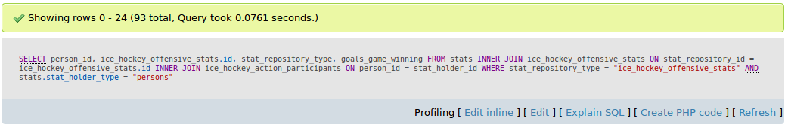**Query:**

**Query Plan:**

**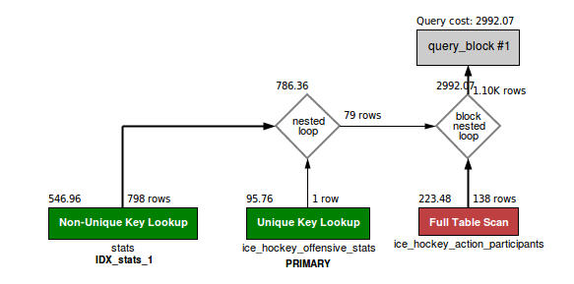**

**Terminal:**

mysql> SELECT person\_id, ice\_hockey\_offensive\_stats.id, stat\_repository\_type, goals\_game\_winning FROM stats INNER JOIN ice\_hockey\_offensive\_stats ON stat\_repository\_id = ice\_hockey\_offensive\_stats.id INNER JOIN ice\_hockey\_action\_participants ON person\_id = stat\_holder\_id WHERE stat\_repository\_type = "ice\_hockey\_offensive\_stats" AND stats.stat\_holder\_type = "persons";

+-----------+------+----------------------------+--------------------+

| person\_id | id | stat\_repository\_type | goals\_game\_winning |

+-----------+------+----------------------------+--------------------+

| 1817 | 4 | ice\_hockey\_offensive\_stats | 0 |

| 1818 | 7 | ice\_hockey\_offensive\_stats | 0 |

| 1819 | 8 | ice\_hockey\_offensive\_stats | 0 |

| 1821 | 3 | ice\_hockey\_offensive\_stats | 0 |

| 1822 | 5 | ice\_hockey\_offensive\_stats | 0 |

| 1823 | 28 | ice\_hockey\_offensive\_stats | 0 |

| 1823 | 48 | ice\_hockey\_offensive\_stats | 0 |

| 1824 | 25 | ice\_hockey\_offensive\_stats | 0 |

| 1824 | 50 | ice\_hockey\_offensive\_stats | 0 |

| 1825 | 22 | ice\_hockey\_offensive\_stats | 1 |

| 1825 | 45 | ice\_hockey\_offensive\_stats | 1 |

| 1826 | 24 | ice\_hockey\_offensive\_stats | 0 |

| 1826 | 47 | ice\_hockey\_offensive\_stats | 0 |

| 1827 | 26 | ice\_hockey\_offensive\_stats | 0 |

| 1827 | 55 | ice\_hockey\_offensive\_stats | 0 |

| 1829 | 27 | ice\_hockey\_offensive\_stats | 0 |

| 1829 | 49 | ice\_hockey\_offensive\_stats | 0 |

| 1830 | 23 | ice\_hockey\_offensive\_stats | 0 |

| 1830 | 53 | ice\_hockey\_offensive\_stats | 0 |

| 1863 | 70 | ice\_hockey\_offensive\_stats | 0 |

| 1863 | 108 | ice\_hockey\_offensive\_stats | 0 |

| 1864 | 72 | ice\_hockey\_offensive\_stats | 0 |

| 1864 | 109 | ice\_hockey\_offensive\_stats | 0 |

| 1865 | 69 | ice\_hockey\_offensive\_stats | 0 |

| 1865 | 107 | ice\_hockey\_offensive\_stats | 0 |

| 1868 | 73 | ice\_hockey\_offensive\_stats | 1 |

| 1868 | 120 | ice\_hockey\_offensive\_stats | 1 |

| 1871 | 89 | ice\_hockey\_offensive\_stats | 0 |

| 1871 | 136 | ice\_hockey\_offensive\_stats | 0 |

| 1872 | 88 | ice\_hockey\_offensive\_stats | 0 |

| 1872 | 142 | ice\_hockey\_offensive\_stats | 0 |

| 1873 | 90 | ice\_hockey\_offensive\_stats | 0 |

| 1873 | 140 | ice\_hockey\_offensive\_stats | 0 |

| 1879 | 91 | ice\_hockey\_offensive\_stats | 0 |

| 1879 | 135 | ice\_hockey\_offensive\_stats | 0 |

| 1975 | 313 | ice\_hockey\_offensive\_stats | 0 |

| 1975 | 701 | ice\_hockey\_offensive\_stats | 0 |

| 1976 | 314 | ice\_hockey\_offensive\_stats | 0 |

| 1976 | 696 | ice\_hockey\_offensive\_stats | 0 |

| 1977 | 312 | ice\_hockey\_offensive\_stats | 0 |

| 1977 | 697 | ice\_hockey\_offensive\_stats | 0 |

| 1978 | 316 | ice\_hockey\_offensive\_stats | 0 |

| 1978 | 690 | ice\_hockey\_offensive\_stats | 0 |

| 1979 | 315 | ice\_hockey\_offensive\_stats | 0 |

| 1979 | 691 | ice\_hockey\_offensive\_stats | 1 |

| 2137 | 530 | ice\_hockey\_offensive\_stats | 0 |

| 2134 | 531 | ice\_hockey\_offensive\_stats | 0 |

| 2138 | 529 | ice\_hockey\_offensive\_stats | 0 |

| 2139 | 510 | ice\_hockey\_offensive\_stats | 0 |

| 2140 | 512 | ice\_hockey\_offensive\_stats | 0 |

| 2141 | 511 | ice\_hockey\_offensive\_stats | 0 |

| 3548 | 823 | ice\_hockey\_offensive\_stats | 1 |

| 3548 | 849 | ice\_hockey\_offensive\_stats | 1 |

| 3549 | 824 | ice\_hockey\_offensive\_stats | 0 |

| 3549 | 858 | ice\_hockey\_offensive\_stats | 0 |

| 3550 | 829 | ice\_hockey\_offensive\_stats | 0 |

| 3550 | 847 | ice\_hockey\_offensive\_stats | 1 |

| 3551 | 828 | ice\_hockey\_offensive\_stats | 0 |

| 3551 | 842 | ice\_hockey\_offensive\_stats | 2 |

| 3552 | 826 | ice\_hockey\_offensive\_stats | 0 |

| 3552 | 844 | ice\_hockey\_offensive\_stats | 0 |

| 3554 | 827 | ice\_hockey\_offensive\_stats | 0 |

| 3554 | 845 | ice\_hockey\_offensive\_stats | 0 |

| 3556 | 825 | ice\_hockey\_offensive\_stats | 0 |

| 3556 | 857 | ice\_hockey\_offensive\_stats | 0 |

| 3746 | 895 | ice\_hockey\_offensive\_stats | 0 |

| 3746 | 931 | ice\_hockey\_offensive\_stats | 1 |

| 3747 | 893 | ice\_hockey\_offensive\_stats | 0 |

| 3747 | 934 | ice\_hockey\_offensive\_stats | 0 |

| 3748 | 896 | ice\_hockey\_offensive\_stats | 0 |

| 3748 | 935 | ice\_hockey\_offensive\_stats | 0 |

| 3750 | 900 | ice\_hockey\_offensive\_stats | 0 |

| 3750 | 941 | ice\_hockey\_offensive\_stats | 0 |

| 3751 | 899 | ice\_hockey\_offensive\_stats | 0 |

| 3751 | 939 | ice\_hockey\_offensive\_stats | 0 |

| 3755 | 894 | ice\_hockey\_offensive\_stats | 1 |

| 3755 | 933 | ice\_hockey\_offensive\_stats | 1 |

| 3756 | 897 | ice\_hockey\_offensive\_stats | 0 |

| 3756 | 936 | ice\_hockey\_offensive\_stats | 1 |

| 3757 | 892 | ice\_hockey\_offensive\_stats | 0 |

| 3757 | 932 | ice\_hockey\_offensive\_stats | 2 |

| 3760 | 898 | ice\_hockey\_offensive\_stats | 0 |

| 3760 | 940 | ice\_hockey\_offensive\_stats | 0 |

| 3776 | 1006 | ice\_hockey\_offensive\_stats | 0 |

| 3776 | 1052 | ice\_hockey\_offensive\_stats | 1 |

| 3780 | 1007 | ice\_hockey\_offensive\_stats | 0 |

| 3780 | 1050 | ice\_hockey\_offensive\_stats | 2 |

| 3774 | 987 | ice\_hockey\_offensive\_stats | 0 |

| 3774 | 1029 | ice\_hockey\_offensive\_stats | 1 |

| 3781 | 988 | ice\_hockey\_offensive\_stats | 0 |

| 3781 | 1032 | ice\_hockey\_offensive\_stats | 0 |

| 3782 | 989 | ice\_hockey\_offensive\_stats | 0 |

| 3782 | 1038 | ice\_hockey\_offensive\_stats | 0 |

+-----------+------+----------------------------+--------------------+

93 rows in set (0.04 sec)

mysql> SHOW STATUS LIKE "last\_query\_cost"; +-----------------+-------------+

| Variable\_name | Value |

+-----------------+-------------+

| Last\_query\_cost | 2992.068216 |

+-----------------+-------------+

1 row in set (0.00 sec)

**WITH HASH INDICES:**

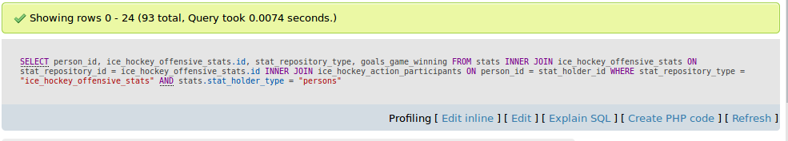**Query:**

**Query Plan:**

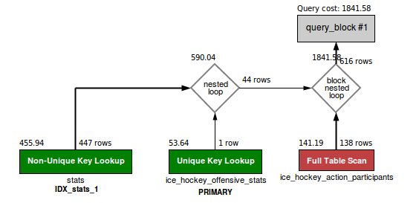

**Terminal:**

SELECT person\_id, ice\_hockey\_offensive\_stats.id, stat\_repository\_type, goals\_game\_winning FROM stats INNER JOIN ice\_hockey\_offensive\_stats ON stat\_repository\_id = ice\_hockey\_offensive\_stats.id INNER JOIN ice\_hockey\_action\_participants ON person\_id = stat\_holder\_id WHERE stat\_repository\_type = "ice\_hockey\_offensive\_stats" AND stats.stat\_holder\_type = "persons";

+-----------+------+----------------------------+--------------------+

| person\_id | id | stat\_repository\_type | goals\_game\_winning |

+-----------+------+----------------------------+--------------------+

| 1817 | 4 | ice\_hockey\_offensive\_stats | 0 |

| 1818 | 7 | ice\_hockey\_offensive\_stats | 0 |

| 1819 | 8 | ice\_hockey\_offensive\_stats | 0 |

| 1821 | 3 | ice\_hockey\_offensive\_stats | 0 |

| 1822 | 5 | ice\_hockey\_offensive\_stats | 0 |

| 1823 | 28 | ice\_hockey\_offensive\_stats | 0 |

| 1823 | 48 | ice\_hockey\_offensive\_stats | 0 |

| 1824 | 25 | ice\_hockey\_offensive\_stats | 0 |

| 1824 | 50 | ice\_hockey\_offensive\_stats | 0 |

| 1825 | 22 | ice\_hockey\_offensive\_stats | 1 |

| 1825 | 45 | ice\_hockey\_offensive\_stats | 1 |

| 1826 | 24 | ice\_hockey\_offensive\_stats | 0 |

| 1826 | 47 | ice\_hockey\_offensive\_stats | 0 |

| 1827 | 26 | ice\_hockey\_offensive\_stats | 0 |

| 1827 | 55 | ice\_hockey\_offensive\_stats | 0 |

| 1829 | 27 | ice\_hockey\_offensive\_stats | 0 |

| 1829 | 49 | ice\_hockey\_offensive\_stats | 0 |

| 1830 | 23 | ice\_hockey\_offensive\_stats | 0 |

| 1830 | 53 | ice\_hockey\_offensive\_stats | 0 |

| 1863 | 70 | ice\_hockey\_offensive\_stats | 0 |

| 1863 | 108 | ice\_hockey\_offensive\_stats | 0 |

| 1864 | 72 | ice\_hockey\_offensive\_stats | 0 |

| 1864 | 109 | ice\_hockey\_offensive\_stats | 0 |

| 1865 | 69 | ice\_hockey\_offensive\_stats | 0 |

| 1865 | 107 | ice\_hockey\_offensive\_stats | 0 |

| 1868 | 73 | ice\_hockey\_offensive\_stats | 1 |

| 1868 | 120 | ice\_hockey\_offensive\_stats | 1 |

| 1871 | 89 | ice\_hockey\_offensive\_stats | 0 |

| 1871 | 136 | ice\_hockey\_offensive\_stats | 0 |

| 1872 | 88 | ice\_hockey\_offensive\_stats | 0 |

| 1872 | 142 | ice\_hockey\_offensive\_stats | 0 |

| 1873 | 90 | ice\_hockey\_offensive\_stats | 0 |

| 1873 | 140 | ice\_hockey\_offensive\_stats | 0 |

| 1879 | 91 | ice\_hockey\_offensive\_stats | 0 |

| 1879 | 135 | ice\_hockey\_offensive\_stats | 0 |

| 1975 | 313 | ice\_hockey\_offensive\_stats | 0 |

| 1975 | 701 | ice\_hockey\_offensive\_stats | 0 |

| 1976 | 314 | ice\_hockey\_offensive\_stats | 0 |

| 1976 | 696 | ice\_hockey\_offensive\_stats | 0 |

| 1977 | 312 | ice\_hockey\_offensive\_stats | 0 |

| 1977 | 697 | ice\_hockey\_offensive\_stats | 0 |

| 1978 | 316 | ice\_hockey\_offensive\_stats | 0 |

| 1978 | 690 | ice\_hockey\_offensive\_stats | 0 |

| 1979 | 315 | ice\_hockey\_offensive\_stats | 0 |

| 1979 | 691 | ice\_hockey\_offensive\_stats | 1 |

| 2137 | 530 | ice\_hockey\_offensive\_stats | 0 |

| 2134 | 531 | ice\_hockey\_offensive\_stats | 0 |

| 2138 | 529 | ice\_hockey\_offensive\_stats | 0 |

| 2139 | 510 | ice\_hockey\_offensive\_stats | 0 |

| 2140 | 512 | ice\_hockey\_offensive\_stats | 0 |

| 2141 | 511 | ice\_hockey\_offensive\_stats | 0 |

| 3548 | 823 | ice\_hockey\_offensive\_stats | 1 |

| 3548 | 849 | ice\_hockey\_offensive\_stats | 1 |

| 3549 | 824 | ice\_hockey\_offensive\_stats | 0 |

| 3549 | 858 | ice\_hockey\_offensive\_stats | 0 |

| 3550 | 829 | ice\_hockey\_offensive\_stats | 0 |

| 3550 | 847 | ice\_hockey\_offensive\_stats | 1 |

| 3551 | 828 | ice\_hockey\_offensive\_stats | 0 |

| 3551 | 842 | ice\_hockey\_offensive\_stats | 2 |

| 3552 | 826 | ice\_hockey\_offensive\_stats | 0 |

| 3552 | 844 | ice\_hockey\_offensive\_stats | 0 |

| 3554 | 827 | ice\_hockey\_offensive\_stats | 0 |

| 3554 | 845 | ice\_hockey\_offensive\_stats | 0 |

| 3556 | 825 | ice\_hockey\_offensive\_stats | 0 |

| 3556 | 857 | ice\_hockey\_offensive\_stats | 0 |

| 3746 | 895 | ice\_hockey\_offensive\_stats | 0 |

| 3746 | 931 | ice\_hockey\_offensive\_stats | 1 |

| 3747 | 893 | ice\_hockey\_offensive\_stats | 0 |

| 3747 | 934 | ice\_hockey\_offensive\_stats | 0 |

| 3748 | 896 | ice\_hockey\_offensive\_stats | 0 |

| 3748 | 935 | ice\_hockey\_offensive\_stats | 0 |

| 3750 | 900 | ice\_hockey\_offensive\_stats | 0 |

| 3750 | 941 | ice\_hockey\_offensive\_stats | 0 |

| 3751 | 899 | ice\_hockey\_offensive\_stats | 0 |

| 3751 | 939 | ice\_hockey\_offensive\_stats | 0 |

| 3755 | 894 | ice\_hockey\_offensive\_stats | 1 |

| 3755 | 933 | ice\_hockey\_offensive\_stats | 1 |

| 3756 | 897 | ice\_hockey\_offensive\_stats | 0 |

| 3756 | 936 | ice\_hockey\_offensive\_stats | 1 |

| 3757 | 892 | ice\_hockey\_offensive\_stats | 0 |

| 3757 | 932 | ice\_hockey\_offensive\_stats | 2 |

| 3760 | 898 | ice\_hockey\_offensive\_stats | 0 |

| 3760 | 940 | ice\_hockey\_offensive\_stats | 0 |

| 3776 | 1006 | ice\_hockey\_offensive\_stats | 0 |

| 3776 | 1052 | ice\_hockey\_offensive\_stats | 1 |

| 3780 | 1007 | ice\_hockey\_offensive\_stats | 0 |

| 3780 | 1050 | ice\_hockey\_offensive\_stats | 2 |

| 3774 | 987 | ice\_hockey\_offensive\_stats | 0 |

| 3774 | 1029 | ice\_hockey\_offensive\_stats | 1 |

| 3781 | 988 | ice\_hockey\_offensive\_stats | 0 |

| 3781 | 1032 | ice\_hockey\_offensive\_stats | 0 |

| 3782 | 989 | ice\_hockey\_offensive\_stats | 0 |

| 3782 | 1038 | ice\_hockey\_offensive\_stats | 0 |

+-----------+------+----------------------------+--------------------+

93 rows in set (0.02 sec)

mysql> SHOW STATUS LIKE "last\_query\_cost";

+-----------------+-------------+

| Variable\_name | Value |

+-----------------+-------------+

| Last\_query\_cost | 1841.578293 |

+-----------------+-------------+

1 row in set (0.00 sec)

**DROPPING ALL INDICES:**

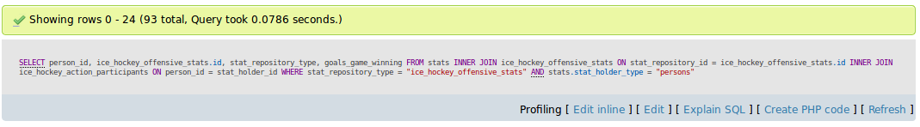**Query:**

**Query Plan:**

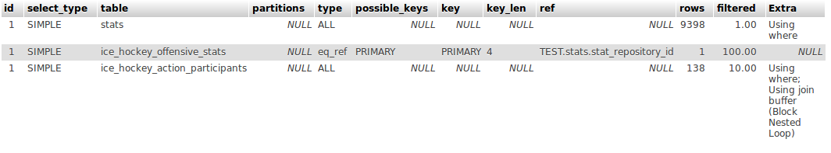

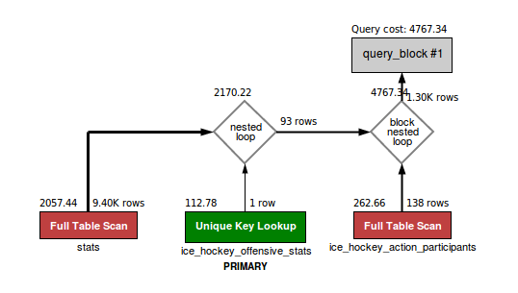

**Terminal:**

mysql> SELECT person\_id, ice\_hockey\_offensive\_stats.id, stat\_repository\_type, goals\_game\_winning FROM stats INNER JOIN ice\_hockey\_offensive\_stats ON stat\_repository\_id = ice\_hockey\_offensive\_stats.id INNER JOIN ice\_hockey\_action\_participants ON person\_id = stat\_holder\_id WHERE stat\_repository\_type = "ice\_hockey\_offensive\_stats" AND stats.stat\_holder\_type = "persons";

+-----------+------+----------------------------+--------------------+

| person\_id | id | stat\_repository\_type | goals\_game\_winning |

+-----------+------+----------------------------+--------------------+

| 1817 | 4 | ice\_hockey\_offensive\_stats | 0 |

| 1818 | 7 | ice\_hockey\_offensive\_stats | 0 |

| 1819 | 8 | ice\_hockey\_offensive\_stats | 0 |

| 1821 | 3 | ice\_hockey\_offensive\_stats | 0 |

| 1822 | 5 | ice\_hockey\_offensive\_stats | 0 |

| 1823 | 28 | ice\_hockey\_offensive\_stats | 0 |

| 1823 | 48 | ice\_hockey\_offensive\_stats | 0 |

| 1824 | 25 | ice\_hockey\_offensive\_stats | 0 |

| 1824 | 50 | ice\_hockey\_offensive\_stats | 0 |

| 1825 | 22 | ice\_hockey\_offensive\_stats | 1 |

| 1825 | 45 | ice\_hockey\_offensive\_stats | 1 |

| 1826 | 24 | ice\_hockey\_offensive\_stats | 0 |

| 1826 | 47 | ice\_hockey\_offensive\_stats | 0 |

| 1827 | 26 | ice\_hockey\_offensive\_stats | 0 |

| 1827 | 55 | ice\_hockey\_offensive\_stats | 0 |

| 1829 | 27 | ice\_hockey\_offensive\_stats | 0 |

| 1829 | 49 | ice\_hockey\_offensive\_stats | 0 |

| 1830 | 23 | ice\_hockey\_offensive\_stats | 0 |

| 1830 | 53 | ice\_hockey\_offensive\_stats | 0 |

| 1863 | 70 | ice\_hockey\_offensive\_stats | 0 |

| 1863 | 108 | ice\_hockey\_offensive\_stats | 0 |

| 1864 | 72 | ice\_hockey\_offensive\_stats | 0 |

| 1864 | 109 | ice\_hockey\_offensive\_stats | 0 |

| 1865 | 69 | ice\_hockey\_offensive\_stats | 0 |

| 1865 | 107 | ice\_hockey\_offensive\_stats | 0 |

| 1868 | 73 | ice\_hockey\_offensive\_stats | 1 |

| 1868 | 120 | ice\_hockey\_offensive\_stats | 1 |

| 1871 | 89 | ice\_hockey\_offensive\_stats | 0 |

| 1871 | 136 | ice\_hockey\_offensive\_stats | 0 |

| 1872 | 88 | ice\_hockey\_offensive\_stats | 0 |

| 1872 | 142 | ice\_hockey\_offensive\_stats | 0 |

| 1873 | 90 | ice\_hockey\_offensive\_stats | 0 |

| 1873 | 140 | ice\_hockey\_offensive\_stats | 0 |

| 1879 | 91 | ice\_hockey\_offensive\_stats | 0 |

| 1879 | 135 | ice\_hockey\_offensive\_stats | 0 |

| 1975 | 313 | ice\_hockey\_offensive\_stats | 0 |

| 1975 | 701 | ice\_hockey\_offensive\_stats | 0 |

| 1976 | 314 | ice\_hockey\_offensive\_stats | 0 |

| 1976 | 696 | ice\_hockey\_offensive\_stats | 0 |

| 1977 | 312 | ice\_hockey\_offensive\_stats | 0 |

| 1977 | 697 | ice\_hockey\_offensive\_stats | 0 |

| 1978 | 316 | ice\_hockey\_offensive\_stats | 0 |

| 1978 | 690 | ice\_hockey\_offensive\_stats | 0 |

| 1979 | 315 | ice\_hockey\_offensive\_stats | 0 |

| 1979 | 691 | ice\_hockey\_offensive\_stats | 1 |

| 2137 | 530 | ice\_hockey\_offensive\_stats | 0 |

| 2134 | 531 | ice\_hockey\_offensive\_stats | 0 |

| 2138 | 529 | ice\_hockey\_offensive\_stats | 0 |

| 2139 | 510 | ice\_hockey\_offensive\_stats | 0 |

| 2140 | 512 | ice\_hockey\_offensive\_stats | 0 |

| 2141 | 511 | ice\_hockey\_offensive\_stats | 0 |

| 3548 | 823 | ice\_hockey\_offensive\_stats | 1 |

| 3548 | 849 | ice\_hockey\_offensive\_stats | 1 |

| 3549 | 824 | ice\_hockey\_offensive\_stats | 0 |

| 3549 | 858 | ice\_hockey\_offensive\_stats | 0 |

| 3550 | 829 | ice\_hockey\_offensive\_stats | 0 |

| 3550 | 847 | ice\_hockey\_offensive\_stats | 1 |

| 3551 | 828 | ice\_hockey\_offensive\_stats | 0 |

| 3551 | 842 | ice\_hockey\_offensive\_stats | 2 |

| 3552 | 826 | ice\_hockey\_offensive\_stats | 0 |

| 3552 | 844 | ice\_hockey\_offensive\_stats | 0 |

| 3554 | 827 | ice\_hockey\_offensive\_stats | 0 |

| 3554 | 845 | ice\_hockey\_offensive\_stats | 0 |

| 3556 | 825 | ice\_hockey\_offensive\_stats | 0 |

| 3556 | 857 | ice\_hockey\_offensive\_stats | 0 |

| 3746 | 895 | ice\_hockey\_offensive\_stats | 0 |

| 3746 | 931 | ice\_hockey\_offensive\_stats | 1 |

| 3747 | 893 | ice\_hockey\_offensive\_stats | 0 |

| 3747 | 934 | ice\_hockey\_offensive\_stats | 0 |

| 3748 | 896 | ice\_hockey\_offensive\_stats | 0 |

| 3748 | 935 | ice\_hockey\_offensive\_stats | 0 |

| 3750 | 900 | ice\_hockey\_offensive\_stats | 0 |

| 3750 | 941 | ice\_hockey\_offensive\_stats | 0 |

| 3751 | 899 | ice\_hockey\_offensive\_stats | 0 |

| 3751 | 939 | ice\_hockey\_offensive\_stats | 0 |

| 3755 | 894 | ice\_hockey\_offensive\_stats | 1 |

| 3755 | 933 | ice\_hockey\_offensive\_stats | 1 |

| 3756 | 897 | ice\_hockey\_offensive\_stats | 0 |

| 3756 | 936 | ice\_hockey\_offensive\_stats | 1 |

| 3757 | 892 | ice\_hockey\_offensive\_stats | 0 |

| 3757 | 932 | ice\_hockey\_offensive\_stats | 2 |

| 3760 | 898 | ice\_hockey\_offensive\_stats | 0 |

| 3760 | 940 | ice\_hockey\_offensive\_stats | 0 |

| 3776 | 1006 | ice\_hockey\_offensive\_stats | 0 |

| 3776 | 1052 | ice\_hockey\_offensive\_stats | 1 |

| 3780 | 1007 | ice\_hockey\_offensive\_stats | 0 |

| 3780 | 1050 | ice\_hockey\_offensive\_stats | 2 |

| 3774 | 987 | ice\_hockey\_offensive\_stats | 0 |

| 3774 | 1029 | ice\_hockey\_offensive\_stats | 1 |

| 3781 | 988 | ice\_hockey\_offensive\_stats | 0 |

| 3781 | 1032 | ice\_hockey\_offensive\_stats | 0 |

| 3782 | 989 | ice\_hockey\_offensive\_stats | 0 |

| 3782 | 1038 | ice\_hockey\_offensive\_stats | 0 |

+-----------+------+----------------------------+--------------------+

93 rows in set (0.05 sec)

mysql> SHOW STATUS LIKE "last\_query\_cost"; +-----------------+-------------+

| Variable\_name | Value |

+-----------------+-------------+

| Last\_query\_cost | 4767.342845 |

+-----------------+-------------+

1 row in set (0.00 sec)

**PROCEDURES:**

1) CREATE DEFINER=`root`@`localhost`

PROCEDURE `statsinfo`(IN `type` VARCHAR(100), OUT `count\_details` INT ZEROFILL, OUT `max\_of\_details` [INT](http://localhost/phpmyadmin/url.php?url=http://dev.mysql.com/doc/refman/5.5/en/numeric-types.html) ZEROFILL) NOT DETERMINISTIC NO SQL SQL SECURITY DEFINER

BEGIN

[SET](http://localhost/phpmyadmin/url.php?url=http://dev.mysql.com/doc/refman/5.5/en/set.html) count\_details = ([SELECT](http://localhost/phpmyadmin/url.php?url=http://dev.mysql.com/doc/refman/5.5/en/select.html) COUNT(id) as count\_details FROM stats WHERE stats.stat\_repository\_type = type AND stats.stat\_holder\_type = "persons");

[SET](http://localhost/phpmyadmin/url.php?url=http://dev.mysql.com/doc/refman/5.5/en/set.html) max\_of\_details = ([SELECT](http://localhost/phpmyadmin/url.php?url=http://dev.mysql.com/doc/refman/5.5/en/select.html) MAX(id) as count\_details FROM stats WHERE stats.stat\_repository\_type = type AND stats.stat\_holder\_type = "persons");

END

2)CREATE DEFINER=`root`@`localhost` PROCEDURE `get\_score\_attempt`(IN `p\_id` INT, OUT `score\_attempt` [VARCHAR](http://localhost/phpmyadmin/url.php?url=http://dev.mysql.com/doc/refman/5.5/en/string-types.html)(100)) [NOT](http://localhost/phpmyadmin/url.php?url=http://dev.mysql.com/doc/refman/5.5/en/logical-operators.html" \l "_blank) DETERMINISTIC READS SQL DATA SQL SECURITY DEFINER

[SET](http://localhost/phpmyadmin/url.php?url=http://dev.mysql.com/doc/refman/5.5/en/set.html) score\_attempt = ([SELECT](http://localhost/phpmyadmin/url.php?url=http://dev.mysql.com/doc/refman/5.5/en/select.html) score\_attempt\_type FROM ice\_hockey\_action\_plays INNER JOIN ice\_hockey\_action\_participants ON ice\_hockey\_action\_participants.ice\_hockey\_action\_play\_id = ice\_hockey\_action\_plays.id WHERE ice\_hockey\_action\_participants.person\_id = p\_id)

**COMPARISION:**

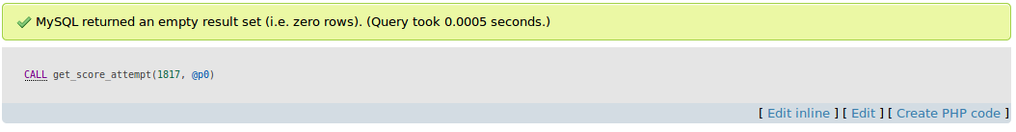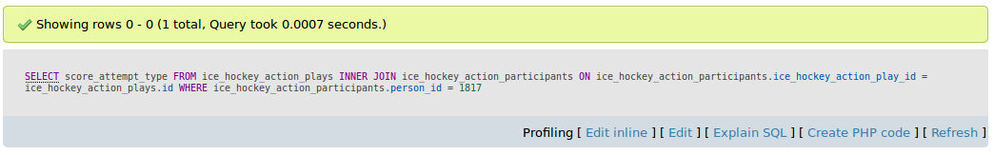

**QUERY PLAN:**

