# AgroBot - Outputs (Task 1)

## 1. Registration Page

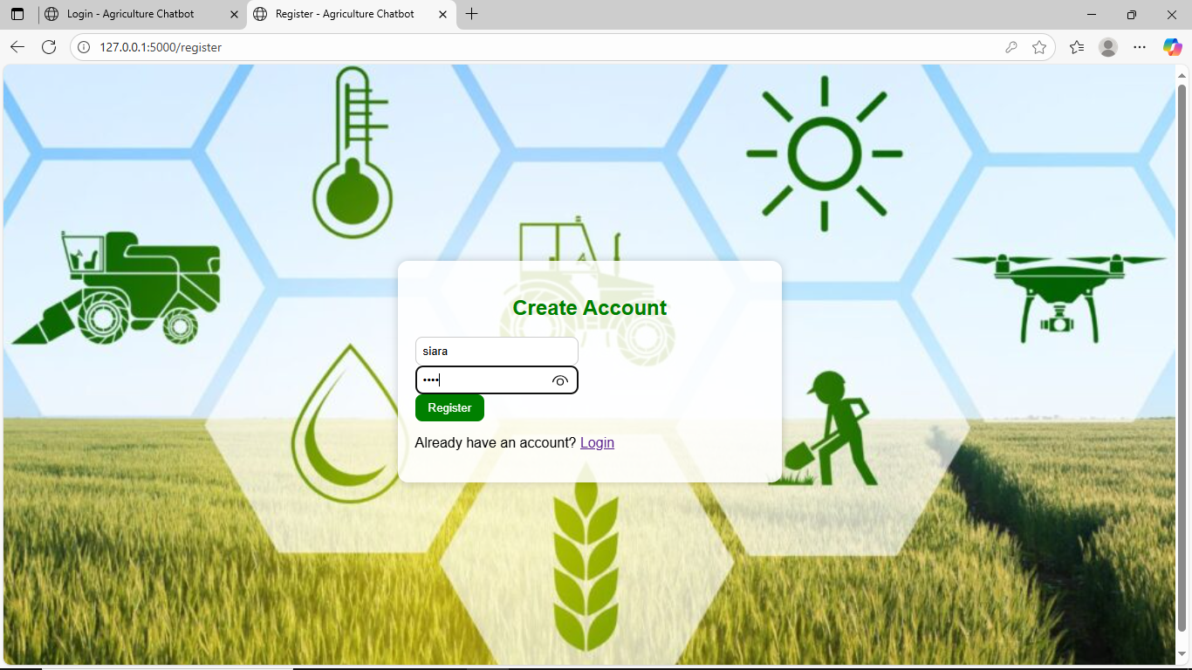

This page allows users to create a new account.

## 2. Login Page

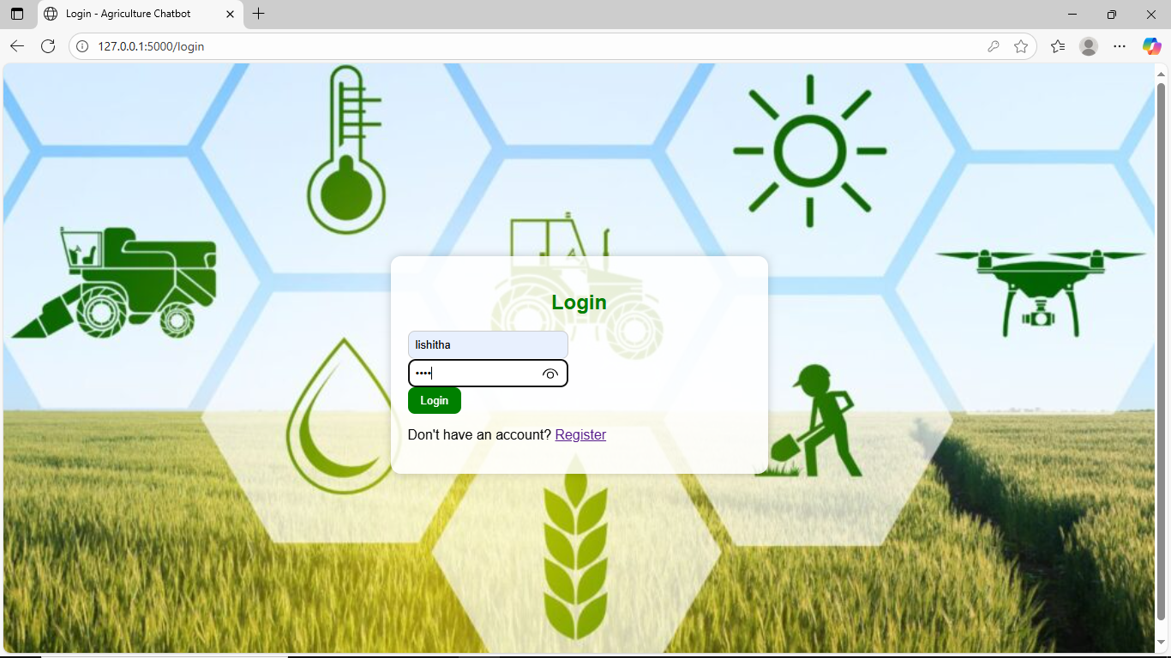

This page allows users to log in securely to the chatbot.

## 3. Chatbot Page

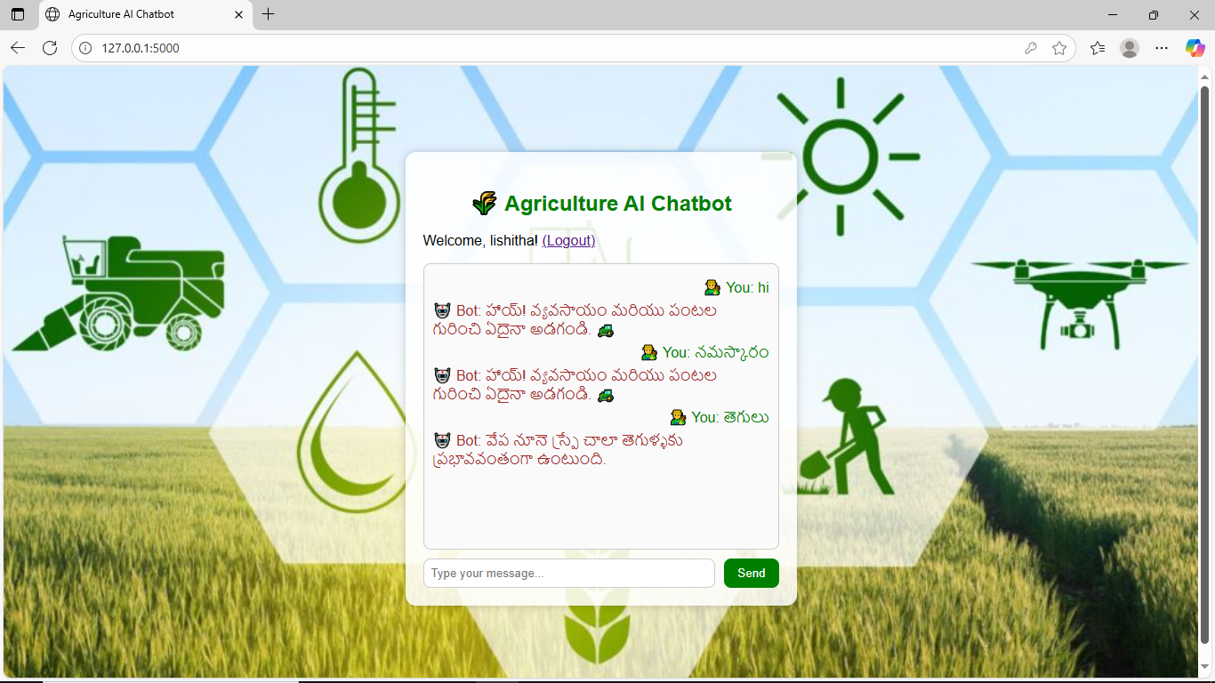

This page provides farming-related chatbot interaction.