AGOL ID Population Documentation

## Background

This ArcPy script tool is used for automatically populating and managing the ‘IDENTIFIER’ field in AGOL feature layers, ensuring consistency and proper formatting of ‘IDENTIFIER’ field values.

## Acronyms

* AGOL = ArcGIS Online
* FL = Feature Layer

## High level workflow

The script tool:

* Defines class FL_ID_Population:
  + **Initializer:** Sets up the class with instance arguments and performs initial searches/queries.
  + **Logging:** Methods include error handling and logging. The output .txt logfile is saved to the user input log location (see #3 in the "Tool parameters" section for more).
  + **Methods:** 
    1. FeatureLayerSearch(self): searches for the input FL and returns its FL ID
    2. ZeroPadAndAdd(self, input): Extracts digits from the input string, converts to integer type and adds 1 to the value, then converts back to string and pads the numeric string with zeros so that the character length == 6.
    3. PrefixCheck(self): Extracts characters from 'IDENTIFIER' field values and adds them to a set, checks to see if the user input prefix is included in the set... if not, it adds a warning message.
    4. NullCheck(self): Checks to see if there are any empty 'IDENTIFIER' values in the user input FL... operation is aborted if none are found.
    5. UpdateIDs(self): Populates empty 'IDENTIFIER' field values in the user input FL.
* The `FL_ID_Population` class is then used to:
  + Connect to an AGOL portal (determined by the portal that ArcPro is connected to when the tool is run)
  + Search for a specific feature layer
  + Query and manipulate ‘IDENTIFIER’ field values in that FL
  + Populate empty ‘IDENTIFIER’ field values with updated values

*NOTE:*

UpdateIDs() is the core functionality... it:

* Checks for consistency in prefixes
* Iterates through features in the input FL
* Assigns new ‘IDENTIFIER’ values to features that don’t have one while ensuring that the new values are incremented properly and are six characters long

## Script diagram

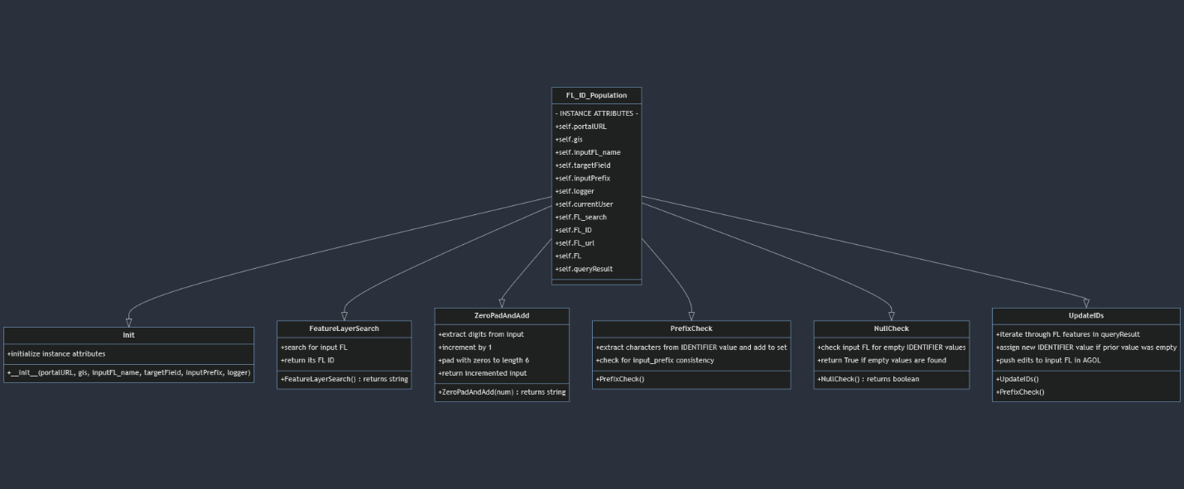

Visual representation of the “FL_ID_Population” class.

## Tool parameters

There are three parameters set by the user:

1. **Target Feature Layer:**

This is the feature layer hosted in ArcGIS Online or Portal that the user wants to update. The tool should auto-populate the available feature layers in the currently active Portal connection.

1. **ID Prefix:**

String to be used as the prefix for new IDENTIFIER values. For example, inputting “ABC” in this parameter will generate values ABC000001, ABC000002, etc.

1. **Logfile Directory:**

This is the directory where logfiles are generated and saved. Each run of the tool will generate a new logfile with a timestamp indicating when the tool ran.

* The timestamp is in "%Y%m%d%H%M%S" format.
  + EX: “FL_ID_Population_20240708153045.txt”

