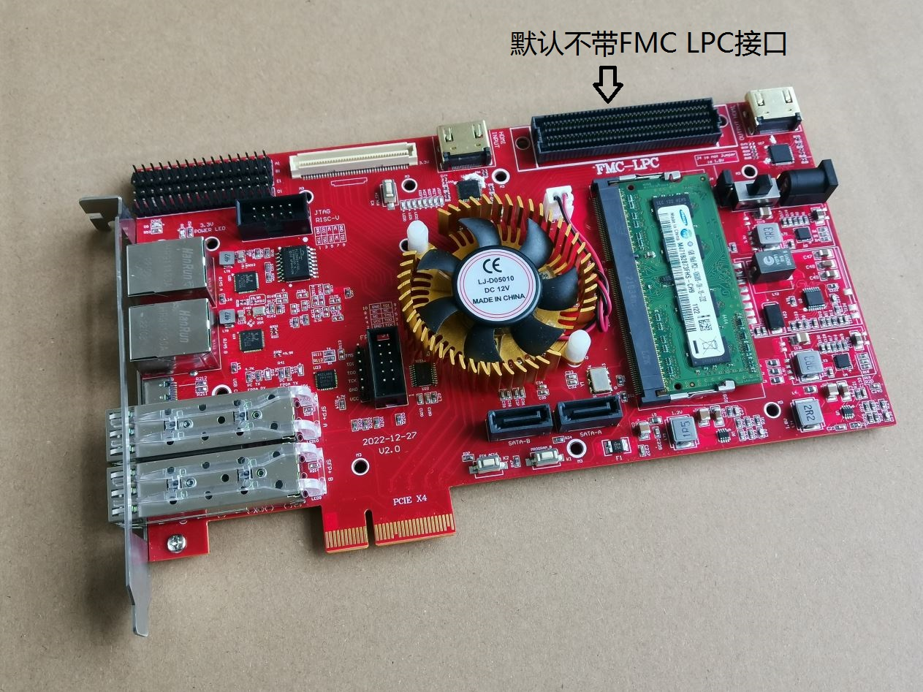

PCIE test (the default is the PCIE test project on the board, no need to download repeatedly)

The test code of PCIe is the test code of the board when it leaves the factory. The board is plugged into the main board of the computer. Under normal circumstances, LED7 will not light up. LED6 will blink. Home desktop self-test is faster. Generally, after starting up, LED7 will go out. If it is a server, the self-inspection time is relatively long, and it will take a while for LED7 to go out.

We are using riffa open source code, and it can only be used on WIN7 64-bit system. Other systems cannot be used. Users who need other functions can refer to other learning codes I gave. We are here just to verify the functionality of PCIe.

You can choose to download the bit file to the board, or download the mcs file to the flash of the board. The download bit file we selected during the test. More convenient. The default program on the board is the PCIe firmware

The PCIe interface will actively supply power to the board. When using PCIE, no external power supply is required. Our PCIe interface is GEN2.0 X4, the theoretical speed is 20G bps bandwidth

Step 1: Insert the board into the PCIE interface of the computer, the physical interface of the board is the size of X4. Your computer motherboard must have at least one PCIE interface that can insert this card. If your computer has an integrated graphics card, you can directly plug it into a free PCIE slot. If your computer has two PCIEX16 interfaces. Or one X16 and one X8. Users need to pay attention to the secondary PCIEX16 interface of the motherboard. Generally, the actual signal is only X4, some have achieved X8, and some have only X1. The sub-jack is only compatible with X16 in appearance, but it is not actually an X16 data link.

Step 2: Download the FPGA code provided by the open source riffa to the board. If you download a bit file, you need to restart the computer, but do not power off the motherboard. If the mcs file is downloaded, it needs to be turned off and on, so that the FPGA can be reloaded.

The picture below shows that after downloading the bit file, select the computer to restart, so that the motherboard will not be powered off.

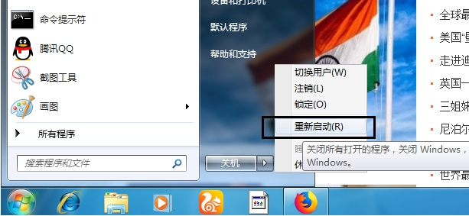

Step 3: After waiting for the restart, you can find the device in the system

Shown is a PCI standard RAM controller, but this is not what we want. To reinstall the driver for him.

There is a driver installation package under the riffa_2.0.2\riffa_2.0.2\install\windows\win7 directory. Just install

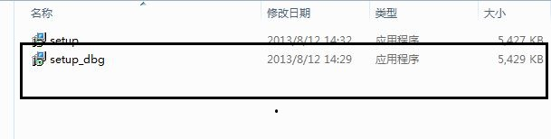

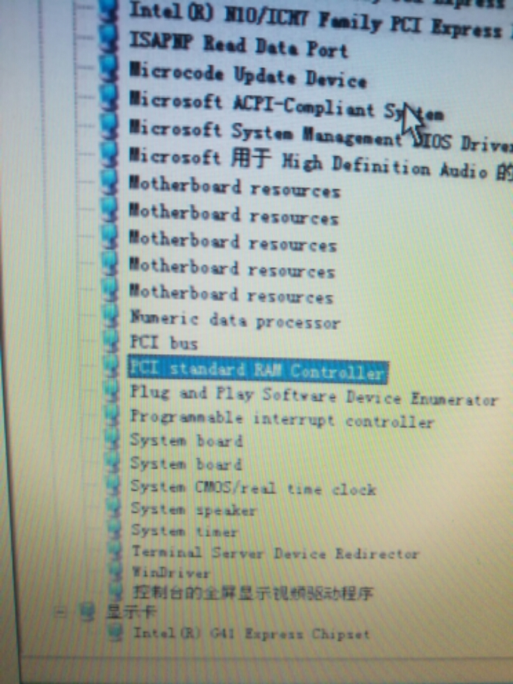

If an exclamation mark appears, the driver is not installed properly. At this time, you try to disable digital signatures.

After installing the setup_dbg.exe driver, if it shows that the driver is not installed, you can try to restart the computer, it must be restarted.

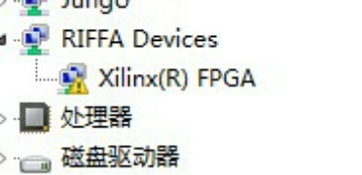

The driver is installed, and there is no exclamation mark under normal circumstances. As shown in the figure below, it can be tested.

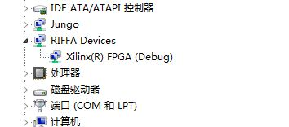

Then find the CMD icon in the C:\Windows\System32 directory, and choose to run as an administrator

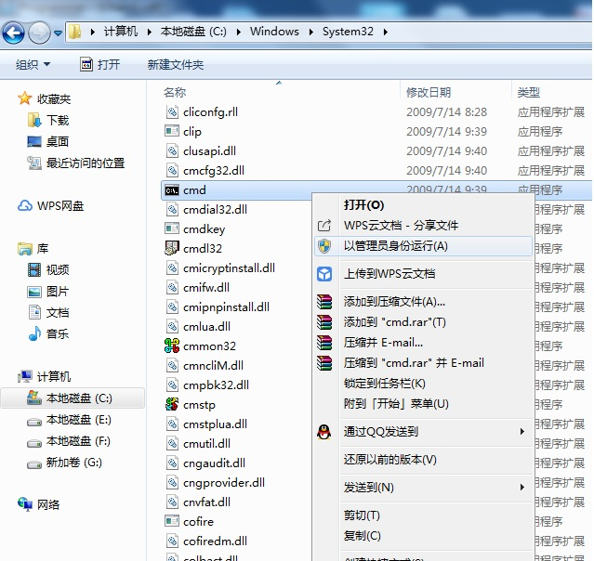

Run the CMD interface

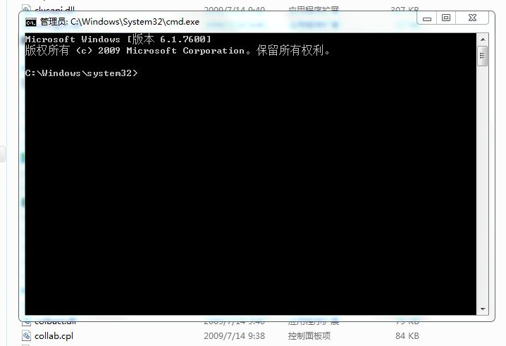

Enter information cd C:\Program Files\Riffa\c_c++ on the DOS interface and press Enter

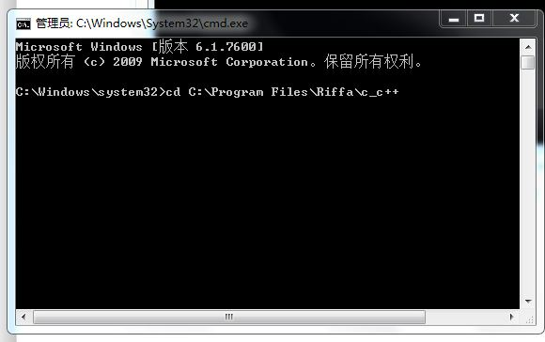

After pressing the Enter key, the display as shown below will appear. Indicates that the installation path of Riffa has been entered

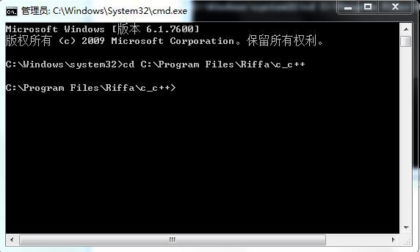

Then enter testutil.exe 0, and then press Enter.

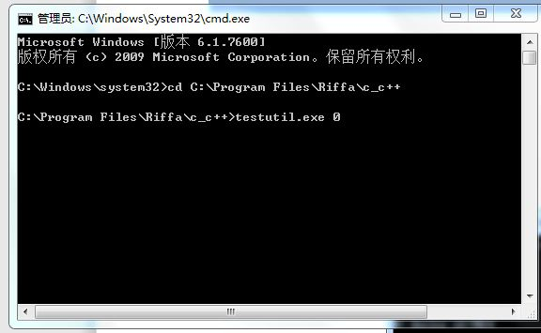

The DOS interface will display the message that the board is found.

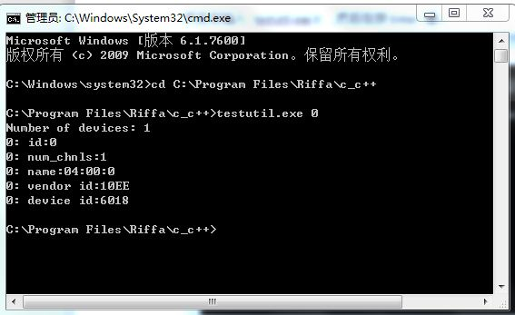

Then enter testutil.exe 2 0 0 10000000 and press Enter to test the board

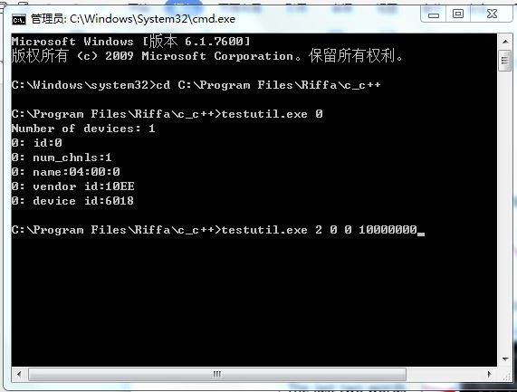

The following is the test data. The actual bandwidth of GEN2.0 X4 depends on your computer configuration. Maybe your test is higher or lower than mine. But generally around 1500M bytes. Some computers can upload more than 1600 Mbytes per second.

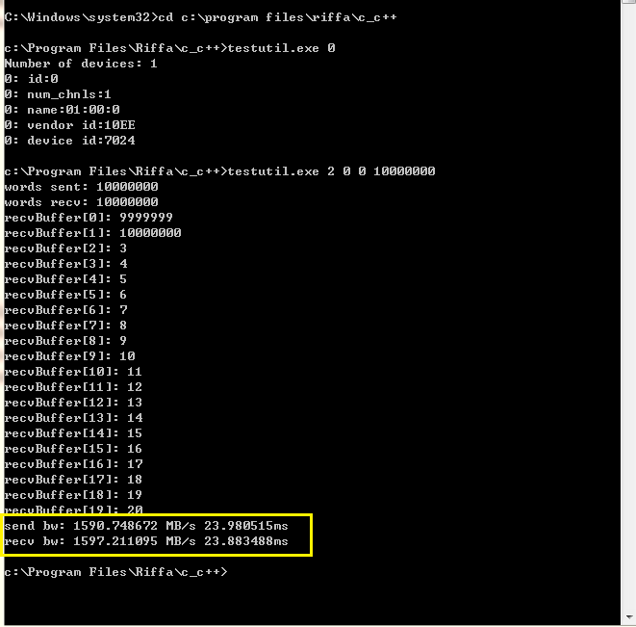

2: Talk about testing the 1000M network, the system is WIN7 or WIN10. The test methods of the two network cards on the board are the same. 88E1111 is gimm mode. Use a 1000M network cable to connect with the computer network card. Then the corresponding network card of the computer will show that 1G is connected.

Note that you must first download the program to the FPGA, and then connect the network cable to the computer. Then arp binds the IP address of the board. Download rgmii_a.bit to FPGA.

The NIC testing process is the same for both versions, I haven't updated the pictures yet.

The NIC testing process is the same for both versions, I haven't updated the pictures yet.

The NIC testing process is the same for both versions, I haven't updated the pictures yet.

If the connection between the computer and the network card is normal, the LED10 LED11 of the RJ45 A port will light up

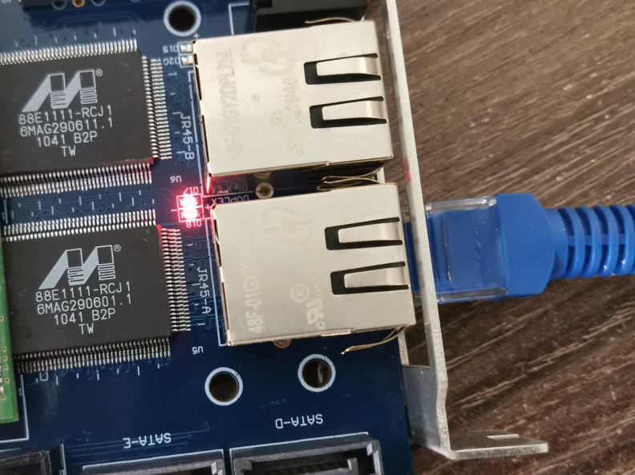

If the connection between the computer and the network card is normal, the LED12 and LED13 of the RJ45 B port will light up

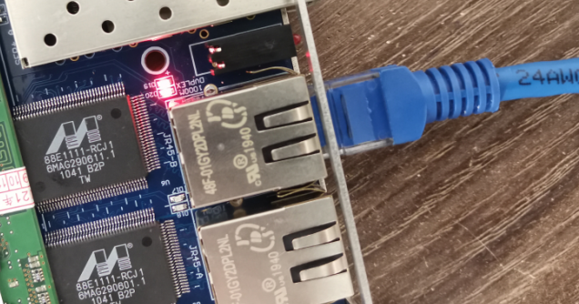

You can see that the local connection shows 1G

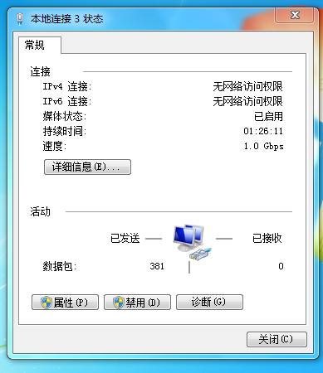

Then set the IP address of the computer to 192.168.1.37. Mask 255.255.255.0. These can be changed in the program.

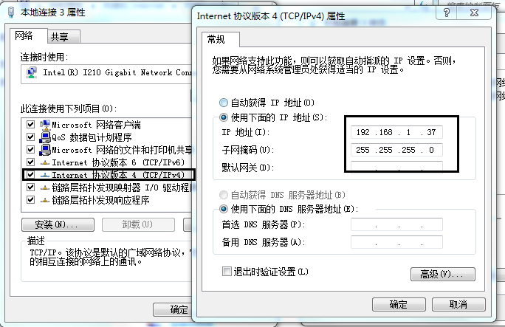

Then find the command prompt in the WINDOS menu and choose to run as an administrator. This step is to bind the IP address and physical address of the network card, which can be modified in this program. Requires run mode as administrator

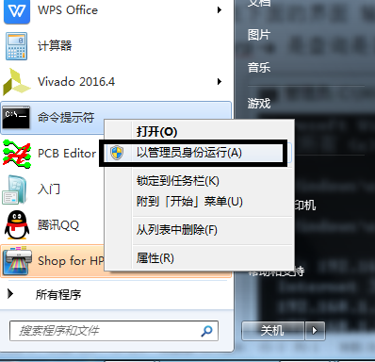

Be careful to re-bind after each boot.

Enter arp -s 192.168.1.183 01-60-6E-11-02-0F in the interface below

Arp -a is to check whether the binding is successful. Success will be displayed. Note that there are spaces when binding the address.

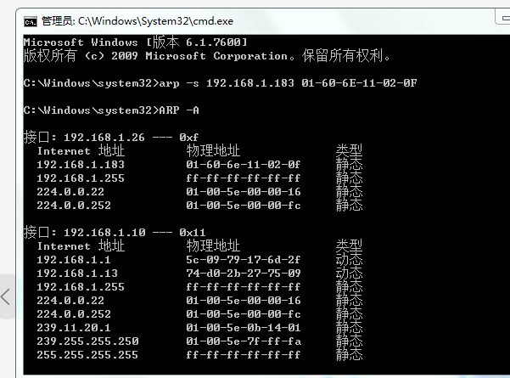

Then open the network debugging tool, set according to the requirements of the figure, select 192.168.1.37

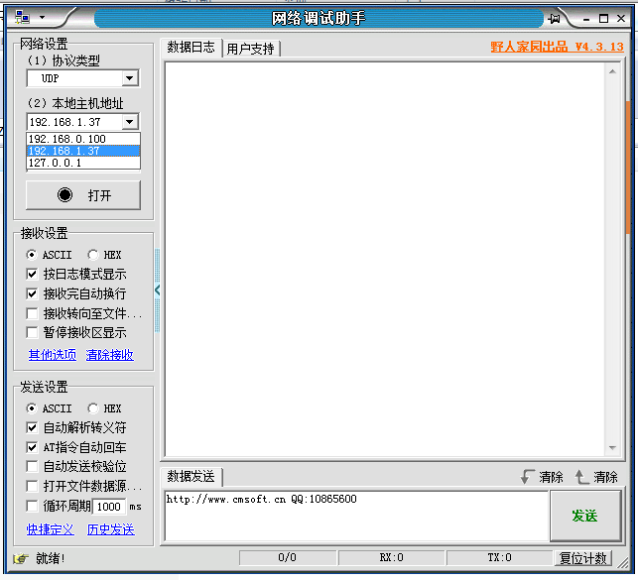

Port number write 8080, click to open

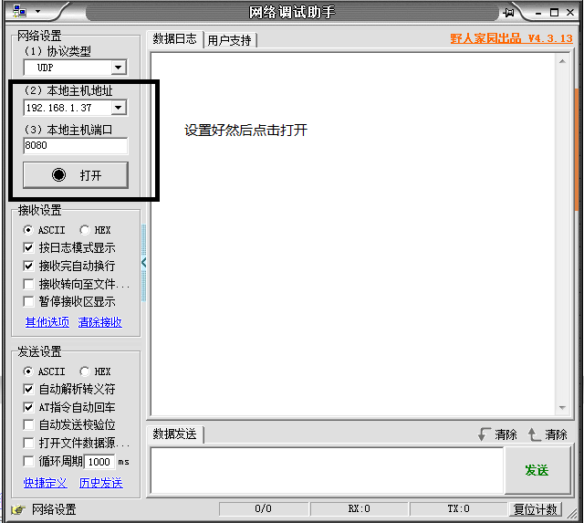

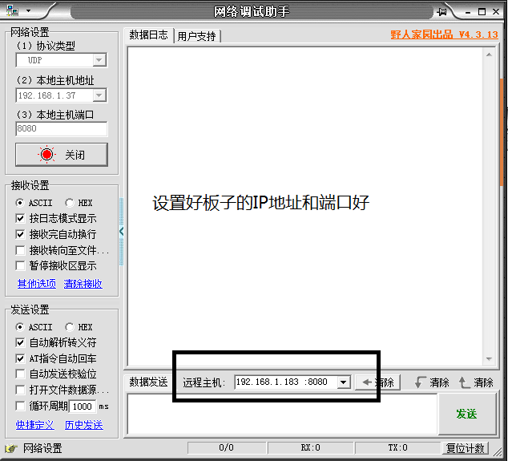

Note that the setting steps are wrong, and the sending and receiving data will not work. Sometimes I make a mistake, and I can only receive data but not send it out.

Fill in the data you want to send in the sending area, and the board will always send the data to the computer when it receives it

As shown below

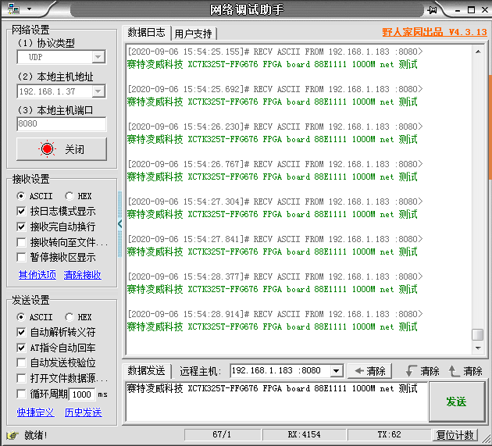

The test process of the network card is probably like this. The test method of the two ports of RJ45A and RJ45B is the same. The IP address of the board has been bound to the arp just now, and there is no need to bind it again when testing another network port. If you want to test this at the next boot, you must rebind.

Only network card and PCIe tests are more troublesome. Other tests are relatively simple

HDMI color display test, after downloading, you can press the button K3, and different information will be displayed.

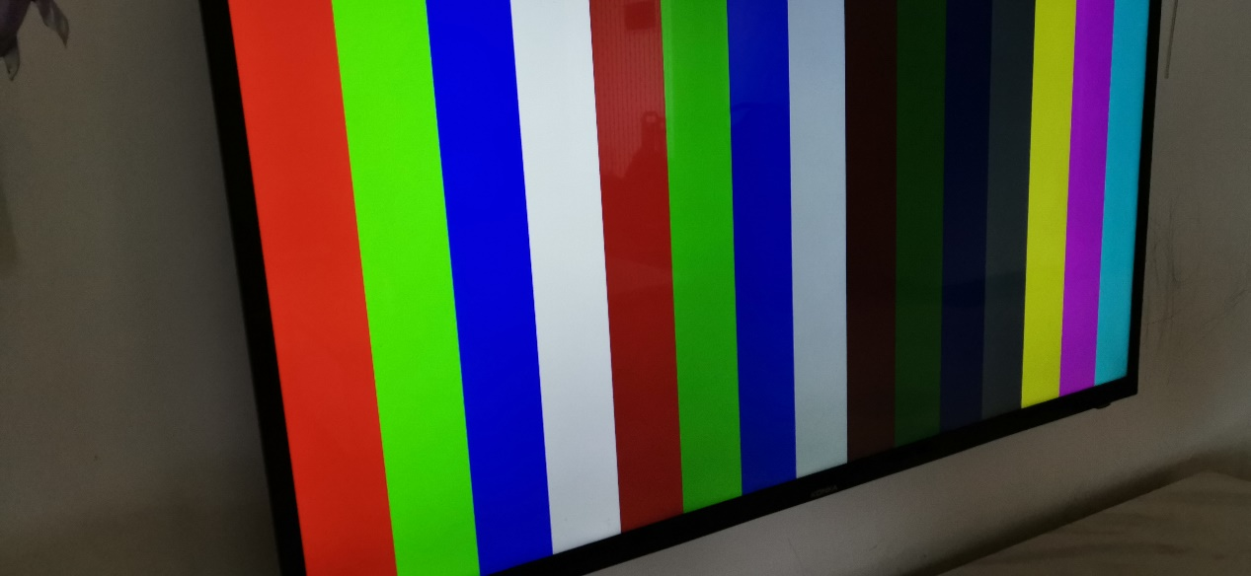

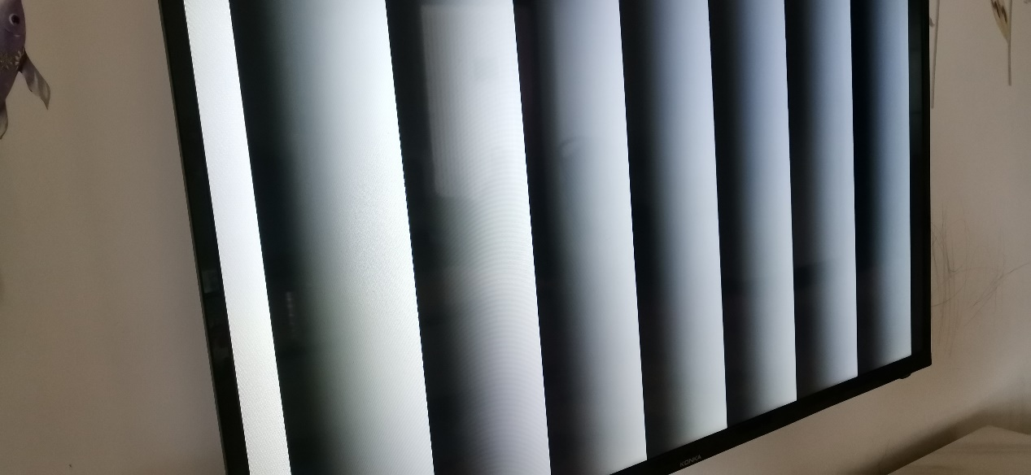

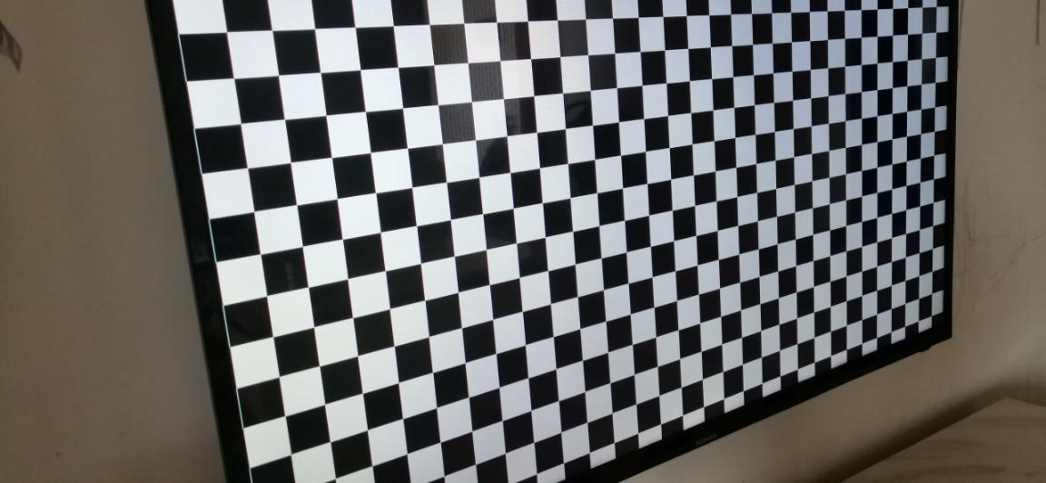

HDMI input and output test

The HDMI signal is input through the INPUT, and then output and displayed through the output. Maximum support for 1920X1080 resolution. The HDMI data cable should use a better quality cable. I tested 3 lines. The lengths are 1.5M, 0.5M and 0.3M lines respectively. Among them, the display effect of the 1.5M and 0.5M lines is basically the same. The display effect of 0.3M is not as good as the previous two lines. I consulted an expert player and said that some data may not be aligned during timing analysis.

When testing the HDMI input and output, I found a problem. I used the HDMI input of the computer graphics card to the FPGA board, and the HDMI output of the FPGA can output and display normally. Then I used the HDMI signal of the telecom TV box at home and another brand of network TV box to input the FPGA board, but there was no output from the board. Not sure what the problem is. I will not modify the code.

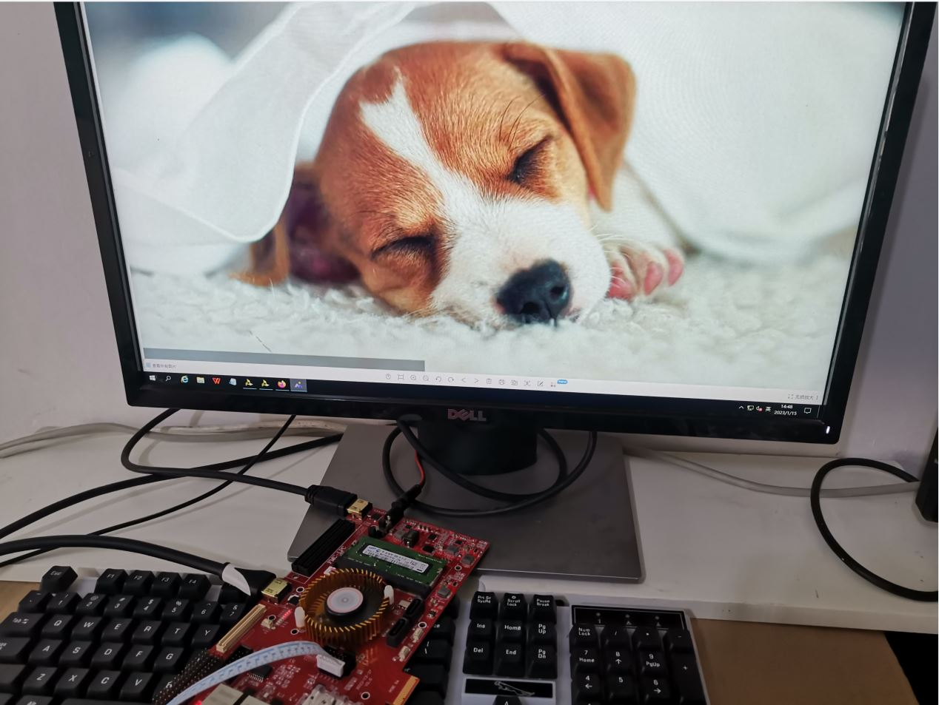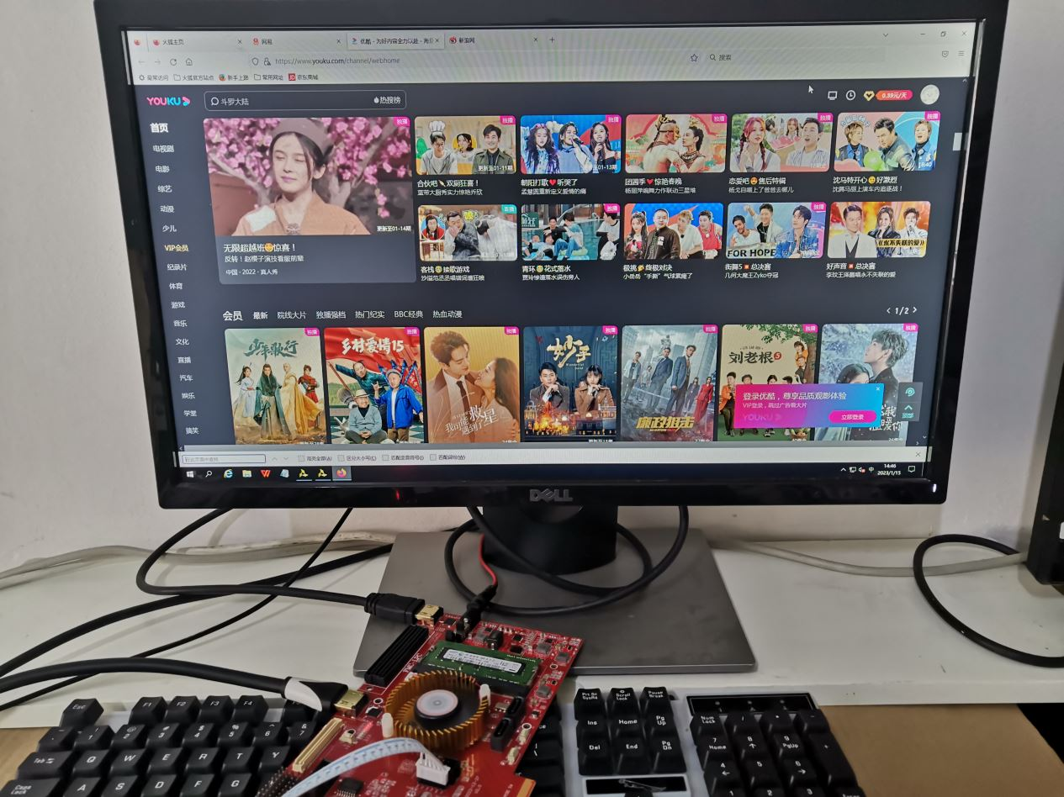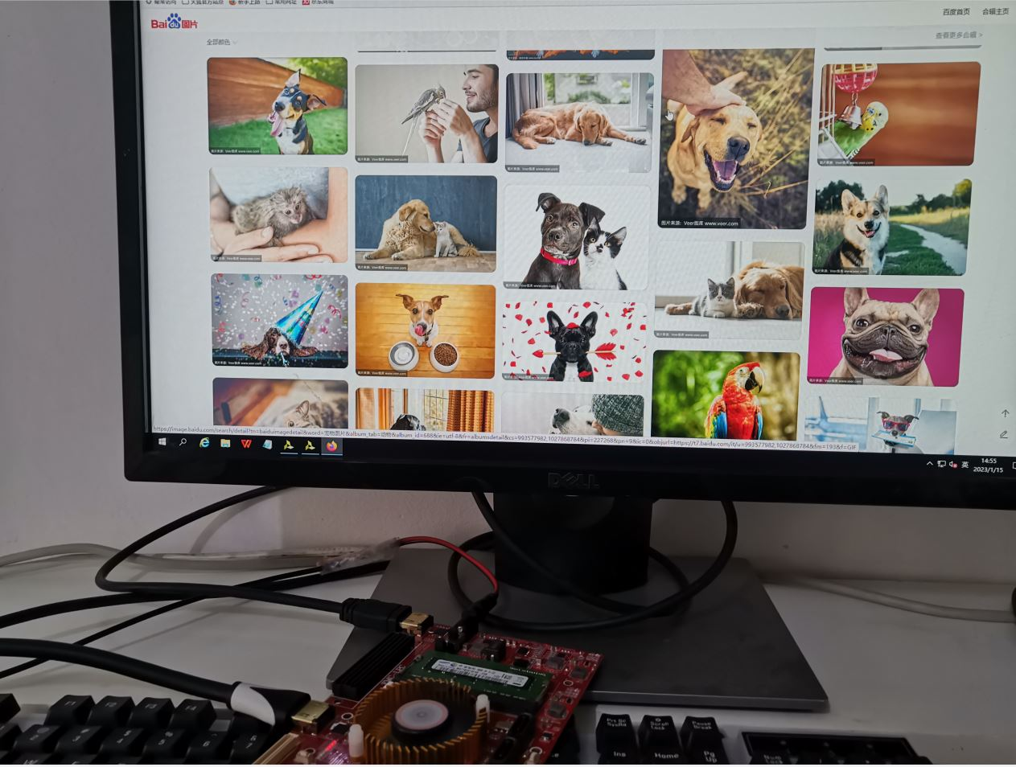

I only did the ibert test for the optical fiber interface and hard disk SATA. The reference study I provided contains the 10G network UDP test code, which can be transplanted. Both are K7

SATA 6Gbps ibert test, this test needs to short the TX and RX of the hard disk interface. This adapter cable is not available in the market, you can only do it yourself. When testing ibert, it should be noted that vivado displays PRBS7bit by default. If you need to select other PRBS, RX and TX must be the same. After selecting, click RESET



Optical fiber interface 10Gbps ibert test, buy double LC for optical fiber. That is, TX and RX are two separate holes on the fiber. For the same reason, the RX and TX of the optical fiber need to be short-circuited. Be careful when buying fiber optic cables. Buy fiber optic cables TX and RX are separate lines. When testing ibert, it should be noted that vivado displays PRBS7bit by default. If you need to select other PRBS, RX and TX must be the same. After selecting, click RESET

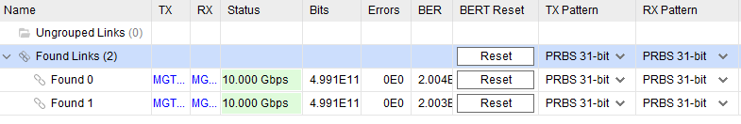

USB to TTL COM serial port test, need to install CP2102 driver. Open the serial debugging tool. The baud rate is 115200, and the baud rate can be modified by modifying the program.

Select the virtual serial port number of the computer, and you can see that the virtual COM6 in the device manager of my computer is based on the actual situation of the user's computer.

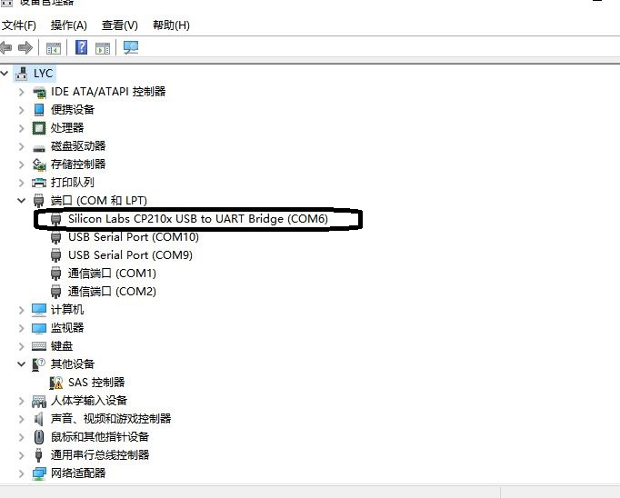

Open the serial port software, select COM6, the baud rate is 115200, and write numbers at the sending end. Click SEND, the LED lights on the board will change. The default is that the FPGA board sends FPGA STLINV to the PC serial port debugging tool, and other characters can be sent to the FPGA in the sending area, and the FPGA sends the characters to the computer after receiving the characters

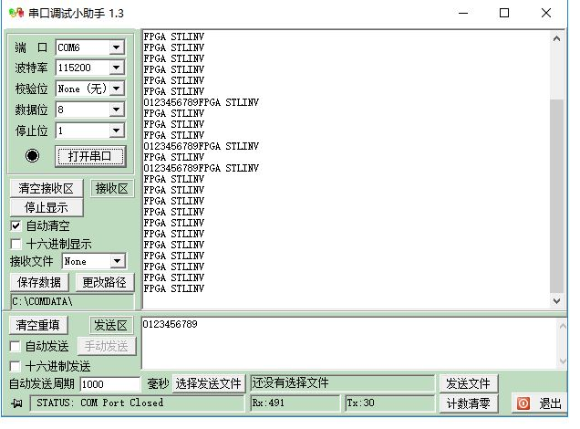

SD card test, use a mini SD card, download the program to the board, press the button K2 (the button next to the PCIE interface), the LED lights LED0 to LED3 will change.

DDR3 test is the simplest, if DDR3 test is normal, only LED0 and LED2 are on. If this is not the case. DDR3 test failed.

Note: Do not insert or remove the DDR3 memory module while the power is on.

The default delivery is 1333M memory stick, which can actually be set to work at a clock frequency of 1600M