Bazoom Returns to SBC Summit with Padel Event
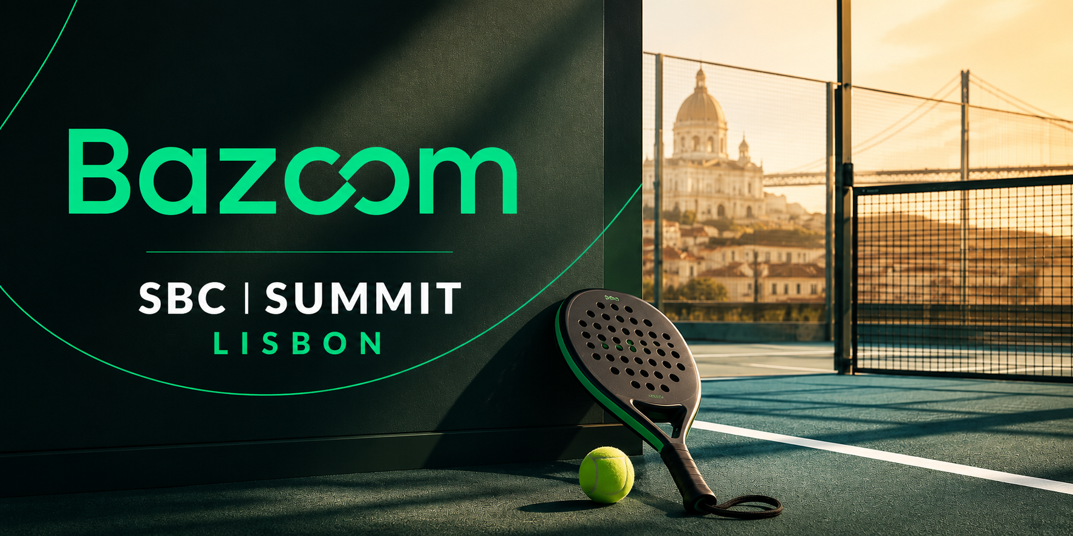
Bazoom, the global link-building company, is set to return to SBC Summit this September and will once again kick off conference week by hosting its padel event on Monday, September 28. The event brings together affiliates, operators, suppliers and industry partners before the exhibition begins, offering a relaxed way to reconnect, meet new people from across the industry and expand professional networks.
SBC week has a habit of starting early. Before the conference doors open, calendars are already filling with catch-up meetings across Lisbon. Bazoom's padel event gives attendees another place to connect before the busy conference schedule takes over. Friendly competition creates an opportunity to strengthen existing relationships, meet new contacts and start conversations that continue throughout the week.
The company's focus has always been on building strong relationships. Rather than operating as a traditional marketplace, Bazoom connects agencies, brands and SEO professionals with publishers through a global network backed by dedicated account managers. Clients also benefit from an average publication turnaround of four days, reflecting the company's emphasis on responsive service, direct collaboration and lasting partnerships. The approach has earned the trust of thousands of SEO professionals around the world.
Bazoom shared in a statement:
"SBC Summit is one of the highlights of our year, and we're excited to return for another great week with the industry. Hosting our padel event before the conference begins gives everyone the opportunity to catch up in a more relaxed setting before schedules fill up. We look forward to welcoming familiar faces, meeting new people and enjoying a few rallies together before the week gets underway."
SBC Summit is expected to welcome more than 40,000 delegates from over 150 countries this year, alongside more than 800 exhibitors and sponsors and 600 speakers. Thousands of affiliates, operators, suppliers and other industry professionals will also attend, making it one of the gaming industry's biggest annual meeting points. The conference offers several days of networking, exhibitions, panel discussions and business development.
Hosting the padel event gives Bazoom another opportunity to connect with clients, partners and new contacts before the conference program gets into full swing. The company looks forward to welcoming attendees to the court and continuing those conversations throughout the week in Lisbon.
Attendees traveling to SBC Summit are invited to join Bazoom on Monday, September 28, for a day of padel before another busy week at one of the industry's biggest events begins.

