模式识别第一次课程作业报告

57119101王晨阳

# 问题描述

编写感知器算法程序，求下列模式分类的解向量：

$$ω_{1}:\left\{{\left(0,0,0\right)}^{T},{\left(1,0,0\right)}^{T},{\left(1,0,1\right)}^{T},{\left(1,1,0\right)}^{T}\right\}$$

$$ω_{2}:\left\{{\left(0,0,1\right)}^{T},{\left(0,1,1\right)}^{T},{\left(0,1,0\right)}^{T},{\left(1,1,1\right)}^{T}\right\}$$

设 $w\left(1\right)={\left(-1,-2,-2,0\right)}^{T}$

# 算法介绍

我们首先定义 Vector 结构用来存储向量：

struct Vector{

    int row;

    vector<int> vec;

};

然后定义 TrainingSample 结构来存储训练样本：

struct TrainingSample{

    Vector vec;

    int tag;

};

然后编写函数用于矩阵运算。本题中需要用到向量乘法、向量数乘、向量加法。下面是它们对应的程序：

auto Multiplication(Vector W, Vector X){

    int ret = 0;

    for (int i = 0; i < W.row; i++){

        ret += (W.vec[i] * X.vec[i]);

    }

    return ret;

}

auto ScalarMultiplication(int c, Vector X){

    Vector ret;

    for (int i = 0; i < X.row; i++){

        ret.vec.push_back(c * X.vec[i]);

    }

    return ret;

}

auto Addition(Vector W, Vector X){

    Vector ret;

    ret.row = W.row;

    for (int i = 0; i < W.row; i++){

        ret.vec.push_back(W.vec[i] + X.vec[i]);

    }

    return ret;

}

对于感知器算法，我们需要知道：训练样本、权向量初始值、校正增量系数。

算法的流程为：

* 选择 $N$ 个分属于 $ω_{1}$ 和 $ω_{2}$ 的模式识别样本构成训练样本集，对样本规范化处理，对 $ω_{2}$ 的所有样本乘以 $-1$。编号为 $X_{1},⋯,X_{N}$，任取权向量初始值 $W\left(1\right)$ 开始迭代
* 第 $k$ 次迭代时，输入一个样本 $X_{i}$
$W\left(k+1\right)=\left\{\begin{matrix}W\left(k\right) & W^{T}\left(k\right)X_{i}>0 \\ W\left(k+1\right)=W\left(k\right)+cX_{i} & W^{T}\left(k\right)X_{i}≤0\end{matrix}\right.$

* $c$ 为校正增量系数， $c>0$
* 若上一轮迭代未发生错误，则迭代结束

简单模拟即可。程序如下：

auto Perception(vector<TrainingSample> Ts, Vector W, int c){

    bool flag = false;

    Vector w_pre = W;

    Vector w_tmp;

    int k = 0;

    w_pre.row = w_tmp.row = W.row;

    while (!flag){

        k++;

        flag = true;

        for (int i = 0; i < Ts.size(); i++){

            if (Multiplication(w_pre, Ts[i].vec) > 0){

                w_tmp = w_pre;

            }

            else{

                w_tmp = Addition(w_pre, ScalarMultiplication(c, Ts[i].vec));

                w_pre = w_tmp;

                flag = false;

            }

        }

    }

    return w_tmp;

}

# 结果分析

我们在 Ubuntu 20.04.3 LTS, 5.10.60.1-microsoft-standard-WSL2, gcc 9.3.0 上测试程序。

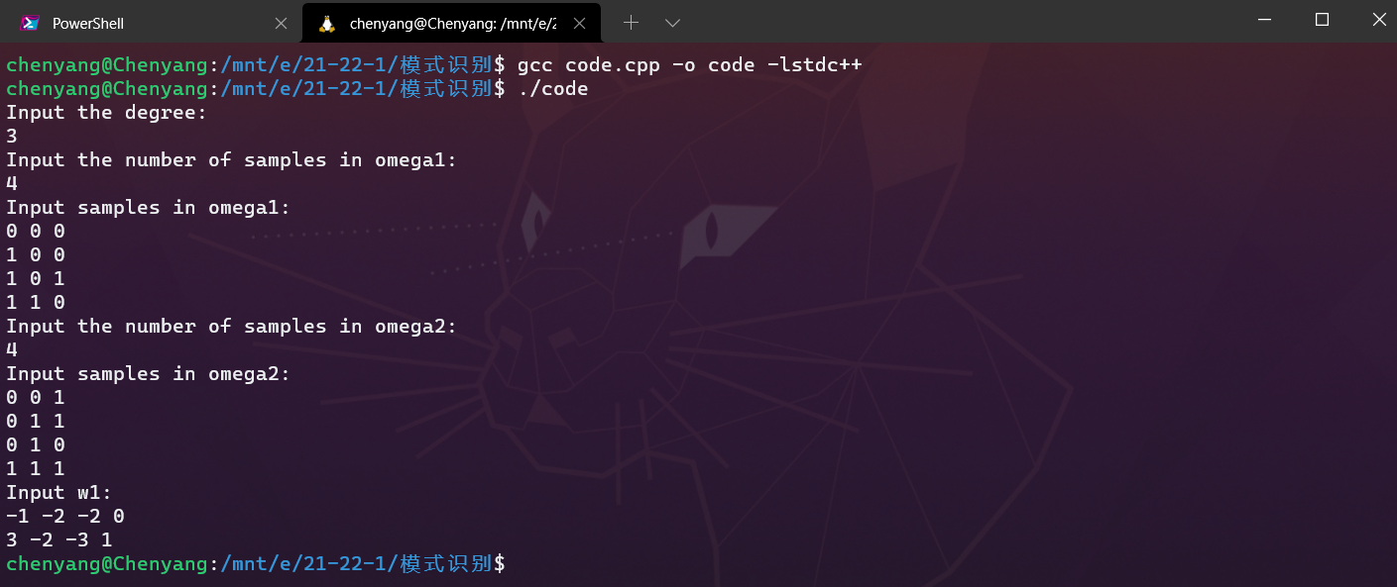

图1 Windows terminal 截图

输入题目所给数据，输出结果为

$$W={\left[3,-2,-3,1\right]}^{T}$$

经验证，结果无误。

# 附录

全部程序：

/**********************************************************************

 * @author Chenyang

 * @date 2021-10-28

 * @description:

 *   Perception algorithm

 * @example

 *   input:

-----------------------------------------------------------------------

Input the degree:

3

Input the number of samples in omega1:

4

Input samples in omega1:

0 0 0

1 0 0

1 0 1

1 1 0

Input the number of samples in omega2:

4

Input samples in omega2:

0 0 1

0 1 1

0 1 0

1 1 1

Input w1:

-1 -2 -2 0

-----------------------------------------------------------------------

 *   output:

-----------------------------------------------------------------------

3 -2 -3 1

-----------------------------------------------------------------------

 * @test passed on Ubuntu 20.04.3 LTS, gcc 9.3.0

 *********************************************************************/

#include <iostream>

#include <vector>

using namespace std;

struct Vector{

    int row;

    vector<int> vec;

};

struct TrainingSample{

    Vector vec;

    int tag;

};

auto Multiplication(Vector W, Vector X){

    int ret = 0;

    for (int i = 0; i < W.row; i++){

        ret += (W.vec[i] * X.vec[i]);

    }

    return ret;

}

auto ScalarMultiplication(int c, Vector X){

    Vector ret;

    for (int i = 0; i < X.row; i++){

        ret.vec.push_back(c * X.vec[i]);

    }

    return ret;

}

auto Addition(Vector W, Vector X){

    Vector ret;

    ret.row = W.row;

    for (int i = 0; i < W.row; i++){

        ret.vec.push_back(W.vec[i] + X.vec[i]);

    }

    return ret;

}

auto Perception(vector<TrainingSample> Ts, Vector W, int c){

    bool flag = false;

    Vector w_pre = W;

    Vector w_tmp;

    int k = 0;

    w_pre.row = w_tmp.row = W.row;

    while (!flag){

        k++;

        flag = true;

        for (int i = 0; i < Ts.size(); i++){

            if (Multiplication(w_pre, Ts[i].vec) > 0){

                w_tmp = w_pre;

            }

            else{

                w_tmp = Addition(w_pre, ScalarMultiplication(c, Ts[i].vec));

                w_pre = w_tmp;

                flag = false;

            }

        }

    }

    return w_tmp;

}

int main(){

    /**

     * @description: input

     */

    vector<TrainingSample> Ts;

    Vector w1;

    int degree, numOfOmega1, numOfOmega2;

    cout << "Input the degree:\n";cin >> degree;

    cout << "Input the number of samples in omega1:\n";cin >> numOfOmega1;

    cout << "Input samples in omega1:\n";

    for (auto i = 0; i < numOfOmega1; i++){

        int x;TrainingSample tmpTrainingSample;

        tmpTrainingSample.vec.row = degree + 1;

        for (auto j = 0; j < degree; j++){cin >> x;tmpTrainingSample.vec.vec.push_back(x);}

        tmpTrainingSample.vec.vec.push_back(1);tmpTrainingSample.tag = 1;

        Ts.push_back(tmpTrainingSample);

    }

    cout << "Input the number of samples in omega2:\n";cin >> numOfOmega2;

    cout << "Input samples in omega2:\n";

    for (auto i = 0; i < numOfOmega2; i++){

        int x;TrainingSample tmpTrainingSample;

        tmpTrainingSample.vec.row = degree + 1;

        for (auto j = 0; j < degree; j++){cin >> x;tmpTrainingSample.vec.vec.push_back(-x); }

        tmpTrainingSample.vec.vec.push_back(-1);tmpTrainingSample.tag = 2;

        Ts.push_back(tmpTrainingSample);

    }

    cout << "Input w1:\n";

    int x;

    for (auto i = 0; i < degree + 1; i++){

        cin >> x;w1.vec.push_back(x);

        w1.row = degree + 1;

    }

    /**

     * @description: main function

     */

    Vector ans = Perception(Ts, w1, 1);

    /**

     * @description: output

     */

    for (auto i = 0; i < ans.row; i++){

        cout << ans.vec[i] << ' ';

    }

    cout << endl;

    return 0;

}