# EX1

#include <iostream>  
#include <stdexcept>  
using namespace std;  
  
class TestException : public runtime_error  
{  
public:  
 TestException() : runtime_error("abnormal program termination") {}  
};  
  
int main()  
{  
 try  
 {  
 throw TestException();  
 }  
 catch (TestException &testexception)  
 {  
 cout << "This is a test\n"  
 << endl;  
 cout << testexception.what() << endl;  
 }  
}

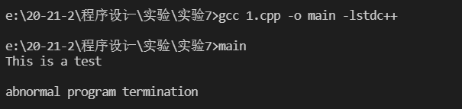

image-20210525133308945

# EX2

#include <iostream>  
#include <stdexcept>  
using namespace std;  
class Item  
{  
public:  
 Item(int x = 3) : value(x)  
 {  
 cout << "Item " << value << " constructor called.\n";  
 if (value == 3)  
 {  
 throw runtime_error("An exception was thrown");  
 }  
 }  
  
 ~Item()  
 {  
 cout << "Item " << value << " destructor called.\n";  
 }  
  
private:  
 int value;  
};  
  
int main()  
{  
 try  
 {  
 Item item1(1);  
 Item item2(2);  
 Item item3(3);  
 }  
 catch (runtime_error &exception)  
 {  
 cerr << exception.what() << endl;  
 }  
}

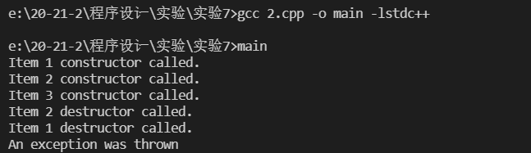

image-20210525133432034

# EX3

#include <iostream>  
#include <stdexcept>  
using namespace std;  
class TestException : public runtime_error  
{  
public:  
 TestException() : runtime_error("abnormal program termination") {}  
};  
void g()  
{  
 try  
 {  
 throw TestException();  
 }  
 catch (TestException &)  
 {  
 cerr << "Exception caught in function g(). Rethrowing...\n";  
 throw;  
 }  
}  
int main()  
{  
 try  
 {  
 g();  
 }  
 catch (TestException &)  
 {  
 cout << "Exception caught in function main()." << endl;  
 }  
}

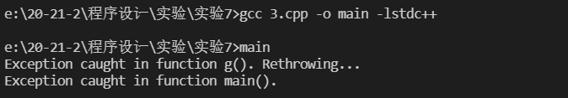

image-20210525133549787

# EX4

#include <iostream>  
#include <stdexcept>  
#include <string>  
using namespace std;  
class TestException : public runtime_error  
{  
public:  
 TestException(string s = "") : runtime_error(s) {}  
};  
void f()  
{  
 throw TestException("TestException");  
}  
void g()  
{  
 f();  
}  
void h()  
{  
 g();  
}  
int main()  
{  
 try  
 {  
 h();  
 }  
 catch (TestException &ex)  
 {  
 cout << "In main: Caught ";  
 cerr << ex.what();  
 }  
}

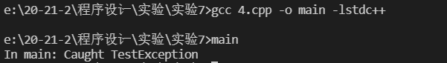

image-20210525133702850