# EX1

#include <iostream>  
#include <string>  
using namespace std;  
template <typename elementType, int numberOfElement>  
class Array  
{  
public:  
 Array(elementType a[numberOfElement])  
 {  
 for (int i = 0; i < numberOfElement; i++)  
 Elements[i] = a[i];  
 };  
 void print()  
 {  
 for (int i = 0; i < numberOfElement; i++)  
 cout << Elements[i] << " ";  
 cout << endl;  
 }  
  
private:  
 elementType Elements[numberOfElement];  
};  
int main()  
{  
 int A[5];  
 cout << "Enter 5 integer values:" << endl;  
 for (int i = 0; i < 5; i++)  
 cin >> A[i];  
 cout << "The values in the intArray are:" << endl;  
 Array<int, 5> a(A);  
 a.print();  
 string B[7];  
 cout << "Enter 7 one word string " << endl;  
 for (int i = 0; i < 7; i++)  
 cin >> B[i];  
 cout << "The values in the stringArray are:" << endl;  
 Array<string, 7> b(B);  
 b.print();  
}

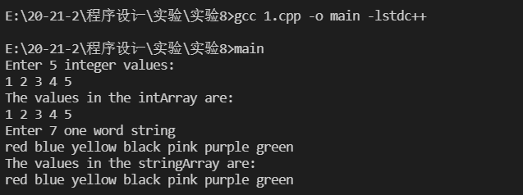

image-20210525134054703

# EX2

#include <iostream>  
using namespace std;  
template <typename T>  
bool isEqualTo(T a, T b)  
{  
 return a == b;  
}  
class Complex  
{  
public:  
 Complex(double input_real = 0, double input_imagine = 0) : real(input_real), imagine(input_imagine) {}  
 double getR()  
 {  
 return real;  
 }  
 double getI()  
 {  
 return imagine;  
 }  
 bool operator==(Complex a)  
 {  
 return real == a.real && imagine == a.imagine;  
 }  
  
private:  
 double real, imagine;  
};  
int main()  
{  
 int a = 1, b = 2;  
 cout << "a is " << (isEqualTo(a, b) ? "" : "not") << " equal to b" << endl;  
 double x = 3.14, y = 6.28;  
 cout << "x is " << (isEqualTo(x, y) ? "" : "not") << " equal to y" << endl;  
 char c = 'A', d = 65;  
 cout << "c is " << (isEqualTo(c, d) ? "" : "not") << " equal to d" << endl;  
 Complex e(2, 3), f(3, 3);  
 cout << "Complex a is " << (isEqualTo(e, f) ? "" : "not") << " equal to complex b" << endl;  
}

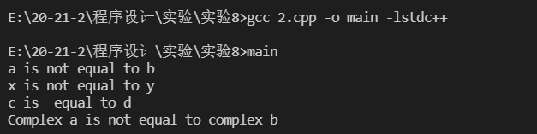

image-20210525134236995

# EX3

#include <iostream>  
using namespace std;  
template <typename T>  
class Vector  
{  
private:  
 int size;  
 T *data;  
  
public:  
 Vector(int input_size) : size(input_size)  
 {  
 data = new T[input_size];  
 for (int i = 0; i < input_size; i++)  
 {  
 data[i] = 0;  
 }  
 }  
 friend ostream &operator<<(ostream &out, Vector<T> k)  
 {  
 for (int i = 0; i < k.size; i++)  
 {  
 out << k.data[i] << " ";  
 }  
 return out;  
 }  
 friend istream &operator>>(istream &in, Vector<T> k)  
 {  
 for (int i = 0; i < k.size; i++)  
 {  
 in >> k.data[i];  
 }  
 return in;  
 }  
};  
int main()  
{  
 Vector<int> a(5);  
 cout << "Enter 5 integers:";  
 cin >> a;  
 cout << a;  
}

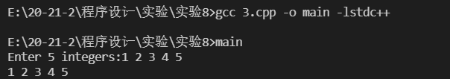

image-20210525134430791