# Ex1

**1.cpp**

#include <iostream>  
#include <vector>  
using namespace std;  
  
template <class T>  
void check(const vector<T> a)  
{  
 int b = a.size() / 2 + 1;  
 bool judge = true;  
 for (int i = 0; i < b; i++)  
 {  
 if (a[i] != a[a.size() - i - 1])  
 {  
 judge = false;  
 }  
 }  
 for (int i = 0; i < a.size(); i++)  
 {  
 cout << a[i] << " ";  
 }  
 cout << "is" << (judge ? " " : " not ") << "a palindrome" << endl;  
}  
  
int main()  
{  
 vector<int> a = {75, 74, 73, 72, 71, 70, 69, 68, 67, 66, 65};  
 vector<char> b{'K', 'J', 'I', 'H', 'G', 'F', 'G', 'H', 'I', 'J', 'K'};  
 check(a);  
 check(b);  
}

**output**



image-20210511204713411

# Ex2

**2.cpp**

#include<iostream>  
#include<set>  
using namespace std;  
  
bool ifPrime(int a){  
 bool isprime = 1;  
 for(int i=2;i<a;i++){  
 if (a%i==0){  
 isprime = 0;  
 break;  
 }  
 }  
 return isprime;  
}  
  
set<int> s;  
void factorize(int a)  
{  
 while (!ifPrime(a))  
 {  
 for (auto p = s.begin(); p != s.end(); p++)  
 {  
 if (a % *p == 0)  
 {  
 a = a / *p;  
 cout << *p << '*';  
 break;  
 }  
 }  
 }  
 cout << a << endl;  
}  
  
int main(){  
 cout << "The prime numbers in the range 2 to 1023 are:" << endl;  
 for (int k=2;k<=1024;k++){  
 if (ifPrime(k)){  
 cout << k << " ";  
 s.insert(k);  
 }  
 }  
 cout << endl;  
  
 while (true)  
 {  
 int j;  
 cout << "Enter a value from 1 to 1023: ";  
 cin >> j;  
 if (ifPrime(j))  
 {  
 cout << j << " is a prime number" << endl;  
 }  
 else  
 {  
 cout << j << " is not a prime number" << endl;  
 cout << "The unique prime factorization of " << j << " is: ";  
 factorize(j);  
 }  
 }  
  
}

**output**

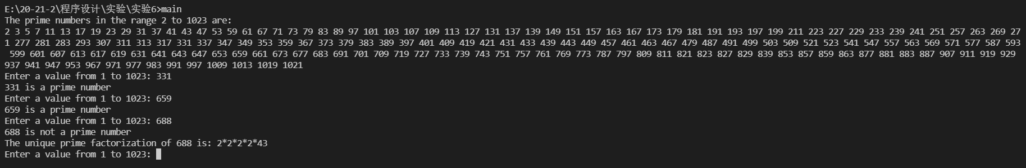

image-20210511205011037