Part1:

1.

The switch will record

2.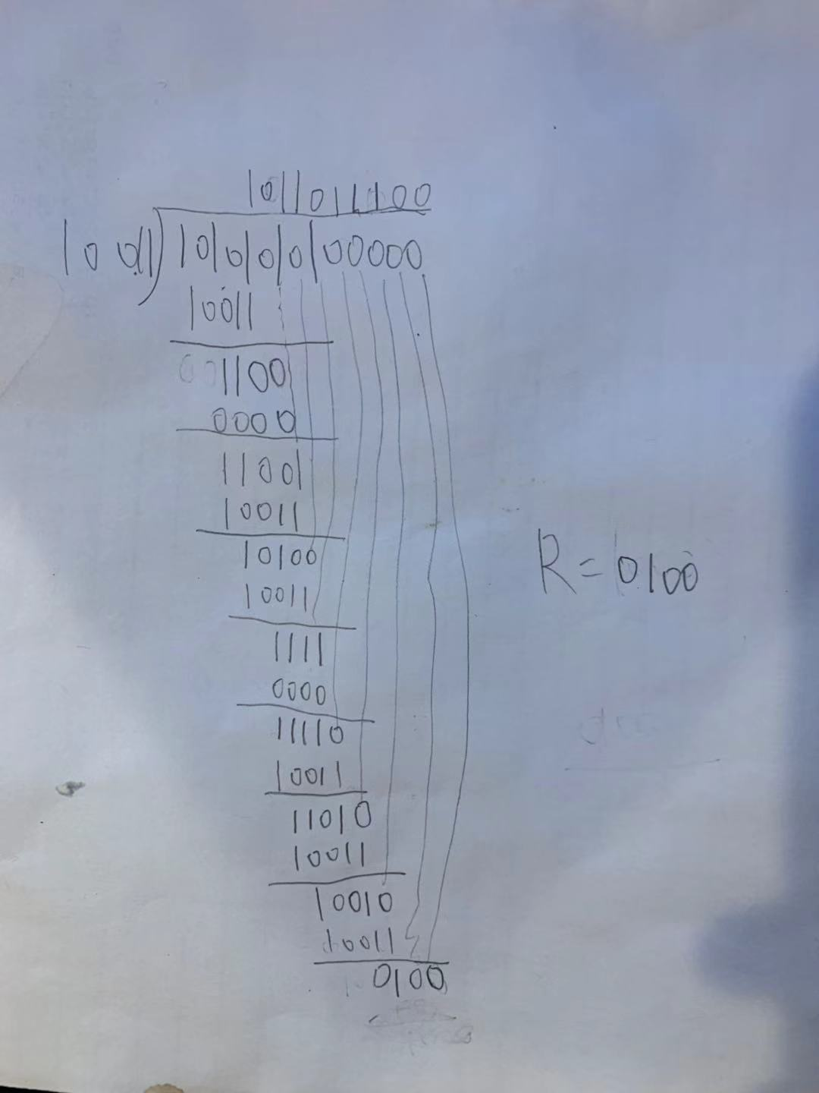

3.

Pure ALOHA transmission can start immediately. At low load, no collisions are expected; as a result, the transmission is likely to be sucessful. In slotted ALOHA we still need to wait for the next slot beginning time to transmit, which introduces a slot time delay and thus delay of Pure ALOHA is less.

4. A switch only has two layers physical and link layer and it uses mac address to filter and forward packets while a router has three layers with physical, link and network layer and it use IP address to forward the packets. Router uses routing algorithms while switch does not. Router remove and replace link layer header and update network layer header fileds while switches do not modify header but only access link layer header.

5.

Link1:

Application layer: TCP source port number:1000

TCP destination port number:80

Network layer:IP source address: 128.111.41.23

IP destination address: 128.111.41.1

Link layer:Ethernet source address:43:00:08:A6:B1:13

Ethernet destination address: 34:7E:09:A0:12:01

Link 2:

Application layer: TCP source port number:1000

TCP destination port number:80

Network layer:IP source address: 128.111.52.1

IP destination address:128.111.52.112

Link layer:Ethernet source address: 0A:09:56:44:BE:CD

Ethernet destination address: 45:32:C9:BD:F9:03

6.

a)

A:128.111.41.1

B:128.111.41.2

C:128.111.42.1

D:128.111.42.2

E:128.111.43.1

F:128.111.43.2

b)

Part2:

Src:00:d0:59:a9:3d:68

2.

Des:00:06:25:da:af:73

This is not the ethernet address of gaia.cs.umass.edu.

The value of the source is 00:06:25:da:af:73. This is the address of the router which the client computer is connected.

The destination address is 00:d0:59:a9:3d:68. This is the ethernet address of the client computer.

5.

Internet address|ethernet address|type

192.168.33.255|ff-ff-ff-ff-ff-ff|static

224.0.0.22 |01-00-5e-00-00-16|static

Internet address is the IP adress, ethernet address is the physical address, static type means it is fixed.

6.

src:00:d0:59:a9:3d:68

des:ff:ff:ff:ff:ff:ff

7. Because the trace happens at the client computer which will not receive the reply of the request sent from another computer. ARP reply will only send to the computer who requests the address. As a result, we will not receive the reply in the client computer and the trace will not catch the result.