|  |  |  |
| --- | --- | --- |
| QF | RMS | C |
| 1 | 5.4684 | 0.9588 |
| 5 | 2.7347 | 0.8819 |
| 10 | 1.9734 | 0.8382 |

Image7401

QF:1

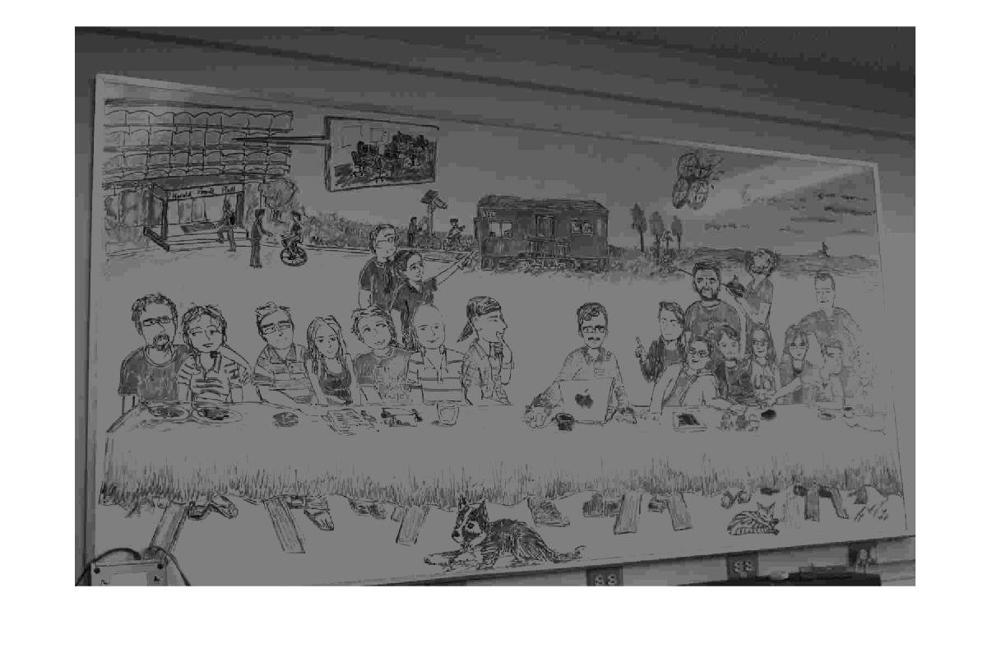

QF:5

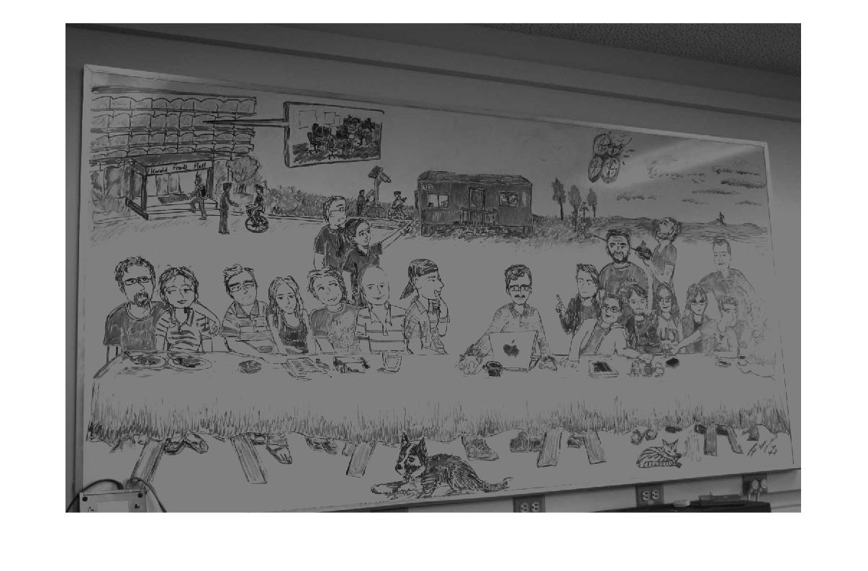

QF:10

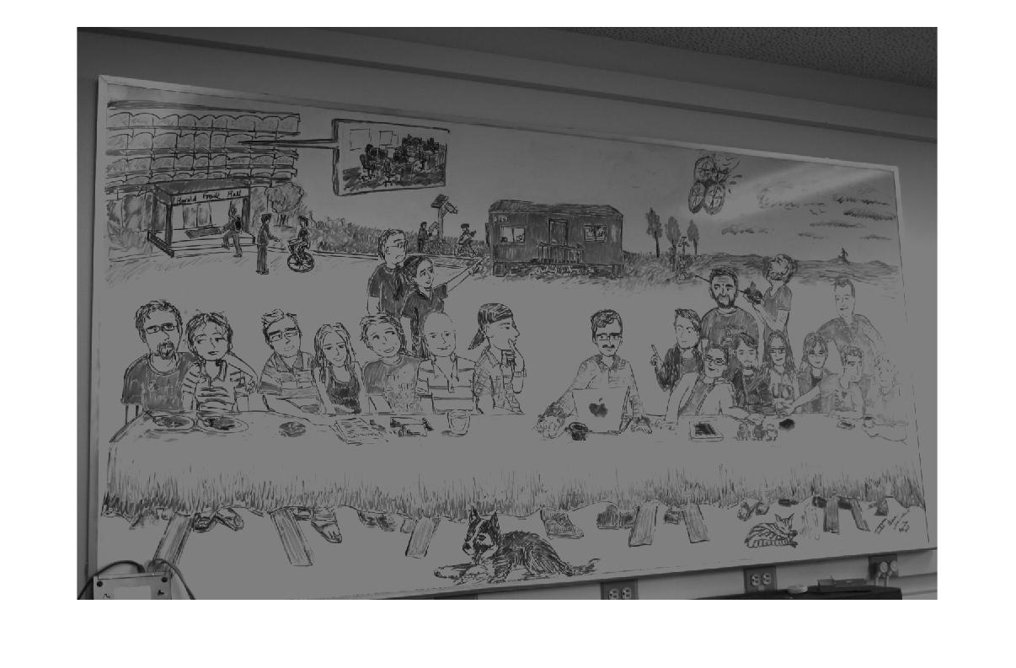

|  |  |  |
| --- | --- | --- |
| QF | RMS | C |
| 1 | 4.1590 | 0.9476 |
| 5 | 2.1626 | 0.8435 |
| 10 | 1.5590 | 0.7869 |

Image:7405

QF:1

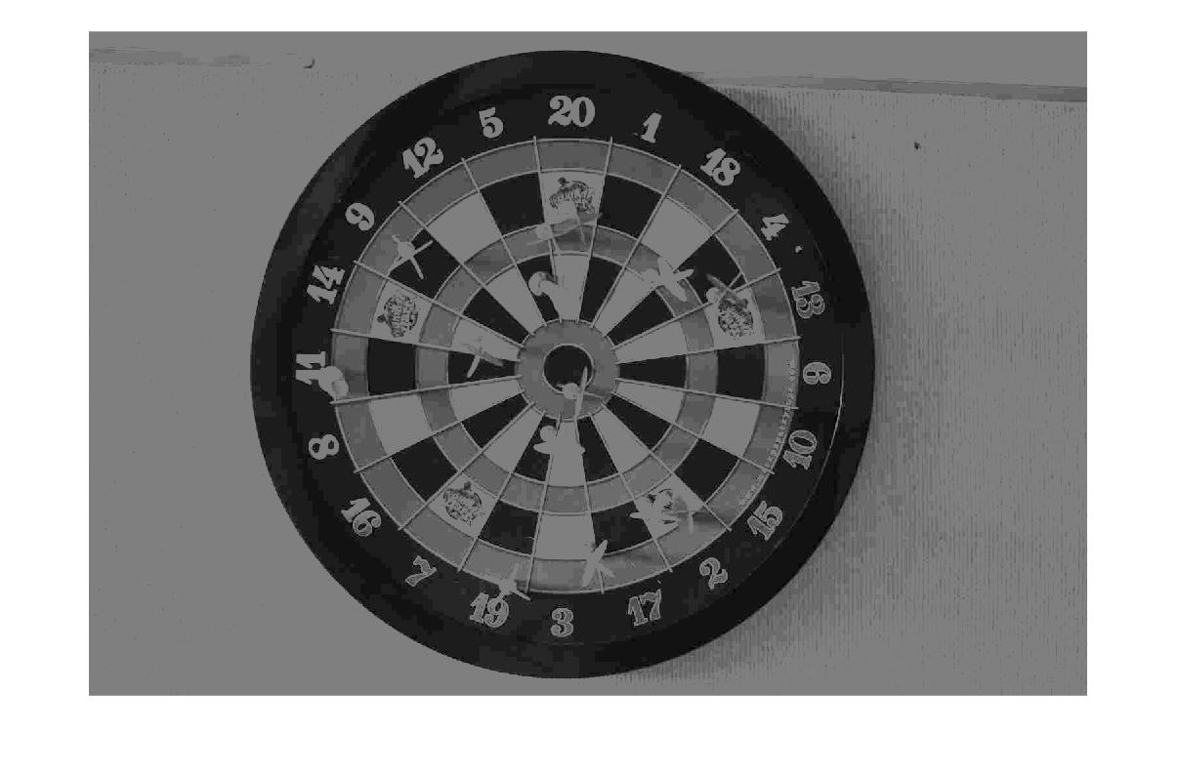

QF:5

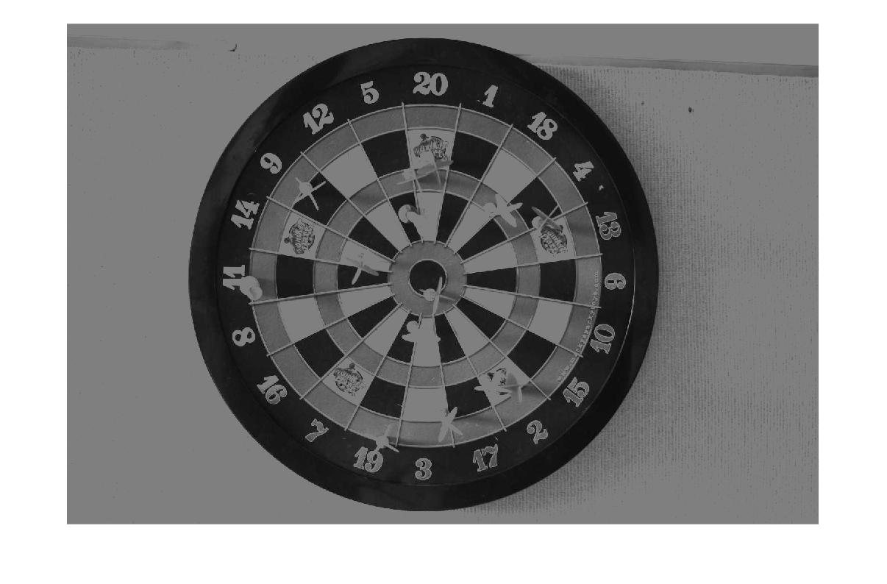

QF:10

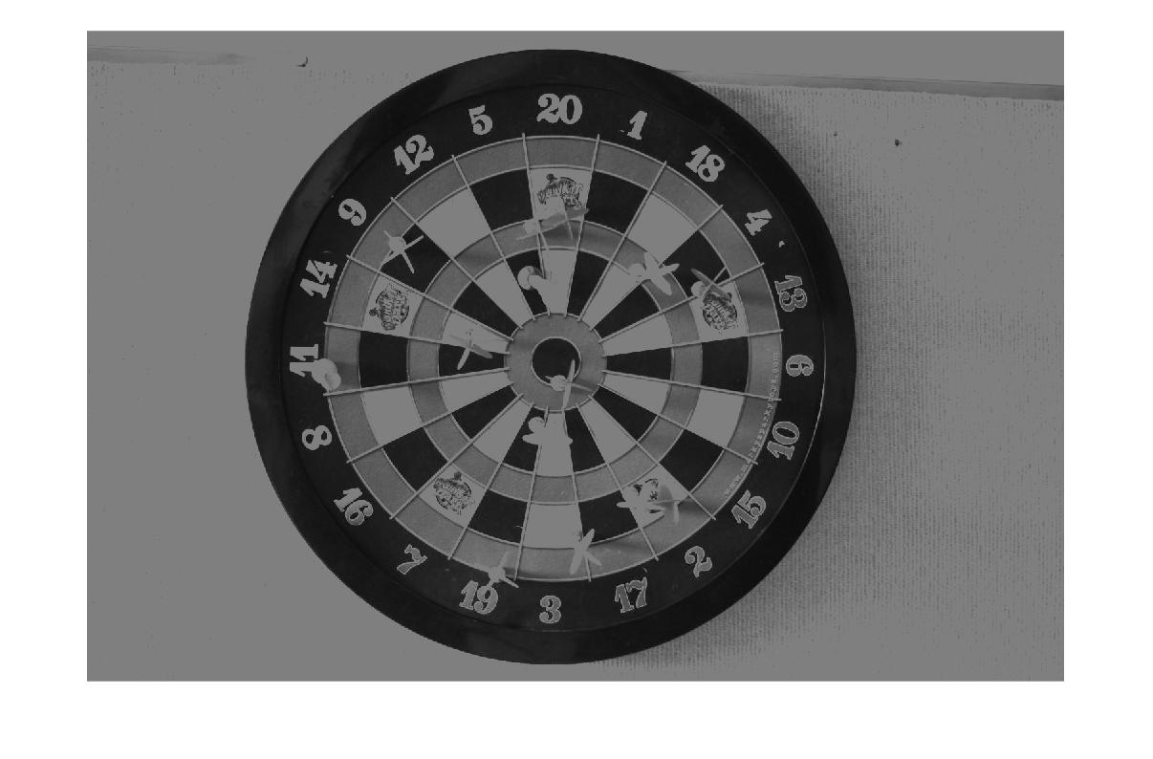

Levelshift Function:

%level shift the matrix by 128 and then do dct2 tranformation

function [J] = levelshift(I)

I = I - 128;

J = dct2(I);

end

MyJpeg Function:

function [J,C,rms] = myJpeg(InputImage,QF)

if nargin == 1

QF = 5;

%set default QF to 5 if no QF is specified

InputImage = double(InputImage);

[M,N] = size(InputImage);

I = InputImage;

%partition the image to 8x8 blocks and do subtracting 128 and computing the

%dct value, the blockproc function by default zero pads the blocks if the

%block is not 8x8 dimension.step (a),(b),(c)

fun = @(block_struct)levelshift(block_struct.data);

B = blockproc(I,[8 8],fun);

%compute the q matrix with quality factor, and divide by q-matrix with 8x8

%block processing, again by default blkproc function zeropad the block that

%is not 8x8 dimension.step(d)

q_mtx = [16 11 10 16 24 40 51 61;

12 12 14 19 26 58 60 55;

14 13 16 24 40 57 69 56;

14 17 22 29 51 87 80 62;

18 22 37 56 68 109 103 77;

24 35 55 64 81 104 113 92;

49 64 78 87 103 121 120 101;

72 92 95 98 112 100 103 99];

q_mtx = q_mtx.*(5/QF);

quantize = @(x)x./q_mtx;

B2 = blkproc(B,[8 8],quantize);

B2 = round(B2);

% calculate the amount of zeros and then compute the compressing

% rate. step(e)

C = 0;

for i = 1:M

for j = 1:N

if(B2(i,j)==0)

C = C+1;

end

end

end

C = C/(M*N);

% inverse part,8x8 block processing multiplied by the q matrix and then do idct2 tranformation, then add 128 back step (f)

iquantize = @(x)(x).*q_mtx;

B3 = blkproc(B2,[8 8],iquantize);

ifun = @(block_struct)(int8(idct2(block_struct.data)));

J = blockproc(B3,[8 8],ifun);

J = J+128;

J = uint8(J);

% compute the rms step(g)

sum = 0;

for i = 1:M

for j = 1:N

sum = sum +double((J(i,j))-(InputImage(i,j)))*double((J(i,j))-(InputImage(i,j)));

end

end

rms = double(sqrt(1/(M*N)*double(sum)));

Script code example for image 7405 with QF = 10:

disp("load image");

I = load("IMG_7405.mat");

O_I=I.I;

QF = 10;

[J,C,rms] = myJpeg(O_I,QF);

figure(1);

imshow(O_I);

figure(2);

imshow(J);

disp("Cmpression rate is:")

disp(C);

disp("root mean square is:")

disp(rms);