ROBOT SWEEPER

Shokey Bexultan, Glazkov Artyom, Kulseitov Yerassyl, Nurymzhan Kaldarov
¹School of IT and Engineering, Kazakh-British Technical University, Almaty, Kazakhstan
¹b_shokey@kbtu.kz, ¹y_kulseitov@kbtu.kz, ¹a_glazkov@kbtu.kz, ¹n_kaldarov@kbtu.kz

Abstract— This project presents a low-cost robot sweeper based on an ESP32 microcontroller. The robot uses an HC-SR04 ultrasonic sensor and a servo motor to detect obstacles and choose a direction for movement. The system includes DC gear motors, a ZK-5AD motor driver, two frontal sweepers, and an external vacuum cleaner for collecting dust and small garbage. The robot moves forward, stops when an obstacle is detected, moves backward, scans the left and right sides, and turns toward the direction with the longest free distance. The main purpose of this project is to demonstrate a simple and affordable autonomous cleaning robot for educational and small cleaning applications.

Keywords— robot cleaner, ESP32, obstacle avoidance, vacuum cleaner.

- Introduction
The design was inspired by an Autonomous Street Sweeper that uses an ESP32 microcontroller. The functionality of this robot demonstrates an obstacle detection method, which uses sensors to identify and overcome obstacles that approach the robot's path, allowing it to move forward without issue. The system combines an Ultrasonic-Sensor(HC-SR04) for obstacle processing, a servomotor for looking right and left sides, and an ESP32 takes those values to compare which destination will be optimal. The robot cleaner consists of a four wheels mobile base, two motors actuated in only in a "forward mode", equipped with two frontal rotating brushes for conveying garbage and with an external vacuum cleaner for collecting the garbage. The uniqueness of this project lies in the availability and low cost of the components, which shows the capabilities for usage in home and street cleaning applications.
- Related works
How to Make Arduino based Smart Vacuum Cleaner Robot Best for Science Project In this project, the author, whose name is Rizwan, made an excellent project and representation of a robot cleaner. The author created an Arduino-based Cleaner Robot using waste materials like plastic bottles, lids, etc, that also uses the obstacle detection method with an Ultrasonic-Sensor(HC-SR04) and servomotor. The author illustrated that by using waste materials, he was able to make a vacuum cleaner that operates as it is expected to. Unlike that project, our project includes 2 sweepers that assist to collect garbage and an external vacuum cleaner that helps to clean the path better.

- Methodology
  - Hardware architecture of this project
The robot is built with Alashed Phobo kit, which was provided by an instructor. The core hardware includes: (Table 1: Mechanical components with specifications)
TABLE I
Mechanical components with specifications
 | Hardware architecture of the project
 | Component | Specs | Remarks
1 | ESP-WROOM-32 | Dual-core microcontroller, up to 240 MHz, Wi-Fi and Bluetooth support | 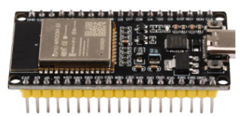
2 | ZK-5AD, TA6586 | H-bridge, Motor voltage: DC 3–14 V  Logic input: 2.2–6 V Current: up to 5 A | 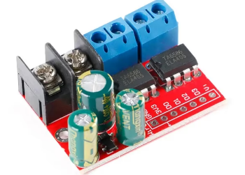
3 | HC-SR04, Ultrasonic distance sensor | 5V DC, ~15 mA,  Range:2cm–400 cm | 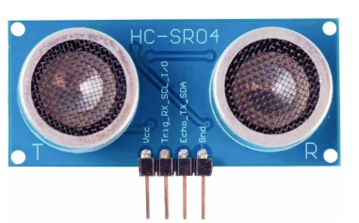
4 | Servo Motor | Operating voltage: 4.8–6V, rotation range: 180° | 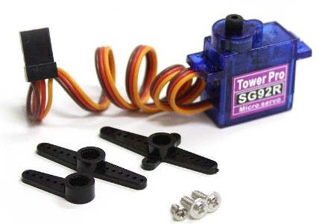
5 | Motor | DC Gear Motor:  DC 3–6 V | 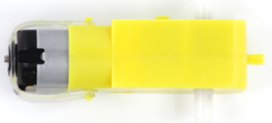
6 | Sweepers | Made by hand using tire from a wheel + regular sweeper | 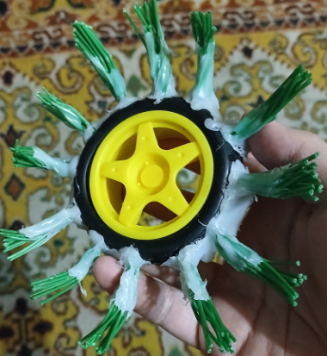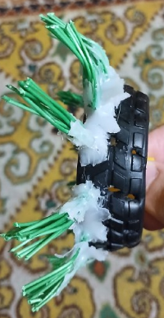

This robot is powered by four 3,7V batteries, of which two are the power source for the ZK-5AD, servo motor and HC-SR04 sensor, and the rest are the power source for sweepers to provide high rpm for cleaning the path. Furthermore, the microcontroller is responsible for controlling every component. To start the robot, the button was implemented to the system. 2). Figure 1 – Overall system architecture and connection between hardware components.

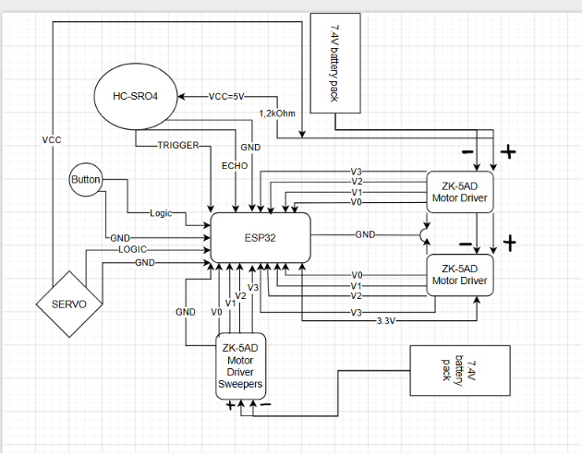

Figure 1 – Connection between Hardware components

Overall, the ESP32 microcontroller is powered by ZK-5AD through the output 3.3V, while ZK-5AD is powered by a 7.4V battery pack. As the ESP32 is the core computing unit, it runs the code and handles every component in hardware. When the code runs, the microcontroller waits for the button to be pressed to start the robot. The ultrasonic sensor, powered by 5V, measures the distance to obstacles and sends the data to the microcontroller. The servo motor, powered by 5V, rotates the ultrasonic sensors to the left or right. Additionally, the sweepers are connected to another ZK-5AD, which causes them to rotate in a HIGH state.
- Software architecture
The software architecture of the robot is designed to provide autonomous behavior using PlatformIO and C++. The software is simple, understandable, easy to maintain, and suitable for future upgrades. The main part of the software is the obstacle detection and motion control module. This module is responsible for the movement and decision-making process of the robot cleaner.
Аfter the code starts running, it waits for the button to be pressed to begin moving, allowing manipulate the activeness of the robot. Initially, the state of the button is set to false using the variable bool systemStarted=false. After the button is pressed,the state becomes true, and the robot starts it actions. Next, for the wheel-motors not always to be in a HIGH state, PWM was implemented. To control it, MOTOR_SPEED was defined, which is set to 150(can be changed in a range of 0-255). For the obstacle detection, ultrasonic-sensor's Trigger and Echo pins are defined. To calculate the distance, SOUND_OF_SPEED and LIMIT_CM are used. The SOUND_OF_SPEED is a constant value of 0.0343 unchangeable, but LIMIT_CM is editable, allowing to regulate the distance of the object. The servo motor’s primary function is to rotate the ultrasonic sensor, so starting with the creation of it by writing Servo scanServo and defining its pin. Additionally, for the proper working of the servo, it is set to 90 degrees, for the left side and right side, 150 and 30 degrees are set respectively.

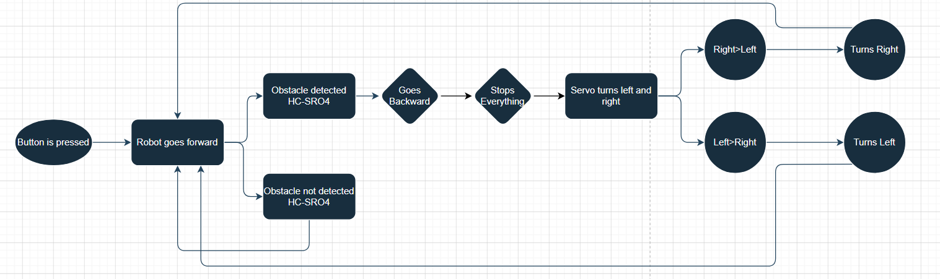
Figure 2 – Software interconnection

Figure 2 illustrates the logic of the robot cleaner. After the button is pressed, the robot starts moving forward. Meanwhile, the ultrasonic sensor starts continuously checking the distance in front of the robot. If no obstacle is detected, the robot will continue going forward. However, if an obstacle is detected, it will go backwards and stop its motors. After stopping, the servo motor rotates the ultrasonic sensor to the left and right sides. Next, the ESP32 compares the measured distances from both directions and decides which direction has a longer free distance. After deciding, it will turn to the left or right side, and the robot will return to moving forward and repeat the same obstacle avoidance process.

Pseudocode

Input:
- btnState(the state of a robot waiting for button to be pressed)=TRUE
Output:
- systemStarted = TRUE;
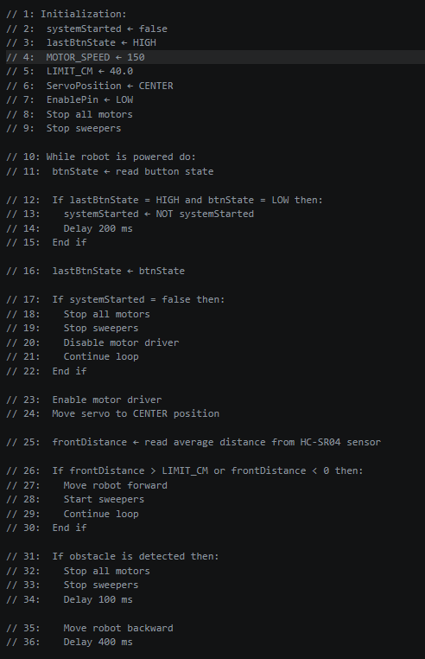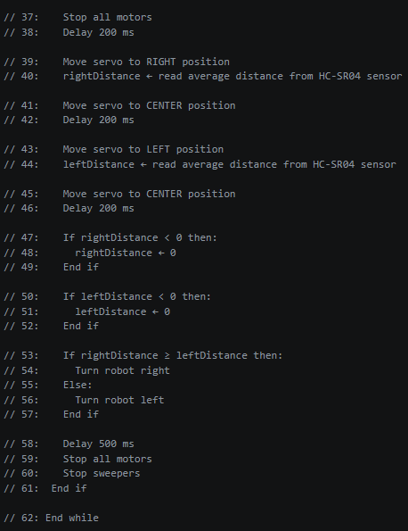

This pseudocode describes a robot's behaviour that uses data from an ultrasonic sensor for obstacle detection and free-path determination. It calculates the distance to the front. If an obstacle is within a defined distance limit, the value is sent to the ESP32. After sending the value, the robot activates the servo motor to rotate the ultrasonic sensor. If the condition, specifically the right or left side, is satisfied, the robot avoids the obstacle and continues the process.

The github link for the code : https://github.com/Listener228/MicroTasks/tree/main/src

- Experimental results
- Experimental setup
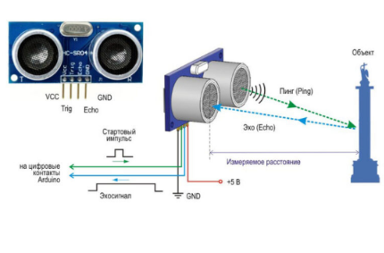
Figure 1. HC-SR04
For the experimental setup, Figure 1 shows the HC-SR04, an ultrasonic distance sensor used for contactless distance measurement. It operates at 5V DC, usually consumes about 15 mA, and uses 40 kHz ultrasonic waves. The Trig pin receives a short control pulse to start the measurement, while the Echo pin outputs a digital pulse related to the measured distance. Its typical measuring range is from 2 cm to 400 cm, with an accuracy of about ±3 mm under normal conditions. The accuracy depends on the object’s surface, angle, temperature, and environment. The sensor works best with solid flat objects and may give poor results with soft, curved, very small, or angled surfaces.

- Results and discussion
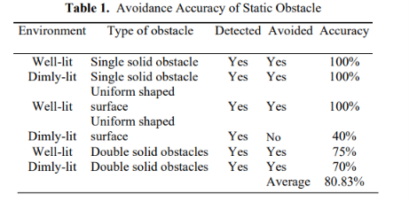
Table 1.
The author[1] of the results table demonstrates the accuracy of the ultrasonic sensor when it is tested against various environments with a variety of obstacle. Experimental results show a fair result, as it is a low-cost sensor element in the system.

- Conclusions
This project presented implementation of a low-cost robot sweeper based on the ESP32 microcontroller with the PlatformIO platform. The robot uses an HC-SR04 ultrasonic sensor and a servo motor to detect obstacles and scan the left and right directions. The use of simple and affordable components makes the project suitable for educational purposes and small cleaning applications. However, the performance of the robot depends on the accuracy of the ultrasonic sensor and the surface of obstacles. Project improvement for the future will require enhanced sensors as well as modifications to sweepers and motors connected to them for a better cleaning process.

Acknowledgement
We acknowledge the guidance and mentorship of course and lab instructors to complete this project.

References
- Joseph Azeta et al 2019 IOP Conf. Ser.: Mater. Sci. Eng. 707 012012

