I was born in Guanghou, but my hometown is not Guangzhou, but another place in Guangdong, Jieyang. Although I have lived in guangzhou for about 10 years since I was born, I don't know much about guangzhou. Instead, I had a deep memory of my hometown, Jieyang. Later, I went to Hangzhou to go to college.

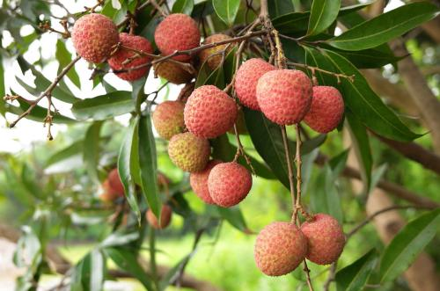When I think back on my time in guangzhou, what has a deep influence on me is the local language. I learned the cantonese that is used in daily life and study there. But it has been ten years now, there are no friends speaking cantonese around, many have forgotten. So I can't speak cantonese fluently now, For the food there, I like the litchi(荔枝) best.

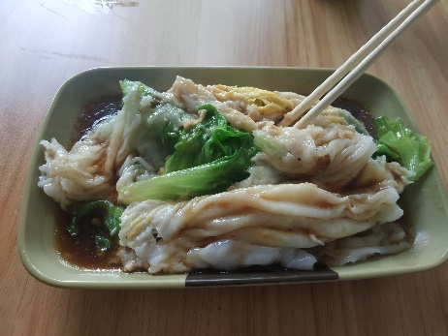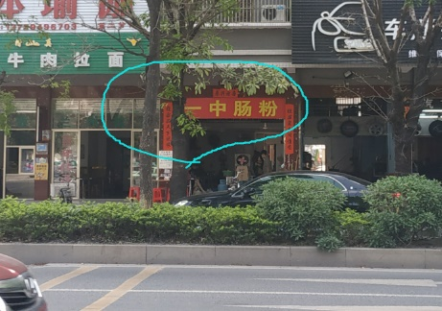I have been living in jieyang for nearly 10 years. In adcdition to Teochew dialect(潮汕话), I have also been exposed to other dialects, such as Hakka dialect(客家话). After contact with several languages, I find that they are the same on the grammatical structure, the difference is only the pronunciation, with this discovery, I quickly mastered the language of these dialects using on daily life, and I could speak quite well. So students in the class often guess wrong about my hometown. In fact , most of all communicated in Chinese in order to communicate conveniently in the school . Although I have learned several languages, my English is not very good. I think the problem is that I have not taken English into daily live. It is difficult to achieve practical effect only by using textbooks. My hometown Jieyang has a lot of delicious food. My favourite one is the steamed vermicelli roll(肠粉) ,which is a kind of Chaozhou-Shantou region food.

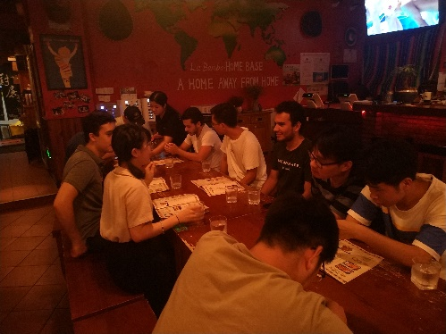Later,I came to HDU. And last year I have taken part in a project with several Mexican graduate students. They are very enthusiastic. During that time there isn't any accident happening because of cultural differences. We go to eat hot pot, barbecue. And then they took us to a Mexican restaurant--labamba. The Mexican food is very tasty. I like all Mexican food except 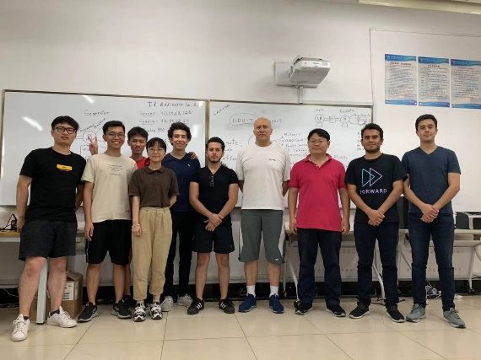avocados(牛油果). I think that there are no much on foreign friends, but brings me a sense of novelty. I enjoy this feeling and look forward to meeting more interesting foreign friends in the future.