基于STM32L476的利尔达NB-IoT开发板

PN: LSD1EV-STMIOTBD 由利尔达展芯科技有限公司设计

简介:
这套开发板集成了ST STEVAL-STLCS01核心控制板与Lierda NB05-01模组，
主控为STM32L476JGY6，板载数字麦克风、加速度计、陀螺仪、磁力计、温湿度传感器、气压计等。用户可通过NB模组，连接到利尔达Senthink或华为OceanConnect IoT平台，实现传感器数据的实时上传。

另外开发板自带的BLE芯片，可蓝牙连接到APP(ST BlueMS),动态演示传感器数据采集及BlueVoice语音传输。

LSD1EV-STMIOTBD 开发板以其强大的硬件功能，能让用户便捷和快速地评估ST MCU，MEMS，BLE等器件，搭配利尔达完整的NB-IoT支持生态，助力各种相关的IoT项目开发。

尺寸:71mm x 34mm
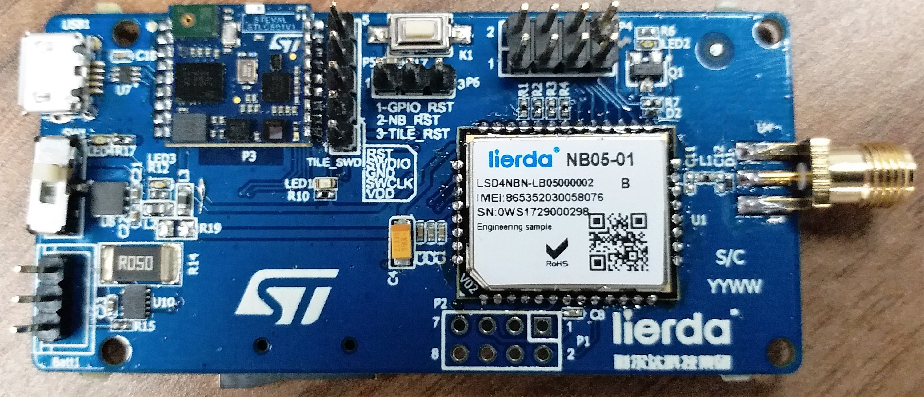

功能及应用:
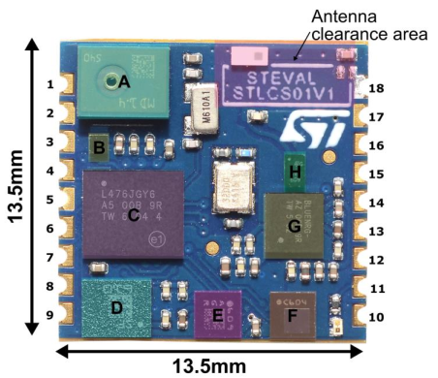
ST STEVAL-STLCS01
A. MP34DT04 数字麦克风
B. LD39115J18R_150mA 1.8V输出LDO
C. STM32L476JGY6:
1M FLASH,128K SRAM,1.71-3.6V,WLCSP72
D. LSM6DSM_6轴传感器
E. LSM303AGR_3轴磁力计
F. LPS22HB_微型气压计
G. BlueNRG-MS_低功耗蓝牙SOC
H. BALF-NRG-01D3_带谐波滤波器的50Ω巴伦

软件支持:
- STM32CubeL4底层固件库 3. MEMS及蓝牙开发资源支持
- 嵌入LiteOS 4. UDP直传Senthink
Lierda NB-IoT EVB Based On STM32L476

PN: LSD1EV-STMIOTBD Designed by Gemzing Technology Co.,Ltd
Brief：
This EVB integrates STEVAL-STLCS01 and Lierda NB05-01 module,with
Controller STM32L476JGY6, Digital Microphone, 3D accelerometer, 3D magnetometer,
3D gyroscope, pressure sensor, humidity and temperature sensor on board. It can connect to Senthink (Lierda) or OceanConnect (HUAWEI) IoT platform through NB-module, performing the real-time data uploading.
Besides,user can also use APP “ST BlueMS”(Andriod or IOS) to demonstrate MEMS data acquisition and BlueVoice audio transmission dynamically, connecting to EVB with Bluetooth.
Benefit from LSD1EV-STMIOTBD powerful hardware function,user can evaluate ST MCU,MEMS and BLE rapidly. With the support from lierda NB-IoT ecosystem, EVB help us accelerate the development of IoT projects.

Dimension:71mm x 34mm

Function and Application:
ST STEVAL-STLCS01
A. MP34DT04—digital microphone
B. LD39115J18R_150mA 1.8V LDO
C. STM32L476JGY6:
1M FLASH,128K SRAM,1.71-3.6V,WLCSP72
- LSM6DSM_low-power 3D accelerometer
and 3D gyroscope
- LSM303AGR_ultra-low power 3D accelerometer
and 3D magnetometer
F. LPS22HB_MEMS nano pressure sensor
G. BlueNRG-MS_BLE network processor
H. BALF-NRG-01D3_50Ωbalun

Software Support:
- STM32CubeL4 Firmware LIB 3. MEMS and BLE
- Embedded LiteOS 4. Upload data to Senthink with UDP

