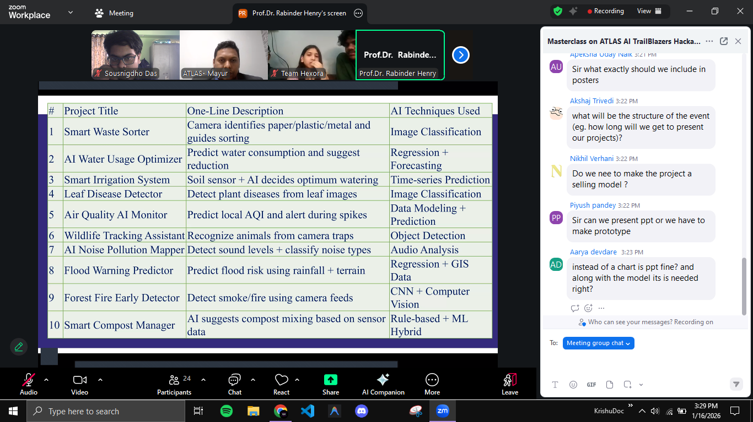
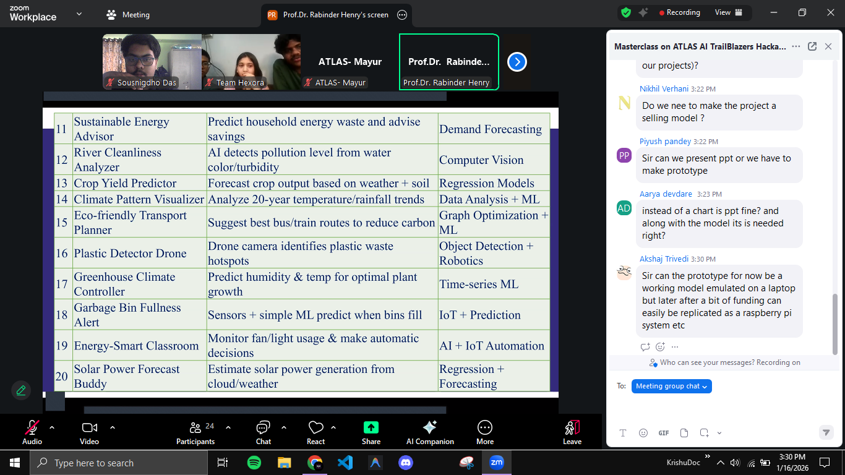
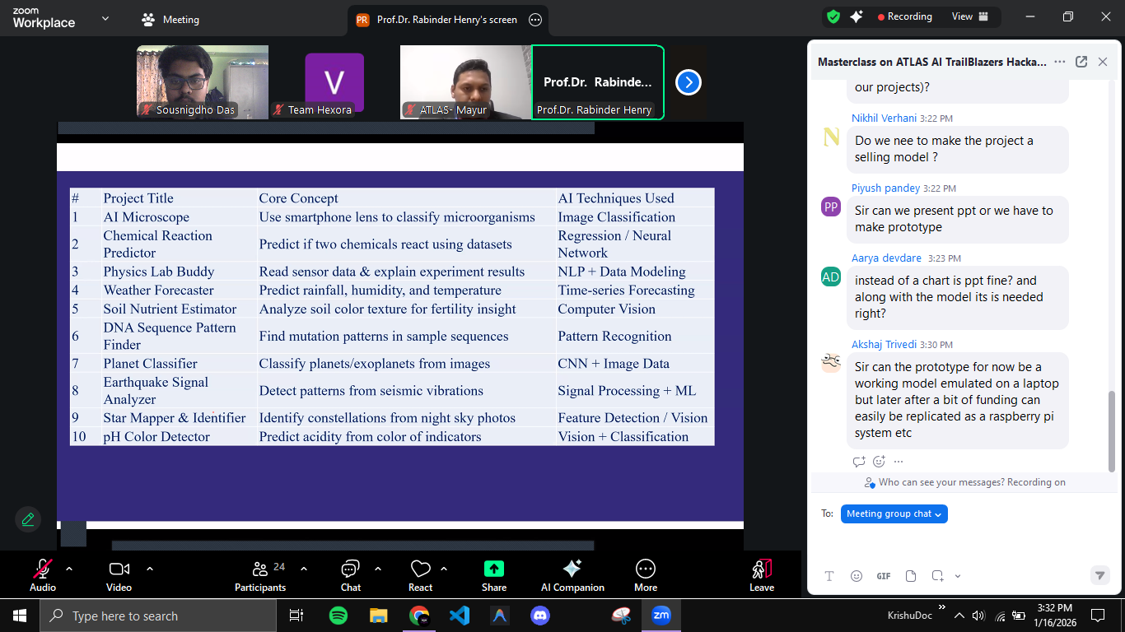
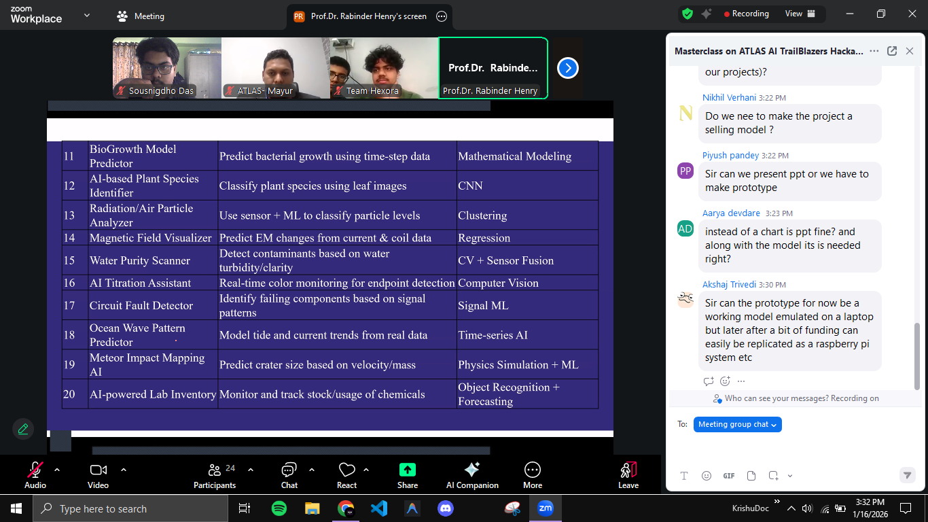
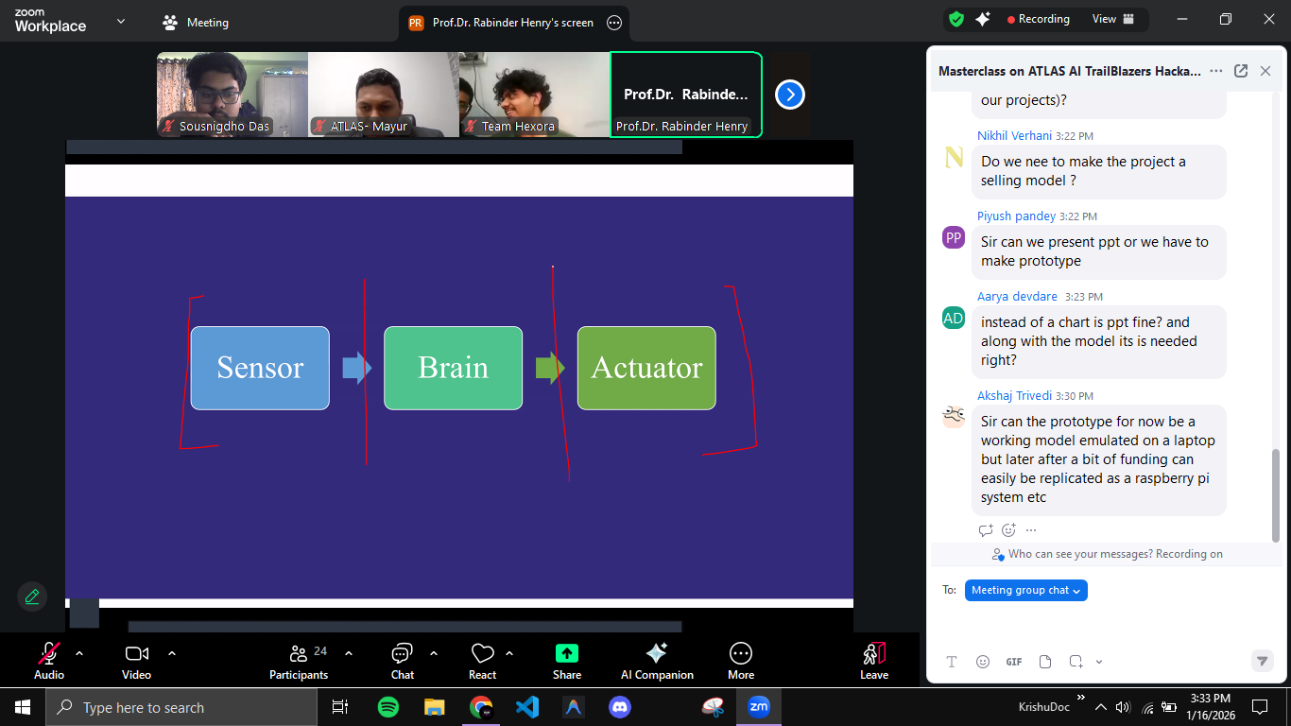All that you need to know about ATLAS AI Trailblazers: Ignite The Future of AI
About ATLAS Skilltech University:
ATLAS SkillTech University is India’s first new-age urban multidisciplinary university. Founded to forge a path to the future, ATLAS is where the confluence of design, technology, strategy, and leadership takes place. We believe in breaking paths and conventions. We are constantly defining, shaping, and redefining the future of education in India right here in the heart of an ever-booming, cosmopolitan, and enterprising Mumbai.
With India’s National Education Policy 2020 as the cornerstone, ATLAS endeavours to deliver a multidisciplinary education across 3 new-age streams: Design & Innovation, Management & Entrepreneurship and Digital Technology. It has adopted a futuristic model co-created with an international community of scholars, academicians, industry experts, and world leaders in education. Our undivided focus on academic excellence, world-class faculty, state-of-the-art infrastructure, global institutional collaborations and unique corporate connect empowers students to succeed in Industry 4.0 and become socially-responsible global leaders.
Vision: To create leaders of the future who are equipped with the skills of tomorrow.
Mission: To empower learners with 21st-century skills and transdisciplinary knowledge to excel in Industry 4.0.
About the Competition:
Welcome to the ATLAS Hackathon 2025, a nationwide innovation challenge designed for young tech enthusiasts of Grades 11th and 12th (Science stream). This unique hackathon aims to inspire future engineers to explore the possibilities of AI-driven problem-solving through coding, logical reasoning, and real-world innovation.
Hosted by ATLAS SkillTech University, this hackathon offers students a chance to compete, learn, and showcase their creativity — all while getting a glimpse into the world of technology and design thinking.
What’s in it for You?
- Exclusive mentorship from ATLAS University’s faculty during the finale.
- Opportunity to network with industry experts and academic leaders.
- Exposure to AI and Coding platforms during the hackathon.
- Top performers may be considered for special recognition during the ATLAS B.Tech 2026 Admissions.
Prizes and Rewards:
- Winners: INR 1,00,000, 25% Scholarship at ATLAS Skilltech University and Trophy
- 1st Runners Up: INR 75,000, 20% Scholarship at ATLAS Skilltech University and Trophy
- 2nd Runners Up: INR 50,000, 15% Scholarship at ATLAS Skilltech University and Trophy
- 10% Scholarship for the remaining 7 Teams in the Top 10!
- All finalists will get a Certificate of Excellence, ATLAS Goodies and Merchandise, Exposure to ATLAS Faculty and Mentorship sessions.
- All participants will receive a Certificate of Participation.
- Finalists will receive a Certificate of Excellence signed by the Chancellor of ATLAS SkillTech University.
Eligibility:
- Open to all students currently studying in Grades 11 and 12 (PCM Only) across India.
- Participation can be in teams of 2-3 members.
- Each team can have members from the same or different schools.
- A student can participate in only one team.
- There is no restriction on the number of teams from a school.
- Any form of plagiarism or unfair practice will result in disqualification.
Competition Structure:
Round 1: MCQ and Coding Round
- Opens on: 1st December 2025
- Participants must register through the Unstop platform to confirm their entry.
- Registered participants will receive a confirmation email with competition details and updates.
- Teams must ensure their profiles are complete before the registration window closes.
- This round combines Aptitude (MCQ-based) and Coding challenges to test participants’ logical reasoning, analytical ability, and technical skills.
- It will be conducted online via Unstop.
- Duration: 60 minutes
- The round will be eliminatory, and Top 25 teams will move forward to the Grand Finale.
Round 2: Grand Finale
- Date: To be announced
- Venue: ATLAS SkillTech University Campus
- The Top 25 Teams from the Online Challenge will be invited to the campus to present their final solution to an esteemed panel of judges.
- Each team will have 10 minutes to present, followed by 5 minutes of Q&A.
- The round will include:
  - Live project presentation or prototypes
  - Jury evaluation based on innovation, feasibility, and presentation
- Winners will be announced on the same day.
All final decisions lie with ATLAS Skilltech University and Unstop.

