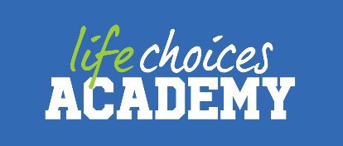

**Student Profile Page:**

## Overview:

Full Name: Litha Kane

Date of Birth: 02-January-2000

Gender: Male

Location (suburb): Nyanga, Cape Town

Nationality: South African

Willing to Relocate (Yes/No – Then where JHB or Durban): No

Any type of criminal record: No

Are you blacklisted or do you have any credit issues: Student Loan(Nsfas)

## Student Bio: “I’m Litha Kane. I’m a junior web developer who codes. I care deeply about creating useful, and beautiful products that help people and make a difference. I can be as involved in your project as you need me to be; from the seed of the idea, to creative direction, design,and even the front-end”

## Please provide us with an idea as to where your passion for the tech space came from.

## Passion Board:

* Writing Poetry
* Mobile gaming
* Reading
* Socialising
* Sewing

## Education:

**Matric (year and school): Oscar Mpetha, 2018**

## Any other education (even if you have dropped-out):

University Name: University of Western Cape

Course Name: Business Administration

Period: 5 months

Completed: No, dropped out

Additional courses

College Name: Elevation Program

Course Name: Life Skills

Period: 1 Week

Completed: Yes

## Working Experience:

Name of programme: Ikamva Youth

Contract: Volunteering

Grades: 10, 11 & 12

Period: 2020 – part-time on weekends

Duties:

* Tutor learners on Business studies, Economics, Accounting & Mathematics Literacy

Contact Us

Email: Lithan71@gmail.com

Contact Number: 081-390-2257

LinkedIn: https://www.linkedin.com/in/litha-kane

GitHub: https://github.com/Lithak