
KARNAVATI UNIVERSITY
UNITEDWORLD INSTITUTE OF TECHNOLOGY (UIT)

MINI PROJECT REPORT

ON

“AeroMind: Multi-Agent Post-Flight Analysis of ArduPilot Drone Missions”
Submitted as a part of the course

AGENTIC AI

Submitted By
Student Name | Enrollment No.
__________________________ | __________________
Program: B.Tech CSE / B.Tech CSE-AIML
Semester: VI
Section: __________

Under the Guidance of
Faculty Name
Assistant Professor
Department of Computer Science & Information Technology
Karnavati University, Gandhinagar

Academic Year: 2026–27

CERTIFICATE
This is to certify that the mini project entitled “AeroMind: Multi-Agent Post-Flight Analysis of ArduPilot Drone Missions” has been successfully completed by the following students of B.Tech AeroMind: Multi-Agent Post-Flight Analysis of ArduPilot Drone Missions Semester VI, Karnavati University, as a part of the course Agentic AI during the academic year 2026–27.
Sr. No. | Student Name | Enrollment No.
1
2
3
4
The project has been carried out under the guidance and supervision of the faculty member. The work presented in this report is the original work carried out by the students as part of their mini project.
Faculty Guide
Name: __________________________
Signature: ______________________
Date: ___________________________

DECLARATION
We hereby declare that the mini project entitled “AeroMind: Multi-Agent Post-Flight Analysis of ArduPilot Drone Missions” submitted as part of the course Agentic AI is our original work carried out under the guidance of the faculty member.
We further declare that this work has not been submitted previously to any other institution or university for the award of any degree, diploma, or academic certification.
All research papers, datasets, frameworks, APIs, libraries, websites, and other resources used during the development of the project have been appropriately acknowledged and referenced.
Sr. No. | Student Name | Enrollment No.
1
2
3
4

Date: __________________
Place: Gandhinagar

ACKNOWLEDGEMENT
We thank our faculty guide for the direction, feedback and patience given throughout this mini project, and the Department of Computer Science & Information Technology, Unitedworld Institute of Technology, Karnavati University, for including Agentic AI in the curriculum and for the laboratory and computing facilities that made the work possible.
The simulation work builds on the disaster-zone world and the Hexa-X airframe our team developed for the Smart India Hackathon 2026 (the Aero Sense project), and on open-source software from the ArduPilot, Gazebo and Python communities: ArduPilot SITL, MAVProxy and pymavlink, Gazebo Harmonic, Streamlit, Plotly, pandas, Pydantic and Ollama. We acknowledge the authors of the third-party simulation models listed in the references.
Finally, we thank every team member for their contribution to the design, implementation, testing and documentation of AeroMind.

ABSTRACT
After a drone flight, the information needed to understand what happened is scattered across a telemetry log, a mission file, a parameter file and the pilot's memory, and reading it takes expertise. Most operators therefore never learn why a flight drifted, ran its battery low or lost its telemetry link, and repeat the same mistakes. This project presents AeroMind, a multi-agent Agentic AI system that analyses the files of one ArduPilot flight and produces a one-page verdict, a phase-by-phase story, a telemetry-link timeline, root causes, a next-mission risk score and a corrected mission file.
Deterministic Python tools convert MAVLink logs into verified metrics with Good/Caution/Bad statuses. An orchestrator builds a manifest, obtains a plan from a large language model (LLM), checks the plan against rules, and runs five specialist agents (Flight Summary, Telemetry Link, Diagnosis, Risk and Advisor) on a shared state. A deterministic Verifier rejects any claim not supported by the data and triggers one self-correction round. A flight history provides long-term memory: personal baselines, battery prediction and recurring issues. The system is built in Python with Pydantic, Streamlit and Plotly, and runs with Claude through the Anthropic API or a local Qwen2.5-3B model through Ollama.
Eight flights were flown in ArduPilot SITL in a Gazebo disaster world with injected faults and known ground truth. AeroMind's agents detected all four injected faults with the correct root cause, located both telemetry dropouts within 0.1 s of the truth, raised no false alarm on the baseline flight and ranked next-mission risk correctly. The mission they corrected for the undersized-battery scenario raised the battery at landing from 14 % to 25 %, and the speed fix reduced the wind-scenario cross-track error from 1.8 m to 1.44 m. The work shows that LLM agents paired with deterministic verification produce useful, grounded flight analysis even with a small model running locally.

TABLE OF CONTENTS
ACKNOWLEDGEMENT 4
ABSTRACT 5
LIST OF FIGURES 8
LIST OF TABLES 9
CHAPTER 1 – INTRODUCTION 10
1.1 Introduction 10
1.2 Background 10
1.3 Problem Statement 10
1.4 Motivation 11
1.5 Objectives 11
1.6 Scope of the Project 11
CHAPTER 2 – LITERATURE REVIEW 12
2.1 Existing Systems and Research 12
2.2 Comparative Analysis 12
2.3 Research Gap 12
CHAPTER 3 – PROPOSED SYSTEM 13
3.1 Proposed Solution 13
3.2 System Requirements 13
3.3 Functional Requirements 13
3.4 Non-Functional Requirements 13
CHAPTER 4 – AGENT ARCHITECTURE 14
4.1 Overall System Architecture 14
4.2 Architecture Components 14
4.3 Agent Roles and Responsibilities 15
4.4 Agent Workflow 15
CHAPTER 5 – AGENTIC AI CONCEPTS USED 16
5.1 ReAct 16
5.2 Planning 16
5.3 Tool Calling 16
5.4 Memory 17
5.5 Retrieval-Augmented Generation 17
5.6 Multi-Agent System 17
5.7 Human-in-the-Loop 17
CHAPTER 6 – METHODOLOGY 18
6.1 Input Processing 18
6.2 Task Understanding 18
6.3 Task Planning 18
6.4 Reasoning and Decision Making 18
6.5 Tool Selection 18
6.6 Task Execution 18
6.7 Observation and Feedback 19
6.8 Final Response Generation 19
6.9 Evaluation Environment 19
CHAPTER 7 – IMPLEMENTATION 20
7.1 Project Structure 20
7.2 Agent Implementation 20
7.3 Tool Implementation 20
7.4 Memory Implementation 20
7.5 RAG Implementation 20
7.6 User Interface 21
CHAPTER 8 – RESULTS AND OUTPUT 22
8.1 Test Cases 22
8.2 Sample Outputs 22
8.3 Agent Execution Trace 23
CHAPTER 9 – PERFORMANCE EVALUATION 24
CHAPTER 10 – CHALLENGES AND LIMITATIONS 25
CHAPTER 11 – FUTURE SCOPE 26
CHAPTER 12 – CONCLUSION 27
REFERENCES 28
APPENDIX 29
Appendix A – Source Code 29
Appendix B – Additional Screenshots 29
Appendix C – Sample Prompts 34
Appendix D – Test Data 34

LIST OF FIGURES
Figure 1: Overall system architecture of AeroMind 14
Figure 2: Agent workflow of one analysis 15
Figure 3: Planning and execution flow of the orchestrator 16
Figure 4: The Gazebo disaster world and the Hexa-X during a SITL mission 19
Figure 5: Dashboard: input form, Summary and Agents tabs 21
Figure 6: Ask tab (S3): an answer verified against the cited metrics 21
Figure 7: Generated report.html for S2 23
Figure 8: Track tab (S3): planned route, flown path coloured by link quality 29
Figure 9: Telemetry tab (S3): link strip, message rate and dropout table 30
Figure 10: History tab (S2 fixed): baseline, trends and what worked before 31
Figure 11: Power & attitude tab (S2) 32
Figure 12: More views of the simulation world 33
Figure 13: Hexa-X over the collapsed buildings 33
Figure 14: Hexa-X flying past the flood zone 33

LIST OF TABLES
Table 1: Literature review summary 12
Table 2: Comparison of existing tools and the proposed system 12
Table 3: Hardware requirements 13
Table 4: Software requirements and technologies used 13
Table 5: Agent roles and responsibilities 15
Table 6: Main metrics and thresholds 18
Table 7: Evaluation scenarios 19
Table 8: Test cases and actual results 22
Table 9: Performance evaluation 24
Table 10: Results before and after the fixed missions 24
Table 11: Sample prompts 34
Table 12: Test data 34

CHAPTER 1 – INTRODUCTION

1.1 Introduction
Artificial Intelligence (AI) builds systems that perceive, reason and decide. Generative AI produces new content: large language models (LLMs) such as Claude and Qwen generate text, code or structured data from a prompt. Agentic AI uses an LLM as the decision-making core of a system that pursues a goal over several steps: it plans, acts through tools or other agents, observes the results and adjusts [1], [11]. A chatbot answers one message at a time; an agent works towards a goal. AeroMind shows each property of an agent:
- Autonomy: once a flight's files are dropped in, the whole analysis runs without further input.
- Planning: an orchestrator decides which agents to run, in what order and why.
- Reasoning: each agent explains what happened and why, citing the metrics it relies on.
- Tool usage: Python tools parse the logs, compute metrics, predict battery use and edit the mission.
- Memory: every analysed flight is stored and later flights are compared with the pilot's own baseline.
- Goal-oriented execution: work continues, with a self-correction round, until the result is verified.

1.2 Background
Drones running the open-source ArduPilot autopilot record their state as MAVLink telemetry, saved by ground stations such as Mission Planner as a .tlog file [8], [9]. Existing tools such as ArduPilot's UAV Log Viewer [10] and PX4 Flight Review [12] plot this data well but leave interpretation to the user, who must know which message holds the cross-track error, what is normal and how to turn it into a better mission. AeroMind gives the arithmetic to tools and the judgement to agents, and checks the agents against the tools.

1.3 Problem Statement
The objective of this project is to develop an Agentic AI-based system that analyses the telemetry log, mission and parameters of an ArduPilot flight, explains how the flight and its telemetry link went, identifies what went wrong and why, scores the risk of the next mission and produces a corrected mission file. Existing systems plot the data but leave diagnosis, risk assessment and mission correction to an expert. Therefore, there is a need for a system that can reason over flight data like an expert while every statement it makes is checked against the data.

1.4 Motivation
Our team builds drones for the Smart India Hackathon and spent hours working out from logs why a flight behaved as it did; small teams rarely have a flight-test engineer. Plotting tools leave interpretation to the user, and a stand-alone LLM can state numbers that are not in the data [6]. Agentic AI lets planned, specialised agents explain and advise while tools keep every number exact.

1.5 Objectives
- To design a multi-agent system that turns one flight's files into a verdict, a flight story, a telemetry-link analysis, root causes, a next-mission risk score and a corrected mission.
- To implement LLM-planned orchestration of specialist agents over a shared state, with rule-checked plans.
- To integrate deterministic tools for log ingestion, metrics, risk scoring and bounded mission editing.
- To implement long-term memory of flights for baselines, battery prediction and recurring issues.
- To verify every agent claim against the data and evaluate the system on flights with known injected faults.

1.6 Scope of the Project
- Target users: pilots and student teams flying ArduPilot multirotors.
- Supported tasks: post-flight analysis of .tlog files (several per flight are merged) with an optional mission, parameters and pilot notes; questions about the flight; a corrected mission file.
- Boundaries: post-flight analysis, evaluated on simulated flights; by design the system never uploads anything to the drone.

CHAPTER 2 – LITERATURE REVIEW

2.1 Existing Systems and Research
Table 1 summarises the work that shaped AeroMind.
Table 1: Literature review summary
Sr. No. | Paper/System | Year | Approach | Key Finding | Limitation
1 | ReAct [1] | 2023 | Reasoning traces with tool actions | Reasoning and acting beat either alone | Errors propagate
2 | AutoGen [2] | 2023 | Conversing specialist agents | Tasks decompose well across agents | No check against data
3 | MetaGPT [3] | 2024 | Role agents, structured hand-offs | Structure reduces errors | Software engineering only
4 | Reflexion [4], Self-Refine [5] | 2023 | Self-critique and retry | Feedback improves results | Critic can accept wrong answers
5 | Log viewers [9], [10], [12] | – | Plot flight logs | Reliable plots of every signal | Interpretation left to user

2.2 Comparative Analysis
Table 2: Comparison of existing tools and the proposed system
Feature | Existing System (log viewers) | Proposed System (AeroMind)
Autonomous Execution | No: the user reads each plot | Yes: files in, full analysis out
Task Planning | No | Orchestrator plans the agents; plan checked by rules
Reasoning | No | Agents explain causes and risk, citing metrics
Tool Usage | Plotting only | Ingest, metrics, memory, risk rules, mission editing
Memory | No | Flight history: baselines, battery prediction, recurring issues
RAG | No | Not used
Multi-Agent Support | No | Five specialist agents and a Verifier
Human Intervention | Entirely manual | Pilot reviews the fixed mission before flying

2.3 Research Gap
As Table 2 shows, log tools are exact but explain nothing, while agent frameworks [1]–[5] do not check what an agent says against data [6]. AeroMind combines both with a Verifier.

CHAPTER 3 – PROPOSED SYSTEM

3.1 Proposed Solution
The user uploads a flight's files in a Streamlit dashboard or the run.py command line. Python tools compute the metrics, the orchestrator plans five agents running on Claude [14] or a local Qwen2.5-3B model [13] via Ollama [15], and the Verifier approves the result, which is written as a report and a fixed mission.

3.2 System Requirements
Table 3 lists the hardware used and Table 4 the software.
Table 3: Hardware requirements
Component | Requirement (as used)
Processor | AMD Ryzen 5 7535HS, 6 cores / 12 threads
RAM | 16 GB (analysis alone needs under 1 GB)
GPU / Internet | NVIDIA GeForce RTX 2050, 4 GB / for the Claude API (both optional)

Table 4: Software requirements and technologies used
Software/Technology | Version/Specification
Operating System | Ubuntu 22.04.5 LTS
Programming Language | Python 3.10.12 (Lua for the simulated battery)
Agent Framework / LLM | Own orchestrator, Pydantic 2.13 [19]; Claude or Qwen2.5-3B via Ollama 0.40.8
Frontend | Streamlit 1.57 [20], Plotly 6.7 [21]; Jinja2 3.1 for report.html
Data and parsing | pymavlink 2.4.49 [16], pandas 2.3 [22], NumPy 2.2
Simulation | ArduCopter SITL, MAVProxy 1.8.74, Gazebo Harmonic 8.15 [18]

3.3 Functional Requirements
The system accepts one or more .tlog files with an optional mission, parameters and notes; computes flight and link metrics with statuses; plans and runs the agents; verifies every claim; remembers past flights; and writes a corrected mission within hard limits.

3.4 Non-Functional Requirements
No number reaches the user unchecked, the analysis always completes, uploads are validated and the dashboard is served only on the local machine.

CHAPTER 4 – AGENT ARCHITECTURE

4.1 Overall System Architecture
Figure 1 shows the architecture: inputs pass through Python tools into a shared state, the orchestrator plans and runs the agents, and the Verifier lets only approved output reach the user and the flight history.
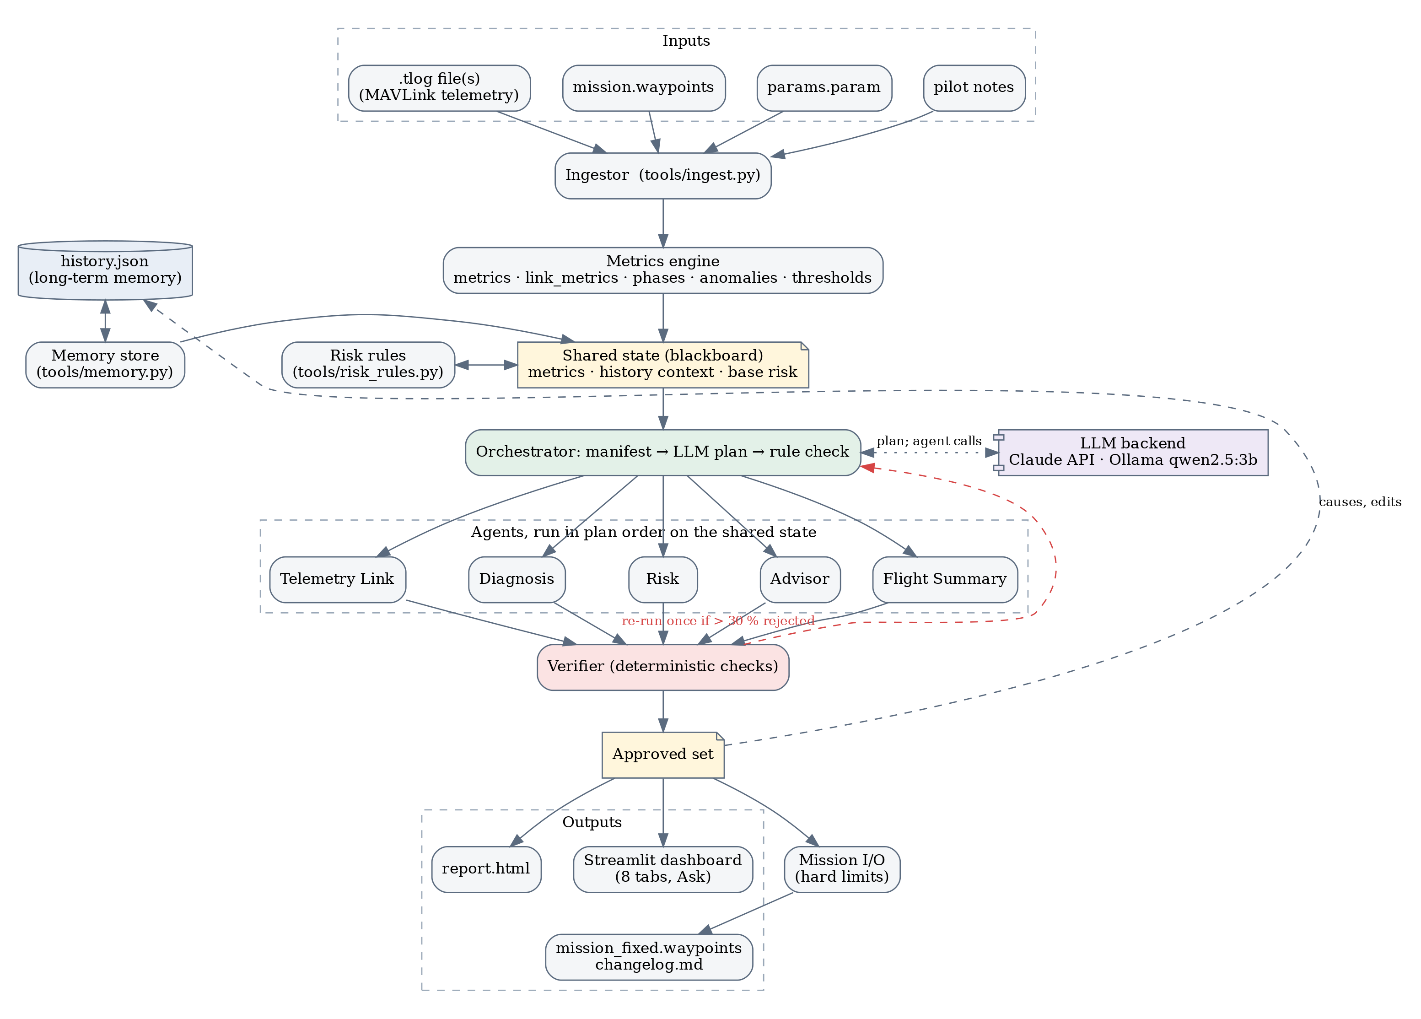
Figure 1: Overall system architecture of AeroMind

4.2 Architecture Components
The user interface is app.py (Streamlit) and run.py; the LLM layer is agents/llm.py; each agent is a prompt and a Pydantic schema run by run_agent(); orchestrator.py plans and executes; tools/ holds the tools; history.json is the long-term memory; pipeline.py writes the outputs. No retriever is used.

4.3 Agent Roles and Responsibilities
Table 5: Agent roles and responsibilities
Agent | Role | Responsibility
Orchestrator | Planner, executor | Plans, checks the plan, runs agents, triggers refinement
Flight Summary | Narrator | Verdict, a line per flight phase, 3-sentence summary
Telemetry Link | Link analyst | Uptime, dropouts (time, duration, waypoint), packet loss
Diagnosis | Analyst | Findings citing metrics; up to 3 root causes with confidence
Risk | Assessor | Adjusts the rule-based risk score by at most ±10 with a reason
Advisor | Mission planner | Mission edits tied to causes; top 3 improvements
Verifier | Reviewer | Checks every claim and number against the data

4.4 Agent Workflow
Table 5 lists the agents. Figure 2 shows one analysis: tools compute metrics and memory, the orchestrator plans, agents run in order, the Verifier observes their outputs, an agent with more than 30 % of its claims rejected refines its answer once, and the result is saved.
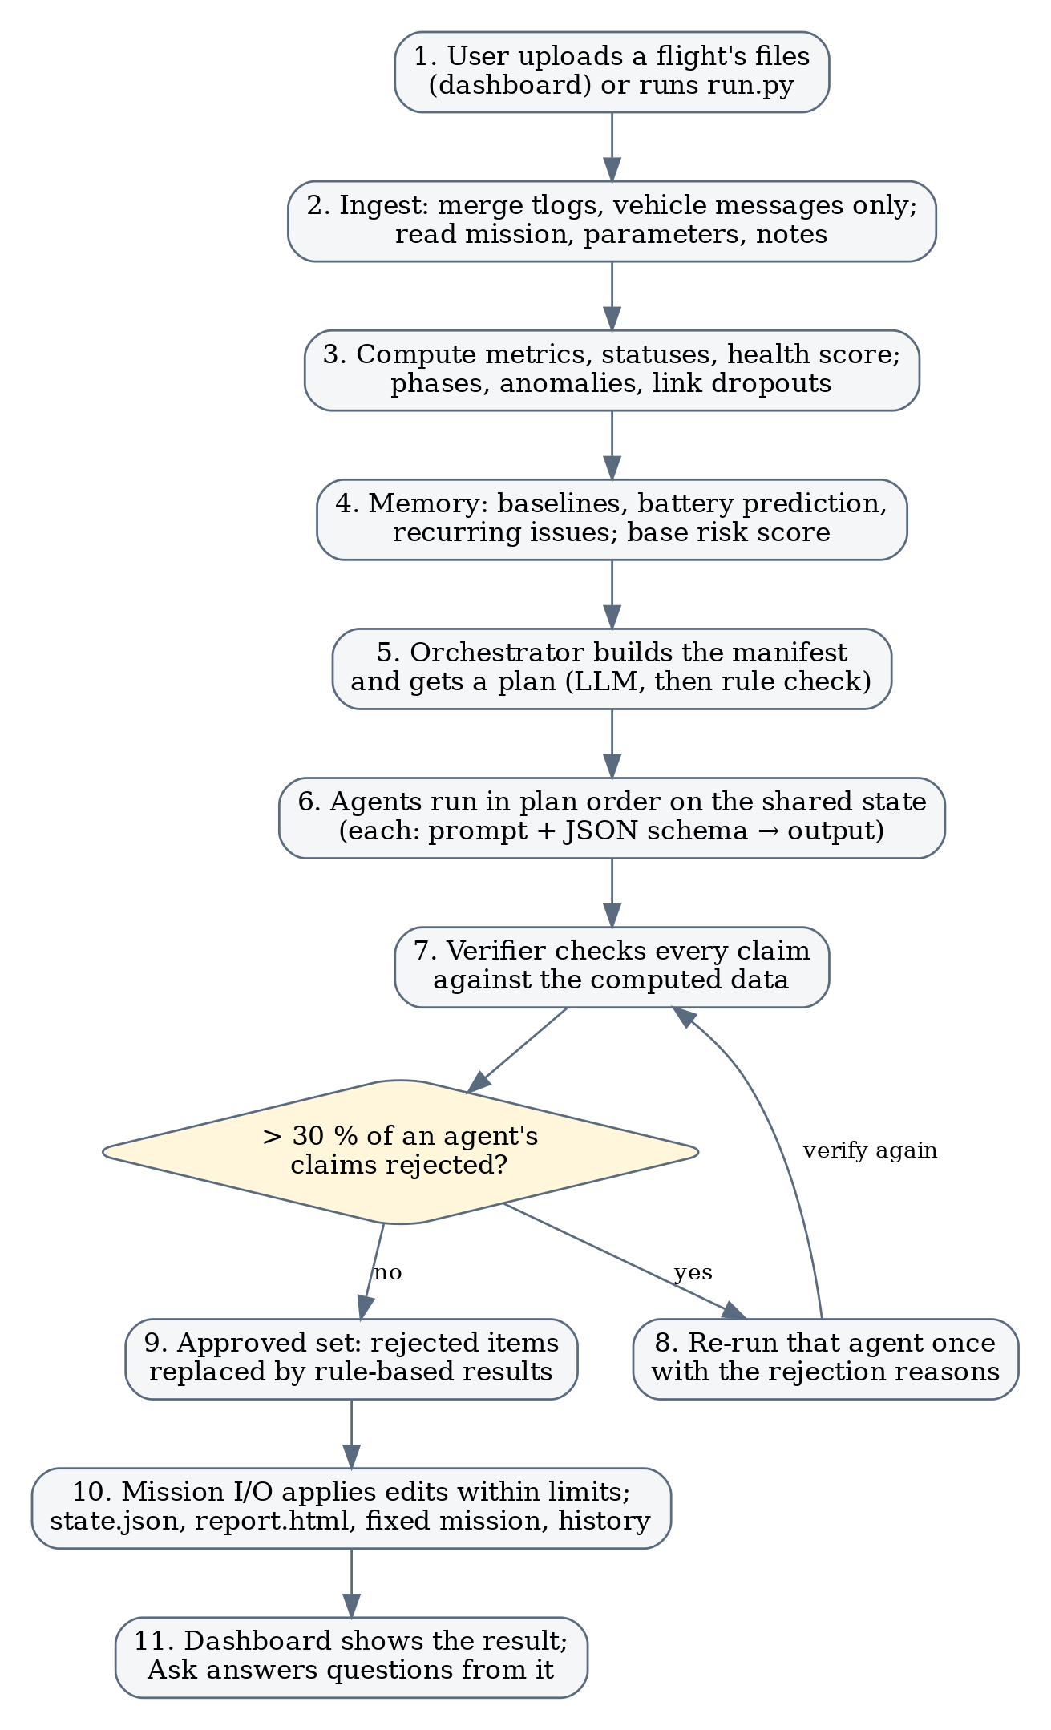
Figure 2: Agent workflow of one analysis

CHAPTER 5 – AGENTIC AI CONCEPTS USED

5.1 ReAct
Instead of letting the LLM pick tools [1], the tools always run first so none can be skipped. The reason → act → observe cycle appears as verify and refine: the Verifier observes each output and the agent acts again with the feedback.

5.2 Planning
The orchestrator uses plan-and-execute (Figure 3). The LLM receives a manifest (inputs, metric statuses, problems, link health, history) and returns an ordered list of agents with a reason each. checked_plan() enforces the rules: Flight Summary first, Verifier last, Diagnosis only when something is Caution or Bad, dependencies in order. A healthy flight therefore skips diagnosis.
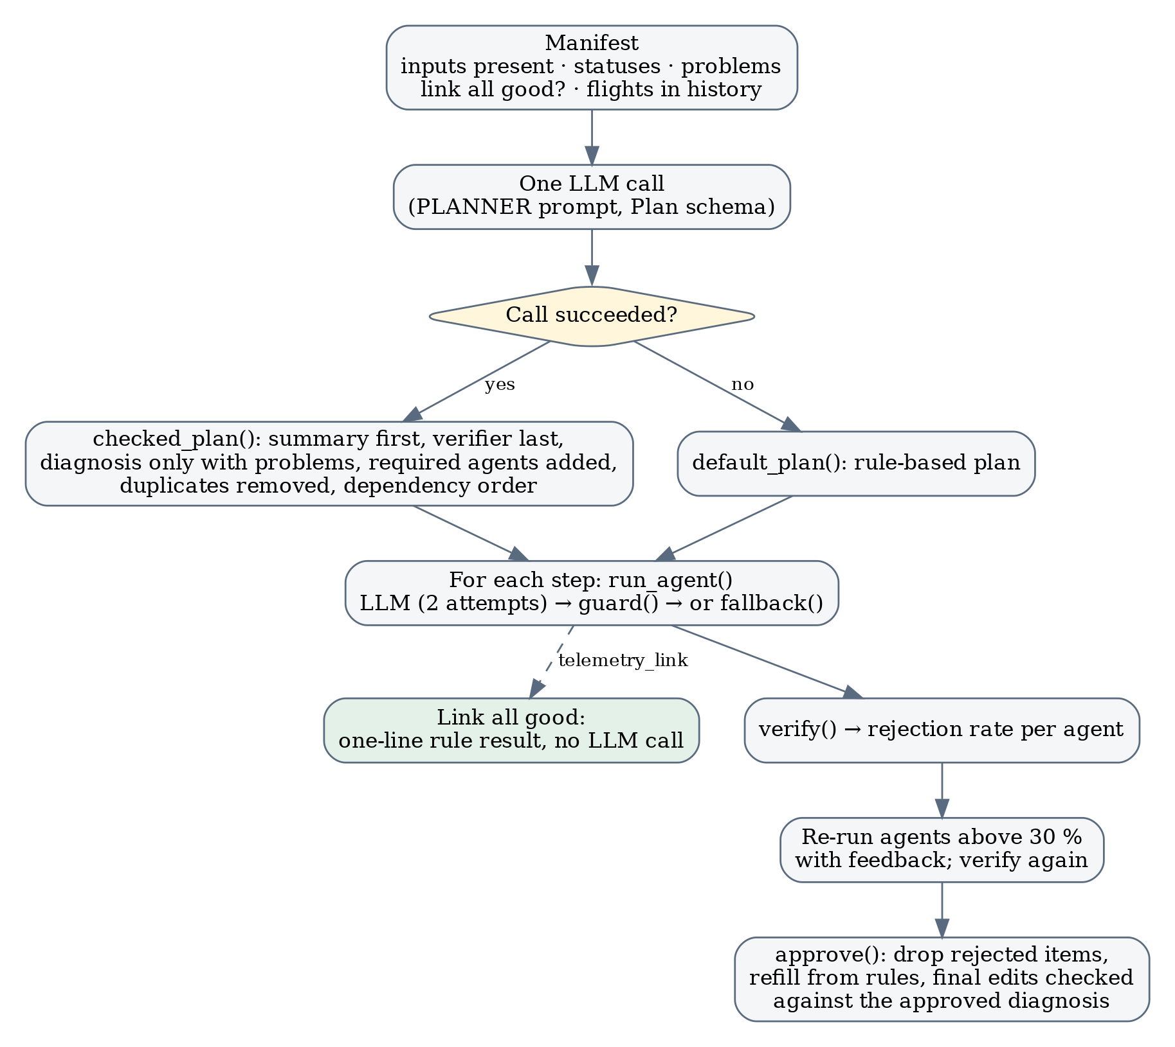
Figure 3: Planning and execution flow of the orchestrator

5.3 Tool Calling
The tools are Python functions run by the pipeline: the ingestor (logs, mission, parameters, notes), the metrics engine (metrics, statuses, phases, anomalies), the memory store, the risk rules, mission I/O (edits within limits) and the report writer. Agents receive their output as compact JSON context.

5.4 Memory
Working memory is the shared state of one analysis. Long-term memory is history.json, one validated record per flight (battery use per km, cross-track, link uptime, health, causes, applied edits, parent run). From it the system computes baselines (2σ test over 3 or more flights), a battery prediction from the median mAh per km, recurring causes (3 of the last 5 flights) and whether past fixes worked.

5.5 Retrieval-Augmented Generation
RAG is not used: the agents' knowledge of the flight comes from computed metrics.

5.6 Multi-Agent System
The agents communicate through the shared state (blackboard): Risk reads the causes from Diagnosis, and the Advisor reads causes and risk. Python guards keep shared quantities consistent: the risk score is always base plus adjustment and mission edits are re-checked against the approved diagnosis. Any agent with more than 30 % of its claims rejected refines its answer once with the reasons.

5.7 Human-in-the-Loop
Nothing is uploaded to the vehicle: the pilot reviews mission_fixed.waypoints and the change log and decides whether to fly it, and can add notes that the agents use as evidence.

CHAPTER 6 – METHODOLOGY

6.1 Input Processing
Files arrive by dashboard upload (extension and size checks, sanitised names) or the command line. ingest.py reads each .tlog with pymavlink [7], [16] and merges several files of one flight by time.

6.2 Task Understanding
The metrics engine computes about 30 metrics and rates 14 of them Good, Caution or Bad (Table 6); the health score starts at 100 and loses 10 per Caution and 25 per Bad.
Table 6: Main metrics and thresholds
Metric | Good | Caution | Bad
Cross-track error, max (m) | < 1 | 1–3 | > 3
Battery at landing (%) | > 30 | 20–30 | < 20
Vibration max, airborne (m/s²) | < 30 | 30–60 | > 60
Link uptime (%) | ≥ 99 | 95–99 | < 95
Dropouts (silence > 2 s) | 0 | 1–2, each ≤ 10 s | > 2, or any > 10 s

6.3 Task Planning
The tool steps always run; the agent steps are planned (Section 5.2).

6.4 Reasoning and Decision Making
Diagnosis starts from candidate causes produced by hint rules; the Risk agent may move the rule-based score (Low < 30, Medium 30–59, High ≥ 60) by at most ±10 with a reason.

6.5 Tool Selection
The pipeline runs the analysis tools; Mission I/O runs when a mission file was given.

6.6 Task Execution
Each LLM call requests output in the agent's schema; an invalid reply is retried with the error. Mission edits (speed 3–10 m/s, altitude 25–120 m [17], waypoint removal, holds) are applied within hard limits.

6.7 Observation and Feedback
The Verifier checks every cited metric and every number with a unit against the data (Listing 1, Section 7.2); its reasons are the feedback for refinement.

6.8 Final Response Generation
approve() keeps the verified items and pipeline.py writes the outputs.

6.9 Evaluation Environment
Flights were flown in ArduCopter SITL [8] in the team's Gazebo [18] disaster world (Figure 4). The Hexa-X hexacopter flew one 1.3 km route at 30 m in five scenarios with known injected faults (Table 7).
Table 7: Evaluation scenarios
ID | Scenario | Injected fault
S0 | Baseline, 5 m/s | None
S1 | Wind + fast flight | 10 m/s wind from the east; mission speed 12 m/s
S2 | Undersized battery | BATT_CAPACITY 2200 mAh instead of 10000
S3 | Telemetry dropout | Link down for 12 s at 90 s and at 200 s
S4 | Combined | S1 + S2 + link loss over the no-network zone
S1/S2/S4 fixed | Re-flights | Same faults, flying the agents' mission_fixed.waypoints

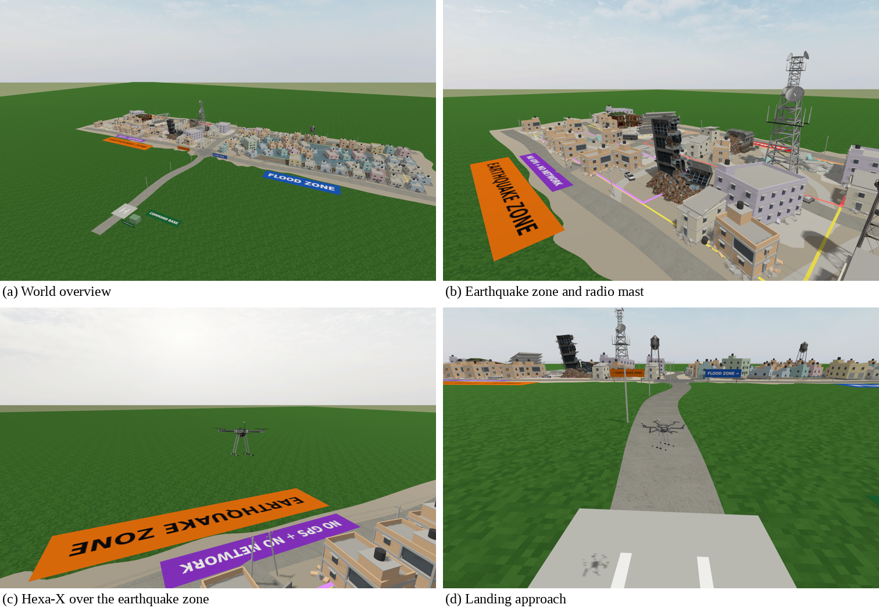
Figure 4: The Gazebo disaster world and the Hexa-X during a SITL mission

CHAPTER 7 – IMPLEMENTATION

7.1 Project Structure
agents/ holds the schemas, LLM backends, prompts, orchestrator and Verifier; tools/ the ingestion, metrics, memory, risk and mission tools; dashboard/ the user interface; sim/ the Gazebo world and fault injection; tests/ 247 pytest tests (about 5,000 lines of Python).

7.2 Agent Implementation
Each agent is a system prompt (Appendix C) plus a Pydantic schema. With Claude, messages.parse() validates the reply against the schema [14]; with Ollama the schema is passed as the output format [15]. Listing 1 shows the Verifier's check of numbers in free text.
def check_text(text: str, known: dict, require_number: bool = False, where: str = "the flight data") -> str:
"""'' if every number with a unit in `text` matches a known value of that unit."""
if require_number and not BARE_NUMBER.search(text):
return "gives no number from the flight data as evidence"
for raw, unit in NUMBER_WITH_UNIT.findall(text):
family, factor = UNITS.get(unit.lower(), UNITS.get(unit, (None, 1)))
value = float(raw) * factor
if family is None or not any(close(value, k, family) for k in known.get(family, [])):
return f"'{raw} {unit}' is not in {where}"
return ""
Listing 1: unit-aware grounding of numbers in free text (agents/verifier.py).

7.3 Tool Implementation
The link tool finds silences longer than 2 s that also appear on the vehicle clock; Mission I/O applies each edit to a copy and re-checks the whole mission before writing it.

7.4 Memory Implementation
tools/memory.py stores validated records in history.json and computes the values of Section 5.4.

7.5 RAG Implementation
Not applicable (Section 5.5).

7.6 User Interface
Figure 5 shows (a) the input form with the Summary tab and (b) the agents' plan, Verifier verdicts and execution; Figure 6 shows the Ask tab. More tabs are in Appendix B.
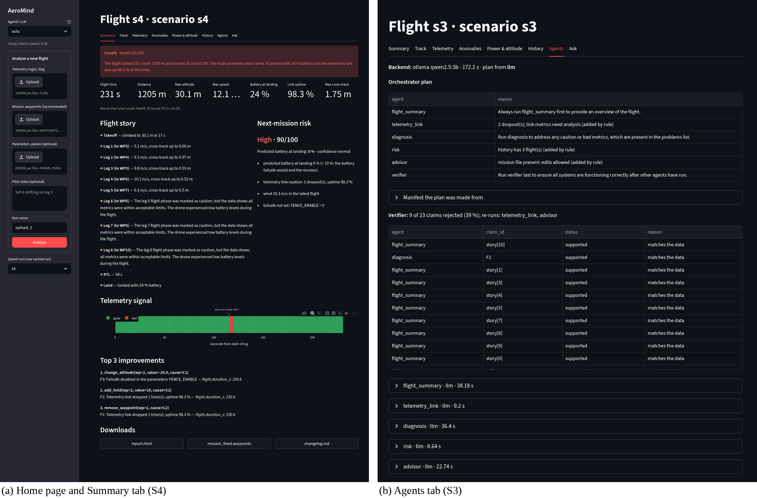
Figure 5: Dashboard: input form, Summary and Agents tabs
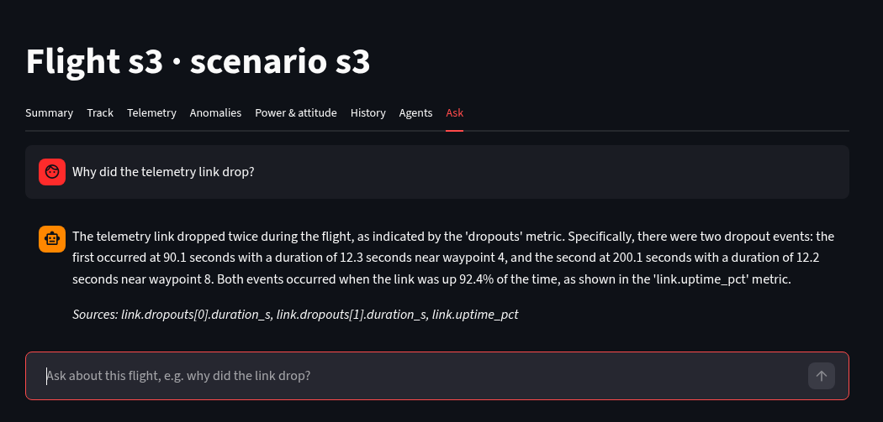
Figure 6: Ask tab (S3): an answer verified against the cited metrics

CHAPTER 8 – RESULTS AND OUTPUT

8.1 Test Cases
Table 8 lists the test cases; outputs come from the saved runs and the dropout ground truth from data/s3/truth.json.
Table 8: Test cases and actual results
ID | Input | Expected Output | Actual Output | Status
TC01 | S0 baseline flight | Good verdict, no Bad metric | Good, health 100, risk Low 10 | Pass
TC02 | S1 wind + 12 m/s | Wind flagged; wind cause; speed edit | wind 10.3 m/s; causes: wind_drift, setup; edit: set_speed WP3 6 m/s | Pass
TC03 | S2 small battery | Battery Bad; low_battery; High risk | landed 14 %; causes: low_battery, setup; risk High 60 | Pass
TC04 | S3 two 12 s outages | 2 dropouts within 3 s of truth | 90.1 s and 200.1 s (truth 90.2 s, 200.2 s), near WP4 and WP8 | Pass
TC05 | S4 combined faults | Wind, battery and link causes; High risk | causes: link_loss, wind_drift, setup; risk High 90 | Pass
TC06 | S2 re-flight | Battery at landing ≥ 25 % | 25 % | Pass
TC07 | S1 re-flight | Cross-track ≥ 40 % lower | 1.8 → 1.44 m (20 % lower) | Partial
TC08 | Ask: “Why did the telemetry link drop?” | Cited, verified answer | Answer citing 3 metric paths, verified (Figure 6) | Pass
TC09 | Invented number in a cause | Verifier rejects it | “77 m/s gusts” rejected | Pass
TC10 | End-to-end time | < 60 s | median 174 s on the laptop's CPU (AMD Ryzen 5 7535HS) | Partial

8.2 Sample Outputs

Test Case 1 – combined faults (S4)
- Input: the S4 logs, mission and parameters.
- Agent action: the LLM plan ran flight summary, telemetry link, diagnosis, risk, advisor; the Verifier checked 26 claims and flight summary, telemetry link, risk, advisor refined answers in the self-correction round.
- Output: verdict Unsafe; causes link_loss, wind_drift, setup; risk High 90 (Figure 5).

Test Case 2 – undersized battery (S2)
- Input: the S2 logs, mission and parameters.
- Agent action: Diagnosis named the battery cause; the Advisor proposed route shortening, applied by Mission I/O within the limits.
- Output: route 1330 m → 1301 m; risk High 60; report generated (Figure 7).
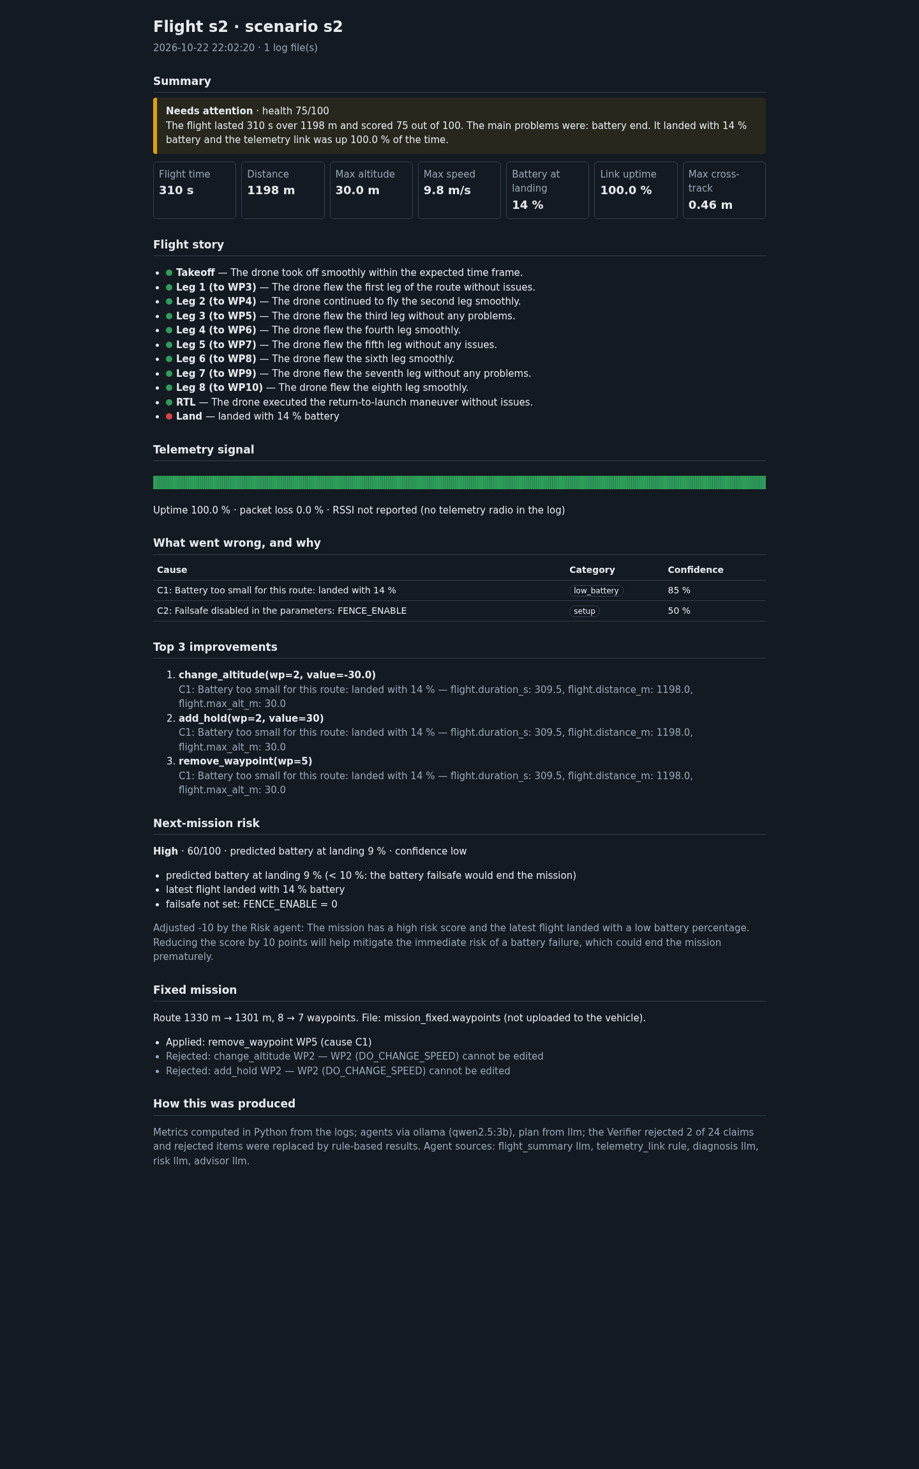
Figure 7: Generated report.html for S2

8.3 Agent Execution Trace
User query S3 logs + mission + params (two 12 s link outages)
↓
Understanding health 50; Bad: link uptime (92.4 %), dropouts (2)
↓
Plan (LLM) flight_summary → telemetry_link → diagnosis → risk → advisor → verifier
↓
Execution flight_summary llm 38.18 s, telemetry_link llm 9.2 s, diagnosis llm 36.4 s, risk llm 8.64 s, advisor llm 22.74 s
↓
Observation Verifier: 23 claims checked
↓
Decision refined: telemetry_link, advisor
↓
Final response Needs attention; causes: link_loss, setup; risk Low 25
Listing 2: execution trace of S3 (from outputs/s3/state.json).

CHAPTER 9 – PERFORMANCE EVALUATION
Table 9 evaluates the system on the hardware of Table 3, computed from the saved runs.
Table 9: Performance evaluation
Metric | Evaluation Method | Result
Task Completion Rate | Analyses completed / started | 8 / 8 (100 %)
Accuracy | Faults detected / root cause correct (S1–S4) | 4 / 4 and 4 / 4
Agent Success Rate | Agent outputs produced by the LLM agents | 34 / 34 (100 %)
Average Response Time | Files in → results (Qwen2.5-3B on the laptop's CPU (AMD Ryzen 5 7535HS)) | median 174 s
Tool-stage Time | Ingest, metrics, memory, risk (no LLM) | 0.70–0.97 s
Grounding | Claims checked by the Verifier | 185
Retrieval Accuracy | Relevant retrievals / total | Not applicable
Test Case Success Rate | Table 8 | 8 / 10
Automated Tests | pytest | 247 / 247 passed; 91 % coverage of agents and tools

Table 10 compares each scenario before and after the mission corrected by the agents was flown under the same faults.
Table 10: Results before and after the fixed missions
Scenario | Verdict | Health | Risk | Key metric | Edits flown
s0 | Good | 100 | Low 10 | health: 100 | –
s1 | Needs attention | 55 → 55 | Medium 35 → Medium 45 | max cross-track m: 1.8 → 1.44 | speed 12 → 6 m/s
s2 | Needs attention | 75 → 90 | High 60 → Medium 30 | battery at landing %: 14.0 → 25.0 | removed WP3, WP4
s3 | Needs attention | 50 | Low 25 | link uptime %: 92.4 | –
s4 | Unsafe | 25 → 25 | High 90 → Medium 55 | battery at landing %: 24.0 → 24.0 | removed WP3, WP4; speed 12 → 6 m/s

Interpretation. The agents met the detection, root-cause, dropout-localisation, false-alarm, battery and risk-ranking targets. The mission they corrected for S2 raised the battery at landing from 14 % to 25 %, and the speed fix for S1 reduced the maximum cross-track error from 1.8 m to 1.44 m. Run time is set by LLM inference on the laptop's CPU (AMD Ryzen 5 7535HS); GPU inference or the Claude API shortens it directly.

CHAPTER 10 – CHALLENGES AND LIMITATIONS
Keeping LLM output grounded. A small model sometimes stated values that were not in the data; the deterministic Verifier and the refinement round ensure only verified content reaches the user.
Consistent agent decisions. Python owns the final risk score (base ± 10) and the mission limits, and a lowered score must name what reduces the risk.
Response time. Agents receive compact JSON context, the link agent is skipped when the link is healthy, and replies are length-capped so a local model answers quickly.
Simulating the faults. SITL over Gazebo had no battery model and ignored wind parameters; we added a Lua battery model and wind as an equivalent force on the airframe.
Accurate measurement. Vibration is measured while airborne and dropouts are confirmed on the vehicle clock, avoiding false alarms from touchdown and simulator timing.
Scope. The evaluation used eight simulated flights and .tlog logs; real flights and other log formats are the next step.

CHAPTER 11 – FUTURE SCOPE
- Larger models and GPU inference for faster, richer agent answers.
- Real flights with telemetry-radio RSSI, and DataFlash .bin logs.
- Live mode that streams telemetry during flight and raises alerts.
- Pre-flight agent that checks a mission and parameters before arming.
- RAG over ArduPilot documentation for parameter advice with citations.
- In-app approval of each proposed mission edit (human-in-the-loop).

CHAPTER 12 – CONCLUSION
AeroMind addresses a practical problem: after a drone flight, the answers to “how did it go, what went wrong and what should I change” are buried in telemetry that few operators can read. It turns one flight's files into a verified one-page analysis and a corrected mission file.
The system combines deterministic tools with a planned team of LLM agents. Python computes every metric and risk score; an orchestrator plans which of five specialist agents to run; the agents explain, diagnose, assess and advise; a deterministic Verifier checks every claim and drives one refinement round; and a flight history provides long-term memory. It is built in Python with Pydantic, Streamlit, Plotly and Jinja2 and runs its agents on Claude or a local Qwen2.5-3B model.
On eight simulated flights with injected faults, the agents detected every fault with the correct top cause, located both telemetry dropouts within 0.1 s, raised no false alarm on the baseline and ranked risk correctly. Their corrected missions improved the next flight: battery at landing rose from 14 % to 25 %, and cross-track error fell from 1.8 m to 1.44 m. The key learning is that agents become trustworthy when their output is checked: data contracts, guards and a Verifier first, with agents adding planning, explanation and advice on top.

REFERENCES
[1] S. Yao, J. Zhao, D. Yu, N. Du, I. Shafran, K. Narasimhan and Y. Cao, “ReAct: Synergizing Reasoning and Acting in Language Models,” in Proc. International Conference on Learning Representations (ICLR), 2023.
[2] Q. Wu et al., “AutoGen: Enabling Next-Gen LLM Applications via Multi-Agent Conversation,” arXiv:2308.08155, 2023.
[3] S. Hong et al., “MetaGPT: Meta Programming for a Multi-Agent Collaborative Framework,” in Proc. ICLR, 2024.
[4] N. Shinn, F. Cassano, A. Gopinath, K. Narasimhan and S. Yao, “Reflexion: Language Agents with Verbal Reinforcement Learning,” in Advances in Neural Information Processing Systems (NeurIPS), 2023.
[5] A. Madaan et al., “Self-Refine: Iterative Refinement with Self-Feedback,” in Advances in NeurIPS, 2023.
[6] Z. Ji et al., “Survey of Hallucination in Natural Language Generation,” ACM Computing Surveys, vol. 55, no. 12, 2023.
[7] A. Koubâa, A. Allouch, M. Alajlan, Y. Javed, A. Belghith and M. Khalgui, “Micro Air Vehicle Link (MAVLink) in a Nutshell: A Survey,” IEEE Access, vol. 7, pp. 87658–87680, 2019.
[8] ArduPilot Dev Team, “ArduPilot Documentation: Copter, SITL, MAVProxy and Log Analysis,” ardupilot.org, 2026.
[9] ArduPilot Dev Team, “Mission Planner Documentation,” ardupilot.org/planner, 2026.
[10] ArduPilot, “UAV Log Viewer,” plot.ardupilot.org, 2026.
[11] L. Wang et al., “A Survey on Large Language Model based Autonomous Agents,” Frontiers of Computer Science, vol. 18, no. 6, 2024.
[12] PX4 Autopilot, “Flight Review and Log Analysis,” docs.px4.io, 2026.
[13] Qwen Team, “Qwen2.5 Technical Report,” arXiv:2412.15115, 2024.
[14] Anthropic, “Claude API Documentation: Messages and Structured Outputs,” docs.anthropic.com, 2026.
[15] Ollama, “Ollama Documentation and API,” ollama.com and github.com/ollama/ollama, 2026.
[16] ArduPilot, “pymavlink” and “MAVProxy,” github.com/ArduPilot, 2026.
[17] Ministry of Civil Aviation, Government of India, “The Drone Rules, 2021,” Gazette of India, 2021.
[18] Open Robotics, “Gazebo Harmonic Documentation,” gazebosim.org, 2026.
[19] Pydantic, “Pydantic Documentation (v2),” docs.pydantic.dev, 2026.
[20] Snowflake Inc., “Streamlit Documentation,” docs.streamlit.io, 2026.
[21] Plotly Technologies Inc., “Plotly Python Graphing Library,” plotly.com/python, 2026.
[22] The pandas development team, “pandas,” pandas.pydata.org, 2026; Pallets, “Jinja,” jinja.palletsprojects.com, 2026.
[23] OpenStreetMap contributors, “OpenStreetMap,” openstreetmap.org (map tiles in the Track tab), 2026.
[24] Simulation assets: Aero Sense world and Hexa-X (the team's SIH 2026 project); tdf_gazebo and darpa_subt_worlds models (MIT); ardupilot_gazebo (LGPL-3.0).

APPENDIX

Appendix A – Source Code
GitHub Repository: ______________________________
Deployed Link: Not deployed (runs locally: streamlit run app.py)
pip install -e .
python3 run.py --batch data/ # analyse all flights
python3 run.py --results # success metrics -> docs/RESULTS.md
streamlit run app.py # dashboard
python3 -m pytest -q # tests

Appendix B – Additional Screenshots
Figures 8–10 show the Track, Telemetry and History tabs referred to in Section 7.6, and Figures 11–14 further dashboard and simulator views.
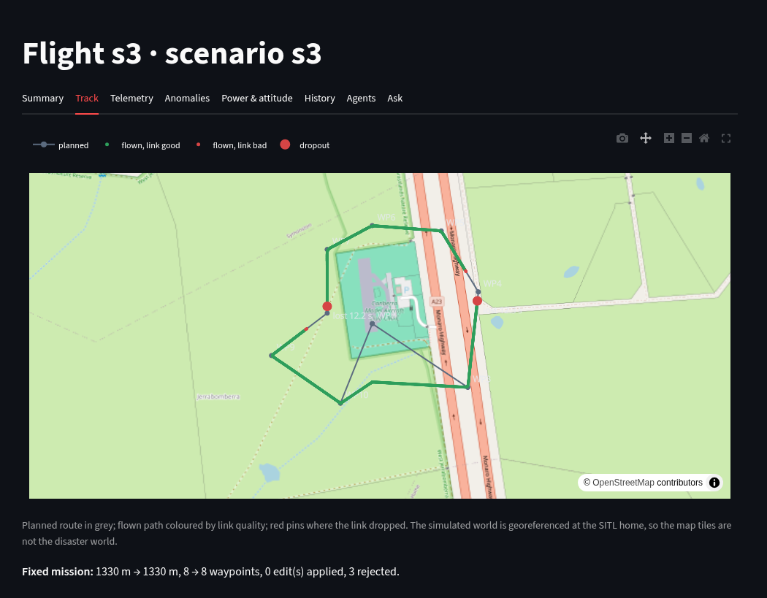
Figure 8: Track tab (S3): planned route, flown path coloured by link quality
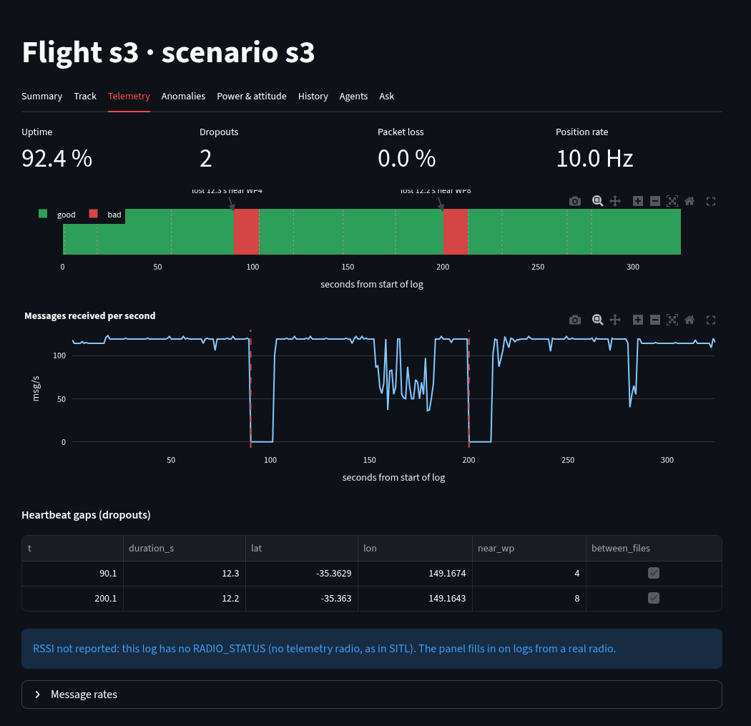
Figure 9: Telemetry tab (S3): link strip, message rate and dropout table
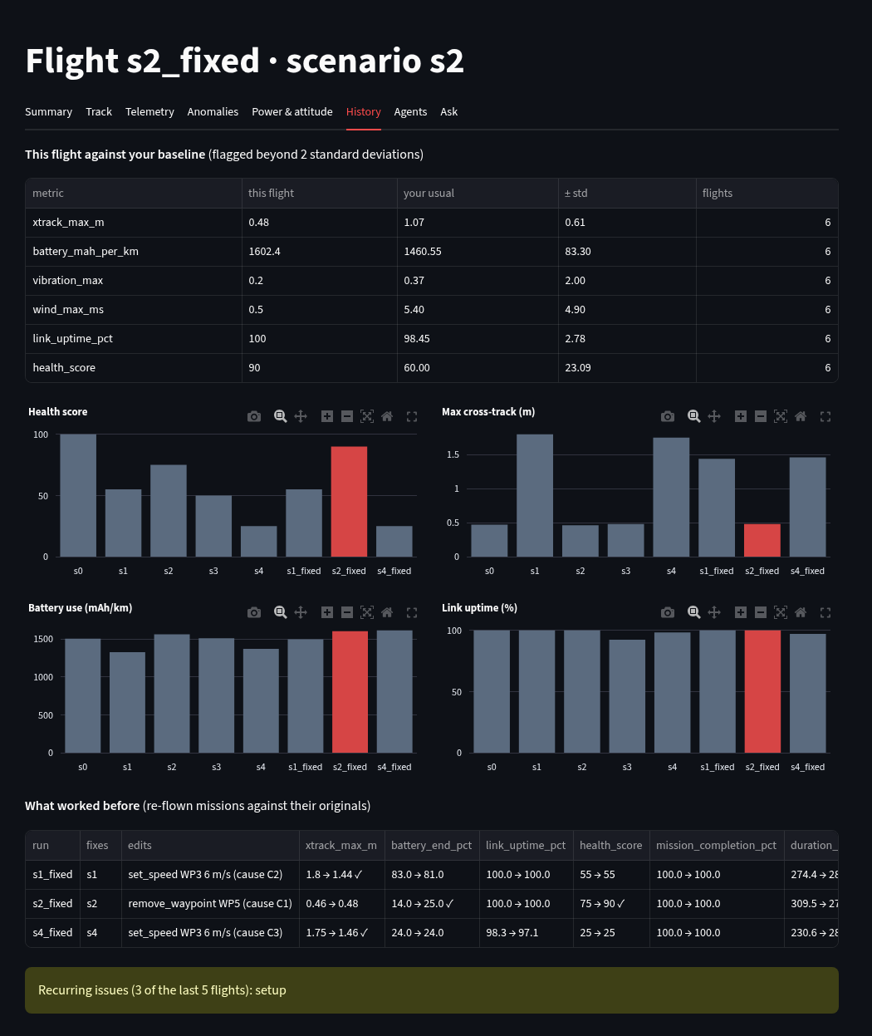
Figure 10: History tab (S2 fixed): baseline, trends and what worked before
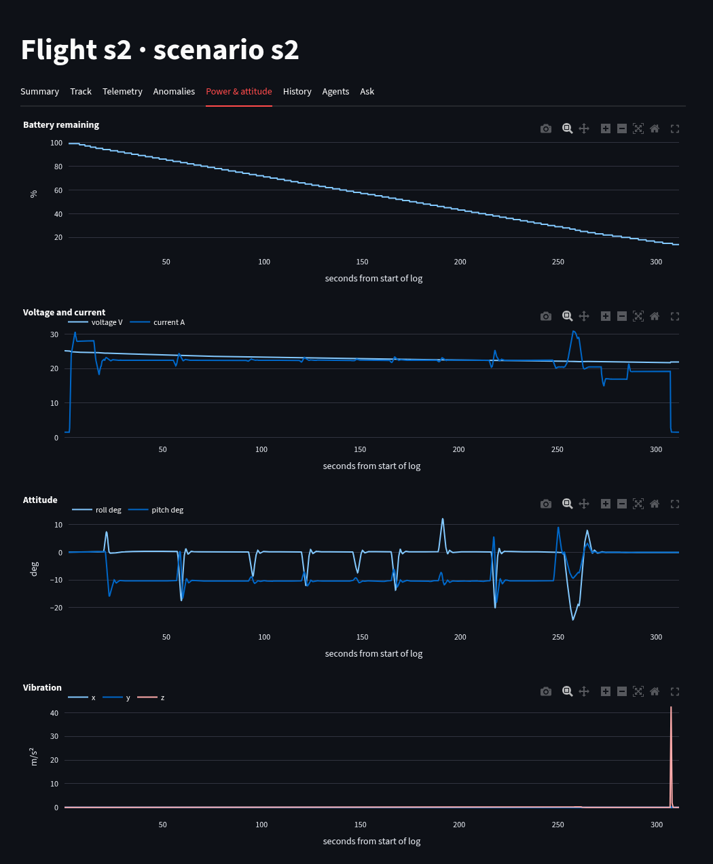
Figure 11: Power & attitude tab (S2)
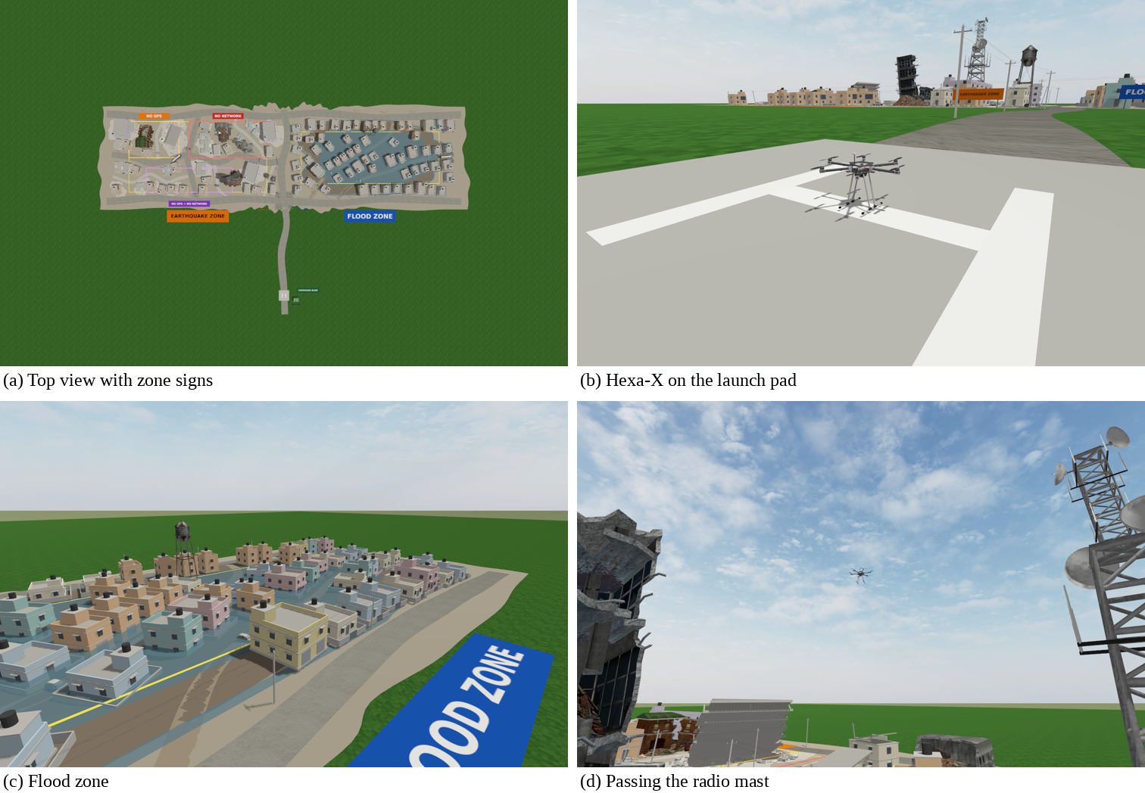
Figure 12: More views of the simulation world
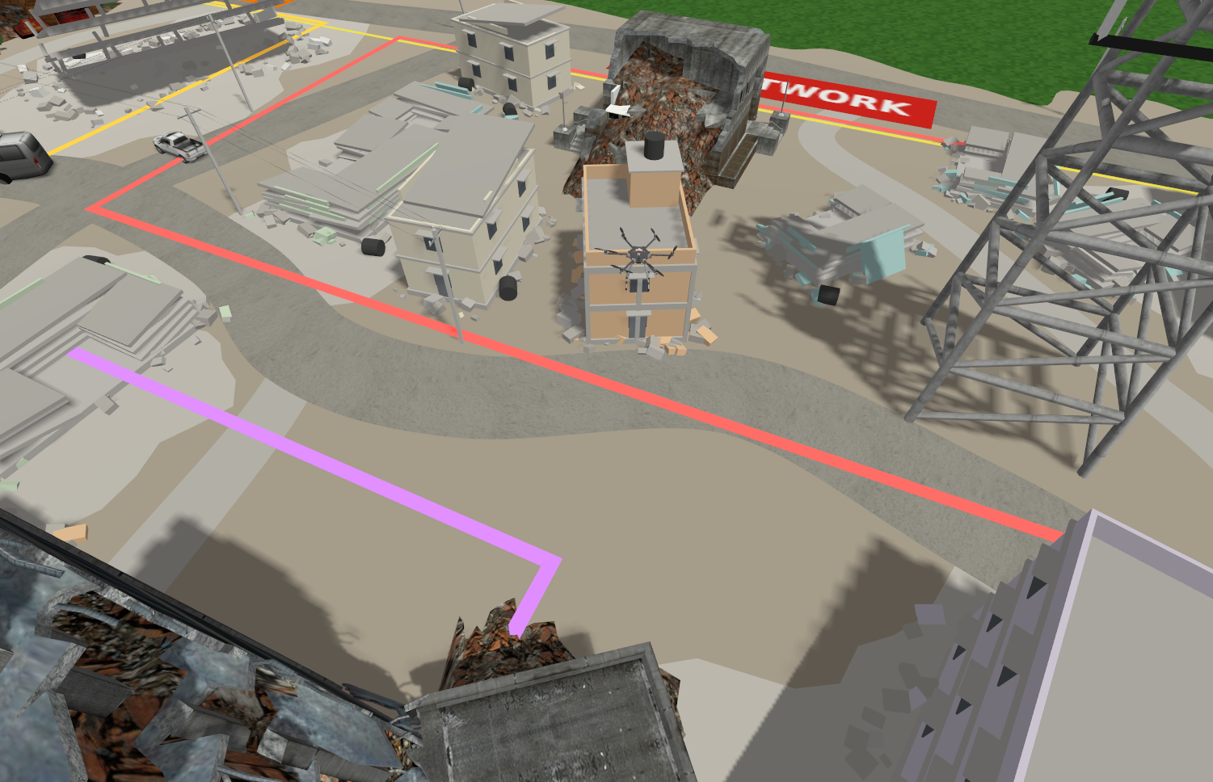
Figure 13: Hexa-X over the collapsed buildings
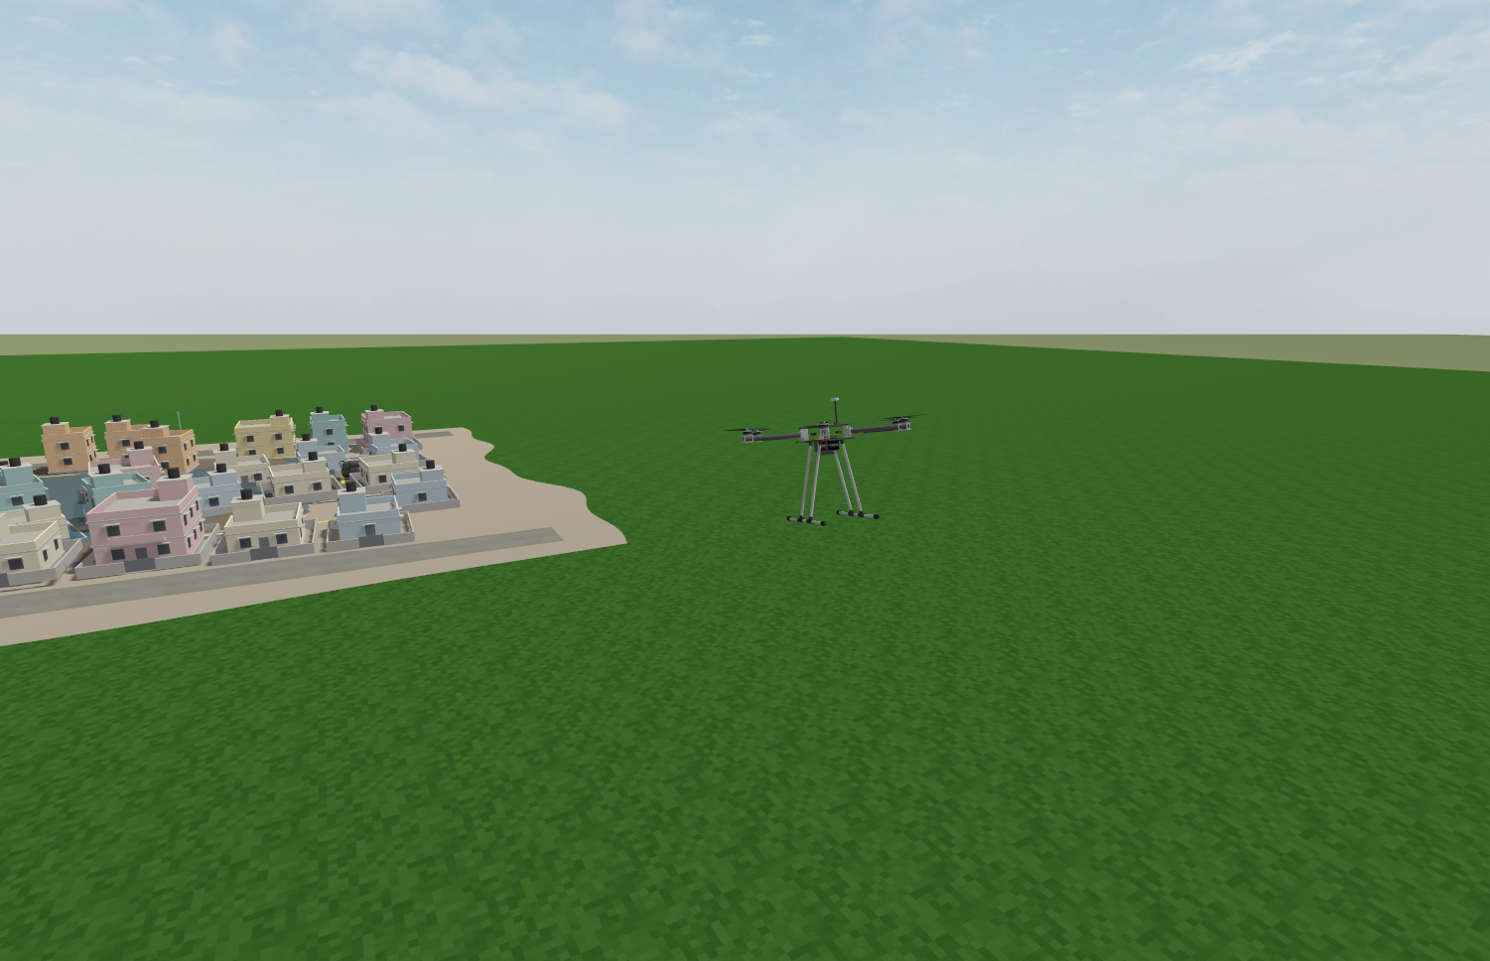
Figure 14: Hexa-X flying past the flood zone

Appendix C – Sample Prompts
Table 11 lists the prompts used by the system (full text in agents/prompts.py).
Table 11: Sample prompts
Sr. No. | Prompt (abbreviated) | Purpose
1 | You are a drone flight-test engineer… a verdict, one line per phase and a 3-sentence summary… | Flight Summary
2 | You are a telemetry radio engineer… for each dropout give its time, duration and nearest waypoint… | Telemetry Link
3 | You are a drone failure analyst… findings citing metric names and values… up to 3 root causes… | Diagnosis
4 | You are a mission risk assessor… adjust it by at most 10 points and explain why… | Risk
5 | You are a mission planner… edits from the allowed actions only, each tied to a cause… | Advisor
6 | You are the orchestrator… choose which agents run and in what order, with a reason each… | Planner

Appendix D – Test Data
Table 12 lists the flights used for testing (all under data/).
Table 12: Test data
Folder | Scenario | tlog files | Flight s | Parent
s0 | Baseline | 1 | 347 | –
s1 | Strong wind + fast flight | 1 | 274 | –
s2 | Undersized battery | 1 | 310 | –
s3 | Telemetry dropout | 3 | 324 | –
s4 | Combined (wind + fast + small battery + radio shadow) | 1 | 231 | –
s1_fixed | Strong wind + fast flight | 1 | 282 | s1
s2_fixed | Undersized battery | 1 | 273 | s2
s4_fixed | Combined (wind + fast + small battery + radio shadow) | 2 | 280 | s4

