Exercise 1: Control Structures
Step 1: Create the Customers Table
CREATE TABLE Customers (
CustomerID NUMBER PRIMARY KEY,
CustomerName VARCHAR2(50),
Age NUMBER,
Balance NUMBER,
IsVIP VARCHAR2(5),
LoanInterestRate NUMBER
);

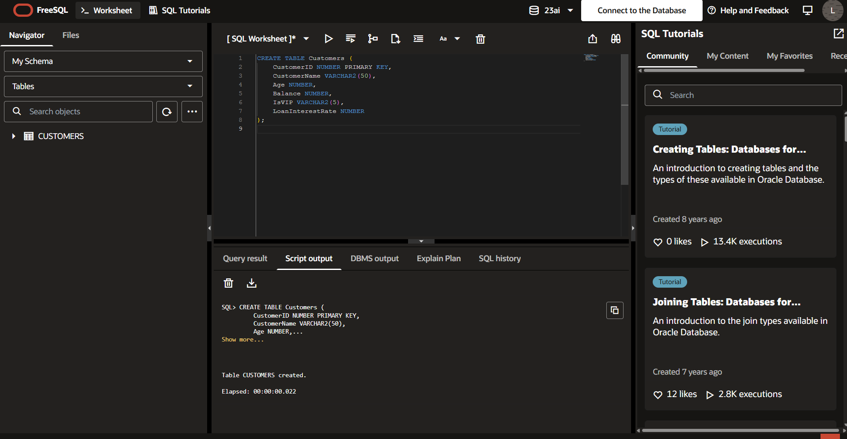

Step 2: Create the Loans Table

CREATE TABLE Loans (
LoanID NUMBER PRIMARY KEY,
CustomerID NUMBER,
DueDate DATE
);
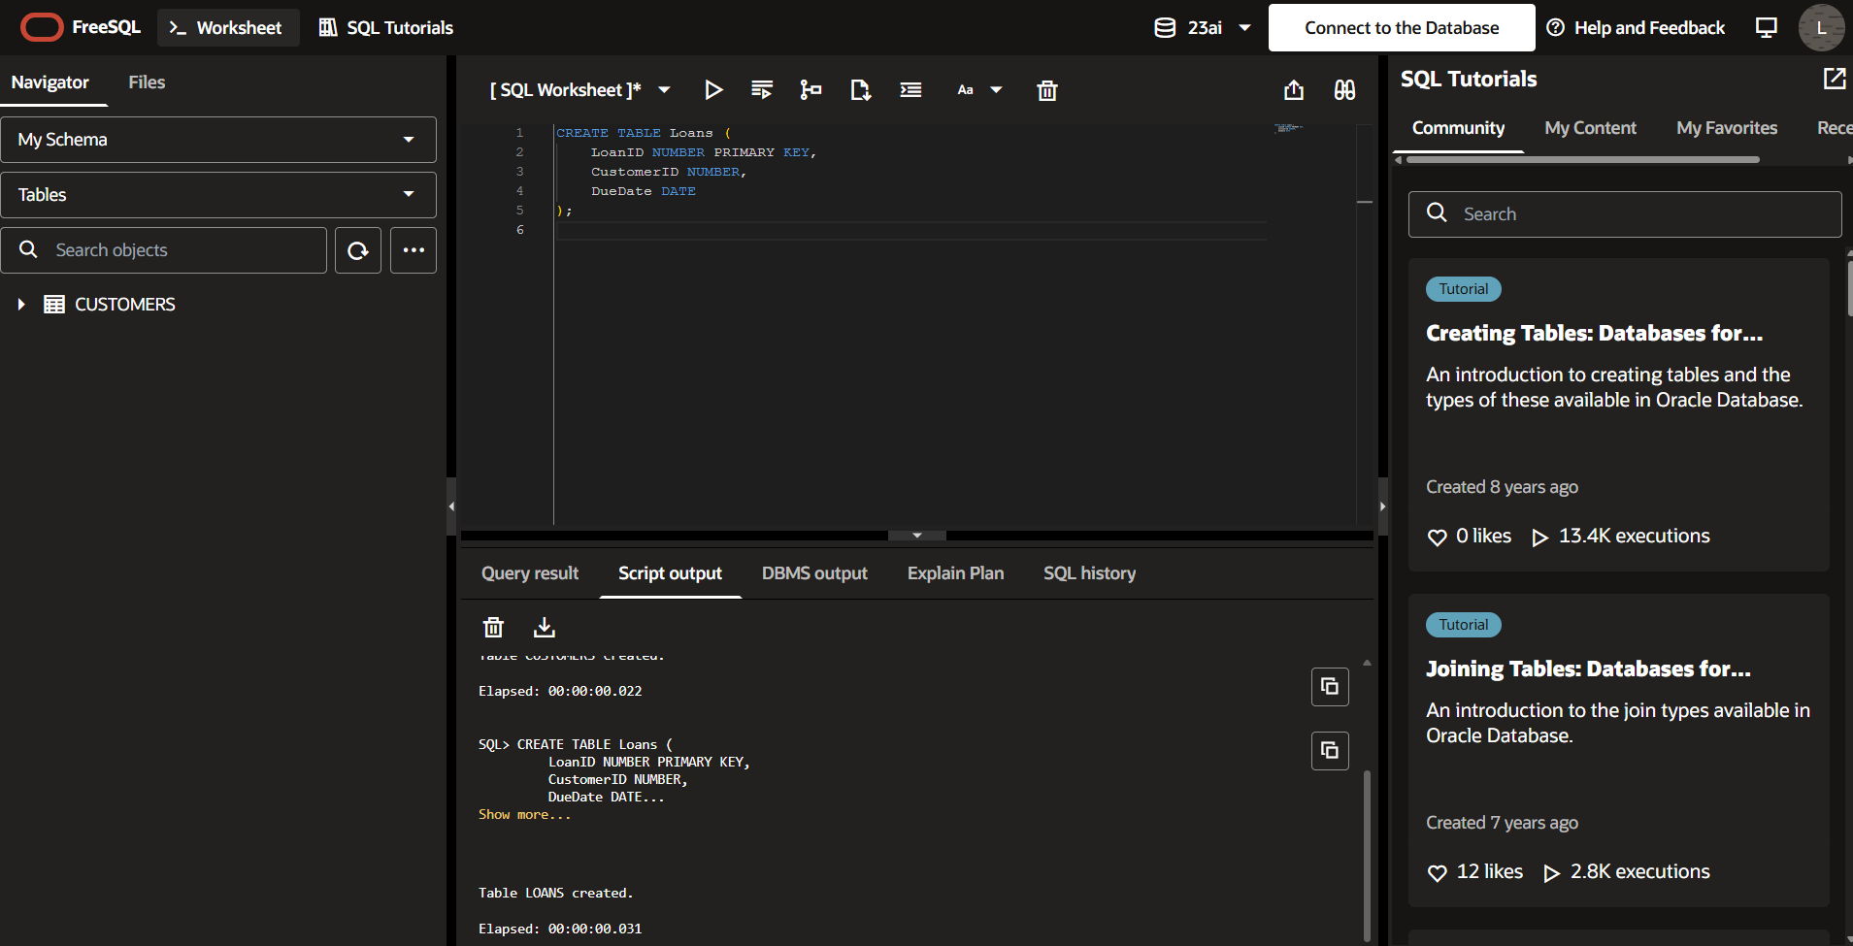
Step 3: Insert Sample Data into Customers

INSERT INTO Customers VALUES (1, 'Ravi', 65, 15000, 'FALSE', 8);

INSERT INTO Customers VALUES (2, 'Priya', 45, 8000, 'FALSE', 9);

INSERT INTO Customers VALUES (3, 'Arun', 70, 20000, 'FALSE', 7);

COMMIT;
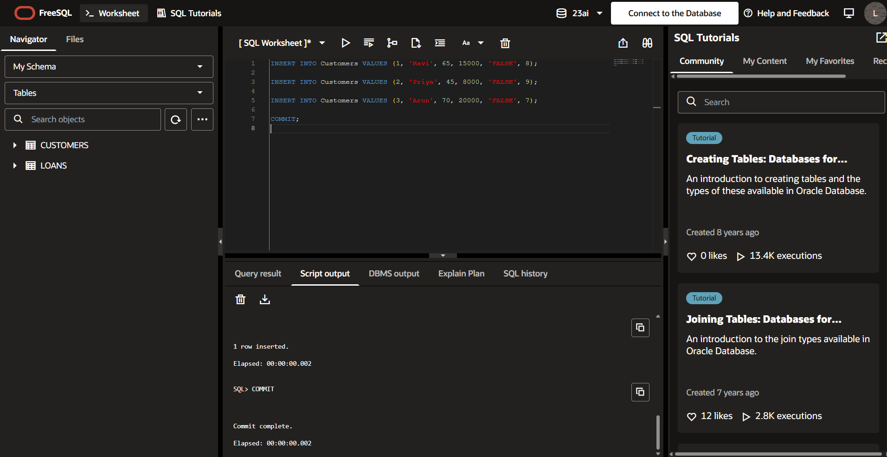

Step 4: Insert Sample Data into Loans
INSERT INTO Loans VALUES (101, 1, SYSDATE + 10);

INSERT INTO Loans VALUES (102, 2, SYSDATE + 40);

INSERT INTO Loans VALUES (103, 3, SYSDATE + 20);

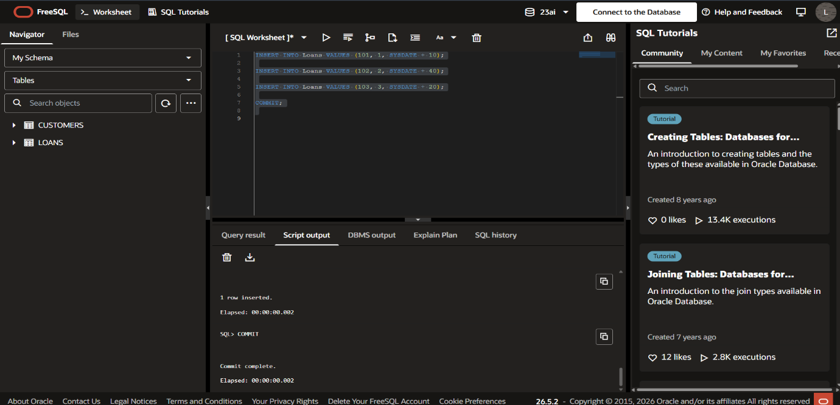
COMMIT;
Scenario 1: Senior Citizen Loan Discount

DECLARE
CURSOR c_customers IS
SELECT CustomerID, Age
FROM Customers;

BEGIN
FOR cust IN c_customers LOOP

IF cust.Age > 60 THEN

UPDATE Customers
SET LoanInterestRate =
LoanInterestRate - 1
WHERE CustomerID = cust.CustomerID;

DBMS_OUTPUT.PUT_LINE(
'Discount applied for Customer ID: '
|| cust.CustomerID);

END IF;

END LOOP;

COMMIT;
END;
/

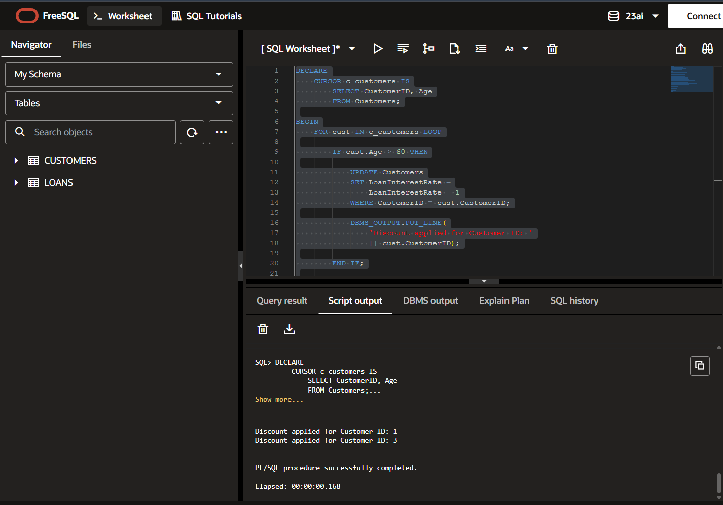

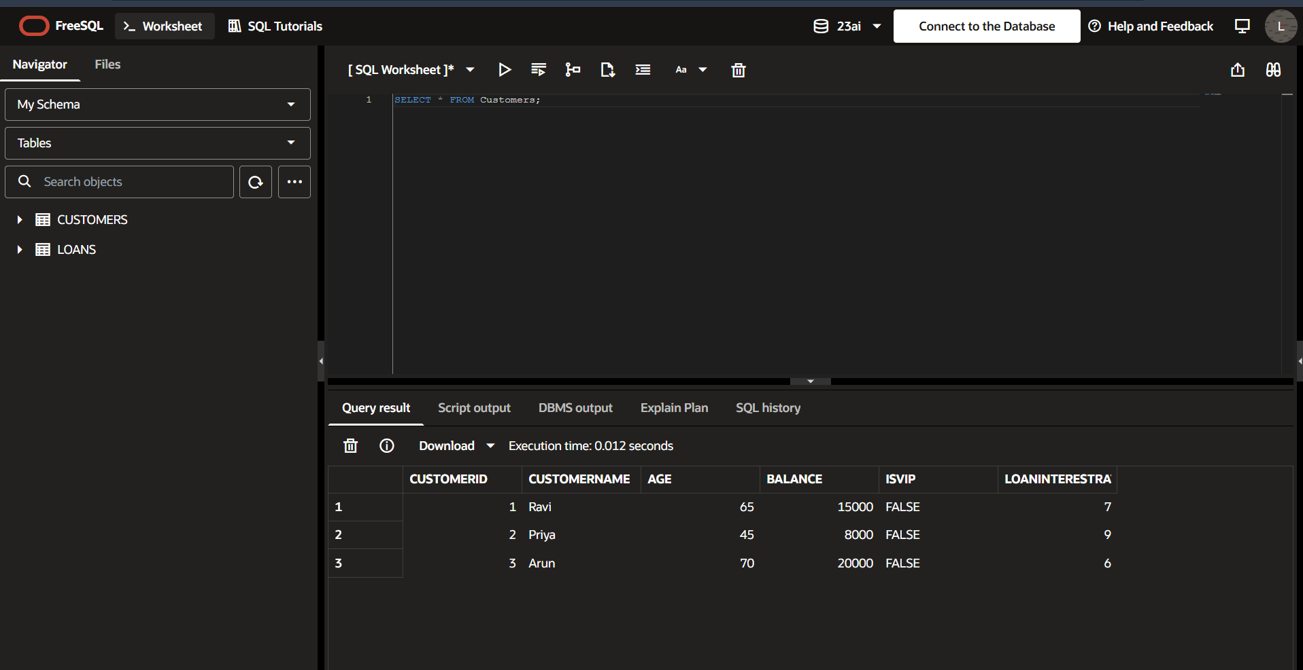

Scenario 2: Promote VIP Customers
DECLARE
CURSOR c_customers IS
SELECT CustomerID, Balance
FROM Customers;

BEGIN
FOR cust IN c_customers LOOP

IF cust.Balance > 10000 THEN

UPDATE Customers
SET IsVIP = 'TRUE'
WHERE CustomerID = cust.CustomerID;

DBMS_OUTPUT.PUT_LINE(
'Customer ID '
|| cust.CustomerID
|| ' promoted to VIP');

END IF;

END LOOP;

COMMIT;
END;
/
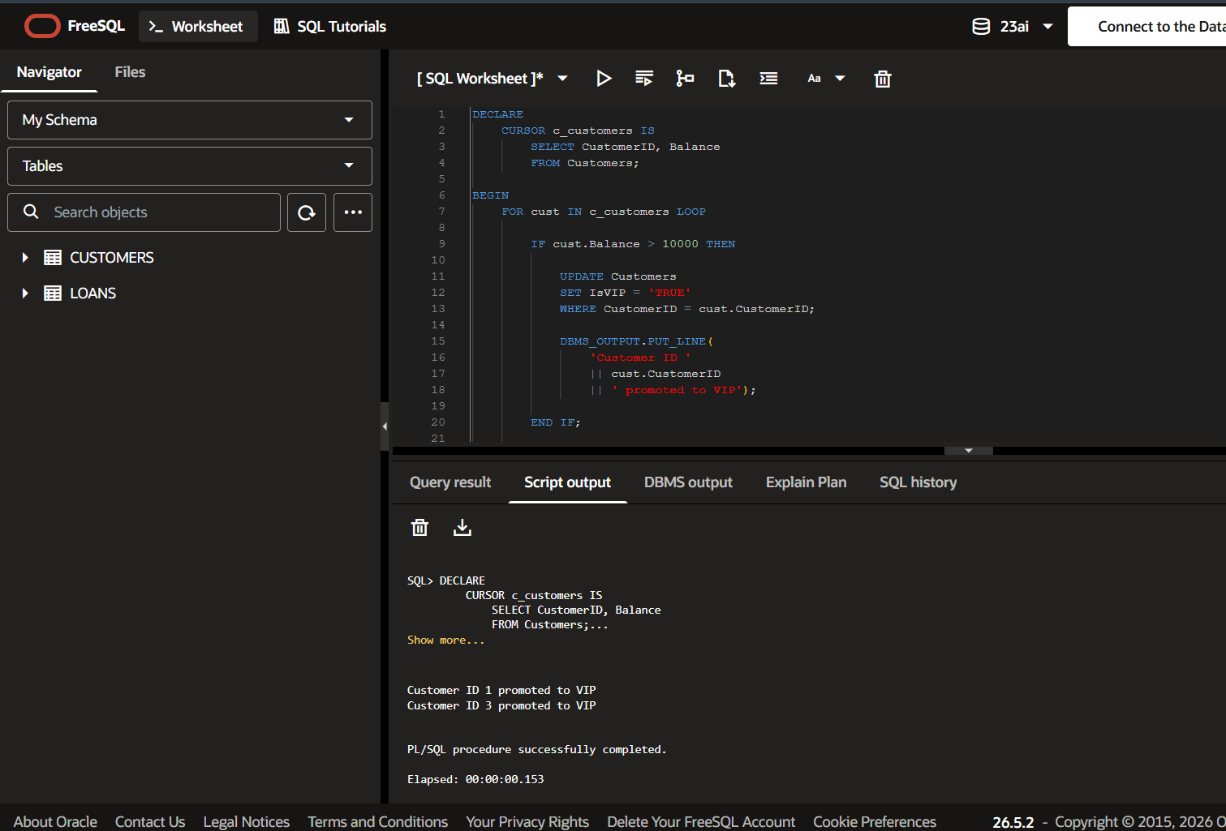

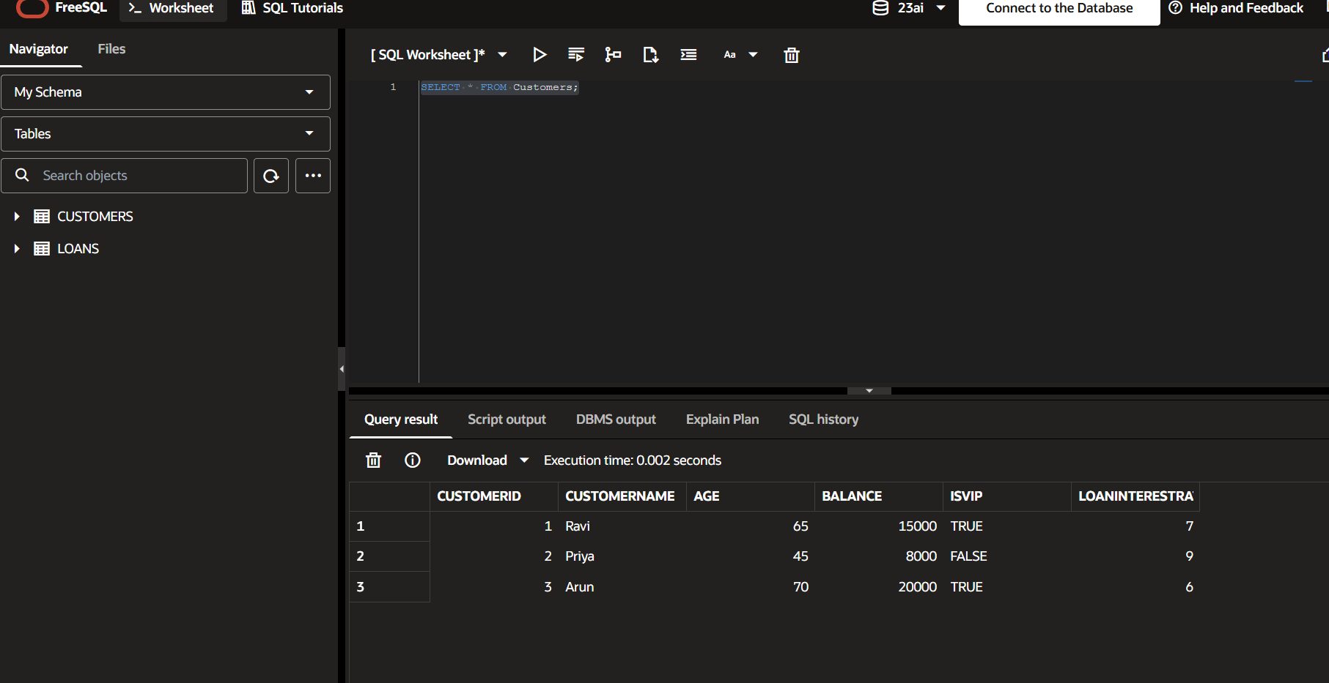

Scenario 3: Loan Reminder
DECLARE
CURSOR c_loans IS
SELECT LoanID, CustomerID, DueDate
FROM Loans
WHERE DueDate BETWEEN SYSDATE
AND SYSDATE + 30;

BEGIN
FOR loan IN c_loans LOOP

DBMS_OUTPUT.PUT_LINE(
'Reminder: Loan ID '
|| loan.LoanID
|| ' for Customer ID '
|| loan.CustomerID
|| ' is due on '
|| TO_CHAR(loan.DueDate,'DD-MON-YYYY'));

END LOOP;
END;
/

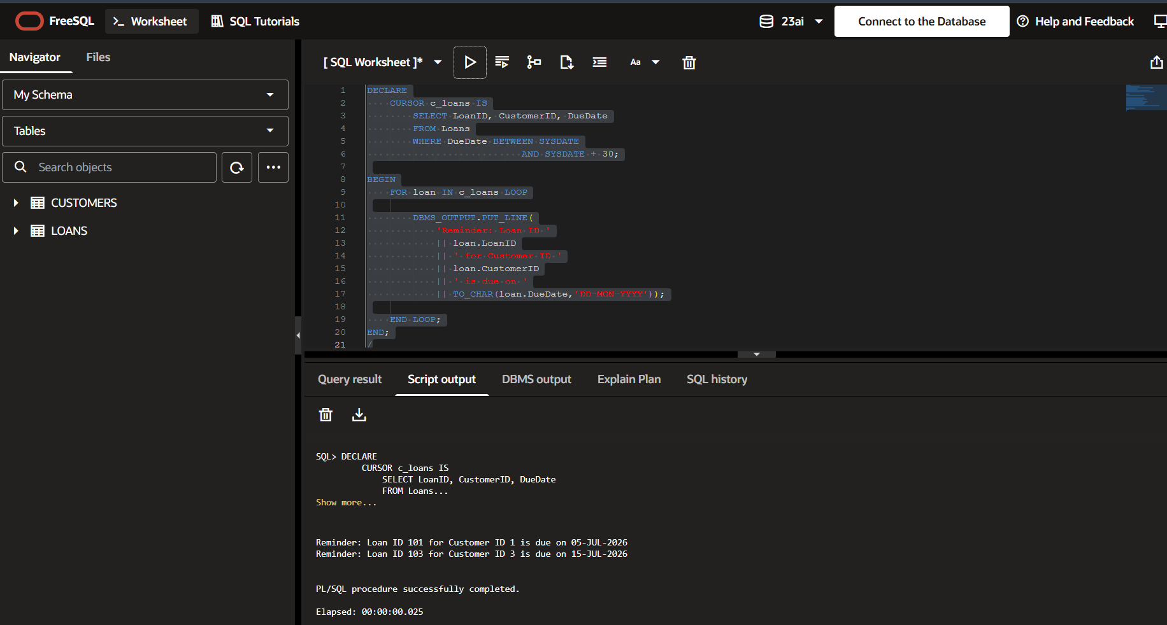

Exercise 3: Stored Procedures

Step1 : Create tables:
CREATE TABLE Accounts (
AccountID NUMBER PRIMARY KEY,
CustomerName VARCHAR2(50),
AccountType VARCHAR2(20),
Balance NUMBER
);

CREATE TABLE Employees (
EmployeeID NUMBER PRIMARY KEY,
EmployeeName VARCHAR2(50),
DepartmentID NUMBER,
Salary NUMBER
);
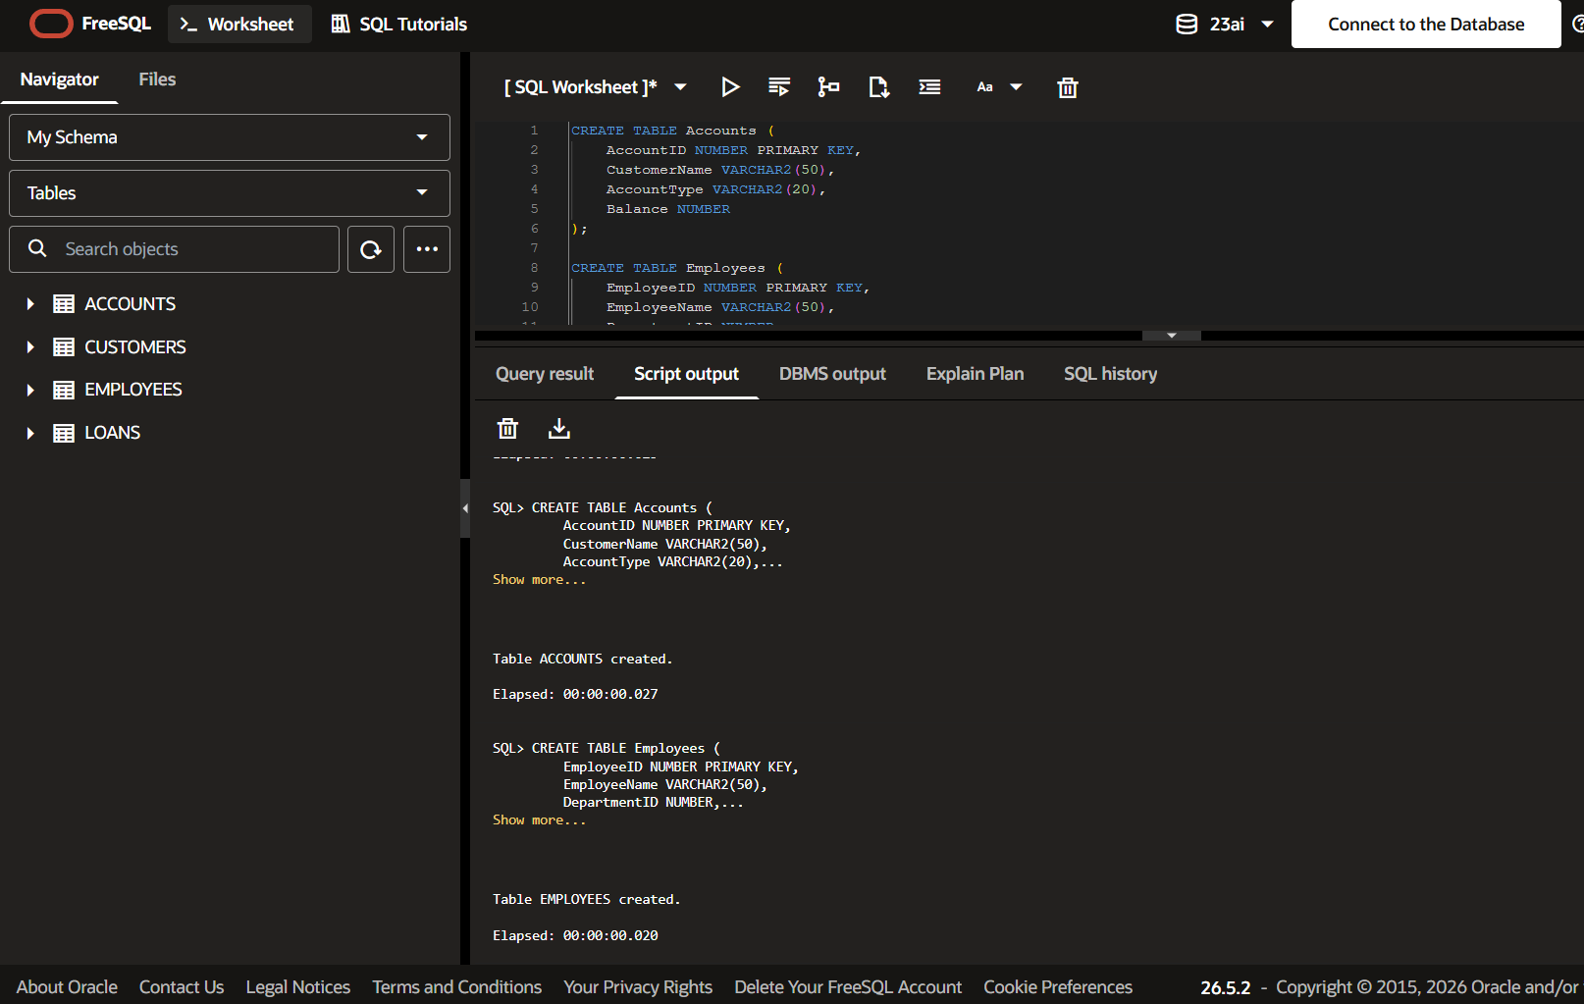

Step 2: Insert data:
INSERT INTO Accounts VALUES (1001, 'Ravi', 'Savings', 50000);
INSERT INTO Accounts VALUES (1002, 'Priya', 'Savings', 30000);
INSERT INTO Accounts VALUES (1003, 'Arun', 'Current', 20000);

INSERT INTO Employees VALUES (1, 'John', 101, 50000);
INSERT INTO Employees VALUES (2, 'Mary', 101, 60000);
INSERT INTO Employees VALUES (3, 'David', 102, 55000);

COMMIT;
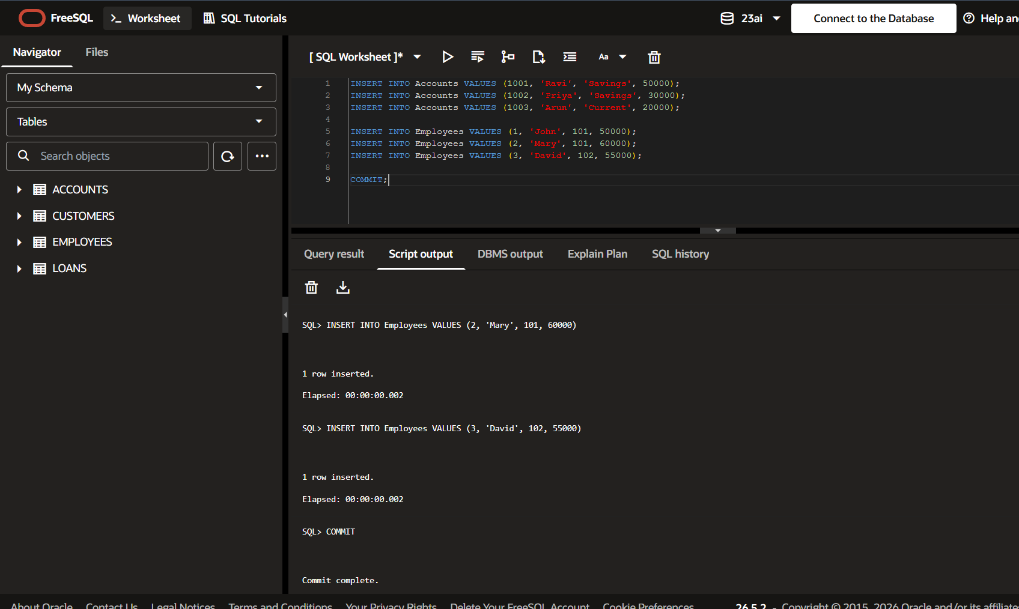

Scenario 1: Process Monthly Interest
Create Procedure
CREATE OR REPLACE PROCEDURE ProcessMonthlyInterest
IS
BEGIN
UPDATE Accounts
SET Balance = Balance + (Balance * 0.01)
WHERE AccountType = 'Savings';
COMMIT;
DBMS_OUTPUT.PUT_LINE('Monthly interest processed successfully.');
END;
/
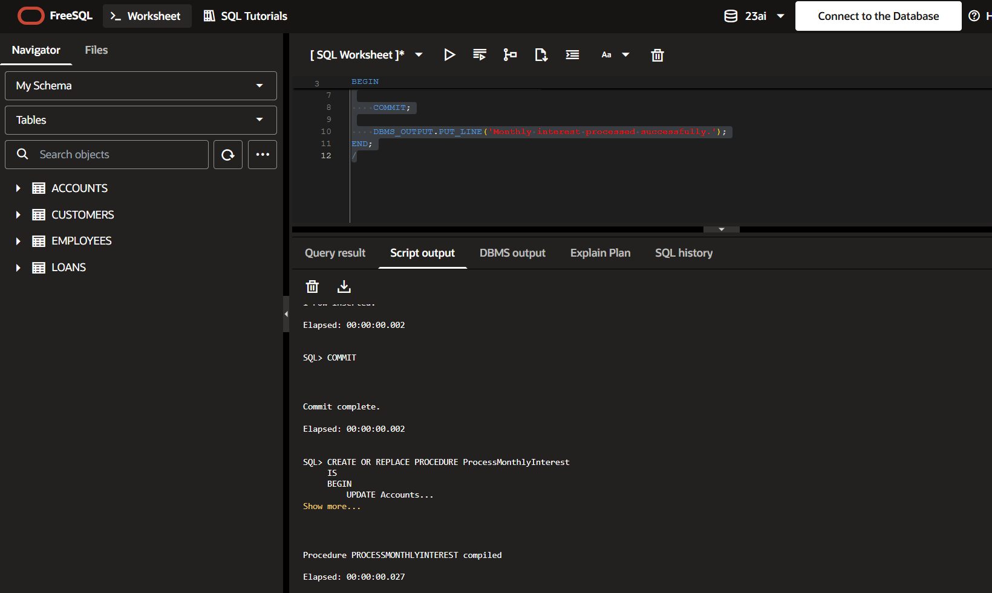
Procedure Execution
BEGIN
ProcessMonthlyInterest;
END;
/
Verify
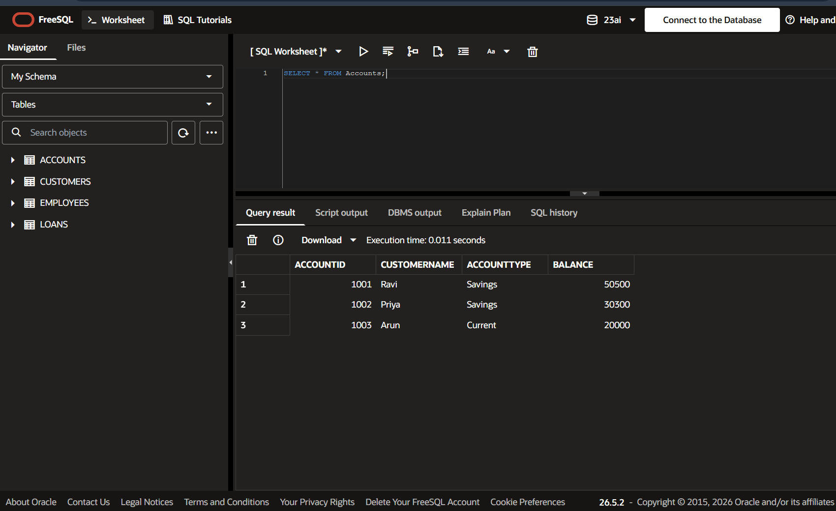
SELECT * FROM Accounts;

Scenario 2: Update Employee Bonus
Create Procedure
CREATE OR REPLACE PROCEDURE UpdateEmployeeBonus(
p_DepartmentID IN NUMBER,
p_BonusPercent IN NUMBER
)
IS
BEGIN
UPDATE Employees
SET Salary = Salary + (Salary * p_BonusPercent / 100)
WHERE DepartmentID = p_DepartmentID;
COMMIT;
DBMS_OUTPUT.PUT_LINE('Employee bonus updated successfully.');
END;
/

Execute Procedure
BEGIN
UpdateEmployeeBonus(101, 10);
END;
/
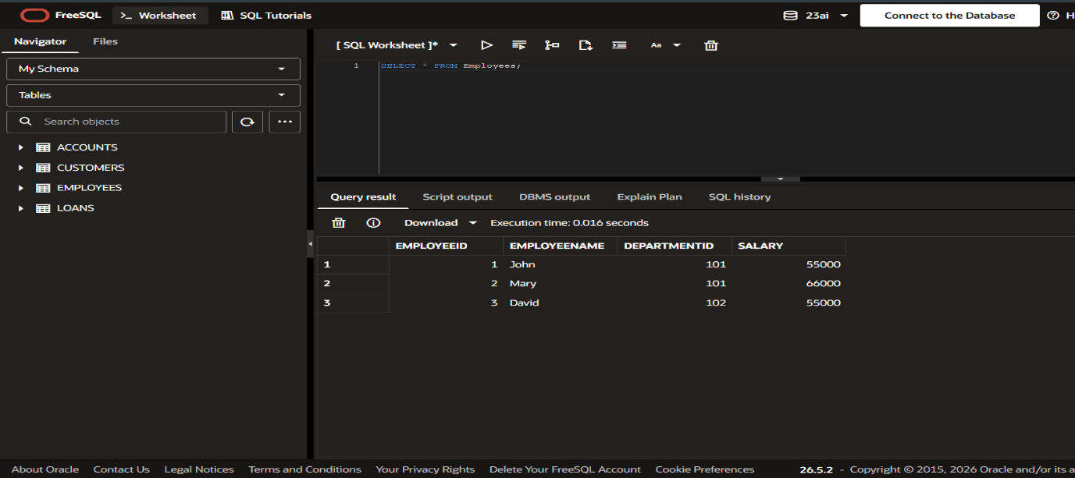
Verify SELECT * FROM Employees;
Scenario 3: Transfer Funds
Create Procedure
CREATE OR REPLACE PROCEDURE TransferFunds(
p_FromAccount IN NUMBER,
p_ToAccount IN NUMBER,
p_Amount IN NUMBER
)
IS
v_Balance NUMBER;
BEGIN
SELECT Balance
INTO v_Balance
FROM Accounts
WHERE AccountID = p_FromAccount;
IF v_Balance >= p_Amount THEN
UPDATE Accounts
SET Balance = Balance - p_Amount
WHERE AccountID = p_FromAccount;
UPDATE Accounts
SET Balance = Balance + p_Amount
WHERE AccountID = p_ToAccount;
COMMIT;
DBMS_OUTPUT.PUT_LINE('Funds transferred successfully.');
ELSE
DBMS_OUTPUT.PUT_LINE('Insufficient balance.');
END IF;
END;
/

Execute Procedure
BEGIN
TransferFunds(1001, 1002, 5000);
END;
/
Verify
SELECT * FROM Accounts;
