**IMAGE RECOGINATION WITH IBM CLOUD’S VISUAL RECOGNITION**

**INTRODUCTION**

IBM Cloud offers a service called “IBM Watson Visual Recognition” that allows you to incorporate image recognition capabilities into your applications. Here are the general steps to perform image recognition using IBM Cloud’s Visual Recognition service

**Objective:-**

Aim is to enable machines to interpret visual data like humans do, by identifying and categorizing objects within images. This technology has a wide range of applications across various industries, including manufacturing, healthcare, retail, agriculture, and security.

**Innovation in Image Recognition with IBM Cloud Visual Recognition:-**

It involves leveraging cutting-edge technologies and approaches to enhance the accuracy, efficiency, and versatility of image analysis. Here are some innovative trends and techniques we can explore with IBM Cloud Recognition:

1) Deep Learning and Neural Networks

2) Transfer Learning

3) Real-time Image Recognition

4) Edge Computing

5) Multimodal Recognition

6) Explainable AI

7) Federated Learning

**Steps**

1. **Create an IBM cloud account**
2. **Create a Watson studio reasoure**
3. **Create a project**
4. **Add a Watson VR service instance**

Create an IBM cloud account

1) **Sign Up for IBM Cloud**:

* + 1. Go to Create a free account on IBM Cloud
  + 2. Enter the details like E-mail id ,name,etc
  + 3. Click Create Account to create your IBM Cloud account.

2**) Confirm your E-mail Address**

1. Check your e-mail, and in the e-mail that was send to you. click confirm Account.

3**) Login to your IBM Cloud account**

1. On the log in to IBM Cloud page , in the ID box , enter your email address and then click

Continue.

**Step 1:**

Afterclicking on continue then click on Proceed.

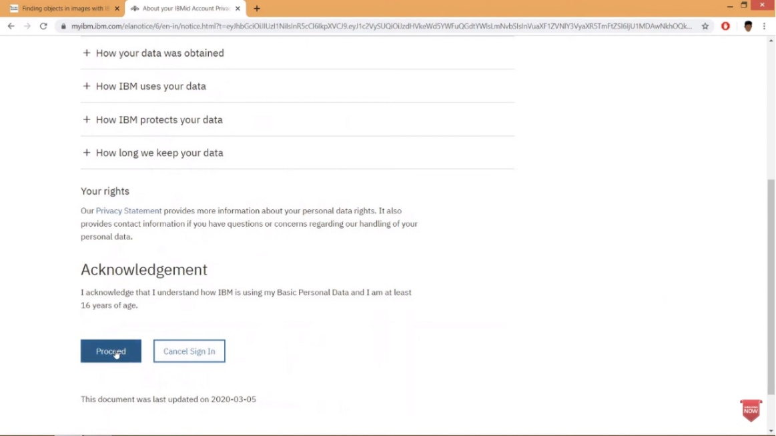

**Create a Watson Studio Resource**

**Step 2:**

After proceed, this will redirect you to IBM Cloud dashboard. On the dashboard click Create Resource.

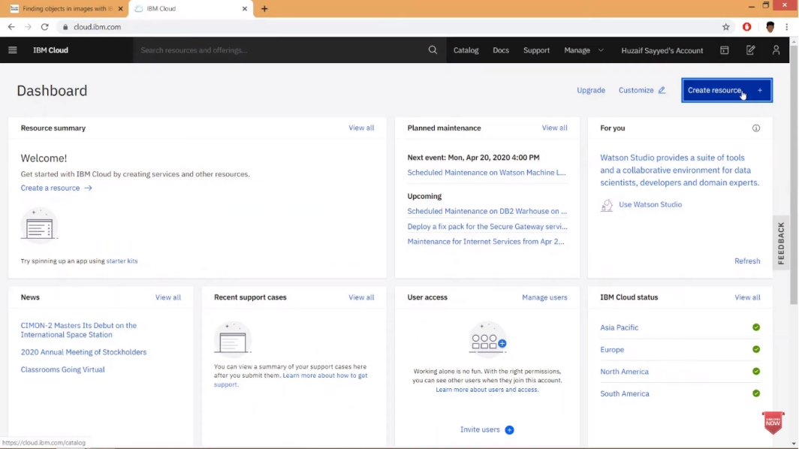

**Step 3:**

In the Catalog check AI .

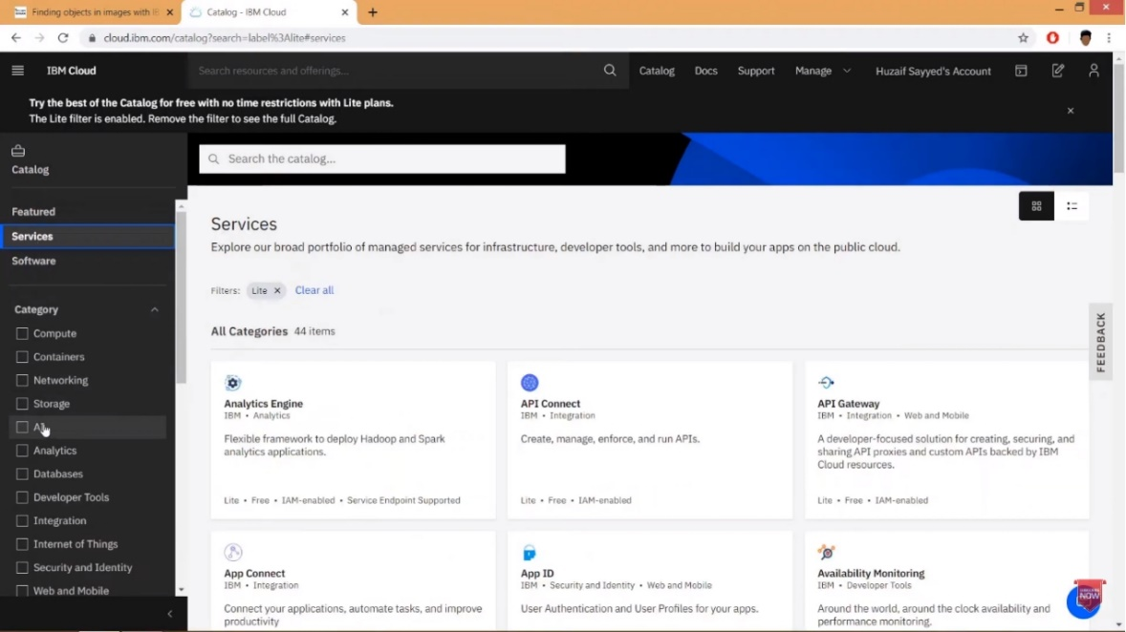

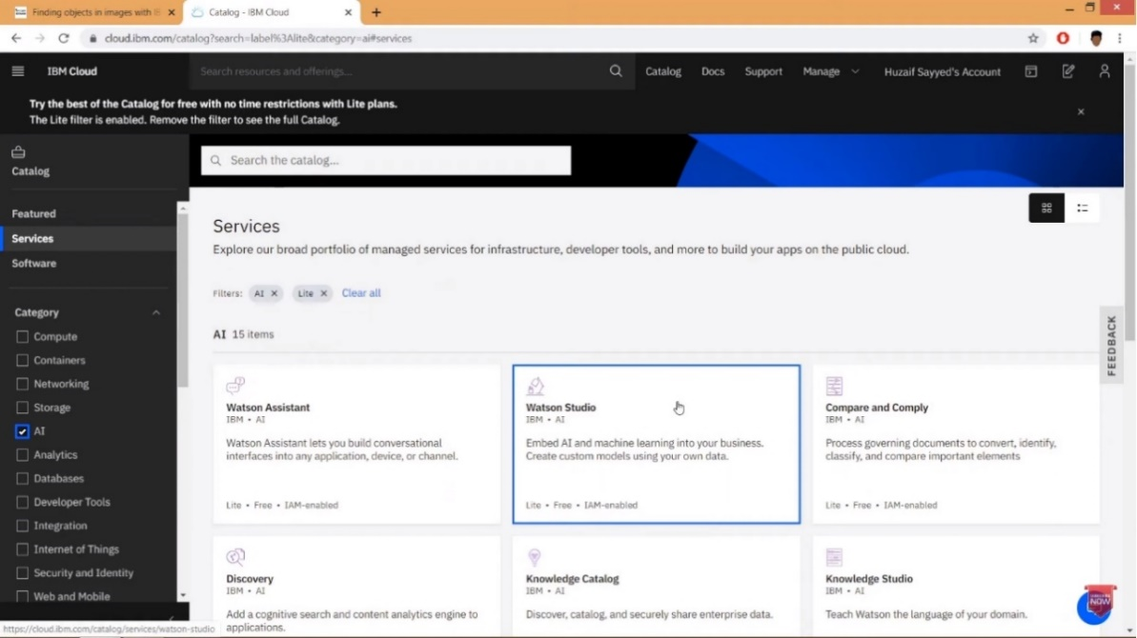**Step 4:**

In the list of Services, click Watson Studio.

On the Watson Studio page, select the region closest to you. verify that the Lite plan is selected and then click Create .

When the Watson Studio resources is successfully created you will see the Watson Studio page. Click Get Started.

**Create a Project**

**Step 5:**

Create an empty project

1.On the Watson Studio Welcome page, click Create a project.

2. On the Create a project page, click Create an empty project.

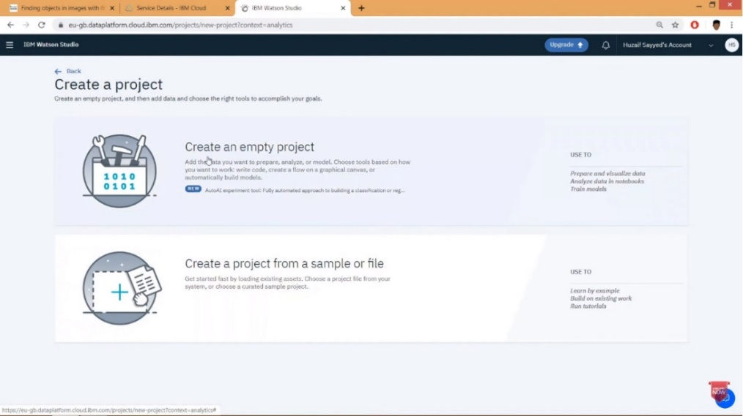

Step 6:

In the new project page, enter a Name and Description for a project. You must define storage for a project before you can create it. Under Select storage service, click Add

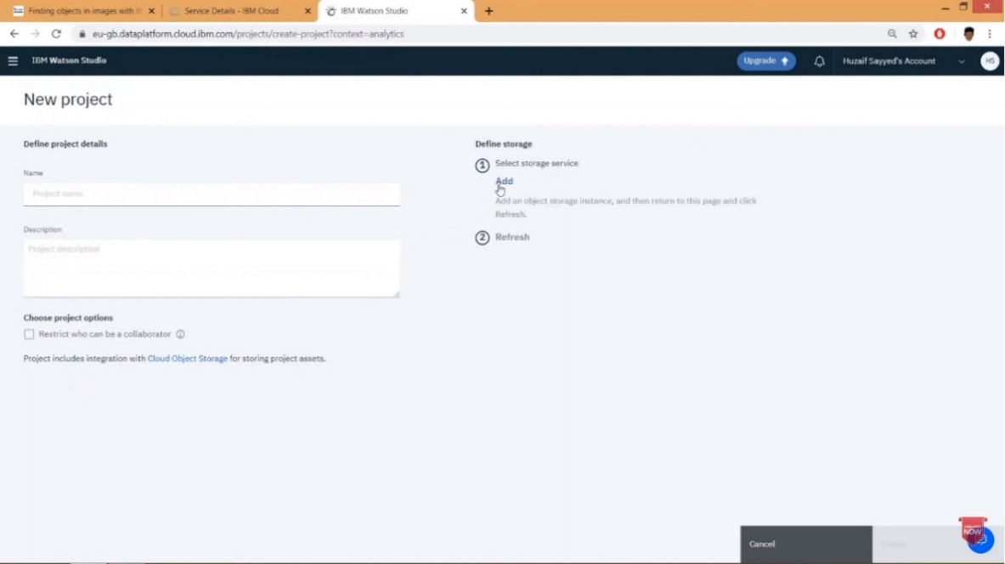

**Step 7**

On theCloud Object Storage page, verify that Lite is selected, and then click Create.

In the Confirm Creation box, click Confirm.

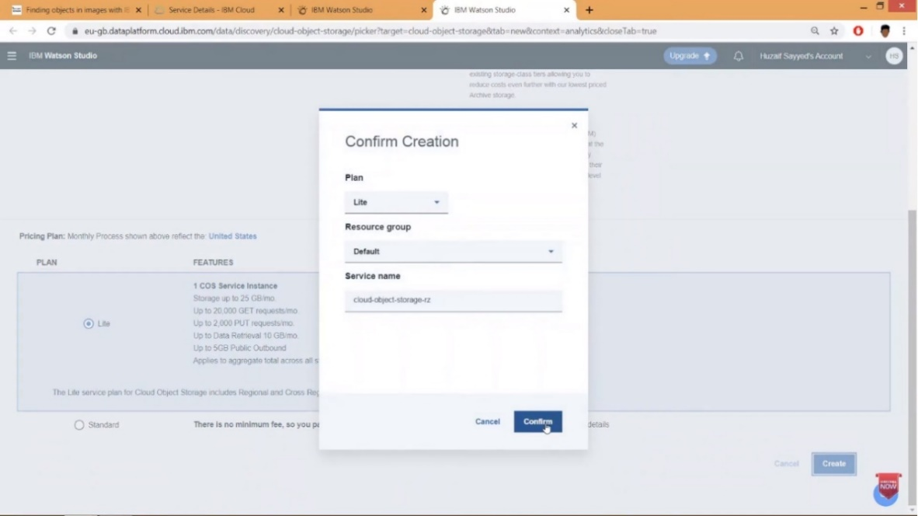

Step 8:

On the New project page, under Define storage, click Refresh, and then click Create.

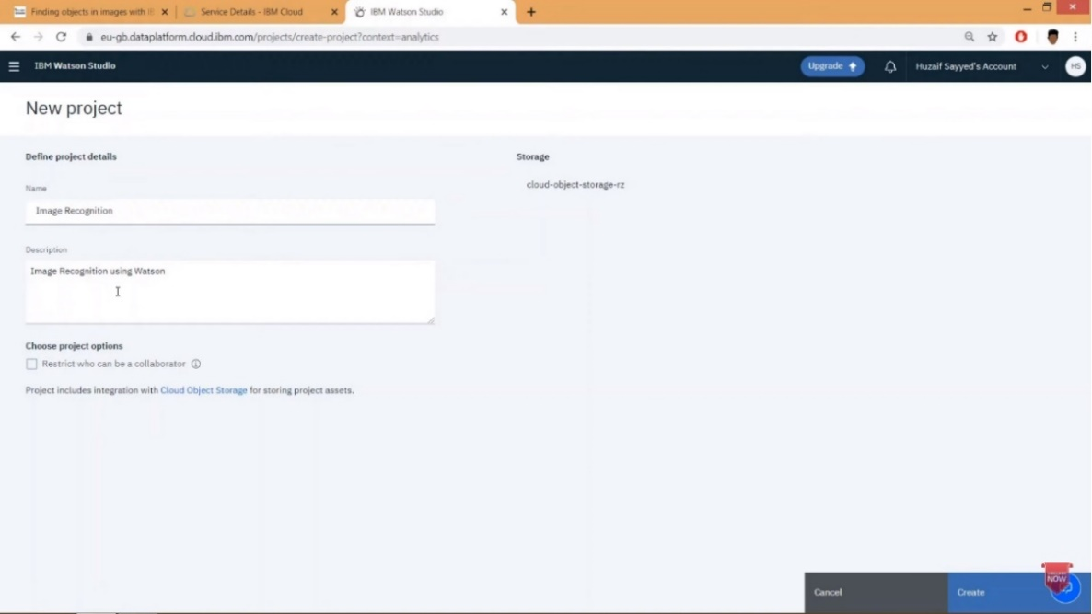

**Add a Watson Visual Recognition Service instance**

Requirements :

We are going to Analyze Images, so we need to add the Watson Visual Recognition service. For that download at least we need 10 images.

Step 9:

To add service to the project, click Add to project.

In the choose assert type box, click Visual Recognition.

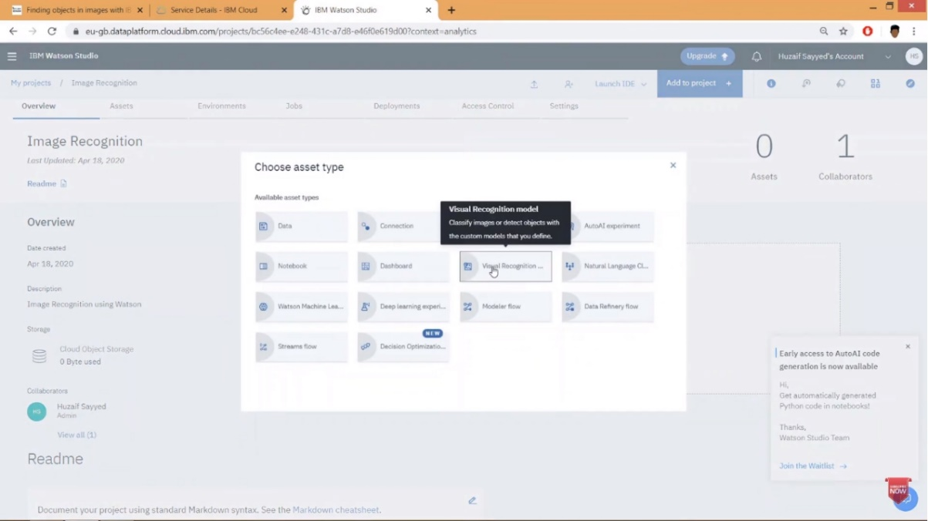

Step 10:

In the Associate a service box, click here

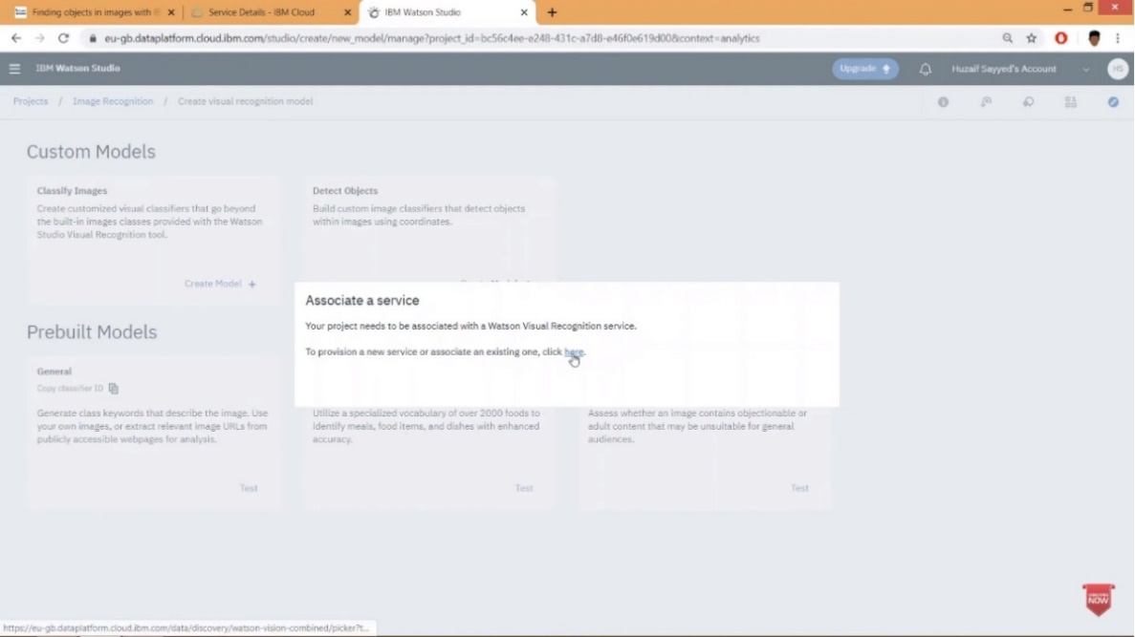

Step 11:

On the Visual is selected, Recognition page, verify that Lite and then click Create. And click Confirm

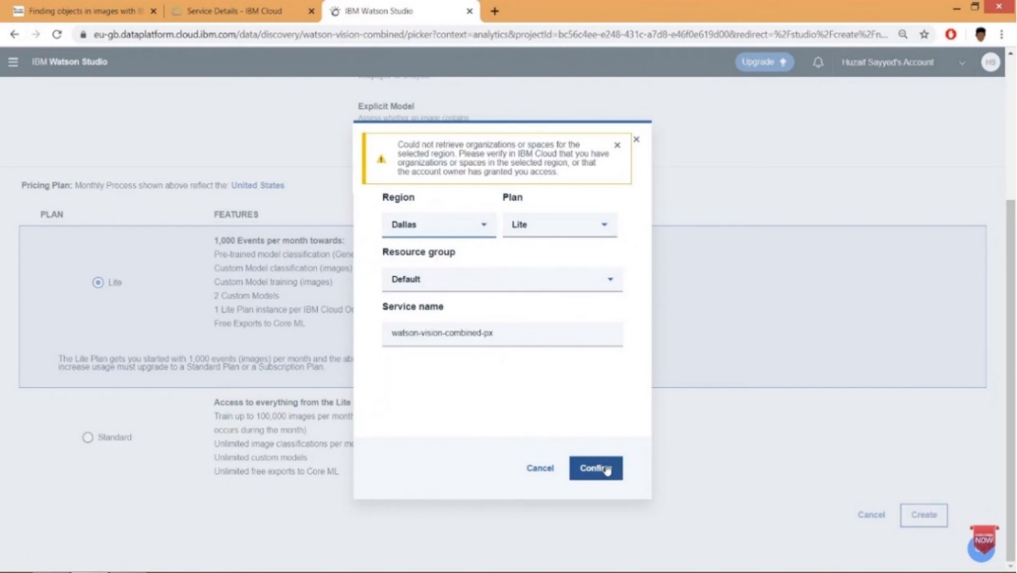

Step 12:

To analyze your images, on the Models page, under Pre Build Models in the General box, click Test.

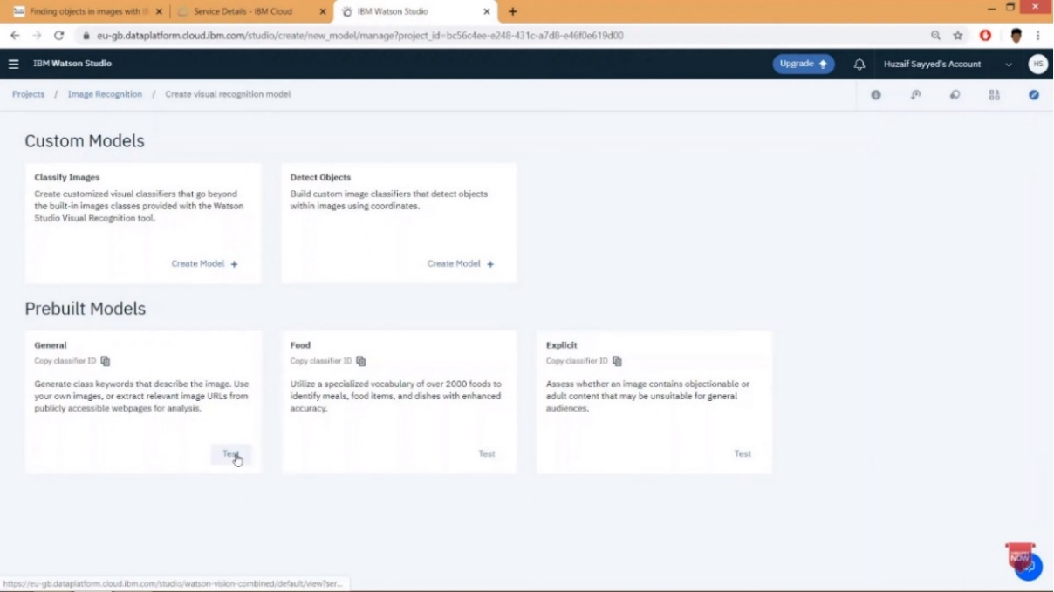

Step 13:

To upload images, on the Test tab, click Browse. select the images you want to upload and then click Open.

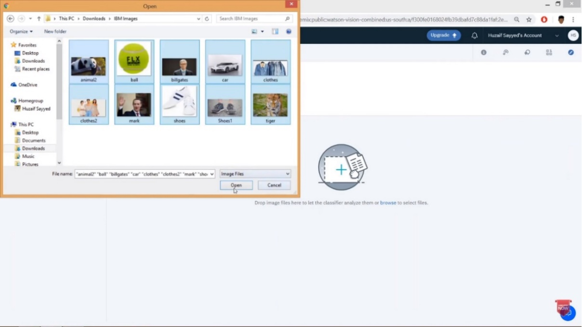

Step 14:

After uploading the images, the following will be the Output.

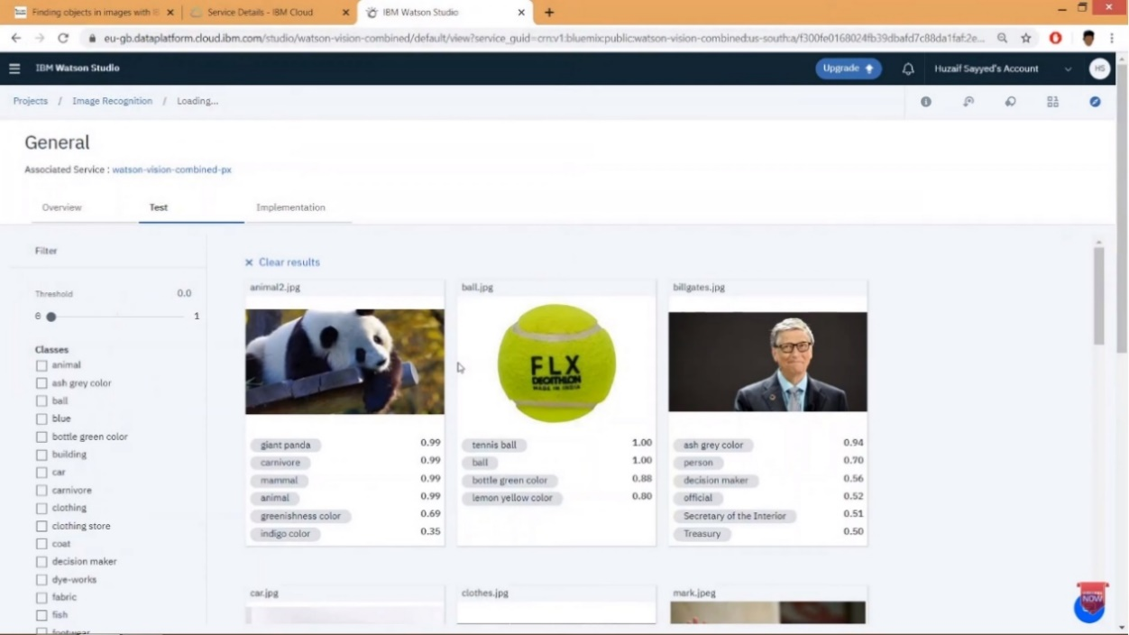

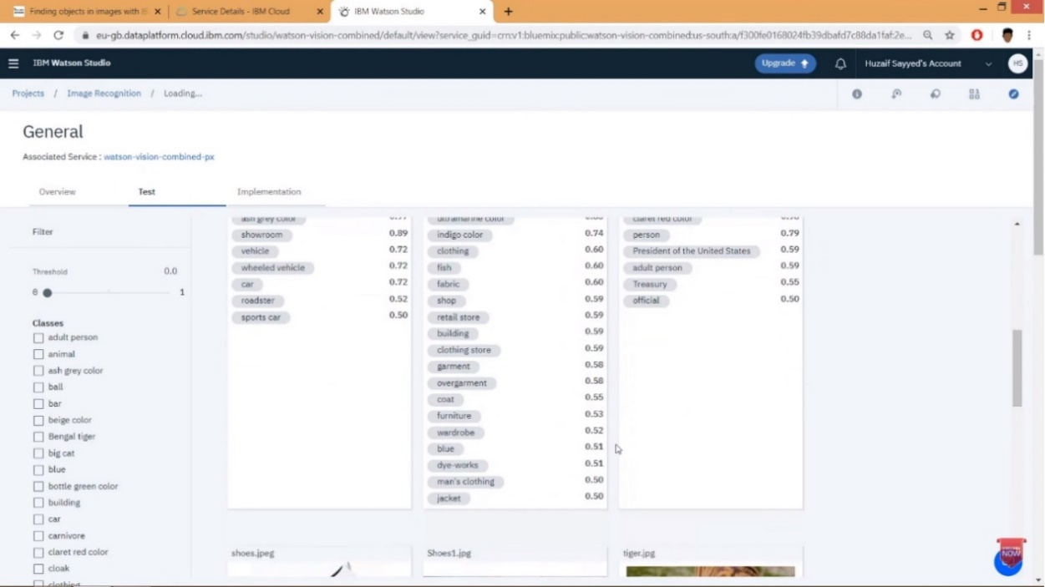

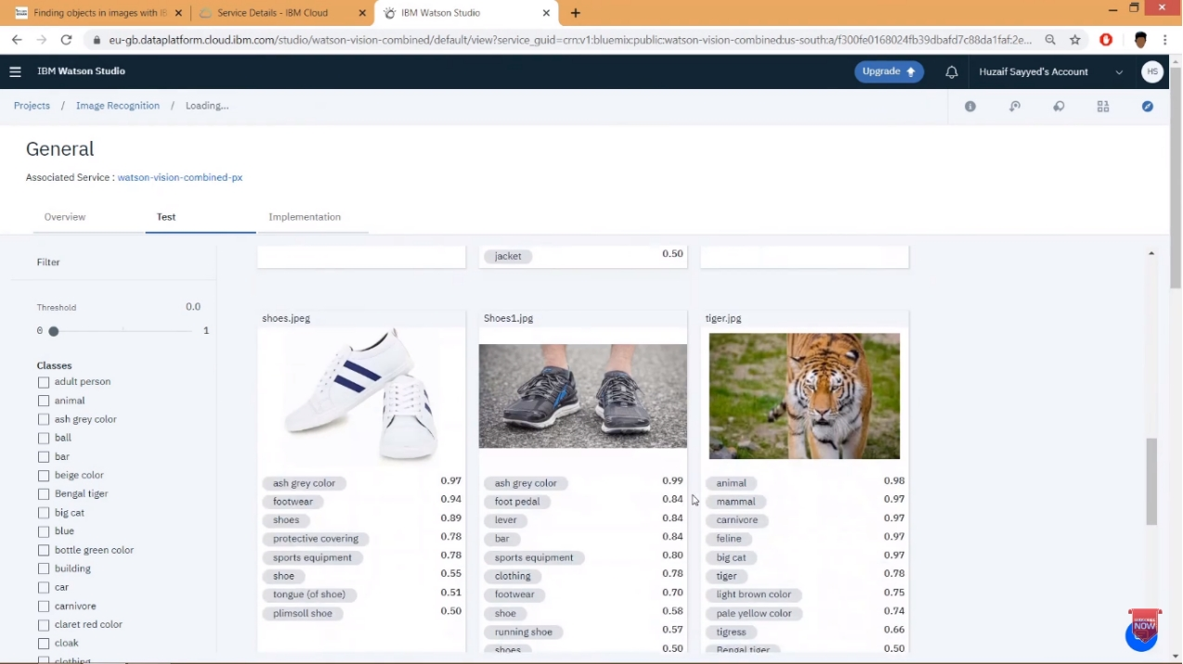

This example is a basic illustration of how to make an image recognition.

**Conclusion:**

From this we conclude that image recognition technology helps us to transform the way of processing, analyzing digital images and videos, making it possible to identify objects accurately and effectively.