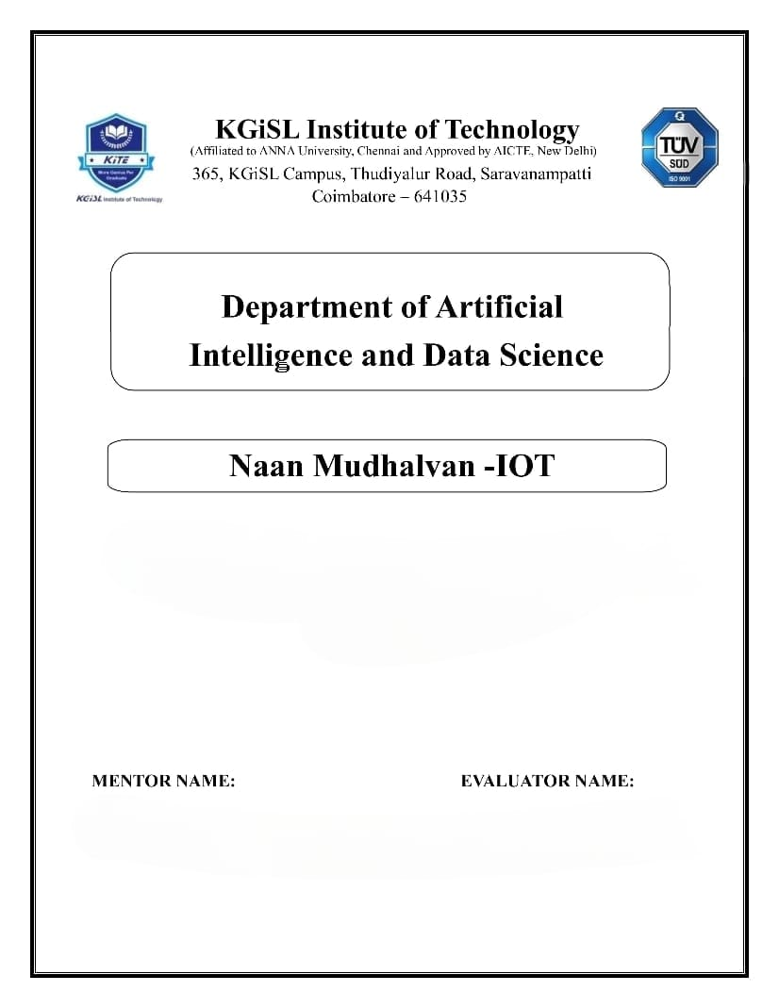

**PROBLEM STATEMENT : AIR QUALITY MONITORING SYSTEM**

Mr.MOHANKUMAR.M

Ms.AKILANDESWARI.M

**Problem Statement:**

We're addressing the issue of a lack of accessible real-time air quality data in our region. People currently lack knowledge about the air they breathe, which may negatively impact their health and quality of life. A system that can continuously check the air quality and provide the public with this essential data is required.

**Solution:**

Our solution aims to provide the public with easy access to vital air quality information, ultimately raising awareness about air quality's impact on health and well-being. By offering real-time data and health recommendations, we empower individuals and communities to make informed decisions to protect their health and the environment.

**Real-Time Monitoring Solution**

We'll measure air quality data (PM2.5, PM10, NO2, CO, O3, SO2) and weather information (temp, humidity, wind) in real-time using IoT devices with sensors.

**A user-friendly platform**

Our web platform will clearly display real-time data via charts and maps, providing that everybody can understand it.

**Health Recommendations**

For vulnerable groups like children and the elderly, the platform will provide health advice depending on air quality.

**Accessibility of Data**

Users can access past data to monitor modifying air quality over time.

**Information Security:**

There will be a strict implementation of security measures to protect data integrity and privacy.

**Integration:**

IoT devices will use the platform to safely transmit data. Before displaying data, Python scripts will verify and analyse the input.

**Design Thinking:**

1. Project Objectives

Real-time monitoring: We aim to have hardware that continuously measures the quality of the air around us. We are able to give current information on the air we are breathing in this way.

Data sharing: We'll develop a website or other platform where anyone can access this air quality data. This implies that you can always monitor the air quality in your region.

Public Education: We want to make sure that everyone is aware of the connection between air quality and health. Our platform will provide tips on how to keep healthy based on the air quality in addition to data.

Health Impact: People who are more likely to have poor air quality, such as children and the elderly, are our primary focus. Our project will offer them detailed guidance on how to protect their health.

1. IoT Devices Designs

Particulate Matter (PM) Sensors:

It may be necessary to deploy multiple PM sensors. It is advisable to include both PM2.5 and PM10 sensors to measure both fine and coarse particles effectively.

Gas Sensors:

To comprehensively monitor air quality and address local concerns, it is essential to install sensors for critical gases like Nitrogen Dioxide (NO2), Carbon Monoxide (CO), Ozone (O3), Sulfur Dioxide (SO2), and Volatile Organic Compounds (VOCs).

Meteorological Sensors:

These should encompass temperature, humidity, wind speed, wind direction, and atmospheric pressure sensors. These meteorological data points are instrumental in assessing air quality conditions.

1. Data Sharing Platform:

1. Air Quality Index (AQI): Use a standardized AQI to show air quality levels, color-coded or categorized for clarity.

2. Pollutant Concentrations: Display real-time pollutant levels through charts or numbers.

3. Graphs and Trends: Visualize historical data to track air quality changes.

4. Maps: Interactive maps show air quality by location.

5. Time-Based Data: Choose time intervals for historical data views.

6. Weather Information: Integrate weather data to show its impact on air quality.

7. Health Advisories: Provide health recommendations based on current air quality.

8. User-Friendly Interface: Ensure easy navigation and responsive design.

9. Data Download: Offer data downloads for research or personal use.

10. Notifications: Alert users about air quality changes or health risks.

4) Integration Approach:

1. Data Collection: IoT devices gather air quality and meteorological data continuously, primarily through sensors.

2. Data Transmission Protocol: Select an appropriate communication method (e.g., MQTT, HTTP) for data transfer based on project requirements.

3. Secure Communication: Implement encryption and authentication to safeguard data during transmission.

4. Data Transmission Frequency: Determine how often IoT devices send data, based on real-time needs.

.