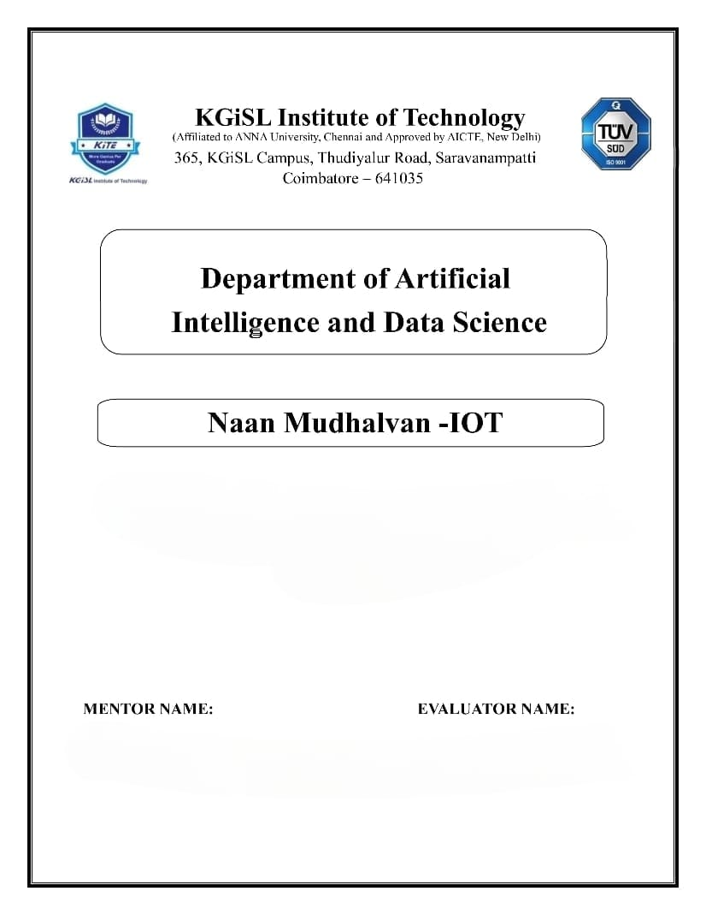

**PROBLEM STATEMENT : AIR QUALITY MONITORING SYSTEM**

Mr.MOHANKUMAR.M

Ms.AKILANDESWARI.M

**The flowchart covers the entire process, from data collection using sensors to displaying real-time air quality information on a web platform.**

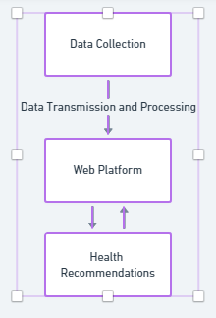

**1. Data Collection (IoT Devices):**

- PM Sensors (PM2.5 and PM10)

- Gas Sensors (NO2, CO, O3, SO2, VOCs)

- Meteorological Sensors (Temp, Humidity, Wind Speed, Wind Direction, Atmospheric Pressure)

**2. Data Transmission and Processing:**

- IoT devices continuously collect data.

- Use an appropriate Data Transmission Protocol (e.g., MQTT, HTTP).

- Secure communication with encryption and authentication.

- Process the data for accuracy and reliability.

**3. Health Recommendations:**

**Children:**

- Stay Indoors on Poor Air Quality Days: Encourage parents to keep children indoors during days with high levels of air pollutants, especially during peak pollution hours.

**General Population:**

- Use Masks on High Pollution Days: Suggest the use of masks, particularly N95 masks, on days when air quality is severely impacted.

Pregnant Women:

- Minimize Outdoor Exposure: Advise pregnant women to minimize outdoor activities on days when air quality is poor to reduce exposure to harmful pollutants.

**Community-wide Recommendations:**

- Promote Green Spaces: Advocate for the creation and maintenance of green spaces to improve overall air quality.

**4. Web Platform:**

- Display Air Quality Index (AQI) using standardized categories.

- Show real-time pollutant concentrations through charts or numbers.

- Visualize historical data with graphs and trends.

- Display air quality on interactive maps.

- Integrate weather data to show its impact on air quality.

- Ensure a user-friendly interface for easy navigation.

- Allow data download for research or personal use.

- Send notifications to users about air quality changes or health risks.

**1. PM Sensors:**

- Deploy PM2.5 and PM10 sensors for fine and coarse particle measurement.

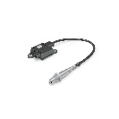

**2. Gas Sensors:**

- Install sensors for NO2, CO, O3, SO2, and VOCs for comprehensive air quality monitoring. 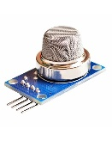

**3. Meteorological Sensors:**

- Include sensors for temperature, humidity, wind speed, wind direction, and atmospheric pressure.

**Full Procedure:**

- IoT devices continuously collect air quality and meteorological data.

- Data is transmitted securely to the web platform using an appropriate protocol.

- The web platform processes and analyzes the data for accuracy.

- Real-time air quality information is displayed on the web platform, including AQI, pollutant concentrations, graphs, and maps.

- Health recommendations are provided based on the analyzed data, especially for vulnerable groups.

- Users can access historical data and download it for further analysis or personal use.

- Notifications are sent to users about changes in air quality or potential health risks.

**This flowchart provides an overview of the entire system, from data collection to user interaction, to address the lack of accessible real-time air quality data in your region.**

